**PowerShell – Notes –**

* **PowerShell is case insensitive**
* **it is a management engine. It is a dll basically that has all the commands and features.**
* **This management engine is built on .Net framework.**
* The engine itsel has to be hosted or run on some sort of application. Some of the consoles can host this application i.e. basically allows you to run PowerShell. So PowerShell is apparently is a hosting application. The hosting application for PowerShell can be linux or windows or nanoserver. Depending on the hosting application for PowerShell, experience of using the PowerShell may differ.
* **Windows PowerShell is actually built on old cmd.exe command line tool. So the PowerShell engine is running inside this cmd window. Here the cmd console is called the traditional or legacy console.**
* The PowerShell Ise known as the graphical console is by default is installed on the client machines like windows 10 or 8.1 etc but it is not installed on the server. We can intall it on the server that supports GUI but there is not need as most of the servers are managed through the client desktops.

What you should know

1. Networking basics
2. Windows client and server basics
3. General troubleshooting skills

-Networking basics

-- Some of the utilities that we are using includes Ping, Trace route, IP config, NS lookup and netshell

--diagonosting and troubleshooting skills/methodology

--Read and understand network diagrams

Prerequisites are: IP address (ipv4, ipv6), switch, router/gateway, firewall, LAN, ARP (address resolution protocol), arp request or tcp port number,

**Right click in PowerShell to paste the copied content instead of ctrl + V**

**Internetworking –** practice of connecting two or more LAN’s together using a gateway or router. For example , when we connect our home network to the internet service provider (ISP) we are internetworking.

When multiple networks are connected together it is called internetwork or internet. Commonly this is called internal network where large private networks are connected in a single internetwork in an organisations.

One of the defined characterstics of an internal network is that a single organization or indivisual owns or actually controls every aspect of it, the routers, switches, firewalls, and the physical copper or fibre optics connections between these devices.

Internet on the other hand consists of millions of connected networks around the world.

.ps1 is the extension for PowerShell scripts

Server manager is the centralized management tool in windows server 2012 and this allows us to work on many of the things on windows server and this also runs PowerShell, everything inside the server manager we are doing here runs PowerShell . so if we add a role inside a server manager, it will generate a PowerShell script in the background.

Active directory administrative center - tool that utilizes PowerShell to work with our active directory environment so if we create a new user in our active directory, server manager behind the scenes will generate a PowerShell commands to do so.

Microsoft uses PowerShell with regard to managing windows. Every application from Microsoft from exchange to sql is built with PowerShell as the basis for administration by the product teams of Microsoft. So every gui tools from Microsoft uses PowerShell under the covers to perform the work.

--getting all the service that is stopped through PowerShell script.

> Get-Service | where-object Status -eq ‘Stopped’ | Select-Object Status,Name,DisplayName | export-csv C:\scripts\servicesstopped.csv

--to open this created file with notepad

> notepad C:\scripts\servicesstopped.csv

$PSversiontable – tells you the version and other information of the PowerShell installed.

RSAT tools: Remote server administration tools are a set of tools that we can install on a windows 8.1 client to give us all the administrative consoles and the PowerShell modules that we need to manage our windows server 2012 and 2012 R2 environment. To get these, we need to download the RSAT tools for our windows client.

**Remember x86 is basically the 32 bit version of the software.**

Install these rsat tools on you client machine.

PowerShell commands uses a syntax of verb-Noun as the best practice. It is interpreted as do something – to something

TO see what all the verbs that are available in PowerShell, use Get-Verb and run. This will give you the list of all the verbs that are available in PowerShell. These verbs are categorised into groups such as Common, Data, Lifecycle, Diagnostic, communications, security and other.

* **Get-verb -verb s\***

Gives the list of all the verbs that starts with s.

* **Get-service -Name M* -Computername Computer1, Computer2**

Lists all the service that starts with M and run on both the computer. Note that the result will not display the computer name on which the service is running. It just displays the status, Name, DisplayName of the services running on the computers.

**PowerShell gets the data as objects.** Here in this example it gets the services starting with M as an object where Status, Name and DisplayName are properties of this object.-Name and -ComputerName are the parameters of the Get-service command.

We can also do it by using aliases for the command so that it is easy to type in.

* **Gsv -Name M* -ComputerName Computer1, Computer2** - gsv is an alias for get-service command.
* **Get-Help *DNS\*** - displays all the commands that has dns in its name in a tabular form.

**Note that** in PowerShell, some of the commands are cmdlets and some are functions. They are basically the same as both of them has parameters etc and works basically the same way. The key major difference is that a function is really a tool that is made up with PowerShell commands and cmdlets. So a function is created using the cmdlets and other code in the logic in order to be able to run.

* **Get-help get-service**  - it will display all the help and description of the get-service command to help you understand the command more and how to work with it. It also gives you the other forms of the service verb commands.

The general way to get help on any command is to use the get-help and then type in the name of the command you want to get the help for.

* To get the examples: get-help get-service -examples
* For more information: get-help get-service -detailed
* For technical information: get-help get-service -full
* To get online help: get-help get-service -online
* To open help in a window : help get-service -showwindow

We can also use ‘help’ instead of get-help to get the information on any command. Help here is a fnctionn in PowerShell which is short form for **get-help | more.**

* Help *about* - it lists all the about files inside of PowerShell.

**Use about_* to research the inner workings of the PowerShell.**

* **Update-Help** - updates all the help files of the PowerShell and keeps it up to date.

**NOTE: any time we download any tools or add any tools like RSAT tool , or add any roles or services we add to our server , you want to update the help as well.** *So always run update-help after installing new roles and features.*

* **Get-command**  **-** it is used for researching about the PowerShell tools in PowerShell. It lets us see all the commands that are installed on the computer, including cmdlets, aliases, functions, workflows, filters, scripts and applications etc.
* **Get-command -type cmdlets**  - lists all the commands that are cmdlets.
* **Get***-***command -Verb New** - lists all the commands that begins with the verb new.
* **Get***-***command -Name *IP\***
* **Get***-***command -Name *IP* -module NetTcpIp**

Get- History allows us to get/see all the cmdlets entered during the current session. It keeps the history as long as the PowerShell window is open. Once PowerShell is closed, history clears automatically.

* Get-history – lists all the command that we have run in the current session and displays it with id.. We can theninvoke these commands.
* **Get-history -Id 45** - triggers the command that we have run previously with id 45

To capture the history

Get-History | out-file C:\scripts\GetHistory01.txt - this commands saves the output of the get-history command to a file of our choice.

* Start-Transcript – path C:\scripts\transcripts01.txt - what this commands does is it keeps track of all that is happening inside the PowerShell current session and transfers this data to the file path provided. But it will only start transcripting once this start-transcripting command is used. Then to stop the transcript use **stop- transcript.**

Anything that has happened between the start and the stop transcript command is logged into a log file in the path provided. So the transcripts has commands its output and also has the header information of the user, computername , start time etc. this information is very handy.

**| - pipelining in PowerShell.** It is a way in PowerShell through which we can send the output of one command to the second command and so on. This allows us to do more complex work on the shell.

The common way that we use pipeline is

Get-something | do-something | output-something

**$_** -> represents the current object in the pipeline.

PowerShell has Foreach alias and foreach enumerator. Do not get confuse with these two.

Foreach-Object example - what we will do here is that we want to compress archive all the files that are not .zip and .exe and whose length is greater than or equal to 1mb . we want to compress the file to the optimum level based on the filename.

Dir -file | where {$_.length -ge 1mb -AND $_.extension -nomatch “.zip | .exe”} | Foreach-object {

Compress-Archive -path $_.fullname

-DestinationnPath “$($_.directory) \ $($_.basename).zip”

-CompressLevel Optimal

}

**Use the semicolon (;) to separate the multiple commands in the same line.**

**Using the foreach-object in the advanced way.**

Foreach-Object has three separate parameters.

-**Begin** {} -> command that run once before anything that’s geeing piped in is processed. Initialising variable, connecting to a database should be there in this begin block.

-**Process** {} parameter -> command that runs once for each incoming object. This is where we can use $_ to represent the current object in the pipeline. This is the default parameter that we use when we run the foreach-object cmdlet in the standard way.

-**End** {} -> command that runs once after everything is processed. It is an optional paramenter like -Begin. So like closing up a db connection goes here.

dir C:\work -Directory |

foreach -begin { $h = @{}; $results = @() }

-process {

$stat = dir $_.FullName -file -Recurse |

Measure-Object -Property length -sum; $h.Path = $_.fullname; $h.files = $stat.Count;

$h.TotalSize = $stat.Sum;

$results += [pscustomobject]$h

}

-end {

$results

}

**Foreach Enumerator ->** the idea here is that for each thing in the collection of things, run these commands or do something. With foreach enumerator , user has the ability to pick the variable name. like in the below example, we have named the enumerator variable as $n. the point to remember here is that the foreach enumerator does not write anything to the pipeline. This is not the case with foreach-object.

$numbers = 1..10

Foreach ($n in $numbers) {

$max = Get-Random -minimum 50 – maximum 500

Set-Content – value (1..$max) -path “TestFile-$n.txt”

}

Things only written to the pipeline with what is inside the foreach enumerator.

Remember at the end of the pipeline PowerShell automatically handles the formatting and the output depending upon what objects are in the pipeline. But what if we want to send the output beyond PowerShell. **For this we have some out cmdlets that lets us to do the same thing.**

1. Out-File -> save it to a file
2. Out-Gridview -> which is a graphical display of columns you can sort and etc.
3. Out-Printer -> so if you have a default printer, it will print the output

get-service | sort status,Name | out-file 'C:\users\Hemant Sharma\desktop\prac.pdf'

get-service | sort status,Name | out-file 'C:\users\Hemant Sharma\desktop\prac.txt' -NoClobber

-**NoClobber** -> it will prevent you to overwrite to a file that already exists.

Get-date | out-file 'C:\users\Hemant Sharma\desktop\prac.txt' -Append

This updates to the existing file. Note that the -**Append** updates the existing file and we can use it to update the file with the result instead of overwriting to the existing file.

Use the following commands to open a file through PowerShell

1. Notepad ‘C:\UserS\hemant Sharma\desktop\pracrice.txt’ -> opens up a txt file
2. Invoke-item ‘C:\UserS\hemant Sharma\desktop\pracrice.pdf’ -> opens up a pdf file.

**Tee-Object -> this cmdlet** saves the command output to a file or variable and also sends it down to a pipeline.

So this cmdlet also displays the result on the screen and we can then store it into a variable or send the result into a file.

Get-process | sort WS -descending | select -first 10 | Tee-Object -FilePath ‘C:\Users\Hemant Sharma\Desktop\proc.txt’

**Pipeline in Depth:-**

Some cmdlets accept pipeline inputs either by value or by propertyName..

Restart-Service cmdlets accepts pipeline input by value

Get-Service winrm | Restart-Service

Get-Service accepts pipeline input by propertyName

[pscustomobject]@{Name = ‘winrm’;ComputerName=’srv1’} | Get-Service

trace-command -name ParameterBinding -Expression {get-service doc | Restart-Service } -PSHost

Trace-Command can do a lot of things. When you run the above command you will see that the trace command gives you some metadata information of what it is that it is doing .

So trace command is used to get a trace of what a command is doing.

**Creating custom properties on the fly and expanding properties.**

@{Name = ‘something’ ; Expression = { <your code> }} -> this is a custom hashtable. It is a key value pair. In this case, the custom hashtable has 2 key value pair. First one is name and the second one is expression.

Get-Process | Select ID, Name,WS,StartTime,@{Name = ‘Runtime’ ; Expression = {(Get-Date) - $_.starttime }}

Here, what we are doing is creating a new custom property on the fly to calculate the running time of the services.

**Expanding property.**

PowerShell outputs objects that come down the pipeline. Sometimes it is a nested object or sometimes it is an array. Or sometimes the user just want to see the value instead of seeing the entire object.

Get-Service winrm | Select -ExpandProperty RequiredServices. -> this returns the names of the services required by the winrm service.

Get-Service winrm | select requiredservices

This returns the object of the services that are required by the winrm service.

Get-Service | Select Name | Out-File ‘C:\Users\Hemant Sharma\Desktop\services.txt’ -> this returns the name property of the object and send it to the file specified. If you open up the file and see the result, you will see that It contains the Name header. This is because PowerShell returns objects as output.

Now if we just want to list all the names of the services that are there in the computer whether running or not***, we need to get the output as value instead of object. To do so, we can use the -ExpandProperty***

Get-Service | Select -ExpandProperty Name | Out-File ‘C:\Users\Hemant Sharma\Desktop\services.txt’

Now if you open up the file to see the result, you won’t see the Name header up top.

---------------------------------------------

Suppose you want to log all the error event log based on the source that created the error.

Get-EventLog application -EntryType Error,Warning -Newest 10| Group Source | foreach {

$file = Join-Path -path 'C:\users\Hemant Sharma\Downloads' -ChildPath “$($_.name).txt”

“$($_.count) entries” | Out-File $file

$_.group | foreach {

$_ | select TimeGenerated,EntryType | Out-File -FilePath $file -Append

$_ | Select -ExpandProperty Message | Out-File -FilePath $file -Append

}

Get-Item $file

}

This creates a file for every group of application type eventlog errors which will contain all the errors created by the same source.

**PowerShell data as objects.** PowerShell places all data that it receives through commands into collections or a table. Each row in the table is an object that has some properties/attributes associated with it.

**Get-Member**  it gets the properties and methods of the object.

For example : get-service | get-member - lists all the method and properties associated with the get-service object.

* **Get-service | where-object status -eq “stopped” | format-list** - this outpus the command result in a list format instead of the default table format.

Formattting

At the end of the pipeline PowerShell has out-default. PowerShell automatically uses it for output. This cmdlet then pass object to Out-Host. Because PowerShell has hosted it in an application. It could be the PowerShell console, or PowerShell ISE or visual studio code, it could be some other product or application. So out-host knows how to talk to the hosting application and can figure out, hey, how do I write something to the screen. In order to do that, it then calls the PowerShell formatting system, the PowerShell formatting cmdlets, to decide what to do with the object and how to display it on the screen. The way it does that is by first looking at the configuration files for some instructions. It will look in the PowerShell home directory which is in the system 32 folder, and it will look for files that are format.ps1xml files, such as DotNetTypes. Within those files that describes the default and alternate layous for a particular type of object, and will tell PowerShell to output as a table with what properties and so on.

PowerShell might also check types.ps1xml files also located in the same folder for default properties for a given object.

Now, if there are less than 5 properties, it will display a table assuming that there is not other formatting rule present to say otherwise.

If there are more than 5 properties, display a list.

We can always override this behaviour with format cmdlets.

1. Format-list (fl)
2. Format-table (ft)
3. Out-gridview
4. Format-Wide
5. Format-Custom – for creating custom formatting. Uses a customize view to do the formatting.

**Format features**

* Select one or more properties. We can also select custom properties created on the fly.
* Grouping
* Autosizing
* Access alternate views
* Create your own custom formatiing

While using any of the formatting type to format the result in PowerShell, there is one more feature with format-table or other formatting cmdlets. This feature is called view. -View parameter tells the PowerShell how you want to view the result set.

There is no easy way to find the view available to use directly. One can always look at these in the formatting data files like mentioned above or one can do this.

Get-Service | format-table -view foo

This will give you an error saying foo is not recognized as a proper view. In the error message though, it will display all the view that are available for formatting.

Get-Service | format-table -view service

NOTE**: out-Gridview is the one cmdlet that you cannot pipe with the output of the formatted result**. It will lead into an error. You can though use out-File or out-Printer to output the formatted result and it will work just fine.

This is because, once the output id formatted it is no longer of the same object that went into the formatting. Instead it is something that PowerShell understands while doing formatting and is a different object.

Get-Service | Get-Member

TypeName: System.ServiceProcess.ServiceController

Get-Service | format-Table | Get-Member

TypeName: Microsoft.PowerShell.Commands.Internal.Format.FormatStartData

Name MemberType Definition

---- ---------- ----------

Equals Method bool Equals(System.Object obj)

GetHashCode Method int GetHashCode()

GetType Method type GetType()

ToString Method string ToString()

autosizeInfo Property Microsoft.PowerShell.Commands.Internal.Format.AutosizeInfo, System.Management.Automation, Versi...

ClassId2e4f51ef21dd47e99d3c952918aff9cd Property string ClassId2e4f51ef21dd47e99d3c952918aff9cd {get;}

groupingEntry Property Microsoft.PowerShell.Commands.Internal.Format.GroupingEntry, System.Management.Automation, Vers...

pageFooterEntry Property Microsoft.PowerShell.Commands.Internal.Format.PageFooterEntry, System.Management.Automation, Ve...

pageHeaderEntry Property Microsoft.PowerShell.Commands.Internal.Format.PageHeaderEntry, System.Management.Automation, Ve...

shapeInfo Property Microsoft.PowerS

you can notice that the output after formatting is not the same ServiceController Object.

Get-service | Format-list - gives more detailed information in the form of a list

Get-service | fl Name,Status -filtering information to name and status only in the list output

Get-service | format-table -Autosize

Get-service | format-table -Wrap

Get-service | format-table -Wrap -autosize

Get-service | ft name,status

* Get-service | out-gridview - this opens up a gripview gui that displays the result. We can filter sort etc in it if finding for a particular value in the resultset.

Get-service | format-wide -> this will take a single peoperty and display it in a wide table format. In this case it takes the name property of the service and displays it in wide format giving us the 2 columns values instead of one.

Get-service | format-wide -Column 4 -> this time it will use 4 column to display the result.

**Getting information with PowerShell.**

1. Computer and hardware
2. Networking
3. Registry
4. Files and printers
5. Active directory objects

Approach to be taken: use Get-command to find the command you are looking for by narrowing it down and then use Get-help to know on things like how to use the found command. Use get-member in order to find the specifics of the command. Like properties etc.

**Get-WMIObject**

In order to get information about the OS and the underlying hardware on a local or remote computer, you need to access windows management instrumentation(WMI) extensions in a windows OS. It is built by Microsoft to allow access to information contained within the operating system. It is based on the common information model or CIM **Get-CIMInstance** which is an open standards that defines how managed elements in an IT environment are represented as a common set of objects as well as the relationship between them. CIM was introduced in PowerShell version 3 to work with WMI. Prior to that we only had access to WMI cmdlets such as get-WMIObjects. Get-CimInstance cmdlets also does the same and is provided in poershell version 3.

When we access the wmi information , we access the wmi repository which contains the namespaces. CIM version 2 is the namespace that contains the classes we are looking for to find the information. The classes are things like win32_processor that contains information we are looking for like Device id and name of our processor. This information is stored as properties that are accessible from the objects output by the commands.

* Get-Counter
* Get-WMIObject
* Get-CIMInstance
* Get-Eventlog

Let’s gather information like system memory, bios version and the last reboot time.

To look at the memory used and all, we are gonna get the memory counters information

Get-command *counter*

* Get-counter
* Get-Counter -listset *memory* - this allows us to list all of the counter sets that are available on the system.
* Get-Counter -listset *memory* | where CounterSetName -eq “Memory”
* Get-Counter -listset *memory* | where CounterSetName -eq “Memory” | select -expand Paths

This will expand the Paths information if truncated.

* Get-counter “memory\% committed bytes in use”

This will give you the information on the memory usage currently on your local desktop.

* Get-CimInstance Win32_physicalMemory

Gives you the memory capacity and other physical memory related information.

* Get-CimClass -ClassName *disk* - cimclass lets us look at all the classes that are available.

It will list all the cimclasses related to disk.

Get-CimClass *BIOS* -gives the bios information

Lastly to check the last time the system was rebooted. We need to check the system event in event viewer wth id number 1074

Get-command *event*

Help get-eventlog

Help get-eventlog -examples

* Get-Eventlog - log system -newest 1000 | where eventid -eq ‘1074’ | format-table machinename, username, timegenerated – autosize

**PowerShell Background Jobs:**

When you run a command PowerShell waits for the command to complete. You do not get your prompt back. Most of the time it is not a big deal. But what happens when you run a command that needs a long time to complete? What if when you do scripting and run a command for say Active Directory, or say sql or sharepoint, you might run into a situation where the command takes a long time to complete. To get around this, we can run a command in PowerShell as a background job. This way you will not have to wait for the PowerShell to complete the command to get your prompt back. **Everything runs in a background runspace. Its like a hidden background PowerShell session.** When the job is complete you can then retrive results as you want.

Job cmdlets

* Start-Job : starts any scriptblock or script.
* Get-Job : to check the job status.
* Receive-Job : when the job is finished running you can receive the job and work with the job results.

There are also 2 other ways you can work with job.

1. Invoke-Command - The AsJob parameter runs any command as a background job on a

remote computer. You can also use Invoke-Command to run

any job command remotely, including a Start-Job command.

1. Get-WMIObject.

Both of these cmdlets also has a parameter that allows you to run a commands and create a background job so that when the command is running the results will go to the job and you get your prompt back.

Help about_jobs

start-job -ScriptBlock {get-service bits} | tee -Variable job1 -> this writes a job object to the pipeline and create the job. In order to reuse it and reference the jobs, we are sending it to tee object and store it in a variable job1.

Start-job {Param($status) Get-service | where status -eq $status} -Name svc -ArgumentLIst @(‘running’)

When you create a job, you create a master or ececutive job, PowerShell will also create one or more child jobs underneath the parent job. It the child jobs that do the work for you.

So when you create a job say with name Job1 and then another job, it will be created with the name Job3 unless a user defined name is provided. Job2 is the child job that has been created by the PowerShelll for the parent job Job1 which does the task for the Job1.

To see all the childJObs that are created

Get-Job -IncludeChildJob

Looking at the child jobs may come handy when troubleshooting.

Get-Job -> displays all the jobs that are there in the PowerShell

Receive-Job svc -> receives the output of the job named svc

**Remember: when you receive the job once, the job data is cleared out of the job queue and you cannot see the data after that.**

**If you want to keep the data after the receive -job command runs once. You need to use the -Keep parameter. This tells the PowerShell to keep the result.**

You can remove the jobs by remove-job command but also it is important to note here that if you do not remove any jobs, the jobs will be there in the PowerShell as long the PowerShell session is running. Once you close the PowerShell session, all the created jobs goes away.

***Invoke-command and get-WMIObject lets you create a job as part of your cmdlet itself.***

Invoke-command -ScriptBlock { get-eventLog -list | where {$_.entries.count -gt 0 }} -Computername $env:Computername -AsJob

Get-Job | wait-Job | Receive-Job -Keep

Help about_remote_jobs

------------------------

Get-wmiobject -class win32_Process -asjob

**Remember cim cmdlets cannot be run as a job directly. You will have to use Start-Job to run these as a job**

Start-Job {Get-CimInstance win32_volume } -Name voljob

**Gathering Networking Information:**

* Ipconfig :
* Get-NetIPAddressConfiguration
* Get-SMBMapping
* New-SMBMapping

Ipconfig – list all the ip configuration information

Ipconfig /all – list the detailed information of the ip configurations.

Dhcp settings if disabled means we have a static ip address. It also gives information on the subnet, gateway and dns information. This is the first thing to lookup when working with network related use. Making sure the configurations are correct so that it allows them to route properly, and also look at the dns so that they can resolve dns names properly.

Now **ipconfig** is a cmd command and though it although works with PowerShell, it is not a PowerShell command. The analogous PowerShell command for the same is Get-NetIpAdress or Get-NetIpConfiguration.

The get-netIpconfiguration is more useful.

Whenever we are looking at things related to a client computer, we are always looking for dns client.

Get-DnsClient

Get-dnsclientserverAddress - this is a great command that can help us understand whether or not the client has correct or incorrect dns server listed on their system.

Suppose a client is trying to get to a website and they are not getting the right website.

Get-dnsClientCache - to view the client cache and this will list all of the cached information that cached locally for dns on our system.

**Mapping a network drive –** we use simple message block or SMB which is the windows functions to getting to network shares.

Get-SMBConnection

Get-SMBMapping

If we want to add a new mapping for a user or to a remote system, use New-SMBMapping

* New-smbMapping -LocalPath C: -RemotePath \\contoso-so\vmFiles

**Testing network connections:**

Ping – it sends the ICMP echo to a remote system

* Ping 4.2.2.1 – if the information says timedout, wee might k=not be able to check where it timed out. For this we can use a tool called teaceroute and tracert allows us to map all of the hops, basically each router, as our packet goes across the network.

Ping analogous is Test-NetConnection 4.2.2.1

Tracert analogous is Test-NetConnection 4.2.2.1 – TraceRoute

* If we want to test by port

Test-NetConnection -CommonTCPPort HTTP -ComputerName pluralsight.com

**Gathering Registry Information with PowerShell**

* GetPSProvider
* Get-Item
* Get-ItemProperty
* Set-ItemProperty

Registry contains all of the information that makes windows a windows. Make sure to a backup of the registry settings before changing it as if in case somethings not right we can always go back and restore to the previous working registry settings. **It also includes the group policy settings, changes you make in the GUI. So if you type something or change the background etc, all these stuffs get stored in the registry.**

Get-PSProvider – it allows us to see a number of different data stores within the system as if they were all file system drive. So it actually allows us to work with and view the registry as if it were our c drive. Normally we have two main registry hives/drives namely HKCU (HKey current user), HKLM (HKey local machine)

To go to the hkey local machine use **Set-location HKLM:** this will change thePS promot from PS C:\Users\user1 > to PS HKLM:\>

Then do a cd Software

PS HKLM:\Software> dir – lists all the directories or softwares in this with its registry properties.

Changing a property value

Set-ItemProperty -Path .\wiredBrainCoffee -Name PackageInstalled – Value 0

**Working with Files and Printers in PowerShell**

* Get-ChildItem
* Copy-Item
* Move-Item
* Rename-Item
* Get-Printer – displays printer related information
* Add-Printer – adds a new printer connection
* Remove-Printer – Removes the printer (remember to use quotes if your name property has spaces in it. Otherwise the PowerShell will not read it as a single text as it treats the space to read a value for a different parameter which might lead to an error.)

If we want to search a file we don’t remember the name of and where we have stored them but we do know the type of file we are looking for. To do this we can use **Get-childitem**

* **Get-ChildItem** -Path C:\ -Recurse -Include *.png

This will output all the png files inside the drive C and its subdirectories. -Recurse looks into the main directory given and its subdirectories. If nothing id found it outputs nothing

What if we want to copy some files from the network share to our local drive.

* Get-Command *copy* -diaplays the list of all the copy related commands in PowerShell that we can use.
* Copy-Item M:\DesktopBackgrounds -Destination C:\backgrounds -Recurse -Verbose

Recurse here will copy everything and verbose tells and displays all the copied files in our poweshell as it copies them.

Verbose tells us the actions it is performing as it is doing them.

* Move-Item : moves the files and folders from source to destination
* Rename-item C:\MovedFolder -NewName c:\RenamedFolder - this renames the folder name.

TO see the file permissions on a folder, it an sometimes becomes a mess doing so in PowerShell. The easiest way to do this is by using a utility called **icacls.exe (built in windows utility).** This not only allows us to view permissions but we can also reset the permissions.

* Icacls.exe M:\DesktopBackgrounds - this will list the users along with the permissions they have on the path provided.

**What is Active Directory:**

Its full name is active directory domain services (ADDS). It is a directory service responsible for centrally organising, managing, administering and locating resources on your network. It is installed on a windows server product. These resources could include files, folders, printers, users and groups, computers and much more. A domain provides an administrative boundary for organisations to centrally manage these resources. These resources we often refer to as objects.

* Get-ADUser
* Search-ADAccount
* Get-ADComputer
* Get-AdGroup
* Get-ADGroupMember
* Add-ADGroupMember

Get-ADUser -Identity jgarcia - displays only a small portion of properties and rest of the are hidden

Get-ADuser -jgarcia -Properties * -displays all the properties

Search-AdAccount -lockedout | select name -filters all the lockout account by name

Search-AdAccount -AccountDisabled | select name - displays names of prople whose account is disabled.

Get-ADComputer -Filter * -displays all the computers

Get-ADComputer -Identity Client02 -Properties * -displays all the properties for the client02 computer.

Administraters use active directories groups to provide users access to resources on a network. Sometimes we get an incident that a user cannot access a resource. So first things we can look is that if they have permissions.

Get-ADGroup -Filter * -displays all the groups in an AD

* **Get-ADGroup -filter * | where name -like “*MKTG*”** - this will display all the groups in and AD which has MKTG in their name.

**Another way to do this is Get-ADGroup -filter { Name -like “*MKTG*”}** - this way is commonly called as filtering left and formatiing right.

* **Get**-ADGroupMember -Identity “MKTG Users” | select Name
* **Add**-AdGroupMember -Identity “MKTG USers” -AccountName jtayler - adds the new user to this ADgroup

Get-ADUser -filter * -properties * | get-member -list all the properties of the users

To filter the users who work from seattle and are in marketing department

Get-AdUser -Property Name,City,Department -filter {Department -eq “MKTG” and City -eq “seattle”} | Filter-table SamAccountName, City,Department -Autosize

**Remoting with PowerShell:**

By default, windows clients like 8, 8.1 and windows 10 does not have PowerShell remoting turned on by default. This is a good point through the security point of view.

PowerShell remoting allows you to send commands to a remote machine on your network. ***It is based on a single remote service called Windows Remote Management or WinRM***. WinRM is responsible for maintaining connections, referred to as sessions, between computer nodes. For WinRM to work the nodes also known as the computers you want to connect to have to have listeners set up so that WinRM knows to listen for PowerShell connection requests.

***Connections are made over the network using WS-MAN (HTTP or HTTPS)*** . a protocol based on HTTP. Once you have established a link between the two nodes/computers, requests are then sent and processed by the listeners on the target, then the result are then transmitted back to the initiating computer.so in a nutshell, it actually allows you to run the PowerShell commands on a remote machine as if you were working directly on the remote machine.

In order to remote to the client using PowerShell, you need to have the right permissions along with having the client enabled for PowerShell remoting.

* **Enable-PSRemoting -**run this command on the target computer to enable remoting. This performs a number of tasks like starting the session listener and configures the windows firewall for remoting.
* **Set-PSPermissionConfiguration**  - this gives the user access to PowerShell remoting. This allows you to modify the session permissions and this will allow the remote connection to happen.
* **Then you need the permissions to actually perform the tasks**. The easiest way to do this is adding the user or the group the user is in to the local administrators group on the target machine. There are granular ways to add permissions without local admin, however, they are very complex.
* **Last there is a good chance you will be working with some cmdlets from older versions of PowerShell like get**-service, get-process, get-wmiobject. When using these remotely, they use DCOM instead of WinRM, so you need to modify your windows firewall appropriately using **Set-NetFirewallRule** commands.
* **Enable**-PSRemoting
* **Get**-PSSessionConfiguration
* **Set**-PSSessionConfiguration
* **Set**-NEtFirewallRule
* Set-PSSessionConfiguration -Name Microsoft.PowerShell -ShowSecurityDescriptorUI
* Get-NetFirewallRule | where DisplayName -Like “*windows management instrumentaion*” | select DisplayName,Name,Enabled - this will give us the information on the inbound traffic on wmi

Enabling the firewall rule for wmi

* Get-NetFirewallRule | where DisplayName -Like “*windows management instrumentaion*” | Set-NetFirewallRule -Enabled True-Verbose

Once the client machine is setup for the PowerShell remoting we can connect to the machine to perform our tasks.

* Enter-PSSession -ComputerName Client02 - this will enter you into the session of the remote computer

This is mainly for domain environment. Most environment are domain joined. ***For non-domain machines we need to use trusted hosts***. Basically what this is, is that when you have standalone systems or say you are connecting to a standalone server that is not a member of your domain, you need to tell your computer that you trust connecting to that remote system because it cant use Active Directory authentication Kerberos, It can’t use two part authentication, so you need to that computer you are getting into. So the first thing we want to do is

* Get-Item WSMAN:\localhost\client\TrustedHosts - this tells us what trusted hosts are trusted on this system.
* Set-Item WSMAN:\localhost\client\trustedhosts -value * - this will trust this system to connect to any system.
* Set-Item WSMAN:\localhost\client\trustedhosts -value “WebServer01” - this will add a value for webserver01 to the trustedhosts and now we can connect to this computer which is outside of our domain.

**Working with variables:**

$a = 1 -a is an integer

$b = server -b is a string.

$c = ger-service -c is a command that contains the output object of the get-service command.

* **Get-Variable**  - this shows all the built in variables inside of PowerShell

Double quotes resolves the value of a variable whereas single quotes does not. Single quotes takes wverything inside it literally.

**Options for remoting with PowerShell:**

-ComputerName : this creates the PowerShell remote session that is used to run the command on the remote server.

*-**PSSession** cmdlets noun. These allows us to create, enter and remove PowerShell remote sessions. With the enter-psSession cmdlet you can actually begin running your console prompt as if its on the remote machine. This is helpful to run commands in real time against remote machine as if you are on the machine. **NOTE: It is not designed for scripting.**

**Invoke-command** : this allows you to run a script block against a remote system. A script block is just a block of PowerShell commands. PowerShell remoting with invoke-command uses XML to transfer the data. The target will serialize the result in XML , transport the output back to you and the data is then deserialized back into objects and it places then in the pipeline of your PowerShell session where you can use them.

**New-CimSession** : typically when we use cim cmdlets, **they use WSMAN by default**. This is great when working with PowerShell 3.0 computers. However, legacy systems uses DCOM, so we can force the cim cmdlets to use DCOM by configuring a cimSession.it is similar to the PSSession we create using PowerShell remoting.

Also some command like SMBMApping does not support the -ComputerName parameter so using New-Cim can get us around that.

**Remoting with PowerShell.**

* Get-process -ComputerName
* New-PSSession
* Enter-PSSession
* Remove-PSsession
* Invoke-Command
* New-CIMSession
* Get-service -ComputerName command in PowerShell, the parameter -ComputerName does not rely on Windows PowerShell Remoting. So it does not use WinRM. So this is one of those cases where you need to make sure that the firewall is setup for this to work. So this is on a cmdlet by cmdlet basis.
* PSSession is good for real time work as it works like as if we are on the remote machine itself.

Enter-PSSession -ComputerName “Client02” -connects to the client02

[Client02]: PS C:\Users\User1\Documents>

Note that as we have not put any credentials, it is going to use whatever credentials with which we are logged in to PowerShell.

Now we can run the get-service command to see the services running on the client02 machine.

To get out of the session. Type Exit.

* Invoke-command allows us to to run scripts against a remote system.

Invoke-command -ComputerName “’Client01” -Credential domain01\user01 -ScriptBlock

{Get-Service}

Scriptblock is the block of commands that we want to run on the remote machine. Also it retrives the data in a list format. This is happening because of the serialization and deserialsation of the data over WinRM.

* ***Both PSSession and cimSession uses WinRM but cimSession comes in play to work with cmdlets or modules which is a group of cmdlets that are not allowed to utilize PSSesions. And one of those modules is the DNS Client module that allows us to get the dns client information.***

***Let try to get a dns information of a remote server system.***

*Parenthesis allows us to run a command inside of another command.*

**Get-DNSClientServerAddress -CimSession (New-CimSession -ComputerName “Client02”)**

This will give you the information of all the dns server on the remote machine.

**Scripting with PowerShell:**

By default PowerShell does not allow execution of scripts. This is done from a security standpoint.

To run the scripts in PowerShell, we need to modify the **Set-ExecutionPolicy.**

* **.\Get-StoppedServices.ps1 -**this will give an error as running scripts in PowerShell is disabled by default.

Set-ExecutionPolicy Unrestricted - this will allow all the scripts to run and execute on the PowerShell.

PowerShell ISE (Integrated scripting Environment) – it is a built in tool to work with scripts in PowerShell.

**Read-Host** is used to read a value through a PowerShell console.

Write-Host is used to write the output to the PowerShell console.

* $ComputerName = Read-Host “Enter Computer Name”
* Get-CinInsatnce -className Win32_OperatingSystem `

-ComputerName $ComputerName | Select-Object -Property CSName,LastBootUpTime

(*`(known as the back tick) is used in PowerShell to show that the command is longer and we are writing it in continuation in the next line.*)

**Creating a parameter in PowerShell:**

To create a parameter in PowerShell **Param** is the keyword then inside the parenthesis we put Parameter in square brackets then the datatype and its name.

Param (

[Parameter(Mandatory = $true)] [String] $ComputerName

)

$os – Get-CimInstance Win32_OperatingSystem | select Caption

$osv2 = (Get-CimInstance win32_OperatingSystem).Caption

**NOTE:** the output of the $os will be with the title caption and its value. That is $os will return the output in a tablular form where as the $osv2 will just return the values. This is called member enumeration.

Creating a help block in PowerShell.

<#

.Synopsis

Short description

.Description

Long description

.Example

Example of how to use the cmdlet

.Example

Another example of how to use this cmdlet

#>

#ScriptName

#Creator

#Date

#Updated

#References, If any

#Variables

#Parameters

#Enter tasks below as remarks

#IP Address

Resolve-DNSName Client02 | select Name,Ipaddress

#DNS Server

(Get-DNSClientServerAddress -cimSession (New-CimSession -ComputerName Client02) `

_InterfaceAlias “ethernet0” -AddressFamily IPv4).ServerAddresses

#OS Description

(Get-CimInstance Win32_OperationSystem -ComputerName client02).caption

#SystemMemory

((((Get-CimInstance Win32_PhysicalMemory -ComputerName Client02).Capacity | measure -Sum).Sum)/1gb)

#DiskCapacity

((Get-PSDrive).Free|measure -Sum).Sum/1gb + ((Get-PSDrive).Used|measure -Sum).Sum/1gb

#Last-Reboot

(Get-CimInstance Win32_OperatingSystem -ComputerName Client02).LastBootUpTime

# C Drive free space

$drive = (Invoke-command -ComputerName Client02 {get-PSDrive | where Name -eq “C”})

$freeSpace = [Math]::Round(($drive.free)/1gb,2)

#UserInfo

(Get-ADUser – Identity hesh – Property *).LastLogonDate

#Retrieeve group membership of AD User Account

(get-ADUser -Identity hesh -Property *).memberOf

#User Accounts On System

(Get-CimInstance Win32_UserAccount -CimSession Client02).Caption

#Printer

Get-Printer -ComputerName Client02 | Select -Property Name,DriveName,Type | ft -Autosize

**Desired State Configuration**

This is something very important as is going to be a part of many environments in the near future.

With PowerShell version 4 and windows management framework 4 Microsoft has introduced a new feature called desired state configuration or DSC. It allows you to create a configuration file of specific settings that are required to be applied or not applied to a computer. Along with this, there is a set of dsc resources, aka special PowerShell modules, that match your configuration items in your configuration file.

Let’s say that we have a computer and we need to have a webserver/IIS role installed on.

With dsc you create a configuration file in PowerShell that is used to generate a MOF file and then send it out to computers where PowerShell will apply the MOF file to the machine and install the web server role. MOF is a file extension for a windows Management Object File Format. These are created in the managed object format. So, this is a modal this is used to describe the common information model or CIM classes.

MOF files are convenient way to change WMI settings and to transfer WMI objects between computers. So this is how we put the configurations down on those systems.

Computers can also be configured to check on regular intervals to determine if the configuration has changed for the system. Simply change the configuration file to be applied to the MOF file. In this case we are adding the file server role and then PowerShell will apply that new feature, the file server role, to our computer.

To add/remove a feature, just modify the configuration file and PowerShell will take care of the rest.

**PowerShell On the Network**

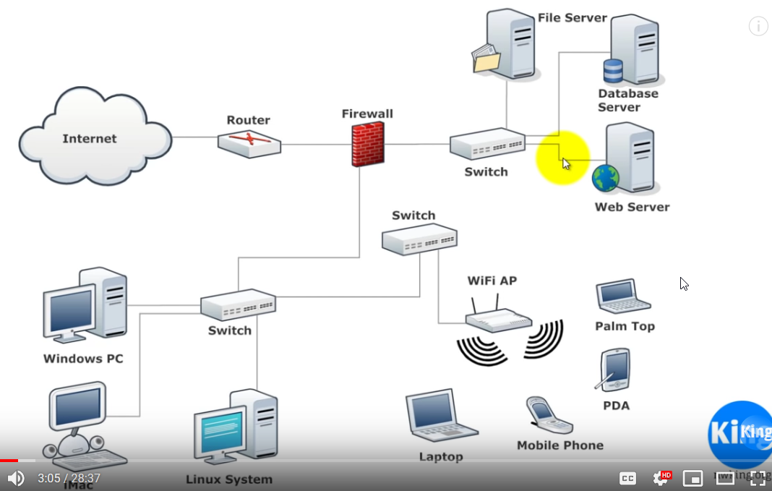

Before we dive into it lets have a basic understanding of what a network is and how it works. What are the terms associated with it.

Initially, two computers can be connected through a RJ45 cable which can be connected to another computer through a port that accepts the RJ45 connector through a port. This port is called the network interface card or a network adapter and this is where the RJ45 connects and using this the two computers connected through a RJ45 cable can communicate with each other. This basic form of networking is called Ethernet.

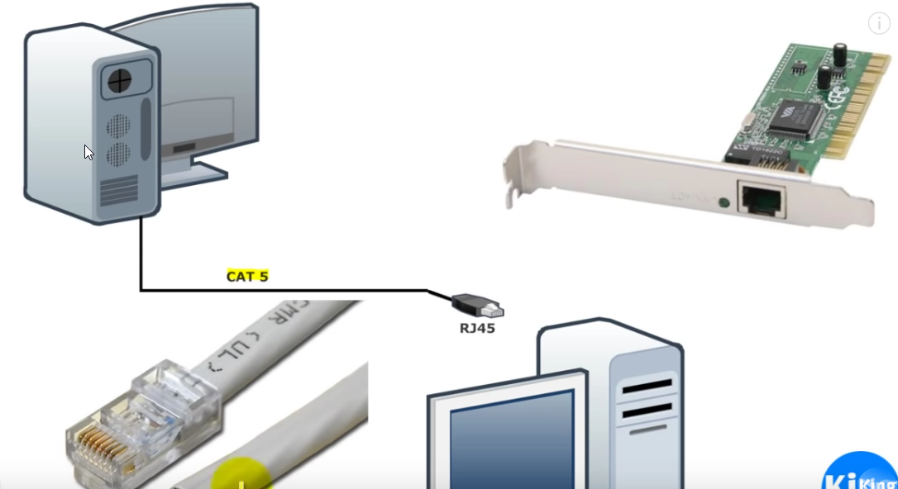

Wireless adapters feature n antenna and connect to networks using Weireless Access Points (WAPs)

If we have more than one computer, it is hard to connect them all through a Ethernet cable because a computer generally has limited ethernet ports. The solution around it is to have a device with many ethernet ports and all the computers are connected to it. Such device is called a hub or a switch.

When all the computers are connected to such a hub, we need a way to identify each one of the computer attached to the hub through a standard approach. This approach should be something that all the computers and the hub/switch understands. One such approach is IP Address. **IP Address is how computers recognize each other on the network.** Then for sending anything to any computer on the network, one only has to know the ip address of that computer.

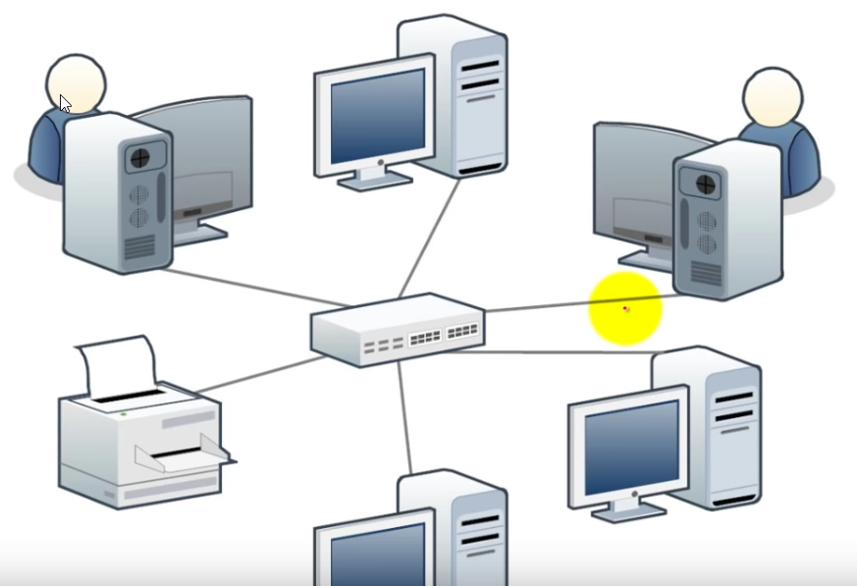

A computer network in a local office is called a **LAN.**

So a LAN consists of

1. Hosts -> devices like computers, laptops etc that needs to be connected. All hosts has an IP Address that identifies the hosts and the network where they are located. IP Address is also used to send and receive data in a network.
2. Central connecting devices like Hub, Switch and Routers.
   1. **Hub:** in this case, the host send data to the hub and then the hub broadcast the data to all the connected devices. There is one major problem with this approach is that it sends data to all the connected devices. What if we want to send the data to only one of the computer connected to the hub. Hub does not handles this situationa dn for this reason **Switches are there in play.**
   2. **Switch:** unlike hub, it can send and receive data simultaneously. It also directs data to its intended destination.
   3. **Routers:** These are at the edge of the LANs. They act as a gateway to other networks. It allowa communication between hosts on different networks.

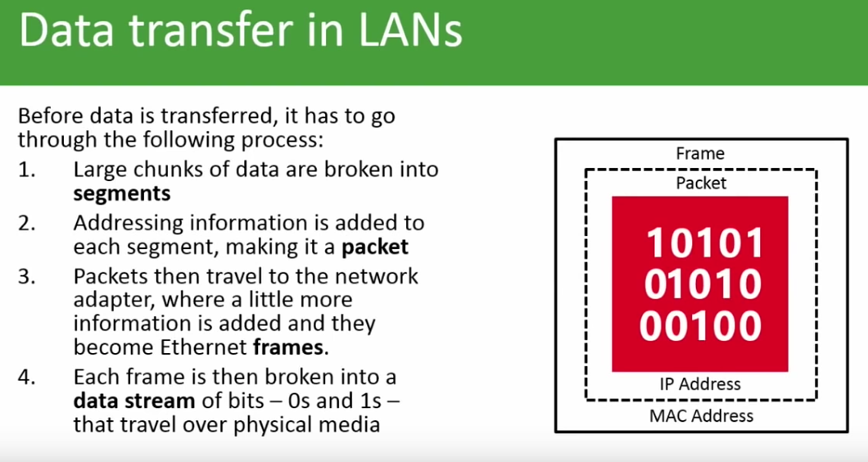

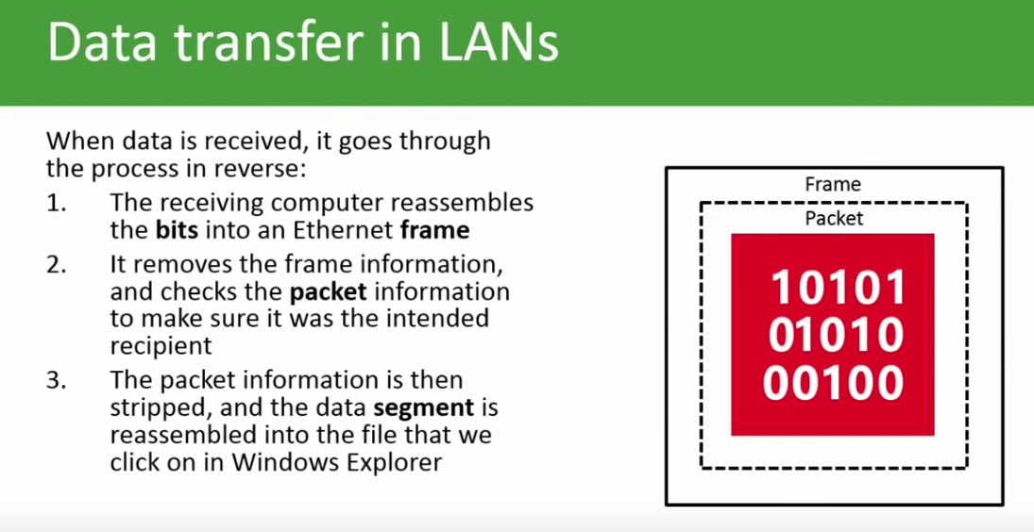

Now suppose you have 2 offices say in Boston and New York. Both these offices has their own LAN. All the computers within these offices can communicate with each other. But what if they want to connect to inter office computers. To do so there must be a way to connect these two offices.

1. One way is to draw a cable from Boston to New York which can be expensive and hard to get the permissions and is very cumbersome both from wiring and budget prespective. This is obviously not a good approach.
2. Another way is to connect each offices to their Local ISP (internet service provider). Now the ISP are already connected to each other through a very high massive bandwidth connections.

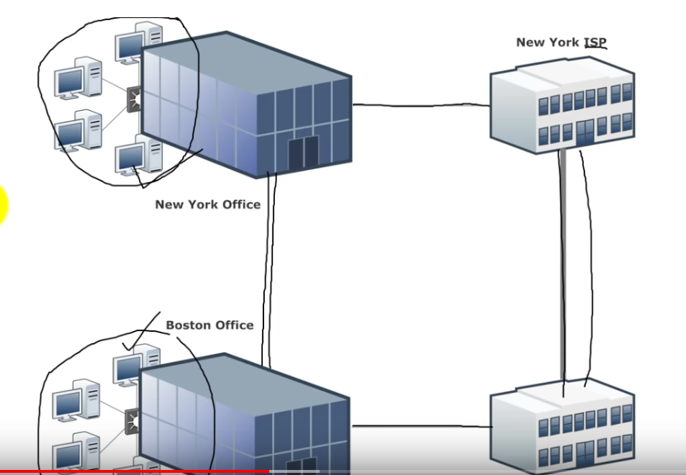

This approach is called the WAN (Wide Area Network).

So wan can be between cities, between countries etc.

The wuestion now is how do we connect our Lan to the ISP. Normal approach is the we get a connection from the ISP to our office and our office has some kind of wall socket to receive the cable and then through that socket, the office router is connected. And all he computers are already connected to the router within our office. This is the same for other office.

**And internet is nothing but a lot of WAN’s interconnected.**

Remember:

Internet speed is always denoted in bit. When we say we have a 10 Mbps connection, we mean that we have a 10 mega bit per second speed. That means it can transfer 1 Mega bit data per second.

Also data is always measured in Bytes.  **1 Byte = 8 bit**

So a file with size 128KB = 128 * 8 bits = 1024 bits = 1Mb (Mega bit). So it will take 1 second for a 128KB file to go across a network having a speed of 1 Mbps.

Network Topology

1. Star – all computers or devices are connected to a central switch. So if connection of computer to the switch goes down, it does not affect everyone else.
2. Ring – every computer is connected to each other. So if one of the connection between 2 computer is down, the connection between them can still happen through the other longer way.
3. Bus

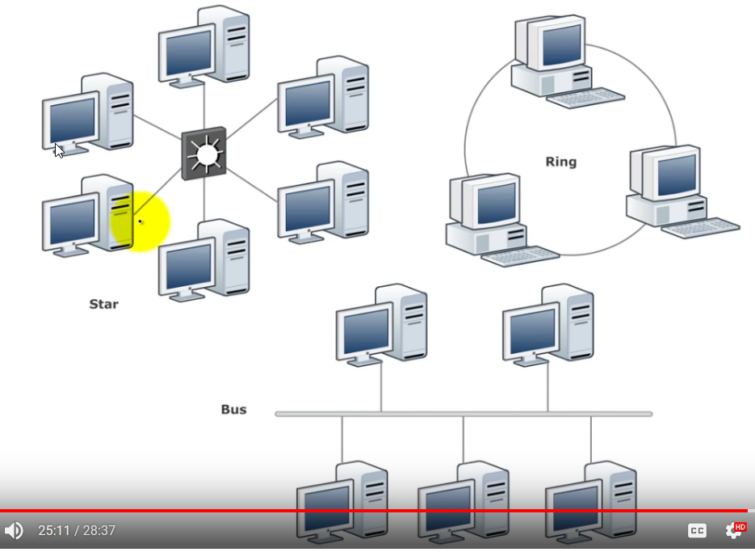

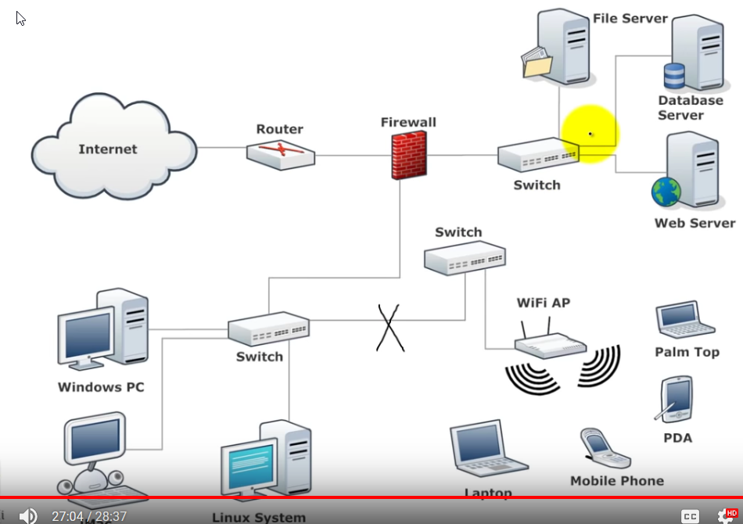

In the above picture, all the computera re connected to the switch and form a star network topology. The switches are all connected to each other and form a Bus network topology.

In todays world, the network topology that is use is hybrid.

**The TCP-IP model and the OSI (Open System Interconnect) model** is nothing but a set of protocols/rules or standards. The TCP IP model is more of a strip version of the OSI model and is more relevant and thus became the industrialized standard.

Both these models are layered models. The left is the **OSI Model** and the right is **TCP/IP Model**

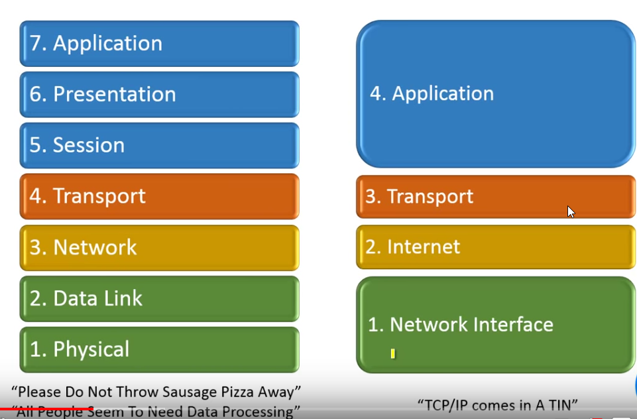

The lower caption in the image is the pnemonics to remember the layers.

Courses to cover to deepen the knowledge

* PowerShell v3/v4 Essentials for IT Admins Part 1- 4 by jeff hicks
* Powerhsell toolmaking fundamentals by Adam Bertram
* Windows PowerShelll desried state configuration fundamentals by jeff hicks
* The case for PowerShell by Mark Minasi

References to look at

Learn PowerShell in a month of lunches 3rd edition by don jones and jeff hicks

PowerShell in depth by Don Jones, Jeff Hicks and Richard Siddaway (Manning 2015)

Windows PowerShell Cookbook by Lee Holmes (O’Reilly 2013)

**PowerShell On the Network**

Remote Connectivity

1. Legacy -> also called traditional remoting. This uses legacy remote protocols like RPC/DCOM. These tyoes of connections and commands has a -ComputerName parameter. It typically uses some sort of legacy server’s endpoint while making the connection to the server. The server is listening for a connection and we are making that connection. It Often requires to have admin privileges on the remote machine. These legacy approaches are not firewall friendly and is not great using these in today’s age of cloud computing. It takes a lot more effort to make these approaches firewall friendly. Some legacy comandlets are

Get-service

Get-Process

Get-EventLog

Test-Connection

Test-NetConnection

Resolve-DNSName

Get-NetFirewallRule

Set- NetFirewallRule

Enable- NetFirewallRule

Disable- NetFirewallRule

* Legacy remoting works best in a domain environment.
* There are usually no provision to provide alternate credentials. It normally uses the logged in credentials to make the connection to the remote machine.
* These connections doesn’t scale very well. If we want to connect to 10 remote machines, it will connect to them sequentially and then run the command and get the results back. This means that our machine will locally connect to the remote machine and pull the results back across the network.

1. Modern Connectivity -> it uses WSMan Protocol. These types of connections has a -Session Parameter or CIMSession or PSSession, i.e. it will have something related to session keyword in the parameter name.

**Network Diagnostics with legacy commands**

Test-connection dom1

Test-connection srv1,srv2,srv3 -Count 1 -Protocol DCOM

“srv1”,”srv2”,”192.168.3.99”,”dom1” | where { Test-Connection -Quiet -ComputerName $_ -Count 1} -- this will ping all the servers 1 time and -quiet help test connection return either a true or a false result. So if it is true then the pipeline will pass that computername on to the end of the pipeline and we will only see the names of servers for the ping is successful.

Test-NetConnection -ComputerName srv1 -- this returns object and also some other information that may help in diagnose more then the Test-Connection command.

Test-NetConnection -ComputerName srv1,srv3 -CommonTCPPort SMB --this will result into an error because this cmdlet only takes a string as a parameter. So the user can pass one computer name at a time.

‘srv2’,’srv3’ | foreach { Test-NetConnection -ComputerName $_ -CommonTCPPort SMB } --now this will work.

To check if dns is running on a server

‘dom1’,’srv1’ | foreach { { Test-NetConnection -ComputerName $_ -Port 53 } -- this will fail for the server which is not running dns.

Test-NetConnection -ComputerName ww.pluralsight.com -CommonTCPPort HTTP -InformationLevel Detailed.

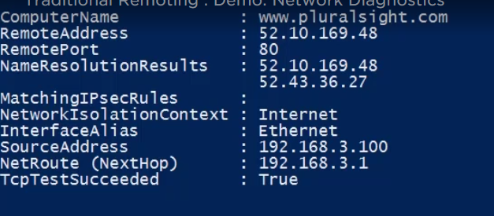

Resolve-DnsName [www.pluralsight.com](http://www.pluralsight.com)

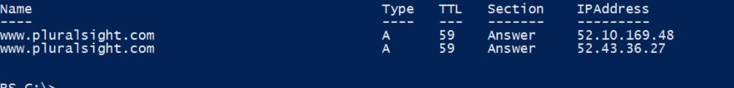

This gives the public addresses for the website.

Resolve-DnsName srv.company.pri | select * -- this list all the properties and will help to understand the problem for connection error more if the srv is not working.

Resolve-Dnsname srv4.compant.pri -DnsOnly --gives the information of the dns only.

Get-service -name bits -computername srv1,srv2,dom1 | select Name, Status,MachineName

Get-service -name bits -computername srv1,srv2,dom1 | Restart-service -Force -PassThru | select Name, Status,MachineName --passthru writes the object back to the pipeline

These all commands works because all the computers are in the same domain. If we try this on a computer which is not in the domain, we will get an error saying **“the operation might require other privileges”**

Get-EventLog -list -ComputerName srv1,srv2,dom1,win10 |

Where log -eq ‘system’ |

Format-table -GroupBy Log -Property @{Name=”ComputerName” Expression={$_.MachineName}},

OverFlowAction,

@{Name=”MaxKB” Expression={$_.MaximumKilobytes}},

@{Name=”Retain” Expression={$_.MinimumRetentionDays}},

@{Name=”RecordCount” Expression={$_.entries.count}}

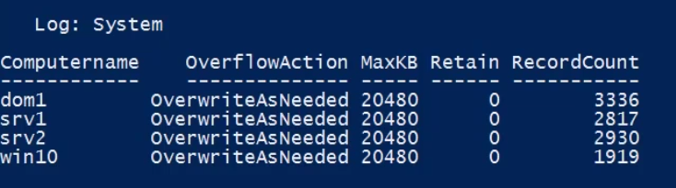

Get-EventLog -list -ComputerName srv1,srv2,dom1 |

Where { $_.entries.count -gt 0 } | Sort MachineName,Log |

Format-table -GroupBy @{Name=”ComputerName” Expression={$_.MachineName.toUpper() }}

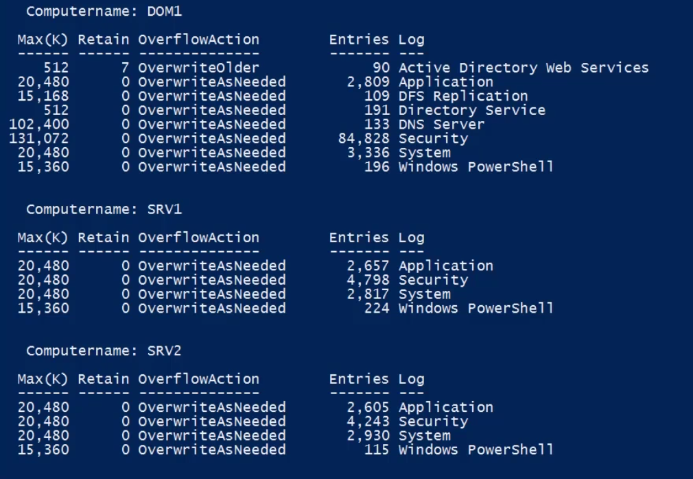

Get-command -CommandType cmdlet -ParameterName ComputerName --this will list all the cmdlet that has a computername as one of its parameter.

Managing firewall through firewall. This is easy for managing small number of computers. For managing multiple servers, using group policy to manage is the better approach to go. Managing group policy might not be possible through PowerShell.

Get-Command -Noun NetFirewallRule -- list all the command that has NetFirewallRule in them.

Get-NetFirewallRule | Out-GridView -Title "FW Rules"

This opens up a gui with the title as FW Rules listing all the rules on the computer in a tabular format.

**To get the firewall rules on the remote computer**

**Get-NetFirewallRule remote* -CimSession srv1 | Select Name, DisplayName, Profile, Enabled, PSComputerName | Format-Table**

**PowerShell Remoting:**

WSMan is an industry accepted protocol which Microsoft has embraced. There are some key benefits of using WSMan.

1. It connects via a single port so this is easy to configure your firewall. By default, you will connect over port 5985(HTTP) which is a TCP connection. This is the connection that poweershell will usr to make a PowerShell remoting connection to servers in your network and this will work over the cloud and it will also work locally. For additional security, you can also use SSL and you would connect over 5986(HTTPS). These ports are configurable but there is no harm in living with the defaults.
2. By default, you will require admin credentials on the remote machine. There are some advance things that you can do where you can create delegated or constrained endpoints where you can specify different set of credentials or different permission, but by default, you will need admin credentials on the remote machines.
3. It uses Kerberos by default for mutual authentication and this works great in a domain environment. Kerberos authentication means that I am kind of protected due to mutual authentication and I don’t have to worry about a man-in-the-middle attack.
4. By default, in WSMan, even over 5985, my connection is encrypted. The data transfer is also encrypted. Adding SSL with add another layer of encryption.
5. This protocol in windows is managed by WinRM service. So this service has to be running in order for the PowerShell pieces to work.
6. **Help about_WS-Management ->**  to read and know more about WSMan

PowerShell remoting is by default disabled on clients operating system such as windows 10, Windows 8.11 etc and older servers such as Windows 2008 R2 or windows 2012. It is only since Windows 2012 R2, Microsoft enabled PowerShell remoting by default.

All the remoting configurations can be done and truned on via a Group Policy.

Using PowerShell remoting to manage works best with minimal effort in a domain environment and that’s because the Kerberos authentication is the default and if you use SSL, you can create certificates that are going to be trusted by the domain.

Whe we make a connection from our client machine to a server, we are passing through the fireawall ofcourse and we ae gonna use the default 5985 port, which the firewall is configured to and pass that traffic on, and so we make conection to the remote machine. This remote machine or serer has an endpoint. This endpoint has, in essence, a listener which is waiting for a connection to be made to it. This endpoint also has a configuration to it. There is access conrol, which by default means you have to an administrator on that machine. This endpoints also defines what commands are available. By default for PowerShell is to have a full access for the PowerShell engine and thus all the commands are available if user is using PowerShell for remoting. This endpoint also control what things you can access, what parts o f the language you can control. All these things are configurable. By default, we got a pretty powerful endpoint that only administrators can connect to.

What happens next is that you execute on the client machine, you send a PowerShell command, and the command is transferred to the remote machine which then executes the command on the remote machine in that little endpoint. Then it returns the result back to the client through the firewall port 5985 as serialized XML.

**Remoting Cmdlets:**

Run Enable-PSRemoting on your client machine in an elevated PowerShell. Note that this command will enable PowerShell remoting and it applies it to non public networks. So if you are in a domain environment, it should not be a problem. Running this cmdlet will start and configure the winRM service because, by default, this service is turned off. It will also create the default listener. It creates those endpoints and has all the default settings that you will need. It will also create all the necessary firewall rules and open everything up.

Test-WSMan ComputerName Srv1 --this cmdlet will verify a remote computer is ready and receiving WSMan connections. You can specify a different port or SSL and also can specify credentials.

In order to use the remoting, there are different ways. One of then is to use Enter-PSSession.

Enter-PSSession -ComputerName srv1 -Credential company\administrator. -- this allows user to do **one-to-one remoting.** This establishes a interactive session on the remote computer. It requires admin credentials. If credentials are not specified, it will use the logged-on credentials to creating the remoting session.

When you run this command, the session that you get back is kind of a Telnet-like session.it looks like on your screen you will get a prompt indicating you are connected to a remote computer and you can run commands.

*If you want to run one command on many PowerShell machines, you can use* ***Invoke-Command.*** *this will create a temporary PSSession using the alternate credentials if specified or the logged-on credentials. This cmdlet is very useful for making* ***one-to-many*** *remoting.*

Invoke-Command -scriptBlock { Get-process -includeUserName } -ComputerName srv1,srv2 -Credential company\administrator

It runs all the commands that is in the -ScriptBlock. You can also specify a file in the scriptBlock which is in your computer. PowerShell will copy the content of the file and basically create a script block on the remote machine that is then executed.

**For disabling the PSRemoting.**

1. Disable-PSRemoting -Force
2. Stop-Service WinRM
3. Set-Service WinRM -StartType Disabled
4. Get-NetFirewallRule *winRm* | Select Name,Enabled,Profile,Direction,Action | Format-Table
5. Disable-NetFirewallRule WinRM-Http*

Now if you run the Test-WSMan command, you should get an error saying WSMan isn’t configured.

**To enable remoting execute cmdlet Enable-PSRemoting with elevated credentials.** Once the command completes execution, execute *Test-WSMan* command and it should give output like this.

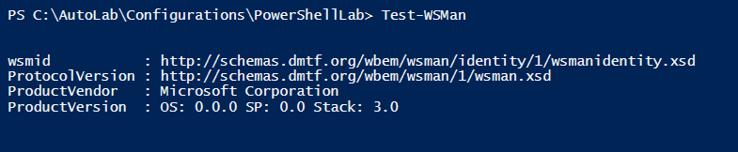

Test-WSMan -ComputerName srv2 -Credential company\administrator -Authentication Default --this will first prompt for the password and the result will be approximately same as above. This only difference is that when we pass the credential, we get the values for OS also which is absent in the above result. This is the OS of the remote computer.

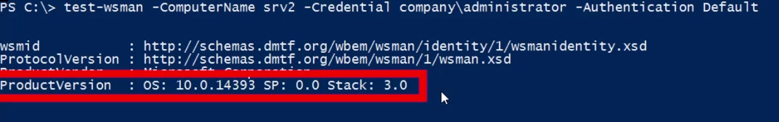

You can also get the status of the winRM service for all the remote machines throu Get-Service legacy command. if it is running on all the servers, that means that the remoting is enabled probably.

Get-Service winRM -ComputerName srv1, srv2, dom1 | select Name, MachineName, Status,StatyType

**Interactive Remoting**

Enter-PSSession -ComputerName srv1 -- this connects to the srv1 and creates a session.



The output [srv1] shows that we are in the srv1 remote machine session. This is called one to one interactive PowerShell remoting. Any command that we type now runs on the server srv1.

Hostname --gives the name of the computer.

Get-Process -IncludeUserName --IncludeUserName parameter only works on the interactive session. You cannot use this remotely. You cannot use this parameter from a client computer to a server remotely.

Cd HKLM: --we can look at the registry, which is not something you can do remotely, but in a remote session we can.

Restart-Computer -whatif --whatif parameter does not runs the command and only list the result for what will happen if the command is ran.

Exit -- to close the interactive remote session.

Whoami -- shows the logged on user. Works only on the host server.

find-module iseremotetab

this searches the provided module into the PSGallery and once you find it, you can do Install-Module <ModuleName> to install the module. Once you have installed the module, you need to import the module into your PowerShell session to use its cmdlets.

get-command -Module ISERemoteTab

this lists all the commands in this module.

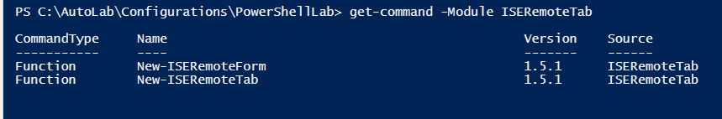

New-ISERemoteForm

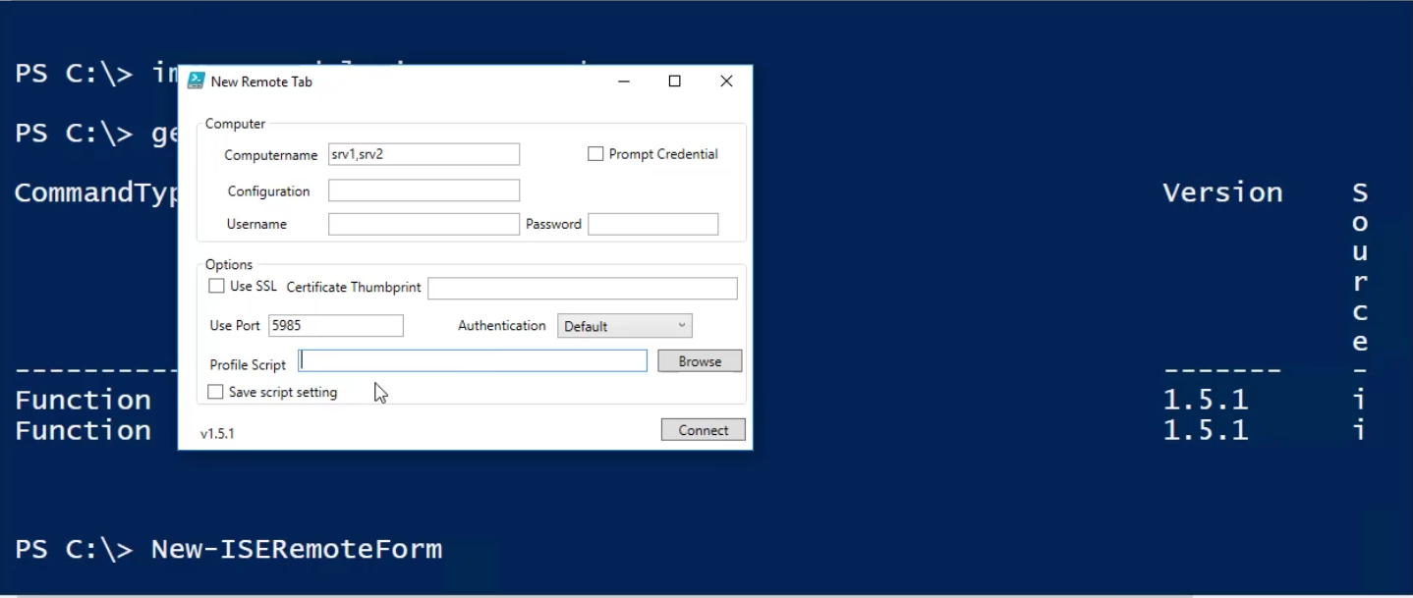

We can also provide the script to run upon connection which can be saved locally on the client machine. And when this command connects to all thee remote servers, it will run that script as part of the login.

**PowerShell Remoting: One to Many Approach: Invoke-Command:**

If you want to run multiple command, you can have one command per line.

$r = Invoke-Command -ScriptBlock {

Get-Item HKLM:\SYSTEM\CurrentConsoles\Control\BitlockerStatus

} -ComputerName srv1

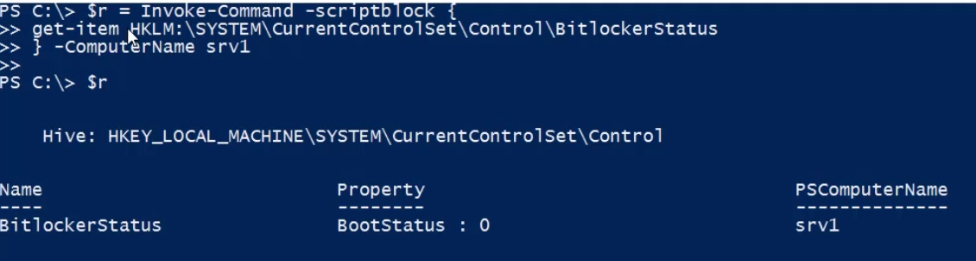

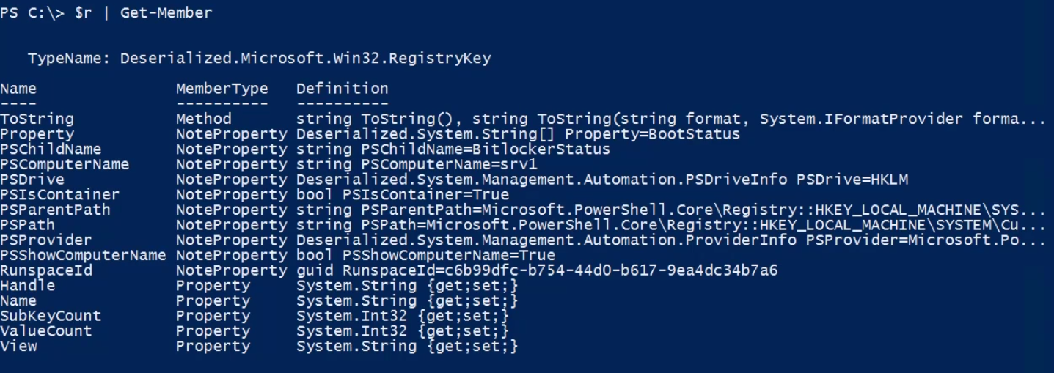

Notice that the object that came back is a deserialized registry key. Remember when command gets execute on the remote machine, what comes back is a serialized XML. Then on the client end PowerShell deserialize that and we get what looks like a same result. It is though not the same result. It is actually is XML, which means that I don’t get any of the methods that come back.

**Remember:** when you run invoke-command, whats happening under the hood is that PowerShell is taking the cmputername that you specify and creating a PSSession, runs the command, you get the results, and then closing the session. So everytime and invoke-command is used, it actually creates a fresh PowerShell session. So whatever commands ran in the previous sessions, the results of that commands is lost.

Using **New-PSSession is a way around this.**

$session = New-PSSession -ComputerName srv1,srv2,dom1

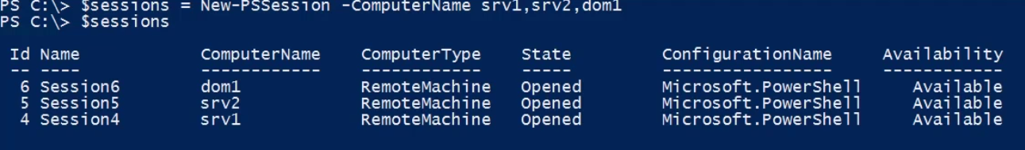

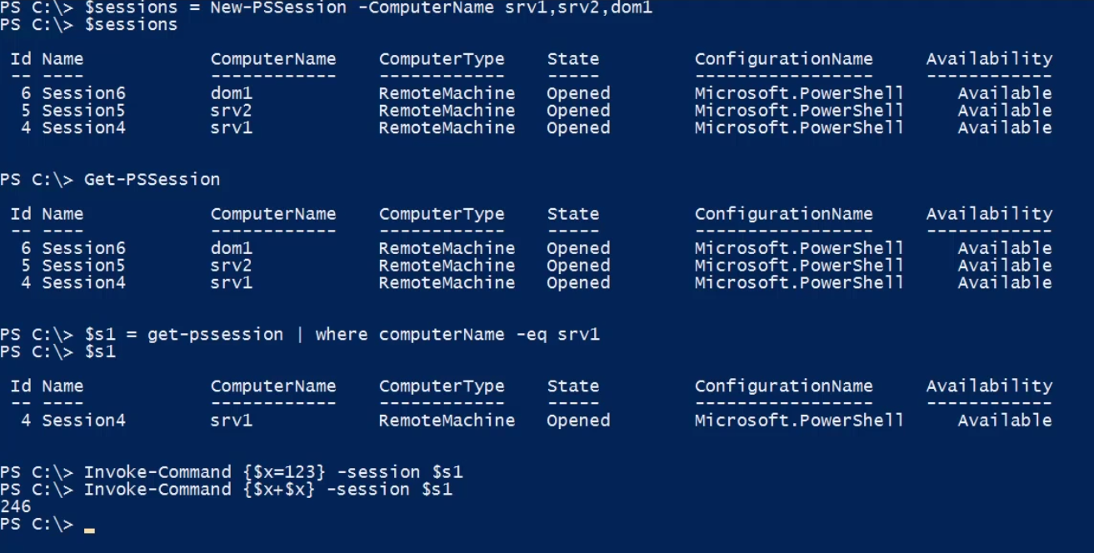

Notice here, how we have used the created sessions in the invoke-command and let it using the same session.

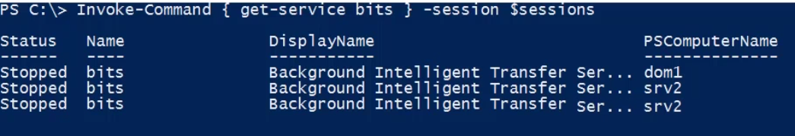

We can also have done this with the -ComputerName parameter, but with this approach, it runs the get-service command on all the computers sequentially. When we use sessions, we are making all the connections at once and the commands are running on the machines at the same time on all of these machines. If on server is busy or a little slow to respond, I don’t have to wait for it before I go to the next one.

***NOTE: You can only do this for 32 machines at a time.***

Creating a longer script block.

$sb = {

$fso = new-Object -com scripting.filessystemobject

$fso.drives | where drivetype -eq 2 | Select Path,

@{ Name = “SizeGB”; Expression={$_.TotalSize/1GB -as [int]}},

@{ Name = “FreeGB”; Expression={$_.FreeSpace/1GB}},

@{ Name = “AvailableGB”; Expression={$_.AvailableSpace/1GB}},

@{ Name = “ComputerName”; Expression={$env:ComputerName }},

}

Invoke-Command -ScriptBlock $sb -Session $sessions

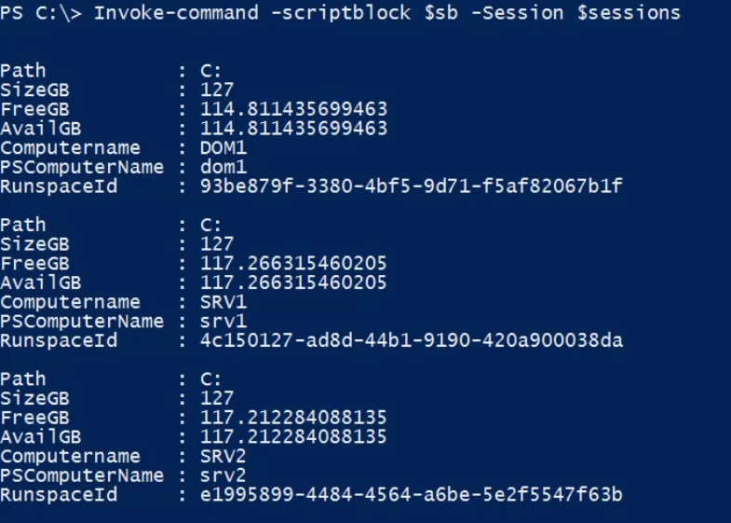

We also get PSComputerName, RunspaceId back in the pipeline as results. This is because invoke-command automatically inserts those. Suppose we don’t want to see the runspaceId and for that we want to clean up the code up a bit.

Invoke-Command -ScriptBlock $sb -Session $sessions -HideComputerName | Select * -ExcludeProperty RunSpaceId

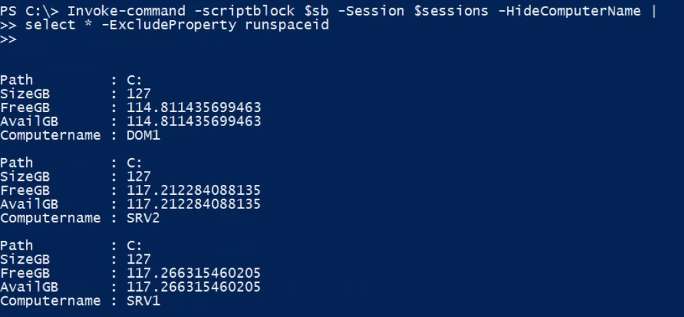

Another way to use Invoke-Command is to pass all the parameters you require to run in the command by setting it in a param variable and then using the variable as a splat. When you splat the parameter, you use @ instead of $.

$params = @{

FilePath = “C:\scripts\fsoreport.ps1”

Argumentlist = @(“C:”, “MB”)

Session = $sessions

HideComputerName = $true

}

$report = Invoke-Command @params | Select * -ExcludeProperty run* --the filePath parameter of this command will copy the content of the script file and make it into a script block to run on the remote computer.

$sessions | Remove-PSSession -- this will remove the PS Session or else the Seession will be closed once the PowerShell is closed.

**Non-Domain Remoting:**

Suppose we have a computer srv3 which in not on the domain.

Test-WSMan srv3 --works fine if the remoting is enabled on the remote machine srv3.

Invoke-Command { Get-Service } -ComputerName srv3 --this will raise an error of authentication as the computer is not on the domain and for the command to run on the machine, wee need to have the admin privileges. If we do not pass the alternate credential to use, PowerShelll uses the logged on user to make the connection which may not have the admin rights on the remote machine.

So as a workaround, we need to pass the credential along with the command.

$cred = Get-Credential srv3\administrator

Test-WSMan -ComputerName srv3 -Credential $cred -Authentication Negotiate --Negotiate is used to inform the computers to find the best way to communicate between themselves. This also fails and on reading the failure message, one can notice that WSMan demands to identify the remote computer. It cannot trust the identity of the remote computer as it is not on the domain. To counter this, we need to tell WSMan to trust the remote computer and we can do this by adding the remote computer to the trusted hosts.

**Get-Item -Path WSMan:\localhost\Client\TrustedHosts --**WSMan is a PSDrive that is created through PowerShell and that allows you to configure and look at the WSMan configuration.

So to pass the computer to the trusted hosts

Set-Item -Path WSMan:\localhost\Client\TrustedHosts -Value SRV3 -- this will add srv3 as the trusted host value and by this we are saying to the WSMan that we are trusting this server and we are verifying that the server is who it says it is. It need not to have a Kerberos mutual authentication to identify the computer.

**If you want to trust everything, just pass the asterisk * sign as the value of the trusted host. But this makes your client vulnerable.**

Now if we rerun the test-WSMan command we should get the proper result.

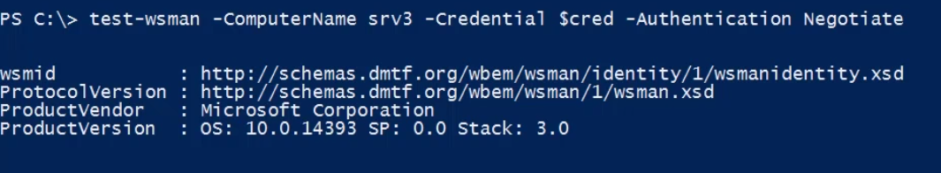

To get more details on remoting, read the help about_remote* on PowerShell.

NOTE: PowerShell will eventually offer SSH along with the WSMAn to remotely manage linus and mac machines. The goal is to give an option for cross platform management.

**WMI:**

WMI :- Think of it as a local repository for system information. In Windows, it is managed by a winmgmt service. It can be queried with a sql like syntax. It is derived from a industry set of standards put forth by the desktop amangement task force (DMTF) way back in the 90’s and WMI is Microsoft implementation of these industry implementation. These standards were designed and intended for hardware and software vendors to provide a centralized location for management information about their products and this is how it’s all setup.

Every Windows computer has a CIM repository. Think of it as a database. This repository is organised at a top level by namespaces. The namespace is basically a way of organising the underlying classes that describe what something looks like on your computer. For example, things like BIOS, or the processor, or a service, a file share, and other software vendors provide configuration information about their products. So it is up to the vendor to decide how they are going to populate and define all these things, but you can query these namespaces and classes and get back a list of instances, which are the real world implementations of say a service. So I can say hey WMI, show me everything that on this computer that looks like a win32 service and then you will get back a list of, and in PowerShell you now get a list back of objects.

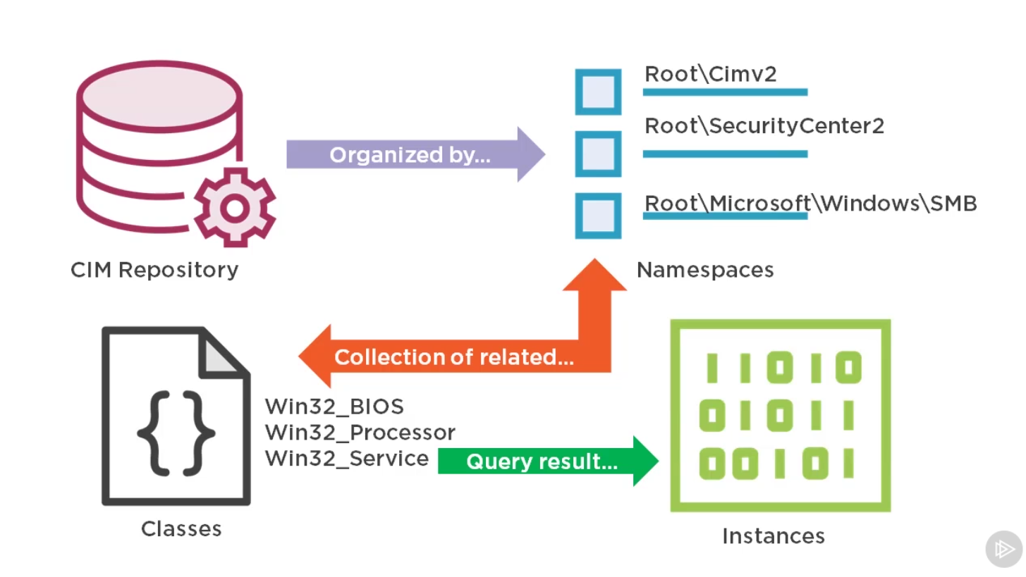

Get-WMIObject -classname win32_service -computername srv1 -Credential company\administraor --all of this can be dom=ne through Get-WmiObject cmdlet. This makes it very easy to query local and remote computers . you specify a classname and computername and PowerShell will make a connection to WMI object and get the things back that you need. You can also specify an alternate set of credentials for remote connections.

NOTE: *WMI uses legacy networking protocols and is not very firewall friendly. It uses RPC and DCOM to make the connections.*

**Get-WMIObject defaults to the ROOT\cimv2 namespace,** that’s where all of the typical classes that you will want to use reside.

Get-WMIObject -list -class win32* | more --it shows all the classes that starts with win32 in the default namespace.

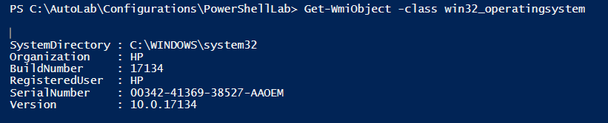

Property that have a __Server (double underscore) are system property and we really never need to access them expect for may be one i.e. __server. So PowerShell team decided that instead of forcing people to try and find a computername property, let’s always have a pSComputerName. PowerShell adds a PSComputerName for __Server Property.

Get-WMIObject -list -class win32* | Select * | more

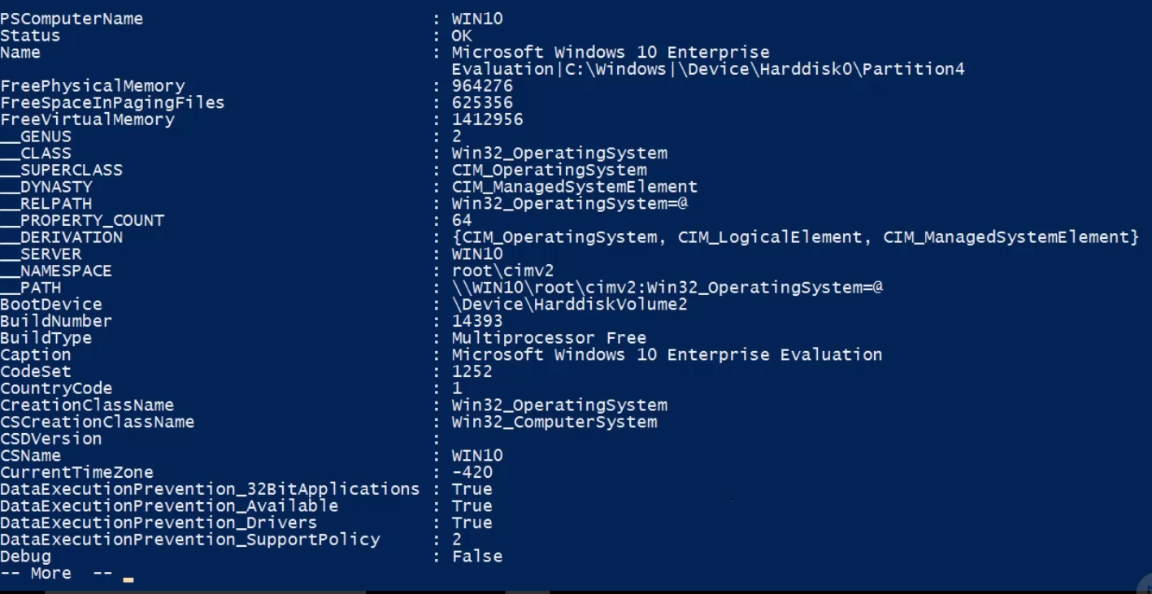

$computers = srv1, srv2, dom1

Get-WmiObject win32_operatingsystem -computername $computers | Select PSComputerName, Caption, OSArchitecture, ServicePackMajorVersion, InstallDate

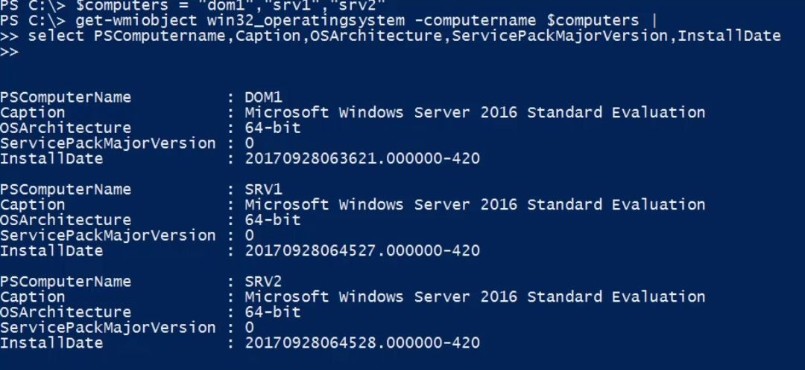

The date format is not readable though.

Get-WmiObject win32_operatingsystem -computername $computers | Select PSComputerName, Caption, OSArchitecture, ServicePackMajorVersion,

@{Name=”InstalledDate”;Expression={$_.ConvertToDateTime($_.InstallDate)}}

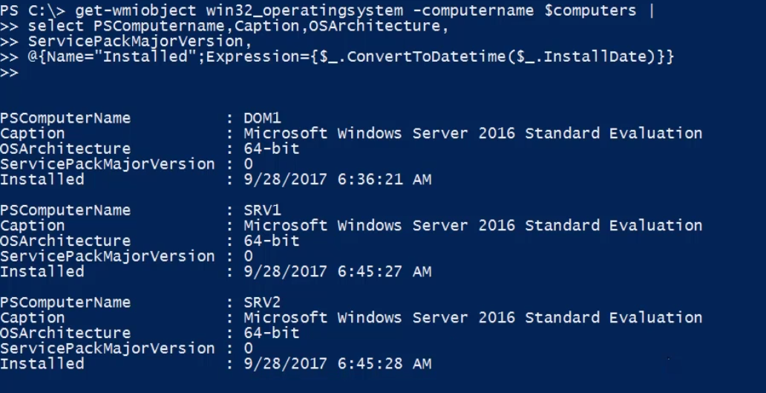

To avoid unwanted network traffic and getting all the unwanted data from remote machine and then filtering out, it is better to filter out data on the remote machine and then get the result back. And WMI has a facility to do that. Using the -query parameter can assist into that.

Get-WMIObject win32_process -Compuername srv2 | where {$_.Name -eq “lsass.exe”} --not an effie=cient way

Get-WMIOnject -query “Select * from Win32_process where name=’lsass.exe’” -computername srv2 | Select Name.WorkingSetSize,ProessId --the operators in this query are legacy operators just llike in sql.

Get-WMIObject win32_process -filter “name=’lsass.exe’” -ComputeerName = srv2 | select Name,ProcessID, WorkingsetSize. --the filter parameter is basically the where portion of the query string. This also gives the same result and is similar to above.

You can also use alternate credentials to connect to a remote computer but cannot provide alternate credentials to a local computer.

$cred = Get-Credential company\administrator

$computers = “srv1”,”srv2”,”dom1”

Get-WMIObject win32_logicldisk -filter “deviceid=’c:’” -Computername $computers -Credential $cred | Select PScomputername, caption,size,freespace

Get-WMIObject win32_logicldisk -filter “deviceid=’c:’” -Computername $computers -Credential $cred | Select PScomputername, caption,@{Name=”SizeGB”;Expression={($_.Size/1GB) -as [int]}}, @{Name=”FreespaceGB”;Expression={($_.Freespace/1GB) -as [int]}},

@{Name=”PctFree”;Expression={($_.Freespace/$_.Size)*100}},

***For troubleshooting purposes, there is one utility in WMI and that has nothing to do with PowerShell but comes in handy if we want to chek why we are not able to connect to a particular remote machine. This utility is called WbemTest.*** You can just start it from the command line.

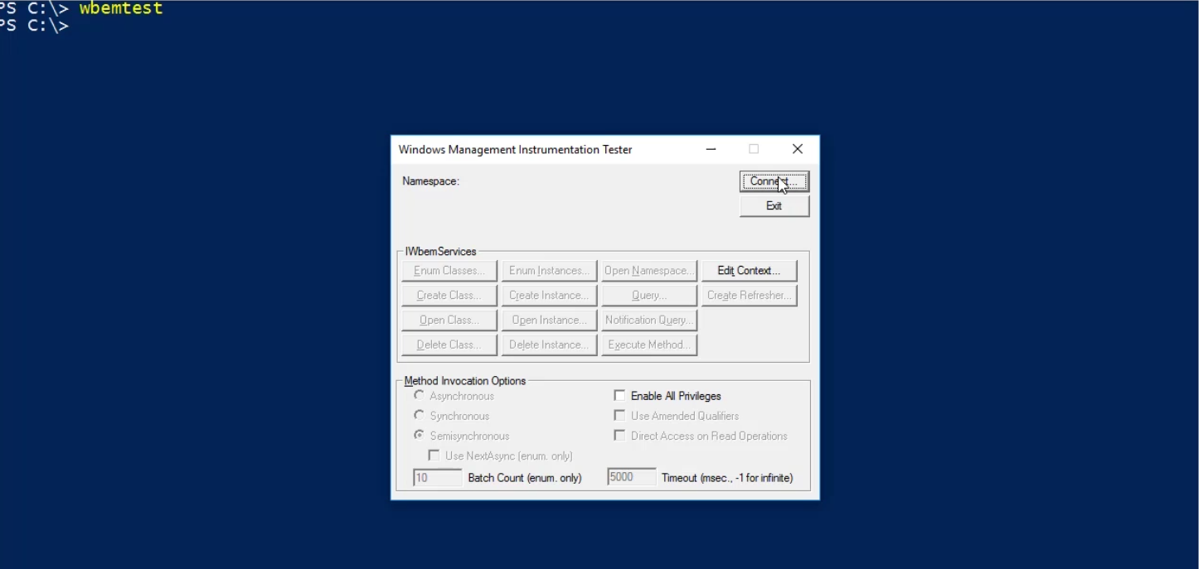

This command start another application called WMI Tester. When we click on connect another window opens up where you can see the default namespace is set to root\cimv2

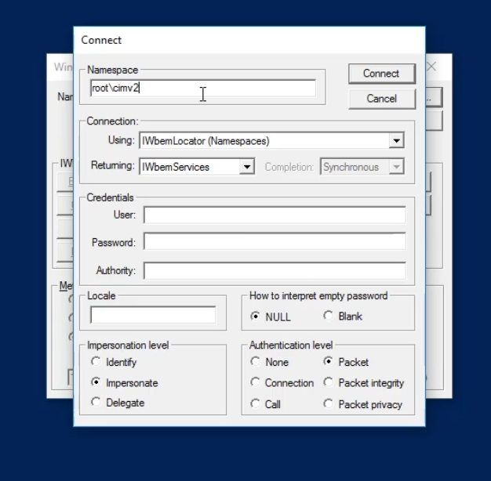

This will connect to a local machine by default. If you want to connect to a remote machine modify the namespace with **\\<remotecomputerName>\root\cimv2.**  Provide the set of credentials with username and password field for the remote computer admin credentials and then click connect.

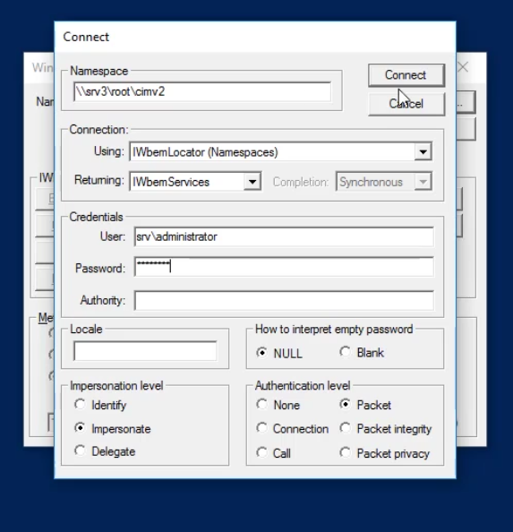

If this fails, you will get an error message. The error message will be like RPC server not available or access denied. The RPC error means that the computer you are trying to connect to has the wrong name or its not accessible over the network with RPC and you cannot connect with WMI.

So if you are not able to connect to a computer through Get-WMIObject and it also fails through wbemtest, its not a PowerShell problem, it could be a firewall problem, could be the winmgmt service is not running or you have something outside of powershel that you have to fix first.

***PowerShell has a few type accelerators. These are shortcuts that will create, in this case a WMI object and it takes a string which is connecting to the local computer. The local computer connection can be identified with the presence of \\. Then we will have the namespace and class separated by colon. We will then access all the properties with the dot (.).***

[wmi]\\.\root\cimv2:win32_logicadisk.deviceid=’C:’ --we will get the same result. The tricky thing here is that we need to have a key, in this case the deviceid for the logical disk and some classes don’t have a key. For example, win32_operatingsystem and when using keys with these classes we will get an error. None of the properties will work as key as this class itself doesnot takes key. *To find out the key for any class, perform the following.*

$c = Get-WMIObject -list win32_service

$c.properties | Select Name,Type,Qualifiers | more

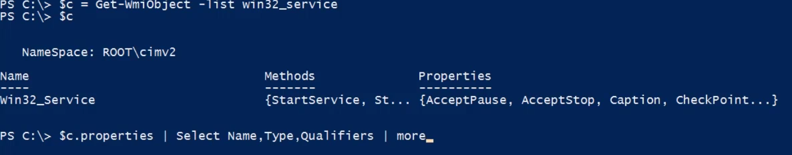

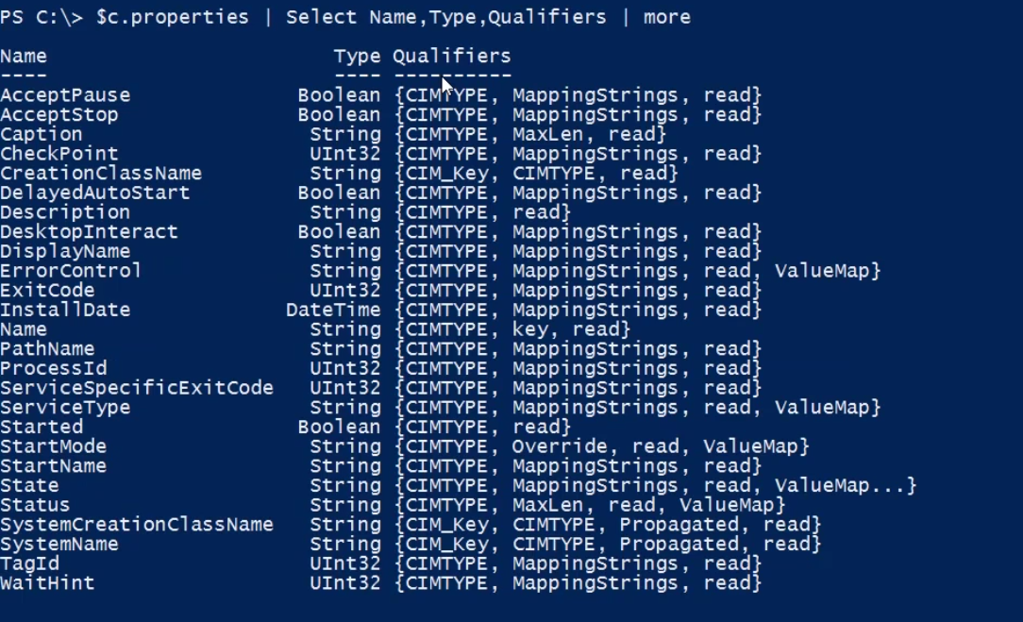

Note that here in the qualifiers, there is a property whose qualifier has key in that, that property can be used as a key while performing shortcut queries.

A better way to find the key is

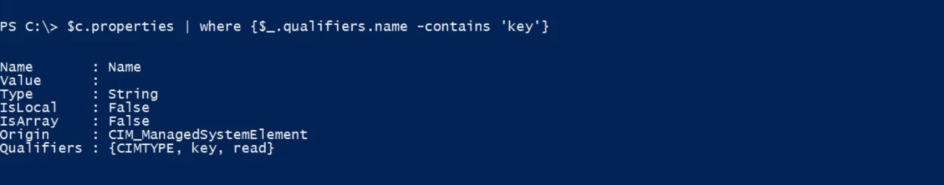

Once you know the key, you can use the wmi accelerator.

[wmi]\\.\root\cimv2:win32_service.name=’bits’

**We also have a WMI searcher accelerator.**

$search = [wmisearcher]”Select * from win32_service where name=’bits’” --here the searcher string is basically a query.

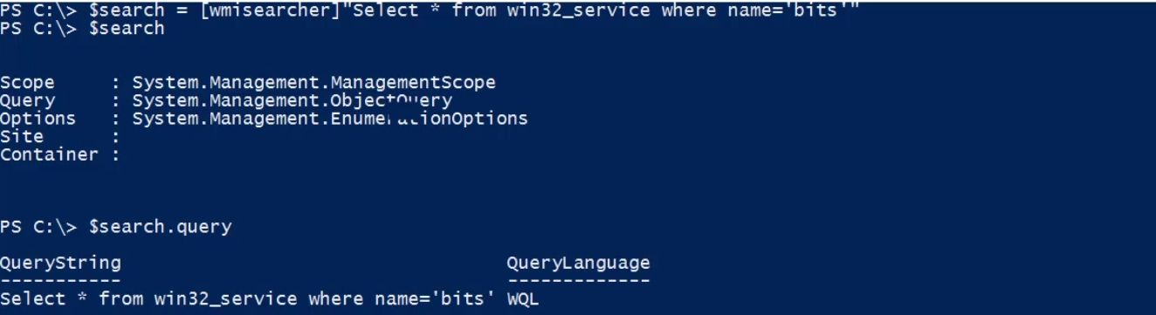

To invoke the searcher query, call the get method.

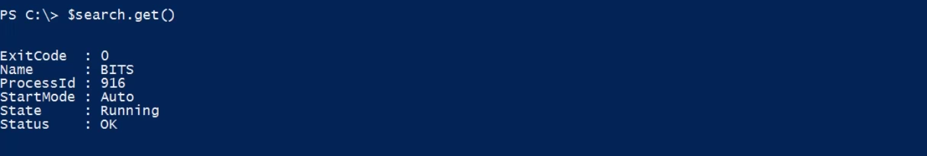

WMI Methods:

$c = [wmiclass]”win32_share”

$c.Methods

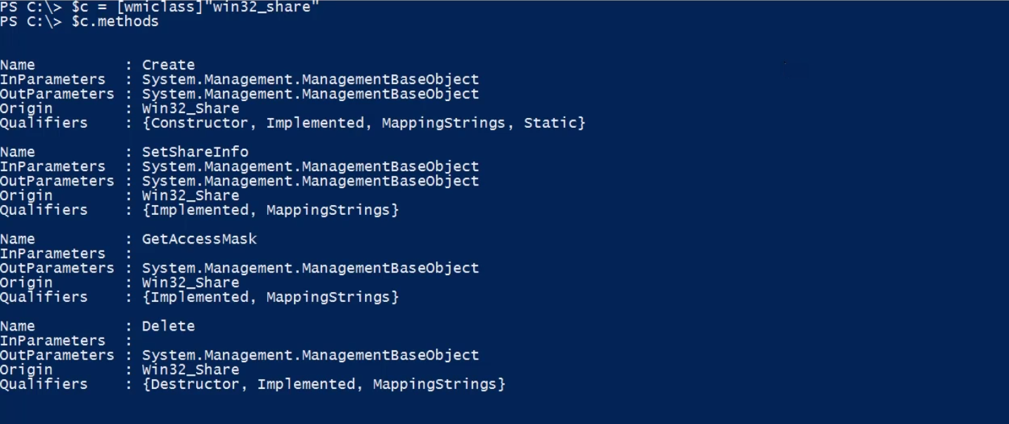

So we got here 4 methods for the wmi win32_share class and we can use these to do something.

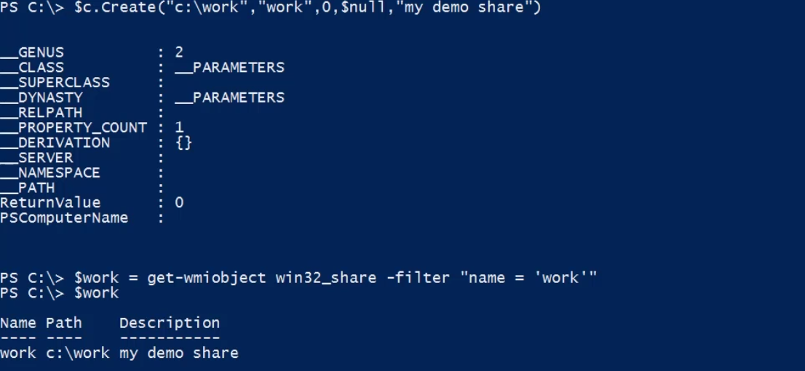

We have created a work wmi object in win32share. The return value of 0 means that it is successful and whe we query to check whether it is created, we get the result back. To delete the created win32_share work wmi object, just call the delete method on the $work instance.

$work.Delete(); --this will delete the created object. There is no parameter like -WhatIf or -Confirm to check what will happen if we try to delete it. Once the method is called, it is gone. Also it is very tedious to het all the parameters right in the same order it needs to be. *So to get around this, you can use the* ***Invoke-WMIMethod*** *cmdlet.*

$c = [wmiclass]”win32_share”

$c.GetMethodParameteres(“Create”) --we will see all the parameters in the alphabetical order.

When we invoke a win32_share class method through the use of Invoke-WMIMethod, we need to pass the arguments in the alphabetical order. So the above listing of parameters for the method we want to use comes in handy.

Invoke-WMIObject -Class Win32_share -Name Create _argumentlsit @($null,”my work files”, $null, “work”,$null, “C:\work”,0)

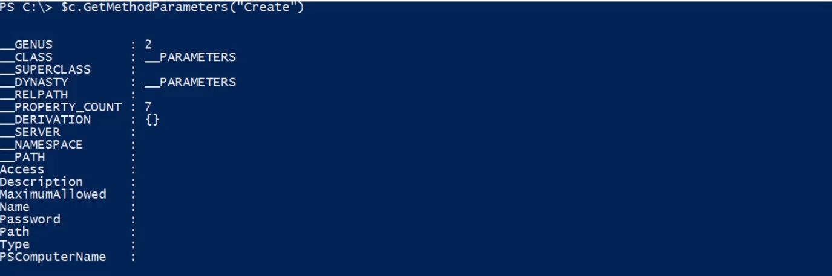

To get the instance and then delete the object created using Invoke-WMIMethod

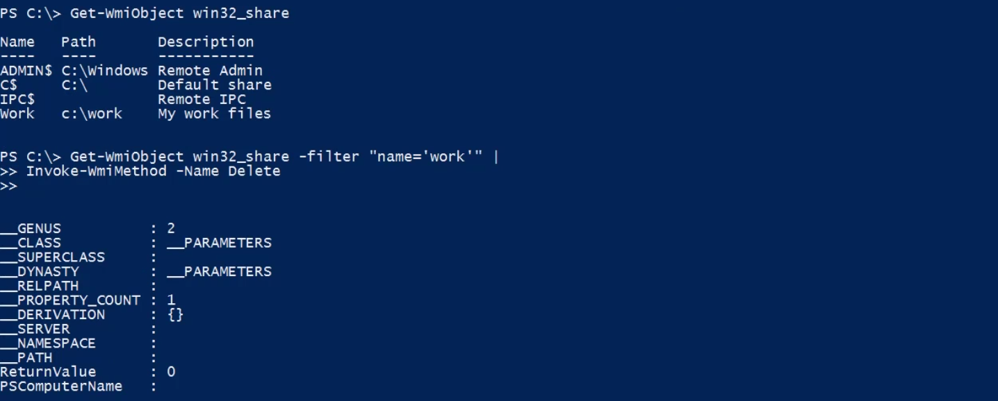

Invoke-WMIMwthod also supports -WHatIf and -Confirm Paramaeters and using this we can have a sanity check of what will happen if we use this command.

Some of the PowerShell commands can take a long time to complete with WMI commands when we are running it against a 100 machines. We don’t want to wait for the command to complete in some cases and want to move ahead with the other commands. But we want to get the result of the command when it completes. In such cases WMI Jobs can come in handy.

***Get-WMIObject has a parameter called asJob. Passing this parameter to the command will run the command in the background as a job and then we can get the results of the command once it completes through the job it creates in PowerShell to run the command.***

$j = Get-WMIObject Win32_Logicaldisk -filter “deviceid=’c:\’” -ComputerName ‘srv1’,’srv2’,’dom1’ -asJob

Now the $j will be a job object.

Wait-Job $j --to wait for the job and to see the status of the job whether it is running or completed.

Finally, we can receive the job. Note that once we receive the job, it is lost from the pipeline. If you want it to be there in the pipeline after we receive it then we need to pass the -Keep parameter. This will ensure that the job will still present in the pipeline after you have received it.

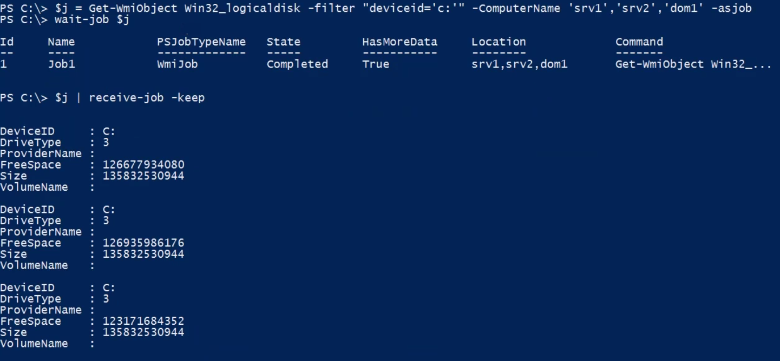

Another way to start a job is to use the Start-Job cmdlet.

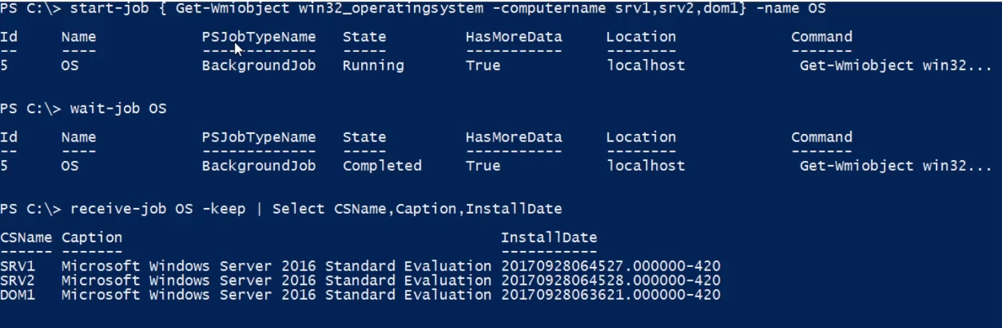

Another way to do this is throughInvoke-Command. this will create a job on the local coputer but will run the sriptblock almost simultaneously on all the machines and return the result.

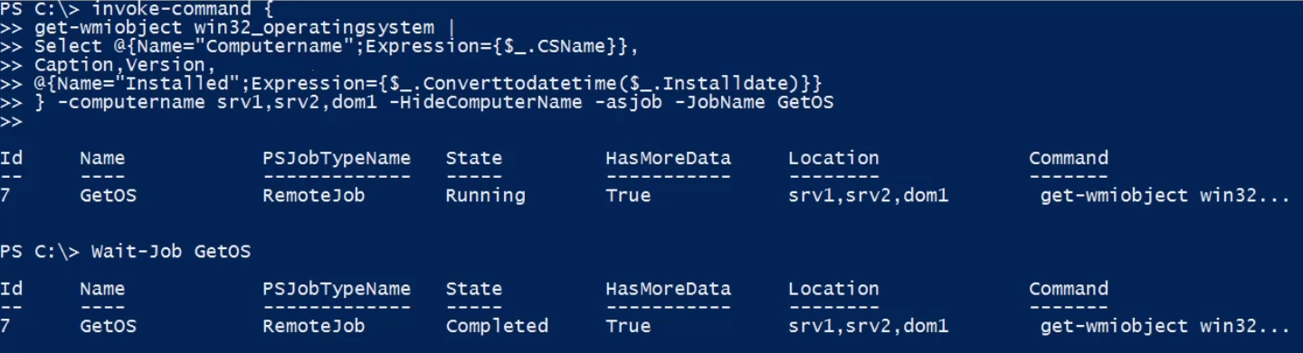

Then we can receive the job

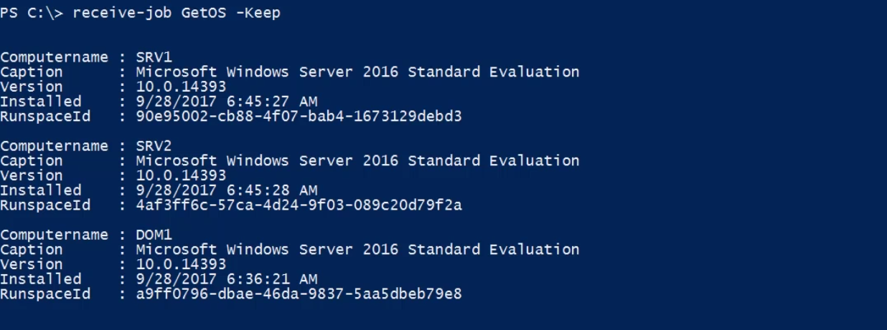

WMI uses legacy protocols and due to this it is handy to use these cmdlets for server let’s say that are down the hallway. But for the servers that are in the azure or any other cloud, it may be a little harder to work with. To work with those, we can use modern CIM cmdlets.

**CIM Cmdlets:**

CIM stands for common information model. It is based on industry developed standards and protocols that Microsoft implemented as WMI, but CIM is a way of describing what things look like. With CIM, everything is same as WMI, it’s just that the way we are going to access the information has changed. WMI has RPC and DCOM connectivity which is not firewall friendly and it also rely on proprietary Microsoft code. These cmdlets only work with Windows and with Windows Systems.

Microsoft now embracing open standards. CIM uses WSMan for remoting. This now will also have support for non Microsoft platforms. This makes cross-platform management easy. These CIM cmdlets query the same WMI information by using a WSMan protocol. This makes it much more friendly when it comes to configuring firewall because WSMan only uses a single port.

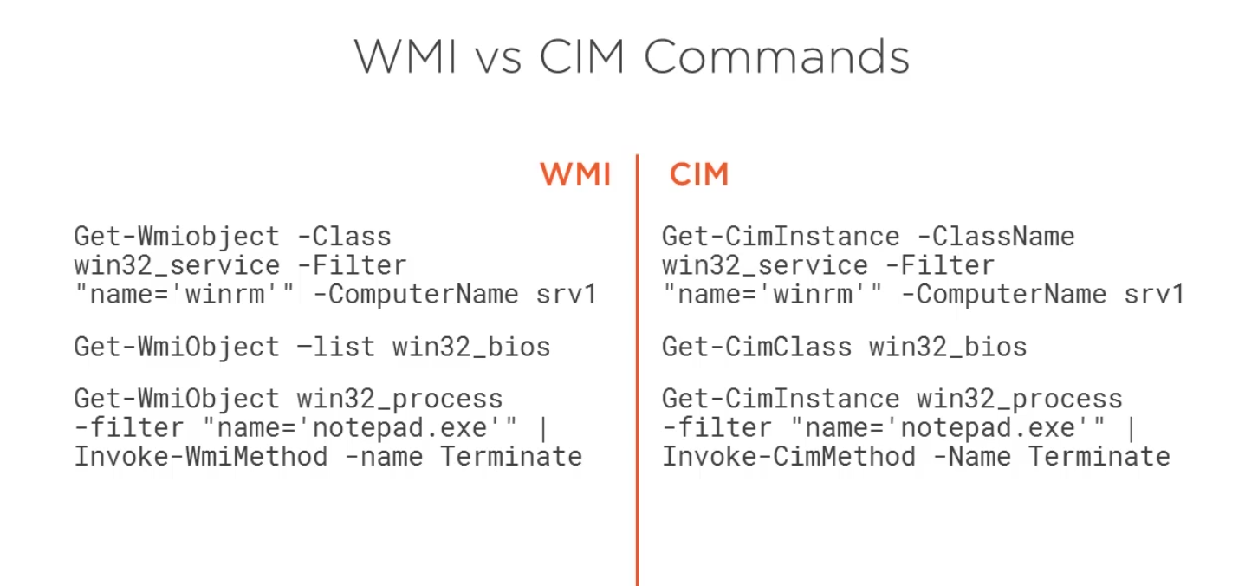

Limitations of CIM cmdlets: Restricted by WSMan limitations

1. CIMSession may provide solution
2. CIM cmdlets lack direct support for alternate credentials. to counter it, we could use a CIM Session.
3. Requires PowerShell 3.0. for older versions/systems, you can configure CIM cmdlets to support legacy i.e. DCOM systems.

Get-CimClass --Get a list of cim classes in a soecific namespace.

Get-CimInstance --Get the cm instances of a class from a cim server. With Cim Instance, you don’t get any of the system properties like __server.

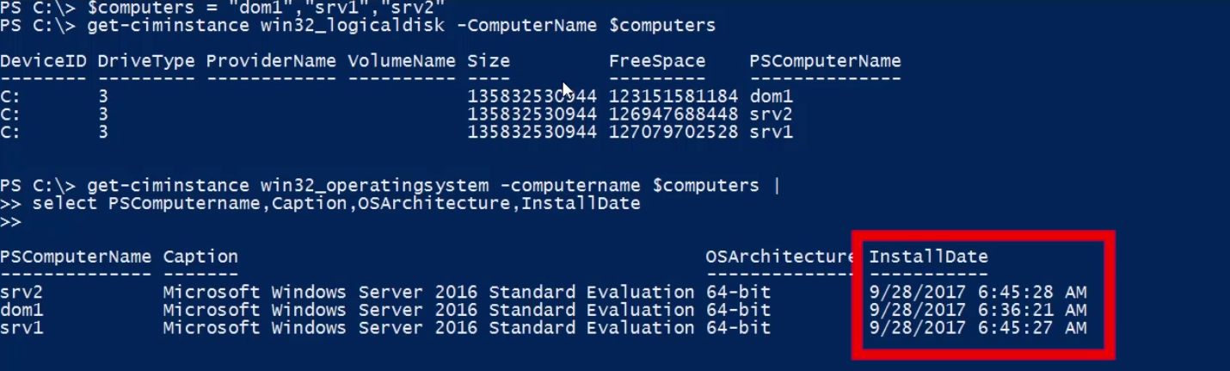

Notice that the Installed date comes already in a readable format. Unlike WMI cmdlets, we need not to convert it into a readable format. WMI cmdlet outputs the installed date in a DMTF format.

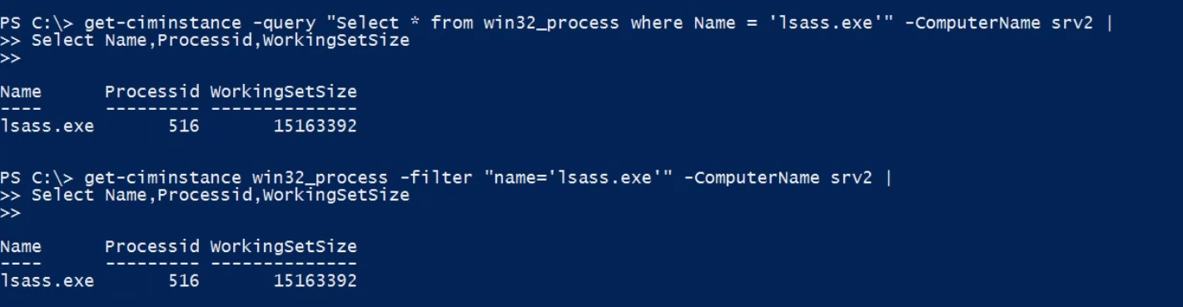

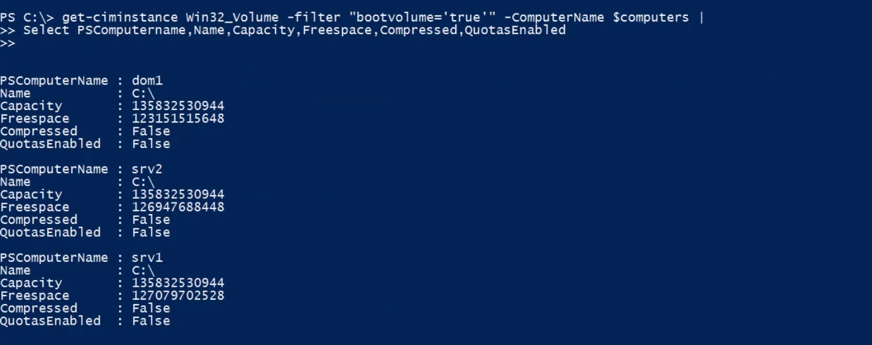Note here that we have assigned the value of the bootvolume property as string and not a Boolean. In legacy cmdlets when using WMI, the property is of string type. It is of the boolan type in the CIM. But CIM also supports for the legacy values and thus it works fine.

New-CIMSession:

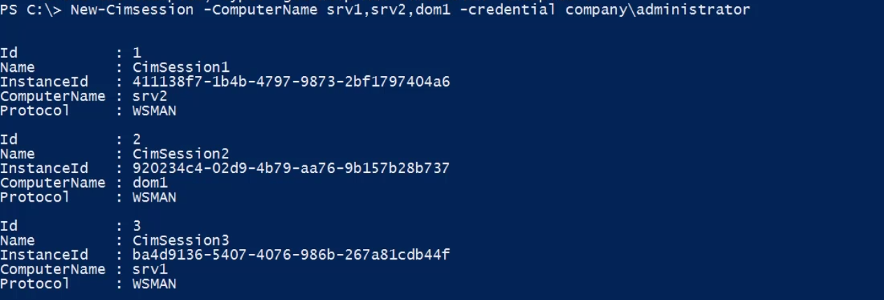

New-CimSessionOption: this helps in teawking the CIM Session. It specifies the advance option for the New-CIMSession cmdlets. We can specify a protocol whether we want to use a SSH or go through a proxy or maybe we need to tweak in coding or skipping a name check or revocation check.

Suppose we want to connect to a old ciputer which does not support WSMan protocol and we want to connect to it using the cim cmdlet.



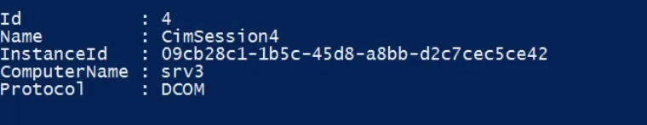

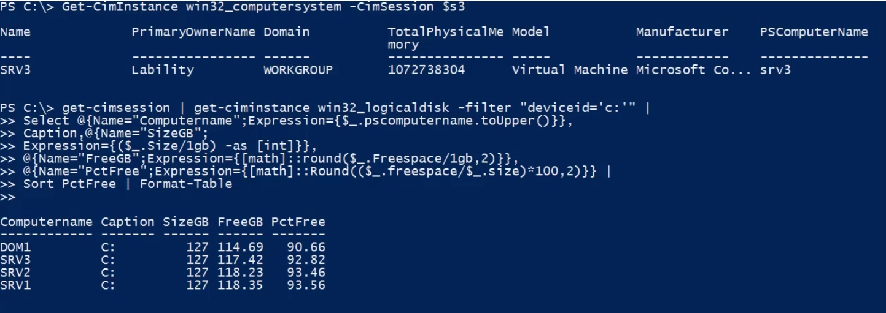

Get-CimSession | Remove-CIMSession --this will remove all the open cim sessions.

Get-Disk | select * --this is equivalent to Get-CimInstance -NameSpace root/Microsoft/Windows/storage -classname MSFT_Disk. This is like a wrapper command on the above Get-cimInstance method.

**Get-TypeData -TypeName *cim* | where { $_.typename -notmatch ‘Win32’} | sort typename | more --this can come in handy to check all the typename the PowerShell supports for all the cim namespaces.**

**CIM Methods:**

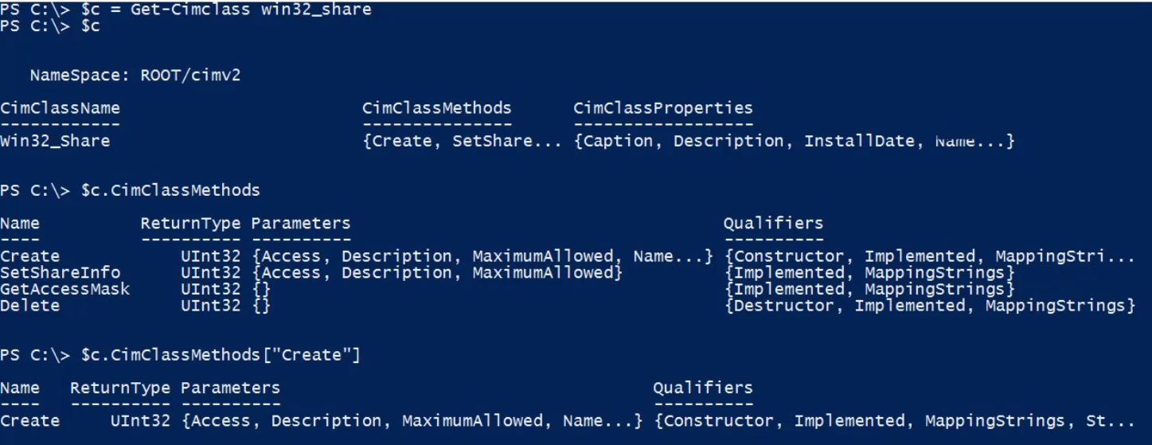

Now when we use the CIMInstance cmdlet to query something, we do not get the methods back. This is because, cim instance uses wsman and even if we query the local computer, we are going through the remote connection and get a serialized xml as an output. And this is why we do not get the methods back.

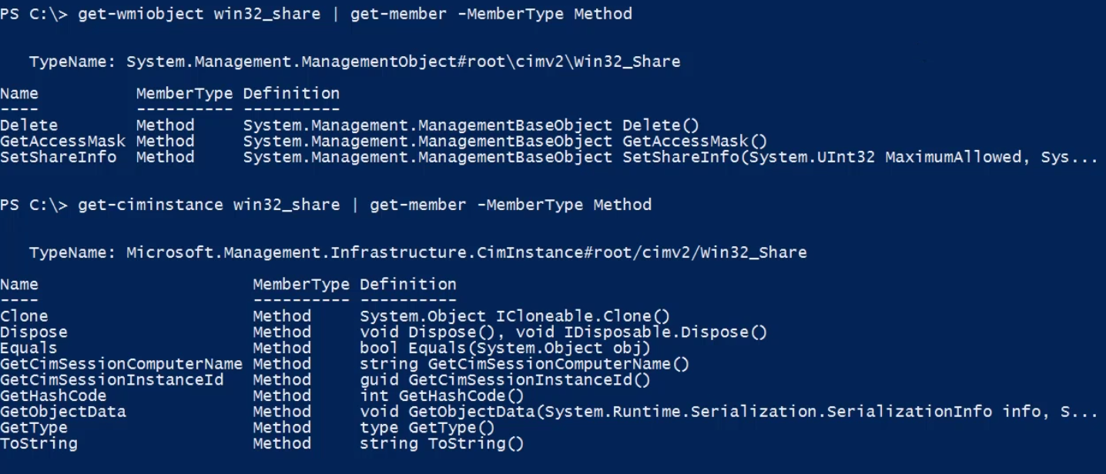

Notce we do not have a delete method with cim instance. This is because we get the text of serialized xml as output and not a object. But we can still call those methods with cim. To do that, we need to use the Invoke-CimMethod cmdlet.

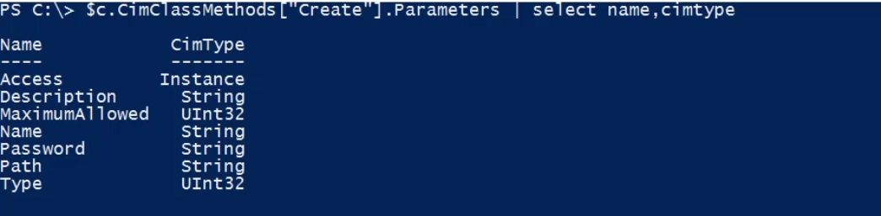

To use these method with wmi, we needed to pass the parameter in the same alphabetical order in the Invoke-WMIMethod cmdlet. With Invoke-CIMMethod cmdlet, this is much more easier. We just need to create a hashtable. Hashtable will have the key-value pair with key as the name of the parameter. They can be in any order.

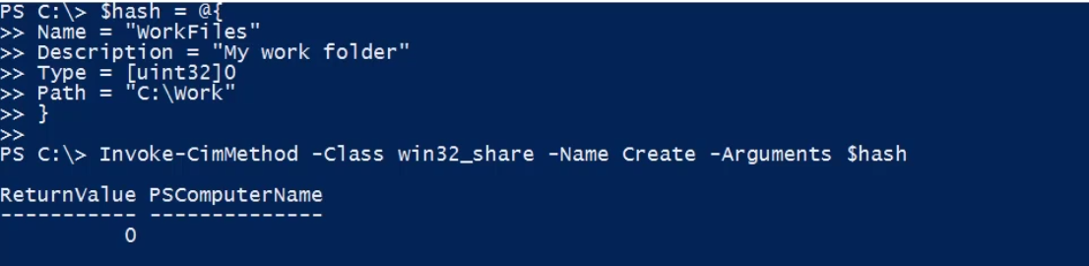

For deleting the shared directory we just created, we need to the cim instance of that directory and call the delete method.

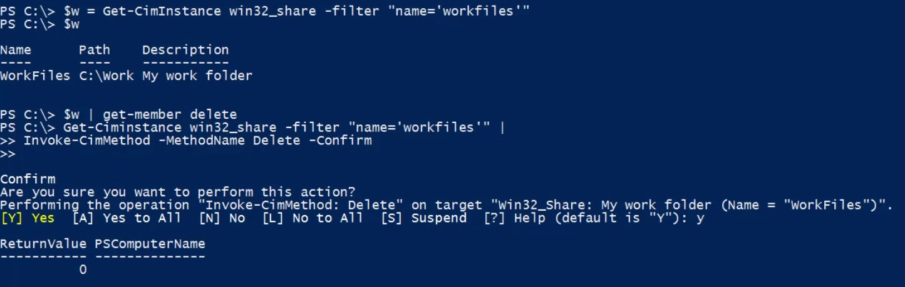

Doing all this stuff with the predefind PowerShell cmdlet

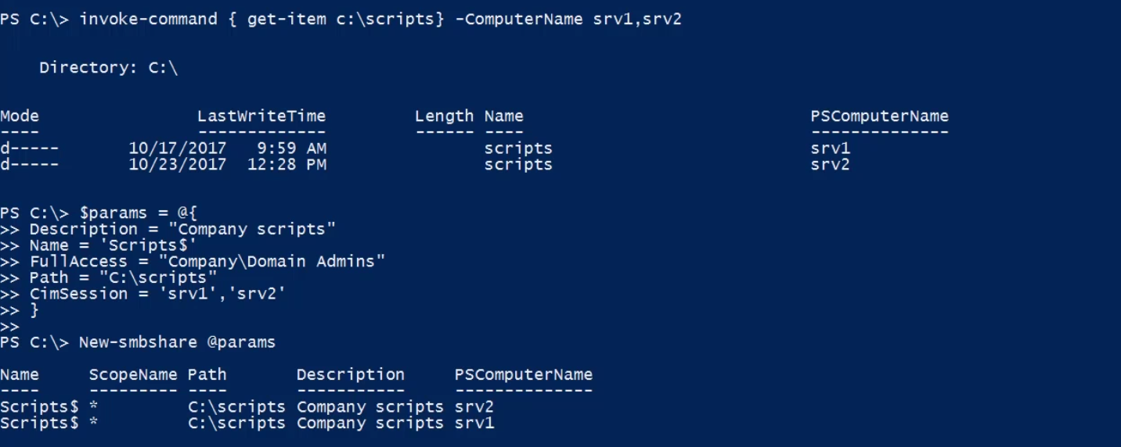

Get-WmiObject has a -asJob parameter but get-CimInstance doesnot. We can use the cim instance cmdlet as a job by using the start-job.

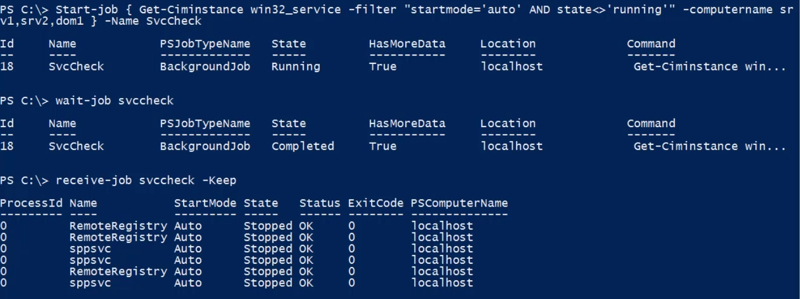

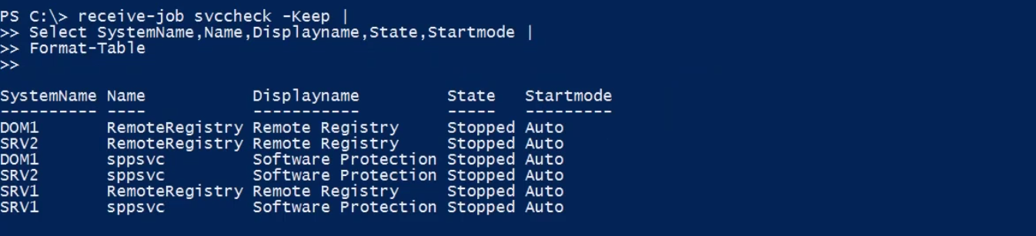

We can also use the invoke-command to do the same thing in the background.

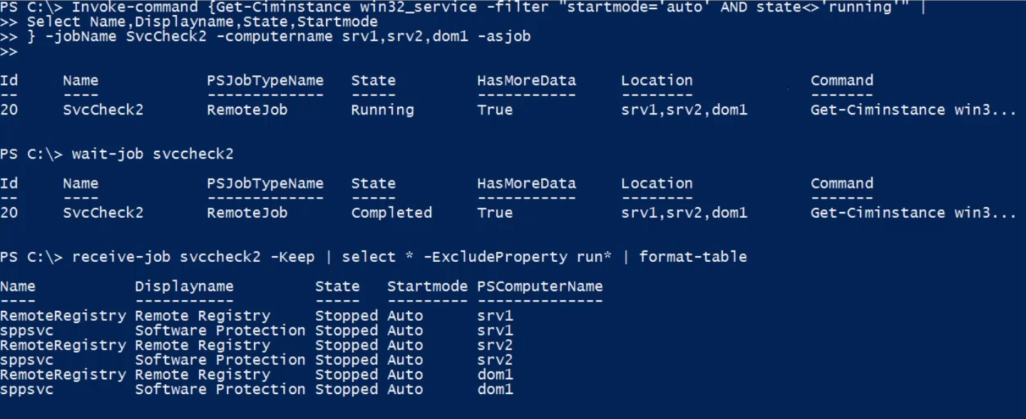

Another way to get this right is the use of the PS session.

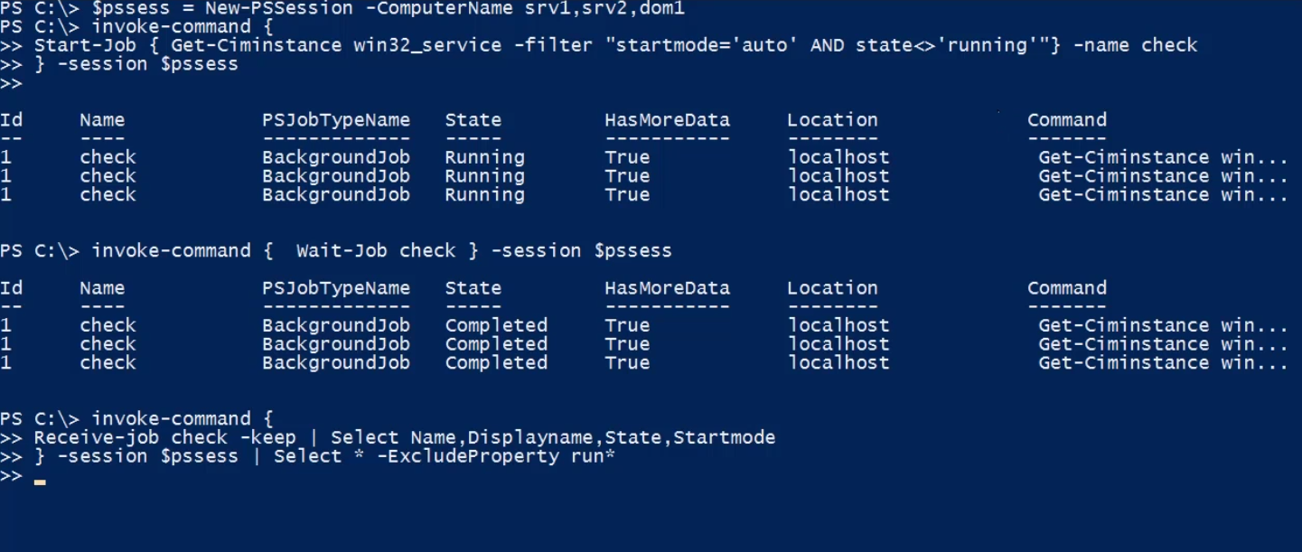

Note that all of these commands are running on the remote computer. We are invoking the start-job command on the remote computer which is executing the Get-CIMInstance cmdlet on the remote machine and we are passing the sessions created locally for those remote computers to the invoke-command command.

**Restart-Computer srv1 -Force -Wait -For WinRM --**execute this command will restart the computer srv1 and we are waiting for the winrm service on that remote computer to turn back up again. This is a good approach to know the computer has restarted.

Getting the uptime report.

**Important point to note is that** the fewer the properties the cimInstance cmdlet will return the faster will be its execution.

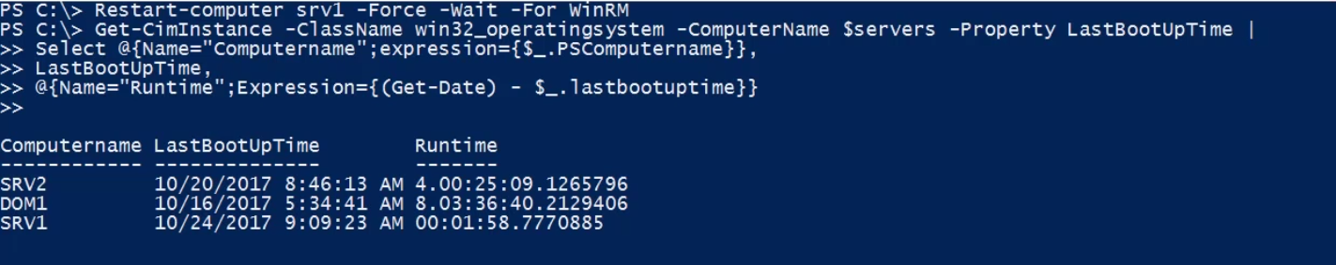

To check what patches are installed

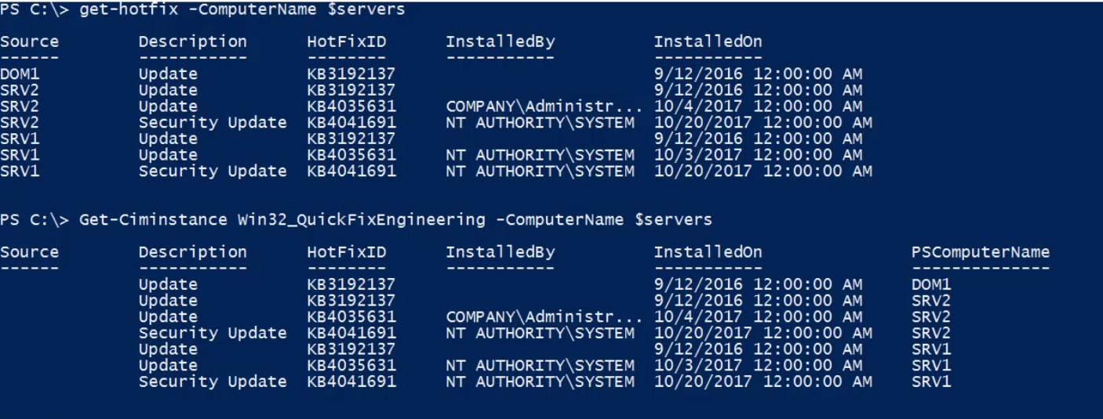

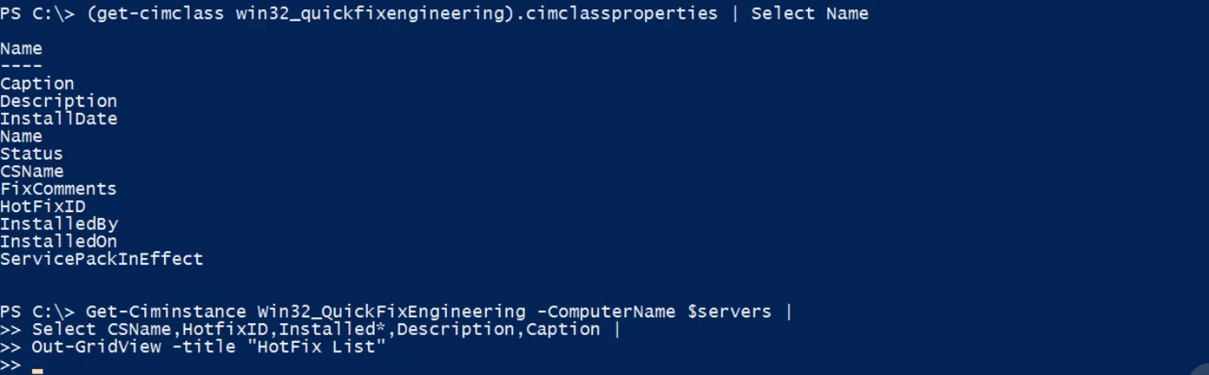

**PowerShell and the Web:**

PowerShell really is designed with the cloud and internet in mind. [However, don't assume](https://app.pluralsight.com/player?course=powershell-network-on-the&author=jeff-hicks&name=662ba022-0a8d-443c-b65f-b0bc46744ec7&clip=0&mode=live&start=23.624000000000002) [that this only means working with servers](https://app.pluralsight.com/player?course=powershell-network-on-the&author=jeff-hicks&name=662ba022-0a8d-443c-b65f-b0bc46744ec7&clip=0&mode=live&start=26.106500000000004) [out on the internet. You could have some](https://app.pluralsight.com/player?course=powershell-network-on-the&author=jeff-hicks&name=662ba022-0a8d-443c-b65f-b0bc46744ec7&clip=0&mode=live&start=28.543444444444447) [internal servers that may be running some](https://app.pluralsight.com/player?course=powershell-network-on-the&author=jeff-hicks&name=662ba022-0a8d-443c-b65f-b0bc46744ec7&clip=0&mode=live&start=30.99681818181818) [application or a platform or something](https://app.pluralsight.com/player?course=powershell-network-on-the&author=jeff-hicks&name=662ba022-0a8d-443c-b65f-b0bc46744ec7&clip=0&mode=live&start=33.037) [that exposes information over a web](https://app.pluralsight.com/player?course=powershell-network-on-the&author=jeff-hicks&name=662ba022-0a8d-443c-b65f-b0bc46744ec7&clip=0&mode=live&start=36.08009090909092) [technology like HTTP and, or REST, and you](https://app.pluralsight.com/player?course=powershell-network-on-the&author=jeff-hicks&name=662ba022-0a8d-443c-b65f-b0bc46744ec7&clip=0&mode=live&start=39.05891666666667) [could manage those servers with these](https://app.pluralsight.com/player?course=powershell-network-on-the&author=jeff-hicks&name=662ba022-0a8d-443c-b65f-b0bc46744ec7&clip=0&mode=live&start=42.60225000000002) [cmdlets as well. The PowerShell commands](https://app.pluralsight.com/player?course=powershell-network-on-the&author=jeff-hicks&name=662ba022-0a8d-443c-b65f-b0bc46744ec7&clip=0&mode=live&start=45.1088) [that we're going to walkthrough kind of](https://app.pluralsight.com/player?course=powershell-network-on-the&author=jeff-hicks&name=662ba022-0a8d-443c-b65f-b0bc46744ec7&clip=0&mode=live&start=47.46440000000001) [abstract the whole process of connecting](https://app.pluralsight.com/player?course=powershell-network-on-the&author=jeff-hicks&name=662ba022-0a8d-443c-b65f-b0bc46744ec7&clip=0&mode=live&start=49.75081818181819) [to the servers, giving it information you](https://app.pluralsight.com/player?course=powershell-network-on-the&author=jeff-hicks&name=662ba022-0a8d-443c-b65f-b0bc46744ec7&clip=0&mode=live&start=51.66466666666667) [want, turning it into useful PowerShell](https://app.pluralsight.com/player?course=powershell-network-on-the&author=jeff-hicks&name=662ba022-0a8d-443c-b65f-b0bc46744ec7&clip=0&mode=live&start=54.01433333333335) [data or objects. This may require a little](https://app.pluralsight.com/player?course=powershell-network-on-the&author=jeff-hicks&name=662ba022-0a8d-443c-b65f-b0bc46744ec7&clip=0&mode=live&start=56.920000000000016) [bit of scripting, especially when you get](https://app.pluralsight.com/player?course=powershell-network-on-the&author=jeff-hicks&name=662ba022-0a8d-443c-b65f-b0bc46744ec7&clip=0&mode=live&start=59.6266153846154) [to building tools](https://app.pluralsight.com/player?course=powershell-network-on-the&author=jeff-hicks&name=662ba022-0a8d-443c-b65f-b0bc46744ec7&clip=0&mode=live&start=61.25707692307695).

**Invoke-WebRequest** --with this command you can send a request to a website and get back a structured object. This is a really handy tool if you want to scrape a website or download a file. Note here, this is not intended to automate your browser. This cmdlet is for connecting to a website and getting data from it, and working with it then in PowerShell. *This get content from a web page on the internet.It uses some of the IE engine under the hood.*

**Invoke-RestMethod --**this command is used for sending requests to rest services. With this command you are gonna send requests to websites that implement some dort of rest api or restful service. The cmdlet will also convert the incoming json to objects. It can also convert the incoming xml data into objects.

**New-WebServiceProxy** --a web service is an application or service which is called by other websites or web applications. But we can use it to create a proxy object. And with this proxy object, you can then invoke methods of that web service much easier then you could have to try and write some sort of .NET application to consume that web service. So the invoke methods are then passed to the web servers through PowerShell and this proxy object and you get some nice results back.

**Invoke-WebRequest:**

Invoke-WebRequest -uri https://www.google.com -UseBasicParsing

Running this command without -UseBasicParsing may result into an error. This command can also be used for downloading files from the internet.

$uri = ‘https://git-scm.com/download/win’

Start $uri

$page = Invoke-WEbRequest -uri $uri -UseBasicParsing -DisableKeepAlive

$page | more

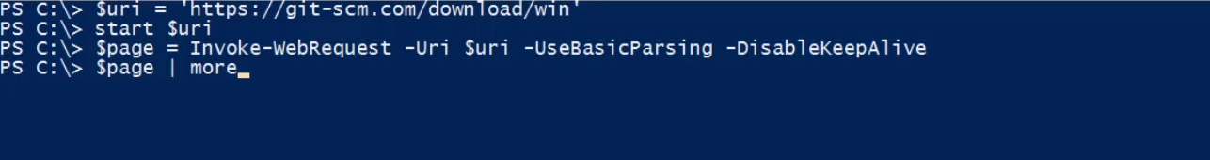

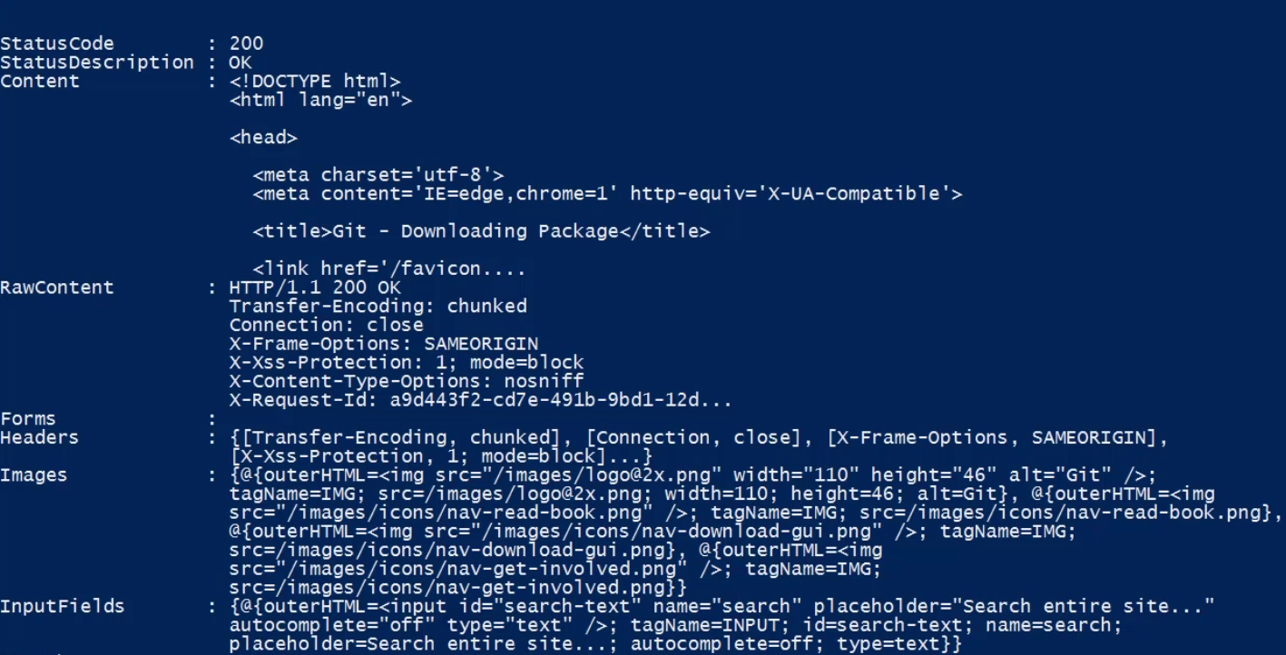

For getting all the links to download, we can say

$page.links

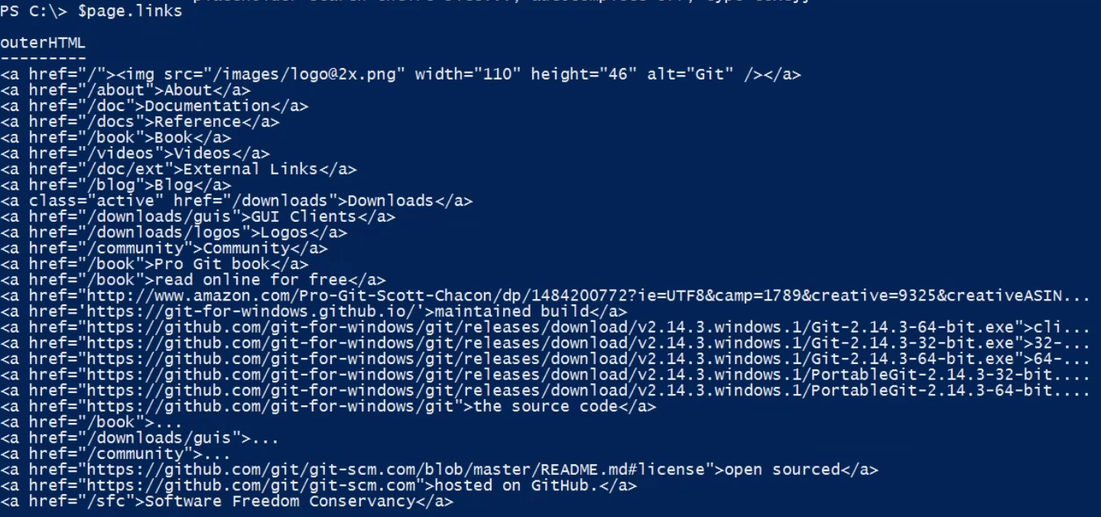

From these multiple links, we can then filter what link we want to download

$dl = $page.links | where-object outerhtml -match ‘git-.*-64-bit.exe’ | select-object -first 1 *

$dl | format-list *

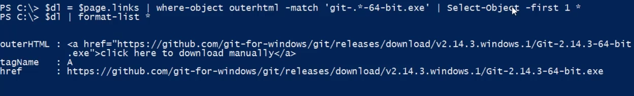

Now we have the href link for the file we want t download and this href contains the name of the fin=lename.

$filename = split-path $dl.href -leaf

And finally we are going to create an out variable to construct the path. So I want to save this file on my work directory present in the C drive.

$out = Join-path -path C:\work –ChildPath $filename

Invoke-WebRequest -uri $dl.href -outFile $out -UseBasicParsing -DisableKeepAlive

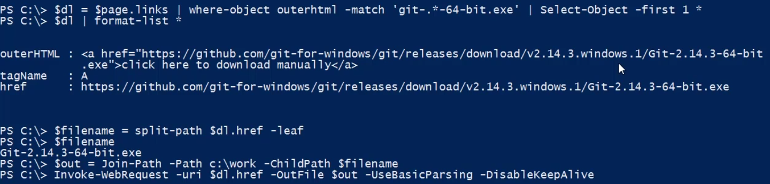

With the final invoke command, the PowerShell will download the file into my c:\work folder.

***If you get an error like this then you need to setup secure Protocol first before invoking the WebRequest command***

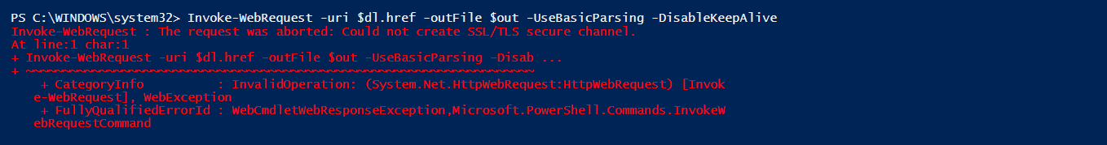

[Net.ServicePointManager]::SecurityProtocol = [Net.SecurityProtocolType]::Tls12

Then finally invoke the command to download the file.

Invoke-WebRequest -uri $dl.href -outFile $out -UseBasicParsing -DisableKeepAlive

Note that for the command to work, you should have a directory exists specified for the download.

**Invoke-RestMethod:**

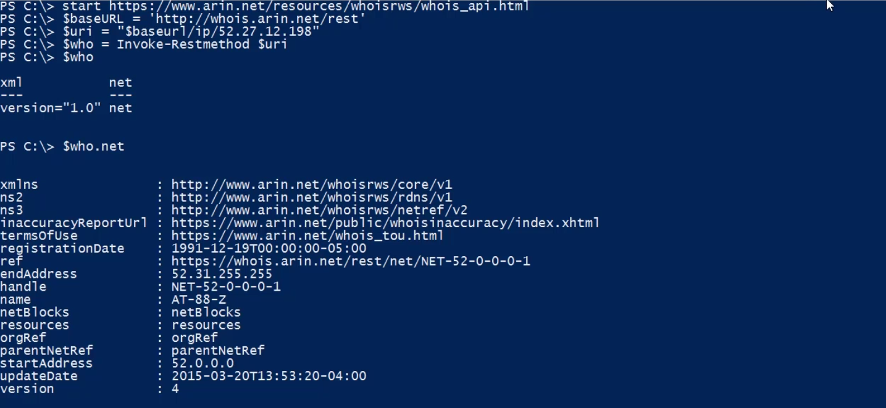

**New-WebServiceProxy:**

This creates a web service proxy object that lets you use and manage the web service in PowerShell

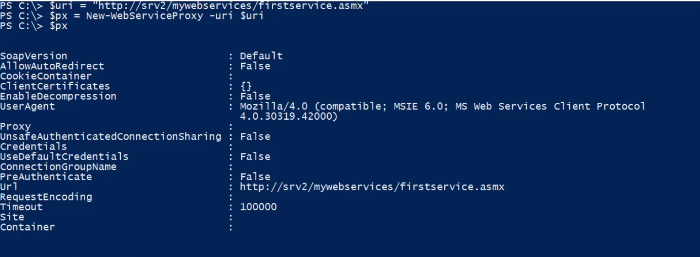

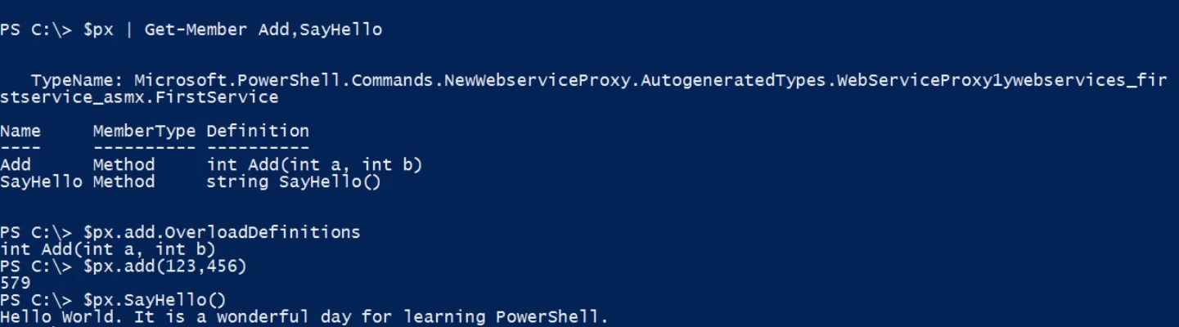

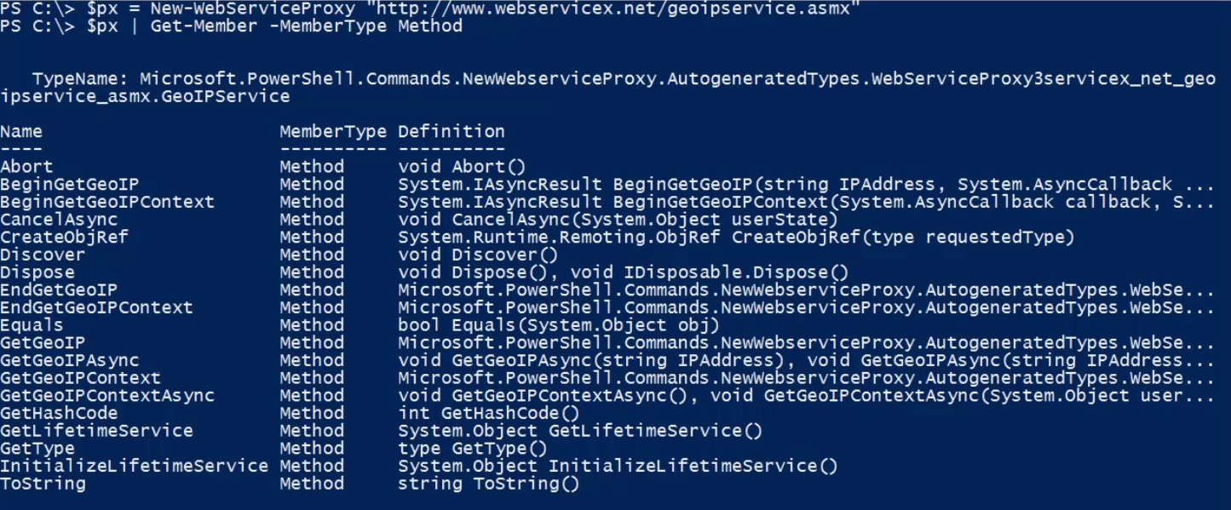

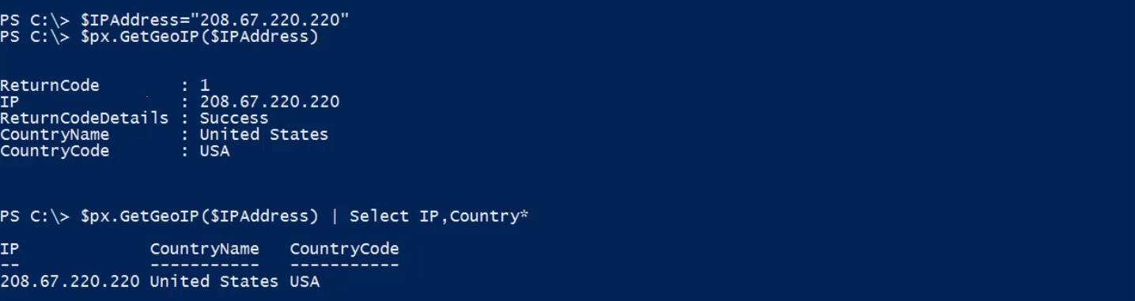

Advanced applications:

1. Odata and PowerShell - [PowerShell](https://app.pluralsight.com/player?course=powershell-network-on-the&author=jeff-hicks&name=662ba022-0a8d-443c-b65f-b0bc46744ec7&clip=4&mode=live&start=9.305666666666669) [has a way of working with OData since](https://app.pluralsight.com/player?course=powershell-network-on-the&author=jeff-hicks&name=662ba022-0a8d-443c-b65f-b0bc46744ec7&clip=4&mode=live&start=12.077384615384615) [we're open data protocol. This is an open](https://app.pluralsight.com/player?course=powershell-network-on-the&author=jeff-hicks&name=662ba022-0a8d-443c-b65f-b0bc46744ec7&clip=4&mode=live&start=14.821076923076923) [standard that you can use to consume](https://app.pluralsight.com/player?course=powershell-network-on-the&author=jeff-hicks&name=662ba022-0a8d-443c-b65f-b0bc46744ec7&clip=4&mode=live&start=17.661692307692306) [RESTful APIs that may be offered on a](https://app.pluralsight.com/player?course=powershell-network-on-the&author=jeff-hicks&name=662ba022-0a8d-443c-b65f-b0bc46744ec7&clip=4&mode=live&start=20.285400000000003) [website or web server. A lot of this is](https://app.pluralsight.com/player?course=powershell-network-on-the&author=jeff-hicks&name=662ba022-0a8d-443c-b65f-b0bc46744ec7&clip=4&mode=live&start=23.494466666666675) [all documented at odata.org.](https://app.pluralsight.com/player?course=powershell-network-on-the&author=jeff-hicks&name=662ba022-0a8d-443c-b65f-b0bc46744ec7&clip=4&mode=live&start=26.906)

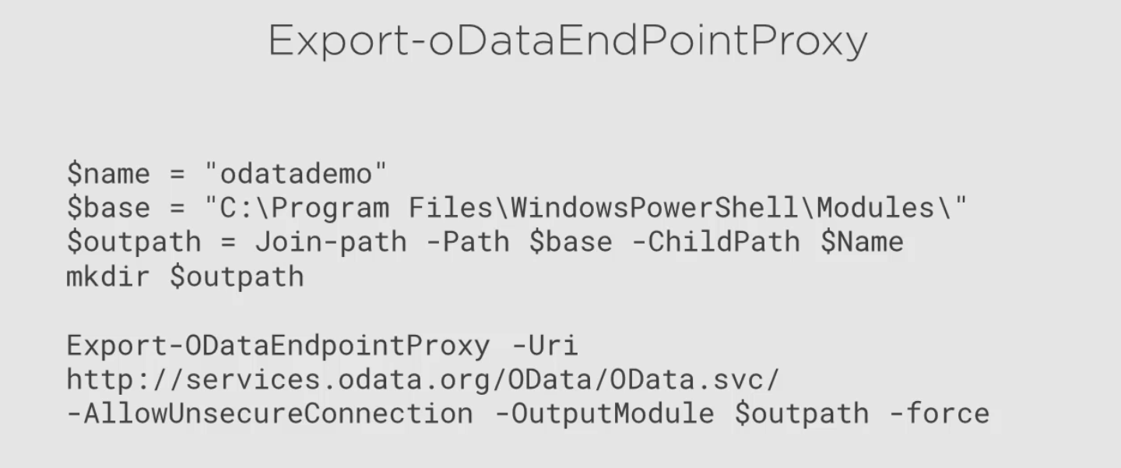

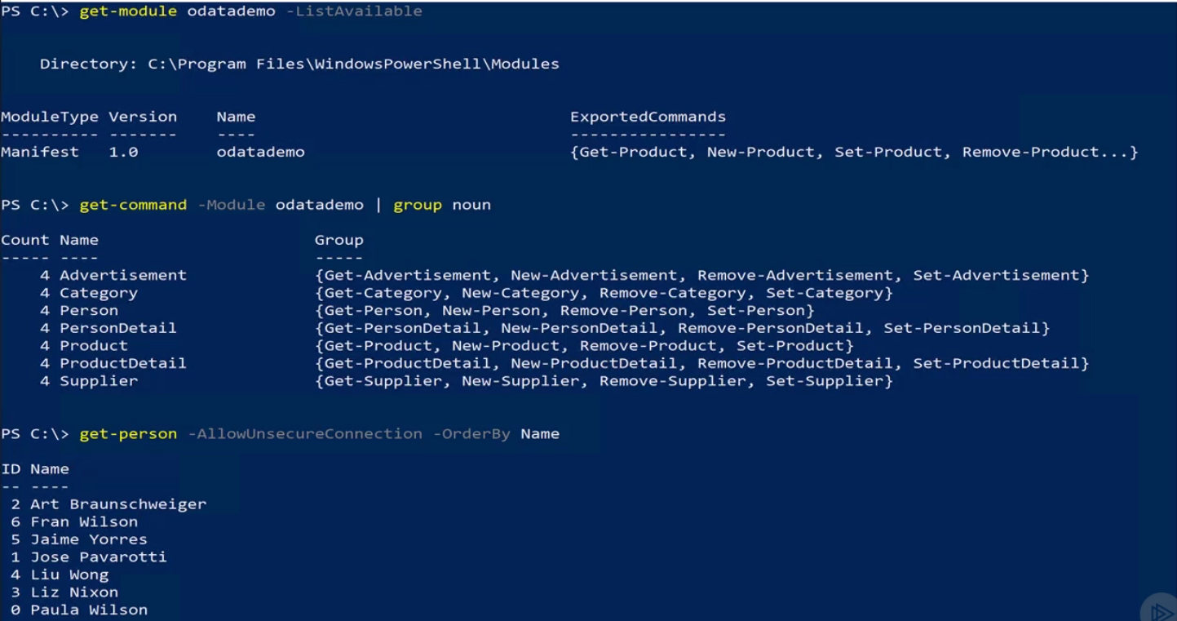

[What you](https://app.pluralsight.com/player?course=powershell-network-on-the&author=jeff-hicks&name=662ba022-0a8d-443c-b65f-b0bc46744ec7&clip=4&mode=live&start=26.906) [will do is end up using a cmdlet called](https://app.pluralsight.com/player?course=powershell-network-on-the&author=jeff-hicks&name=662ba022-0a8d-443c-b65f-b0bc46744ec7&clip=4&mode=live&start=29.386538461538464) [export OData endpoint. So with this](https://app.pluralsight.com/player?course=powershell-network-on-the&author=jeff-hicks&name=662ba022-0a8d-443c-b65f-b0bc46744ec7&clip=4&mode=live&start=32.417461538461545) [cmdlet, what you're going to do is](https://app.pluralsight.com/player?course=powershell-network-on-the&author=jeff-hicks&name=662ba022-0a8d-443c-b65f-b0bc46744ec7&clip=4&mode=live&start=34.52700000000001) [basically create a local module that will](https://app.pluralsight.com/player?course=powershell-network-on-the&author=jeff-hicks&name=662ba022-0a8d-443c-b65f-b0bc46744ec7&clip=4&mode=live&start=37.04000000000002) [consume the OData endpoint and kind of](https://app.pluralsight.com/player?course=powershell-network-on-the&author=jeff-hicks&name=662ba022-0a8d-443c-b65f-b0bc46744ec7&clip=4&mode=live&start=41.10607692307691) [create a proxy if you will for those](https://app.pluralsight.com/player?course=powershell-network-on-the&author=jeff-hicks&name=662ba022-0a8d-443c-b65f-b0bc46744ec7&clip=4&mode=live&start=45.431) [commands like we did with web servers](https://app.pluralsight.com/player?course=powershell-network-on-the&author=jeff-hicks&name=662ba022-0a8d-443c-b65f-b0bc46744ec7&clip=4&mode=live&start=47.713500000000025) [proxy. So you're basically going to export](https://app.pluralsight.com/player?course=powershell-network-on-the&author=jeff-hicks&name=662ba022-0a8d-443c-b65f-b0bc46744ec7&clip=4&mode=live&start=49.71068750000005) [all the information about that OData](https://app.pluralsight.com/player?course=powershell-network-on-the&author=jeff-hicks&name=662ba022-0a8d-443c-b65f-b0bc46744ec7&clip=4&mode=live&start=51.515090909090894) [endpoint and then create a local module.](https://app.pluralsight.com/player?course=powershell-network-on-the&author=jeff-hicks&name=662ba022-0a8d-443c-b65f-b0bc46744ec7&clip=4&mode=live&start=53.29557142857143) [You can then import that module and the](https://app.pluralsight.com/player?course=powershell-network-on-the&author=jeff-hicks&name=662ba022-0a8d-443c-b65f-b0bc46744ec7&clip=4&mode=live&start=56.66108333333334) [commands in that module basically will tie](https://app.pluralsight.com/player?course=powershell-network-on-the&author=jeff-hicks&name=662ba022-0a8d-443c-b65f-b0bc46744ec7&clip=4&mode=live&start=58.885750000000016) [back to the methods that are offered by](https://app.pluralsight.com/player?course=powershell-network-on-the&author=jeff-hicks&name=662ba022-0a8d-443c-b65f-b0bc46744ec7&clip=4&mode=live&start=61.135999999999996) [that OData service and here's a quick](https://app.pluralsight.com/player?course=powershell-network-on-the&author=jeff-hicks&name=662ba022-0a8d-443c-b65f-b0bc46744ec7&clip=4&mode=live&start=63.96799999999999) [little example of what that might look](https://app.pluralsight.com/player?course=powershell-network-on-the&author=jeff-hicks&name=662ba022-0a8d-443c-b65f-b0bc46744ec7&clip=4&mode=live&start=67.00185714285718) [like.](https://app.pluralsight.com/player?course=powershell-network-on-the&author=jeff-hicks&name=662ba022-0a8d-443c-b65f-b0bc46744ec7&clip=4&mode=live&start=70.12835714285721)

1. PSSwagger - T[his too is supposed](https://app.pluralsight.com/player?course=powershell-network-on-the&author=jeff-hicks&name=662ba022-0a8d-443c-b65f-b0bc46744ec7&clip=4&mode=live&start=76.79692307692312) [to allow you to autogenerate cmdlets from](https://app.pluralsight.com/player?course=powershell-network-on-the&author=jeff-hicks&name=662ba022-0a8d-443c-b65f-b0bc46744ec7&clip=4&mode=live&start=79.47866666666668) [RESTful services using Swagger and Open](https://app.pluralsight.com/player?course=powershell-network-on-the&author=jeff-hicks&name=662ba022-0a8d-443c-b65f-b0bc46744ec7&clip=4&mode=live&start=81.58333333333339) [API and some other services. This may](https://app.pluralsight.com/player?course=powershell-network-on-the&author=jeff-hicks&name=662ba022-0a8d-443c-b65f-b0bc46744ec7&clip=4&mode=live&start=84.50200000000001) [start becoming a bit more developer](https://app.pluralsight.com/player?course=powershell-network-on-the&author=jeff-hicks&name=662ba022-0a8d-443c-b65f-b0bc46744ec7&clip=4&mode=live&start=87.80850000000001) [focused, so don't worry too much if this](https://app.pluralsight.com/player?course=powershell-network-on-the&author=jeff-hicks&name=662ba022-0a8d-443c-b65f-b0bc46744ec7&clip=4&mode=live&start=89.87400000000002) [doesn't sound of any interest to you](https://app.pluralsight.com/player?course=powershell-network-on-the&author=jeff-hicks&name=662ba022-0a8d-443c-b65f-b0bc46744ec7&clip=4&mode=live&start=92.43746153846152) [because unless you are kind of a](https://app.pluralsight.com/player?course=powershell-network-on-the&author=jeff-hicks&name=662ba022-0a8d-443c-b65f-b0bc46744ec7&clip=4&mode=live&start=94.51376923076917) [developer, those are the people I think](https://app.pluralsight.com/player?course=powershell-network-on-the&author=jeff-hicks&name=662ba022-0a8d-443c-b65f-b0bc46744ec7&clip=4&mode=live&start=96.44128571428574) [will be interested in this, but is](https://app.pluralsight.com/player?course=powershell-network-on-the&author=jeff-hicks&name=662ba022-0a8d-443c-b65f-b0bc46744ec7&clip=4&mode=live&start=98.30928571428578) [something to at least keep an eye and to](https://app.pluralsight.com/player?course=powershell-network-on-the&author=jeff-hicks&name=662ba022-0a8d-443c-b65f-b0bc46744ec7&clip=4&mode=live&start=99.96407142857142) [see how this develops over the next few](https://app.pluralsight.com/player?course=powershell-network-on-the&author=jeff-hicks&name=662ba022-0a8d-443c-b65f-b0bc46744ec7&clip=4&mode=live&start=101.982) [years. And there is right now, it's an](https://app.pluralsight.com/player?course=powershell-network-on-the&author=jeff-hicks&name=662ba022-0a8d-443c-b65f-b0bc46744ec7&clip=4&mode=live&start=104.38644444444449) [open source project on GitHub, so if you](https://app.pluralsight.com/player?course=powershell-network-on-the&author=jeff-hicks&name=662ba022-0a8d-443c-b65f-b0bc46744ec7&clip=4&mode=live&start=106.23574999999998) [are interested and want to get involved, that would be the place to go.](https://app.pluralsight.com/player?course=powershell-network-on-the&author=jeff-hicks&name=662ba022-0a8d-443c-b65f-b0bc46744ec7&clip=4&mode=live&start=107.97285714285715)

[https://github.com/PowerShell/PSSwagger](https://github.com/Powershell/PSSwagger)

Where to go next:

1. Learn the PowerShell remotingfundamentals course on pluralsight
2. Desired state configuration or DSC – this is a way of using PowerShell and PowerShell remoting to implement basically your infrastructure as code. You define what your servers should look like in applications and how they are all configured through a set of configuration documents and then you can apply or deploy those configurations and within minutes, you can have your servers configured the way that you need them to be. This goes with the approach of “Treating your servers like cattle and not like pets”. So if your server no longer behaves the way you want it to be, don’t spend a lot of time try to fix it, just kill it and bring up a new server because you have the configuration that can happen really quickly
3. JEA: Just Enough Administration – this gives you the ability to create endpoints where if you want to delegate administrative access to a server, even to another domain admin, but you don’t want to give them access to absolutely everything on that server, you can dynamically allow restricted or remote administration. This way you can give your administrators or the helpdesk just what they need to do their job and nothing more. This is a great security measure that you will want to look into, especially if you have non admins needing to manage the servers in your network.
4. Disconnected Seessions: with this you can create a session, run your command in it, disconnect that session. The session will continue t o run on the remote server, and then you can reconnect later, even from a totally different computer. This is important is you are managing a lot of servers and have things that are going to take a long time to run, this is a great technique to larn how to do.
5. Advanced WMI/CIM techniques – techniques which with you can find associate and related classes. This can help to discover the interconnections in WMI. You can also create event subscriptions. Something like if you want to know when the bits service status changes on say 10 servers from running to stopped.

We can use PowerShell cim cmdlets to alert me, and maybe even automatically take some action when that event happens or fired. There are a lot of third party tools that kind of does that for you but if you want to learn, it is possible through wmi and cim.

1. You can also continue to build your own cim based tools through CDXML. This is the technique that Microsoft used to spin up a lot of cmdlets for those new things like Get-Disk and Get-Volume.
2. PowerShell WorkFlow: you can create a PowerShell script that will run an orchestrated set of commands on one or more remote computers. You can design these commands that you run to persist network interruptions or reboot the server and have your workflow continue up again. Workflow is a whole paradigm in and of itself.
3. PowerShell Web Access: Wouldn’t it be cool to access remoting outside of your office. Most of the time we are accessing remoting for servers that are on the network and are connected to internet. To access it from outside can be done by PowerShell remote sessions through a web browser and this is done by setting up a PowerShell web access server. This means you an use tablets, phones, to connect to the web server which is completely secure and run command remotely to manage the server from the browser poershell window.
4. SSH and Cross-Platform managemnent: upcoming in PowerShell.
5. <http://bit.ly/PSinDepth2>
6. PowerShell.org

**Automation with PowerShell Scripts:**

[By default, PowerShell](https://app.pluralsight.com/player?course=automation-powershell-scripts&author=jeff-hicks&name=082e5a51-3fb4-4df7-a1d3-32100999f2ce&clip=0&mode=live&start=24.798461538461538) [will not run anything it considers to be a](https://app.pluralsight.com/player?course=automation-powershell-scripts&author=jeff-hicks&name=082e5a51-3fb4-4df7-a1d3-32100999f2ce&clip=0&mode=live&start=26.781499999999994) [PowerShell script or executable. These are](https://app.pluralsight.com/player?course=automation-powershell-scripts&author=jeff-hicks&name=082e5a51-3fb4-4df7-a1d3-32100999f2ce&clip=0&mode=live&start=30.68) [files with a ps1, psm1, or ps1xml file](https://app.pluralsight.com/player?course=automation-powershell-scripts&author=jeff-hicks&name=082e5a51-3fb4-4df7-a1d3-32100999f2ce&clip=0&mode=live&start=33.50109090909092) [extension, so PowerShell will not run](https://app.pluralsight.com/player?course=automation-powershell-scripts&author=jeff-hicks&name=082e5a51-3fb4-4df7-a1d3-32100999f2ce&clip=0&mode=live&start=37.527249999999995) [those by default](https://app.pluralsight.com/player?course=automation-powershell-scripts&author=jeff-hicks&name=082e5a51-3fb4-4df7-a1d3-32100999f2ce&clip=0&mode=live&start=40.87774999999999). Th default application for ps1 files is notepad. So if you double click to open a ps1 file, it will open in notepad.

If you want to run a script you have to specify the full path of the script. If you are in the same directory, you need to specify the relative path of the script file.

**Execution policy:-** this controls whether PowerShell will run script files or not. By default, this is set to *Restricted.*this means that you cannot run all the PowerShell script files in PowerShell.

-RemoteSigned: - when you set the execution policy to remote signed, PowerShell will run scripts created locally or any scripts that has been digitally signed.

-AllSigned:- This is more secure than remoteSigned and this tells PowerShell to run only those scripts that are digitally signed with a specific type of code signing certificate. If it has been signed and the files **has not been modified** then yes, go ahead and execute the script file. But if it has not been signed or if it is signed but something has changed and it has not been resigned, then do not run the script. *This is the best approach to take if you eed to be most secure.*

**Unrestricted:-** this is fine for testing or lab environments. This tells PowerShell to run the scripts irrespective of it is signed or not. This is the most unsecure way of executing scripts in PowerShell ans is not recommended.

**ByPass:-** It says PowerShell that you do not need to worry about the security of the script files. I am taking care of it outsie of the PowerShell world.

*Set-ExecutionPolicy RemoteSigned --*run in an elevated PowerShell. Only need to run this once per machine as it is stored in registry. This can also be set via group policy.

NOTE: you don’t have to specify the extension of the script file but I will recommend it. You can use tab for expansion.

--------------------------------------------------------------------------------------

Use the *Get-Content* command to see the contents of a file.

*Invoke-Item . --*this will open up the current directory.

Any file that is downloaded from the internet and is not digitally signed is harmful and cannot be trusted by PowerShell. If you open up the file properties, you will see that at the bottom. Also there will be an option to unblock the file. But we can also unblock the file from PowerShell.

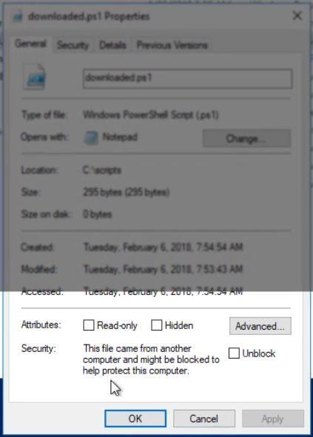

*Unblock-file C:\scripts\downloaded.ps1 --*this command will unblock the file.

Now if we still try to run the script file, we will get a not digitally signed error. This is because our execution policy is set to RemoteSigned and this file is not digitally signed. So PowerShelll cannot trust it.

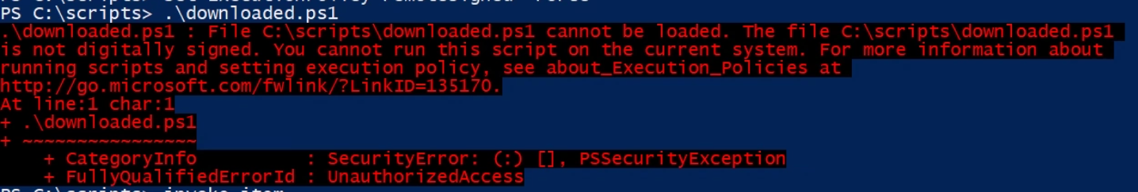

**PowerShell Scopes:**

* Global
* Script
* Private
* Numbered Scope

NOTE: PowerShell can only write or create in the current scope.

To reference a variable of the global scope

$global:x --where x is the name of the global variable.

Some of the cmdlets in PowerShell has a scope parameter. This is your way of getting around the normal scope rules.

NOTE: everything in the PowerShell ise runs in the global scope. So everything in the ise shares the same scope. We do not have a concept of nested scope in PowerShell ise.

**PowerShell Profile Scripts:**

These scripts do follow execution rules. If you want to configure your PowerShell session to meet your needs, you can create a profile script which may contain hard coded file paths and ome of the path may not even exists but you need to create them. Other PowerShell tools like VSCode and Sapien pascal code/shell may have their own PowerShell profiles configuration. So if you want some setting that needs to be common for all the tools, you can add them in the application specific profile.

$profile is a predefind variable in PowerShell that contains the pathe to the PowerShell profile. It contains several properties.

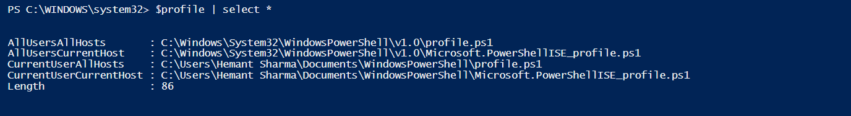

Any setting that I want to apply for the current user and the current PowerShell host i.e. the application tool currently opened for using PowerShell, I am gonna put them in the CurrentUserCurrentHost PowerShell profile.

If you have commands, variables and other things that you want to persist for all the host of the current user, you can put themin CurrentUserAllHost PowerShell profile. If this profile does not exists then you have to create the PowerShell profile ps1 file and also the folder where it needed to store the file, if the folder is also not created.

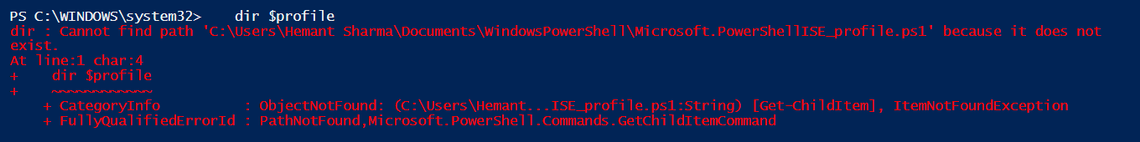

Since the profile does not exists, we can go ahead and create them.

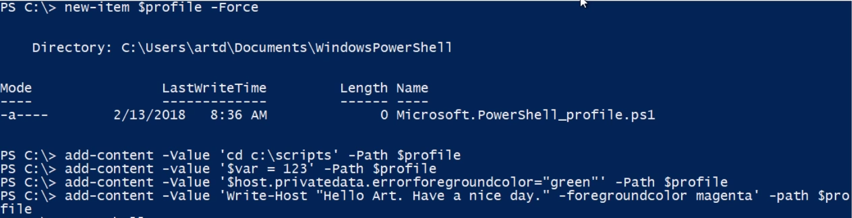

So we have created the profile with the *new-item* command. also we have added bunch of values in the profile aying to default the path to C:scripts when we open the PowerShell, a $var variable with value 123, changed the error foreground color to green from the standard red and black background and also added a Hello greeting text as soon as the PowerShell opens.

**A Basic script**

**#get a breakdown of error sources in the System eventlog**

**#start with a command that works in the console**

$computername = $env:computername

$data = Get-Eventlog System -EntryType Error -Newest 1000 -ComputerName $Computername |

Group -Property Source -NoElement

#create an HTML report

$title = "System Log Analysis"

$footer = "<h5>report run $(Get-Date)</h5>"

$css = "http://jdhitsolutions.com/sample.css"

$data | Sort -Property Count,Name -Descending |

Select Count,Name |

ConvertTo-Html -Title $Title -PreContent "<H1>$Computername</H1>" -PostContent $footer -CssUri $css |

Out-File c:\work\systemsources.html

# Invoke-Item c:\work\systemsources.html

But this is has a problem which is that the script is static. If someone needs to run it for another computer, they wil need to change the script. To make it dynamic, we need to parameterize the script. This solves our issue of hard coding values.

***Use Param() at the beginning of the script to add parametrs in the script.*** Within this, we create a comma separated list which becomes parameters.

Param(

[string]$Logname,

[string]$ComputerName = $env:computerName

[string]$Path

[int32]Newest = 500

)

**Recommend:** to specify the object type of the declared parameter variables

*Use code <name of the file> --to open it in visual studio code through PowerShell*

Now, lets create the prameterize script of the above basic script.

#get a breakdown of error sources in the System eventlog

Param(

[string]$Log = "System",

[string]$Computername = $env:COMPUTERNAME,

[int32]$Newest = 500,

[string]$ReportTitle = "Event Log Report",

[Parameter(Mandatory,HelpMessage = "Enter the path for the HTML file.")]

[string]$Path

)

#get event log data and group it

$data = Get-Eventlog -logname $Log -EntryType Error -Newest $newest -ComputerName $Computername |

Group-object -Property Source -NoElement

#create an HTML report

$footer = "<h5><i>report run $(Get-Date)</i></h5>"

$css = "http://jdhitsolutions.com/sample.css"

$precontent = "<H1>$Computername</H1><H2>Last $newest error sources from $Log</H2>"

$data |Sort-Object -Property Count, Name -Descending |

Select-Object Count, Name |

ConvertTo-Html -Title $ReportTitle -PreContent $precontent -PostContent $footer -CssUri $css |

Out-File $Path

---------------------------------

Help .\paramscript.ps1



Since we have parametres in the script, PowerShell analysed and shows us the help for our paramaters automatically

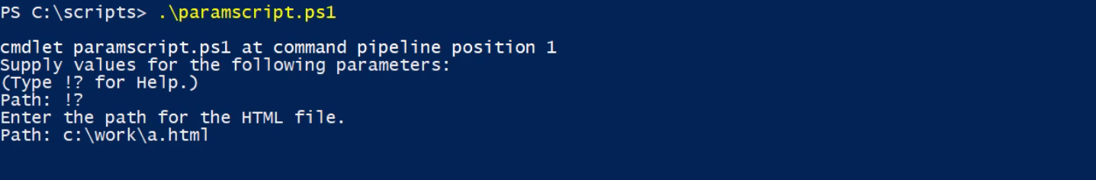

Since we made the $Path parameter mandatory, PowerShell asks for it. To see the help for the parameter, !? is used.

**Best Practices for making script:**

1. Parameterize to avoid hard coding.
2. No hard-coded passwords and credentials
3. Don’t use aliases. (for cross-platform and make it easy to understand)
4. Format your code. (**VS Code** also has option to remove aliases.)

If (<some condition is true>) {

<do something>

}

ElseIf ((<some other condition is true>) {

<do something else if this is true>

}

Else {

<do something else if it isn’t true>

}

NOTE: you can include as many elseIf you need, but PowerShell only runs the one which is matched. Once a condition is matched, it will not check other conditions. Final else is optional.

|  |  |
| --- | --- |
| **Foreach-Object Cmdlet** | **Foreach Enumeration** |
| 1. This is a cmdlet. 2. This command has an alias of Foreach which is the same as the Foreach keyword. However, PowerShell can tell based upon a context of ow you are using ForEach. 3. 2,5,6,8,9 | ForEach {$_ * 3} --PowerShell will treat this foreach as a foreach cmdlet. 4. It passes object back to the pipeline. | 1. This is a keyword. 2. Foreach something in a group of things, run these commands.   $n = 1..10  Foreach ($item in $n) {  $file = “TestFile-$item.txt”  New-Item $file  }   1. It does not pass objects to the pipeline. |
|  |  |

**Arrays:** collection of things. Created automatically by PowerShell.

To declare it, *@ symbol is used.*

$arr = @() --*typically, the things in the array are the same type of objects but are not required.* ***Creates an empty array.***

***$arr += 100 --adds an item to the array.***

***NOTE:*** *you can’t remove individual items from an array. You can recreate your array with the filtered items.*

***PowerShell treats any comma separated items as an array.***

***PowerShell automatically unrolls the array. You can reference individual items of an array through index.*** *All array starts with index 0. Use -1 to start at the end.*

*$n = 1..5 --$n is an array of numbers. The ‘..’ is the range operator.*

*$s = Get-service -- $s is now an array of service object.*

$b = “jeff”,”Jason”,”don”,”tim”,”adam” --$b is an array of names.

***$b -is [array]*** --Test if something is an array. We can also use the count property to see if it has more than one object.

**Hashtable:** collection of key/value pair. Also known as dictionary object. Used very extensively in PowerShell.

**Syntax: @{Key = Value}**

$hash= @{Name=”jeff”} --the key here is Name and the value id jeff. Separate multipleentries with semicolon if they are in one line. Or type each key value pair in new line. *The keys in the hashtable need to be unique.*

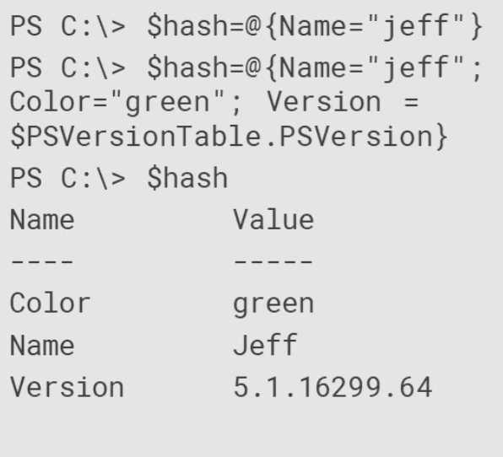

The second line $hash has multiple key value pair. When PowerShell unrolls the hashtable, it displays entries in an undetermined order and not in the same order in which it were passed. ***We can get around that though.***

$hash.Add(“foo”, 1) --adds new element into the hashtable.

$hash.color = “red” -- modifies the value of the color key.

**To have ordered hastable: PowerShell will now display the entries in which they have been entered.**

$h = [ordered]@{

Name = ‘jeff’

Color= ‘green’

Version = $psversiontable.psversion

}

**Using PowerShell hashtable as Splatting.**

Splatting is a concept where we define a hashtable of parameter names and values for a given cmdlet. We can then Splat that hashtable to the command. so instead of passing 5 parameters to the cmdlet regularly, we can create a hashtable of the pramaeters and then splat it in the cmdlet using the @ symbol. *Note the keys must match the parameter of the cmdlet.*

*$params = @{*

*ComputerName = ‘Server01’*

*ClassName = ‘win32_logicaldisk’*

*Filter = “deviceid=’C:’”*

*Verbose = $true*

*}*

*Get-CimInstance @params*

***The best thing about using hashtable is that we can change it on the fly. We can add or move key value pairs or change the values of the keys in the hashtable.***

*Select-Object -- selecting the object in the pipeline with just the properties you need.*

*New-Object --creating a new object in the pipeline*

*[psCustomObject] --creates a custom object with this type accelerator.*

Also with the Select-Object we can create custom properties with hashtable on the fly. The hashtable in this case has a two key value pairs where are keys are hard-coded. These keys can only be Name and Expression.

Dir c:\work -file | Select-Object Name, LatWriteTime,

@{Name=”Size”; Expression={$_.Length}},

@{Name=”Age”; Expression={(Get-Date) - $_.lastWriteTime}} | Sort Age -Descending | Select-Object -first 10

*Note that in the Sort we are using the Age which is the custom property created on the fly. Let’s take a look at the another example.*

*$f = dir c:\work -file*

*$n = Get-Date*

*Foreach ($file in $f) {*

*$h=@{*

*Name = $file.name*

*Modified = $file.LastWriteTime*

*Size = $file.length*

*Age= $n - $file.lastWriteTime*

*}*

*New-Object psObject -Property $h*

*}*

Another way to achieve this is:

Dir c:\work -file | Foreach-Object {

*[pscustomobject]@{*

*Name = $_.name*

*Modified = $_.LastWriteTime*

Size = $_.length

Age = (Get-Date) - $_.LastWriteTime

*}*

}

**Using the try-catch block:** use this for error handling. We write the terminating exception command in the try block. We create a terminating exception by *including the ErrorAction parameter and setting its value to Stop. This tells PowerShell, if an error happens when trying to run this code, stop the pipeline, throw the exception, and then the exception object is tossed to the Catch block. In the catch block, we can use the $_ to reference the exception object itself.*

*There is an optional Finally block that will run regardless of error.*

*$computername = “foo”*

*Try {*

*Get-Service bits -computername $computername -ErrorAction Stop*

*}*

*Catch {*

*Write-Warning “Failed to get service from $computername. $($_.exception.message)”*

*}*

*------------------------------------------*----

**Multiline string in PowerShell:**

Use herestring to have multiline string in PowerShell.

**Syntax: @”<multiline content>”@**

$header = @”

Disk History Report $((Get-Date).ToShortDatetring())

******************************************

Data Source = $Path

******************

Latest Check

**********

”@

**PowerShell Fun:**

$s = “PowerShell rocks!”

$s | Get-Member --shows all the methods and properties that are available for this string variable.

$s.TOUpper() -- converts the string into uppercase but does not change the value of the $s variable.

$s | get-member substring -- gives the details of the substring method on the string variable $s.

***$s.substring.OverloadDefinitions*** --this will show all the different ways that PowerShell can use this particular method.

***$s.***Replace(“e”,”3”) --replaces all the e’s in the string with 3. This method is case sensitive. E does not mean E.

***$name = $s.***Replace(“p”,”P”).Replace(“s”,”S”) --this is also possible as the first replace method still writes the string to the pipeline.

**------------------------------------**

$t = ‘a,b,c,d,e,f,g’ --this seems like it will create an array of letters. But note carefully the single quotes. It makes the entire thing a single string.

$split = $t.Split(“,”) --this will split the string $t with comma(,) and now the $split variable will be array of string.

***Creating a random password:***

**$alpha =** ‘a,b,c,d,e,f,g,h,i,j,k,l,m,n,o,p,q,r,s,t,u,v,w,x,y,z’

**$num= 0..9**

**$char=**’!,),@,(,/,*,$,&,^,%,[,],>,<’

**$arr =** @() --initialising an empty array

**$arr +=** $alpha.Split(“,”) | Get-Random -count 5 --splitting the $alpha with comma to convert it into an array and then getting the random 5 alphabets and assigning it to the $arr array variable.

**$arr[0].ToUpper()**

**$arr[-1].ToUpper()**

**$arr +=** $num | Get-Random -count 2

**$arr +=** $char.Split(“,”) | Get-Random -count 3

*Since still the $arr is an array and for the password, we need a string, we need to convert the array to string.*

*($arr | Get-Random -Count $arr.count) -join “”* --here we are converting the array to string by joining it to the double quotes. Before that we are again randomising the array contents by making the count equal to the array count.

**Working with Dates:**

$now = Get-Date --gets the current datetime and assigns it to the now variable.

$now | Get-Member | more --Lists all the methods available for datetime object.

TypeName: System.DateTime

Name MemberType Definition

---- ---------- ----------

Add Method datetime Add(timespan value)

AddDays Method datetime AddDays(double value)

AddHours Method datetime AddHours(double value)

AddMilliseconds Method datetime AddMilliseconds(double value)

AddMinutes Method datetime AddMinutes(double value)

AddMonths Method datetime AddMonths(int months)

AddSeconds Method datetime AddSeconds(double value)

AddTicks Method datetime AddTicks(long value)

AddYears Method datetime AddYears(int value)

CompareTo Method int CompareTo(System.Object value), int CompareTo(d...

Equals Method bool Equals(System.Object value), bool Equals(datet...

GetDateTimeFormats Method string[] GetDateTimeFormats(), string[] GetDateTime...

GetHashCode Method int GetHashCode()

GetObjectData Method void ISerializable.GetObjectData(System.Runtime.Ser...

GetType Method type GetType()

GetTypeCode Method System.TypeCode GetTypeCode(), System.TypeCode ICon...

IsDaylightSavingTime Method bool IsDaylightSavingTime()

Subtract Method timespan Subtract(datetime value), datetime Subtrac...

ToBinary Method long ToBinary()

ToBoolean Method bool IConvertible.ToBoolean(System.IFormatProvider ...

ToByte Method byte IConvertible.ToByte(System.IFormatProvider pro...

ToChar Method char IConvertible.ToChar(System.IFormatProvider pro...

ToDateTime Method datetime IConvertible.ToDateTime(System.IFormatProv...

ToDecimal Method decimal IConvertible.ToDecimal(System.IFormatProvid...

ToDouble Method double IConvertible.ToDouble(System.IFormatProvider...

ToFileTime Method long ToFileTime()

ToFileTimeUtc Method long ToFileTimeUtc()

ToInt16 Method int16 IConvertible.ToInt16(System.IFormatProvider p...

ToInt32 Method int IConvertible.ToInt32(System.IFormatProvider pro...

ToInt64 Method long IConvertible.ToInt64(System.IFormatProvider pr...

ToLocalTime Method datetime ToLocalTime()

ToLongDateString Method string ToLongDateString()

ToLongTimeString Method string ToLongTimeString()

ToOADate Method double ToOADate()

ToSByte Method sbyte IConvertible.ToSByte(System.IFormatProvider p...

ToShortDateString Method string ToShortDateString()

ToShortTimeString Method string ToShortTimeString()

ToSingle Method float IConvertible.ToSingle(System.IFormatProvider ...

ToString Method string ToString(), string ToString(string format), ...

ToType Method System.Object IConvertible.ToType(type conversionTy...

ToUInt16 Method uint16 IConvertible.ToUInt16(System.IFormatProvider...

ToUInt32 Method uint32 IConvertible.ToUInt32(System.IFormatProvider...

ToUInt64 Method uint64 IConvertible.ToUInt64(System.IFormatProvider...

ToUniversalTime Method datetime ToUniversalTime()

DisplayHint NoteProperty DisplayHintType DisplayHint=DateTime

Date Property datetime Date {get;}

Day Property int Day {get;}

DayOfWeek Property System.DayOfWeek DayOfWeek {get;}

DayOfYear Property int DayOfYear {get;}

Hour Property int Hour {get;}

Kind Property System.DateTimeKind Kind {get;}

Millisecond Property int Millisecond {get;}

Minute Property int Minute {get;}

Month Property int Month {get;}

Second Property int Second {get;}

Ticks Property long Ticks {get;}

TimeOfDay Property timespan TimeOfDay {get;}

Year Property int Year {get;}

DateTime ScriptProperty System.Object DateTime {get=if ((& { Set-StrictMode...

$now | select * --Retruns all the properties a datetime variable has.

DisplayHint : DateTime

DateTime : 09 February 2019 20:36:54

Date : 09-02-2019 00:00:00

Day : 9

DayOfWeek : Saturday

DayOfYear : 40

Hour : 20

Kind : Local

Millisecond : 766

Minute : 36

Month : 2

Second : 54

Ticks : 636853414147663783

TimeOfDay : 20:36:54.7663783

Year : 2019

$now.ToShortDateString()

09-02-2019

$now.ToShortTimeString()

20:36

$now.ToUniversalTime()

09 February 2019 15:06:54

Get-Date -Format ddMMyyyy

Get-Date -Format ddMMyyyy_hhmmss

$now.AddDays(42)

$now.AddHours(500)

$now.AddDays(-60) #Get Date Backwards

"6/1/2018 9:10am" -as [datetime] #converts a string to date

Get-Date "6/1/2018 9:10am" #converts a string to date

$cutoff = (Get-Date).AddDays(-180).Date #Strips off the time part from the date

#usage

dir \\srv\public -File | Where { $_.LastWriteTime -le $cutoff }

-------------------------------------------------------------------------------------

**Working with the math class:**

The dotnet framework has a math class that we can use in PowerShell.

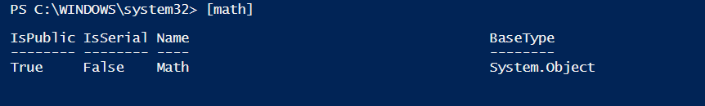

Within this class, there are a number of static methods and propertices/fields that we can work within poershell to do mathematical operations. We don’t have any cmdlets to do these in PowerShell.

[math].GetMembers() | Select Name,MemberType -unique | Sort MemberType,Name

Name MemberType

---- ----------

E Field

PI Field

Abs Method

Acos Method

Asin Method

Atan Method

Atan2 Method

BigMul Method

Ceiling Method

Cos Method

Cosh Method

DivRem Method

Equals Method

Exp Method

Floor Method

GetHashCode Method

GetType Method

IEEERemainder Method

Log Method

Log10 Method

Max Method

Min Method

Pow Method

Round Method

Sign Method

Sin Method

Sinh Method

Sqrt Method

Tan Method

Tanh Method

ToString Method

Truncate Method

To Invoke any of these method or properties, we need to use the static operator which is :: (*double colon)*  in PowerShell.

PS C:\WINDOWS\system32> [math]::PI

3.14159265358979

PS C:\WINDOWS\system32> [math]::E

2.71828182845905

PS C:\WINDOWS\system32> [math]::pow.OverloadDefinitions

static double Pow(double x, double y)

PS C:\WINDOWS\system32> [math]::pow(3,2)

9

PS C:\WINDOWS\system32> [math]::Sqrt(144)

12

PS C:\WINDOWS\system32> $n = 1234.5678

PS C:\WINDOWS\system32> [math]::Truncate($n)

1234

PS C:\WINDOWS\system32> [math]::Round($n,2)

1234.57

PS C:\WINDOWS\system32> $n -as [int] #Round and truncates the number

1235

Real world usage can be like below.

PS C:\WINDOWS\system32> dir $env:temp -file -recurse | Measure-Object Length -Sum | Select Count,@{Name="SumMB"; Expression={[math]::Round($_.sum/ 1MB, 3)}}

Count SumMB

----- -----

252 176.97

PS C:\WINDOWS\system32> Get-CimInstance -ClassName win32_operatingsystem | Select *memory*

FreePhysicalMemory : 3607768

FreeVirtualMemory : 6686984

MaxProcessMemorySize : 137438953344

TotalVirtualMemorySize : 15052936

TotalVisibleMemorySize : 8303524

PS C:\WINDOWS\system32> Get-CimInstance -ClassName win32_operatingsystem -ComputerName $env:COMPUTERNAME | Select PSComputerName, @{Name="TotalMemoryGB";Expression={$_.totalvisiblememorysize / 1MB -as [int]}},@{Name="FreeMemoryGB";Expression={[math]::round(($_.freephysicalmemory / 1MB),4)}},@{Name="PctFreeMemory";Expression={[math]::round(($_.freephysicalmemory / $_.totalvisiblememorysize) * 100, 2)}}

PSComputerName TotalMemoryGB FreeMemoryGB PctFreeMemory

-------------- ------------- ------------ -------------

HEMANT 8 3.3769 42.64

-----------------------------------------------------------------------------------

***We can use dotnet framework to access com objects like we used to use with vbscript.***

PS C:\WINDOWS\system32> $wsh = new-object -ComObject wscript.shell

PS C:\WINDOWS\system32> $wsh.Popup.OverloadDefinitions

int Popup (string, Variant, Variant, Variant)

PS C:\WINDOWS\system32> $wsh.Popup("Isn't thsi Fun!",10,"PowerShell Automation",0+64)

-1

PS C:\WINDOWS\system32> $wsh.Popup("Isn't thsi Fun!",10,"PowerShell Automation",0+64)

1

The first parameter is the message

Second parameter is the seconds to wait for the user to hit a button. If user does not hit the button then the result is -1 else it is 1.

The third parameter is the title

The fourth parameter is the combination of icon values and button values.

$wsh.Popup("Failed to do something. Do you want to try again?", -1,"Script Error",4+32)

The -1 seconds means that the popup will wait for the user to do something to it.

4+32 is the combination of yes and no buttons in the popup. Yes will result to 6 and No will result to 7 as the output.

Window title can also be accessed through PowerShell

$Host.UI.RawUI.WindowTitle

PS C:\WINDOWS\system32> $Host.UI.RawUI.WindowTitle

Administrator: Windows PowerShell ISE

**Using the title bar as a progress bar:**

$saved = $Host.UI.RawUI.WindowTitle

"dom1","srv1","srv2","win10" | ForEach-Object {

$Host.UI.RawUI.WindowTitle = "Querying uptime from $($_.ToUpper())"

Start-Sleep -Seconds 2

Get-CimInstance Win32_OperatingSystem -ComputerName $_ |

Select PSComputerName, LastBootUpTime,

@{Name="Uptime";Expression={(Get-Date) - $_.LastBootupTime}}

}

$Host.UI.RawUI.WindowTitle = $saved

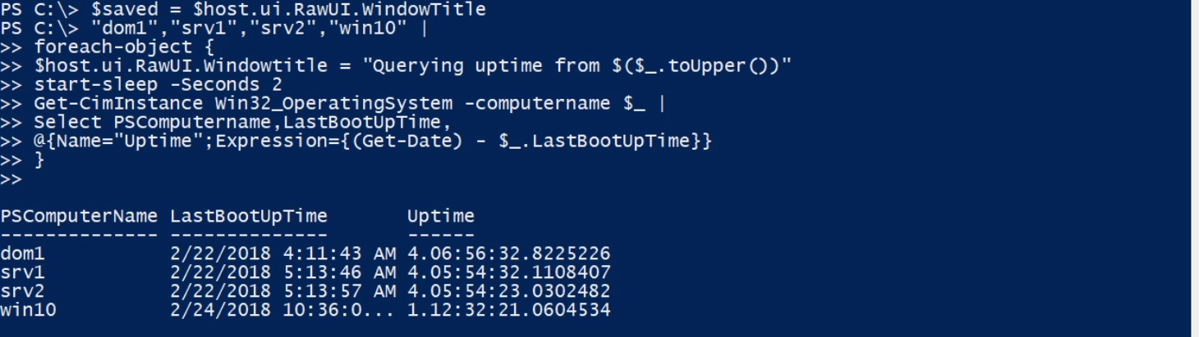

Sometimes when we run a cmdlet in PowerShell without specifying the parameters, if the cmdlet has any mandatory parameter, it will ask for it. One thing we can do is we can create a PSDefaultParameterValues hashtable. This is the built in hashtable in PowerShell and we can add to it the key value pair of the parameter of the cmdlet we want to have a default value. *For example, the logname parameter of the Get-EventLog cmdlet is mandatory and this is how we can give this parameter a default value and then add this to the psdefaultParameterValues inbuilt hastable of the PowerShell.*

$PSDefaultParameterValues.Add(“get-eventlog:logname”,”system”) --this will assign system as the value of the logname parameter, everytime the Get-EventLog cmdlet is ran.

$PSDefaultParameterValues.Add(“Get-CimInstance:verbose”,”$true”)

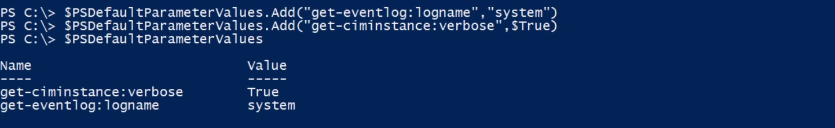

To remove an entry from the defaults

$PSDefaultParameterValues.Remove(“Get-CimInstance:verbose”,”$true”)

$PSDefaultParameterValues.Clear() --clears the hashtable and removes all the deafault values from it.

***Here is the script example that uses all the above concepts to create a new AD user.***

#create a temporary user in Active Directory

#This requires the ActiveDirectory PowerShell module from RSAT

Param(

[Parameter(Mandatory, HelpMessage = "Enter the user name like 'Al Fredo'")]

[String]$Name,

[string]$Title,

[string]$Description,

[string]$Department

)

Write-Host "Creating temporary AD Account for $Name." -ForegroundColor Cyan

#split the name into first and last name

$first = $name.split(' ')[0]

$last = $name.split(' ')[1]

#create the samaccountname

if ($last.Length -gt 13) {

$accountname = "$($first[0])$($last.Substring(0,13))"

}

else {

$accountname = "$($first[0])$last"

}

$upn = "$accountname@company.pri"

#create a password

#use these characters as the source

#no o(scar) or l(arry) characters to avoid confusing with zero and one.

$seed = "abcdefghijkmnpqrstuvwxyz0192837465)!(@*#&$^"

#get 9 random characters

$random9 = $seed.ToCharArray() | get-random -count 9

#join back to a string

$randomstring = $random9 -join ""

#this is a regular expression pattern to match on any character from a to z

[regex]$rx = "[a-z]"

#get the first matching alphabet character

$firstalpha = $rx.match($randomstring).value

#replace the first alphabet character with its upper case version

$plaintext = $randomstring.Replace($firstalpha, $firstalpha.toUpper())

#convert the password to a secure string for the New-ADUser cmdlet

$password = ConvertTo-SecureString -String $plaintext -AsPlainText -Force

#define a hashtable of parameter values to splat to New-ADUser

$new = @{

DisplayName = $Name

GivenName = $first

Surname = $last

Name = $accountName

samaccountname = $accountName

UserPrincipalName = $upn

enabled = $True

AccountExpirationDate = (Get-Date).AddDays(180).Date

AccountPassword = $password

path = "OU=Employees,DC=company,DC=pri"

Title = $Title

Department = $Department

Description = $Description

ErrorAction = "Stop"

}

Try {

New-ADUser @new

Write-Host "Created user $accountname that expires $($new.AccountExpirationDate). Password is $plaintext." -ForegroundColor Green

}

Catch {

$wsh = new-object -com wscript.shell

$msg = "Failed to create user $Name. $($_.exception.message)"

#display a popup warning and force user to click ok

$wsh.Popup($msg, -1, "New User", 0 + 48)

}

Finally {

Write-Host "Finished $($myinvocation.MyCommand)" -ForegroundColor Cyan

}

<#

demo usage

$p = @{

Name = "Matilda Fuzziwick"

Title = "Shipping Clerk"

Department = "Sales"

Description = "Seasonal hire"

}

.\Create-newADUser.ps1 @p

get-aduser mfuzziwick -Properties title,department,description

#try to create the user again

#reset demo

get-aduser mfuzziwick | remove-aduser -confirm:$false

#>

--------------------------------------------------------------------

**Walkthrough – Creating a controller script:**

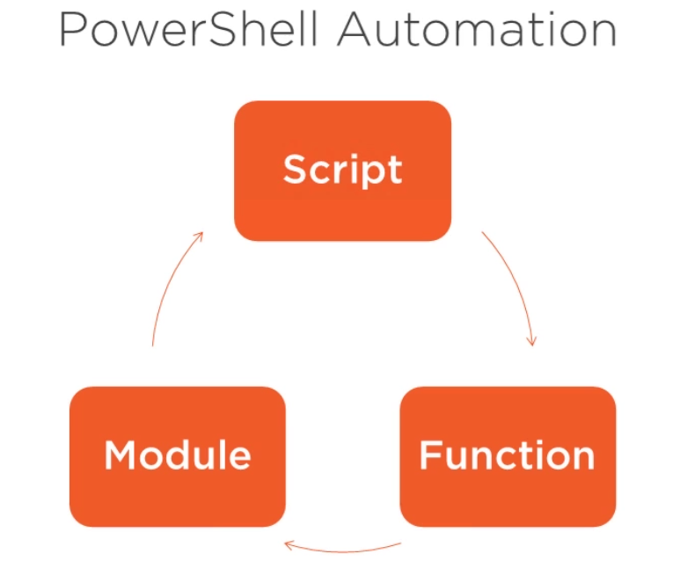

A PowerShell controller script is one that orchestrates or runs other PowerShell commands, functions and scripts.

PSEdit <path of the ps1 filename>--to open it in the PowerShell ise.

Read:

1. Help About_scripts
2. Help about_scriptingHelp
3. Help about_scripting_best_practices
4. Help about_do
5. Help about_while
6. Help about_for
7. Help about_switch
8. Help about_*operators
9. Wth PowerShell functions you will be able to build your own PowerShell tools and then these tools are packaged into modules.
10. Create graphical PowerShell tools with wpf.with this we can put GUI which wil have PowerShell under the hood.
11. Learn about DSC.
12. Learn about Workflows.

Courses to look upon: In Pluralsight

1. Play by Play: PowerShell from idea to Action
2. Building advanced PowerShell Functions and Modules.
3. PowerShell Toolmaking fundamentals

**PowerShell Gotchas:**

***Gotcha 1: Tilda (~)***

Get-Item ~ --returns the C:\Users\Hesh folder. This happens to be my home folder on this machine. This means that we can use Tilda in the path parameter of the cmdlets to quickly reference this folder. For example,

Cd ~/documents

The value of tilde depends on where I am working inside of the poewrshell shell.

Let set our current location to hkcu:

PS C:\> Cd hkcu:

PS HKCU:\> Get-Item ~

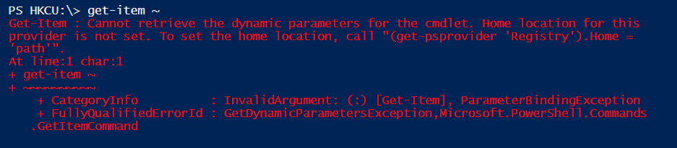

Here tilde gives an error saying *home location for the provider is not set.* Which provider? PowerShell allows you to have different types of drive inside of your session. The C:\ and D:\ drives are parts of the **FileSystem** and the HKLM and HKCU represebts the parts of the **Registry**.to PowerShell these both represents the hierarchy of items that we can interact with using standard item cmdlets like nre-item, get-item etc. In order to support these item operations, PowerShell uses entities called providers. So C:\ and D:\ drives are backed by the Filesystem Provider and the HKCU and HKLM are backed by the Registry Provider.

Providers allow operations to execute between drives. We can copy or move an item from D:\ to C:\ let’s say. However, it is not possible to execute item operations between two providers. This is why when we are in the HKCU drive, tilde does not work as for it to work, it needs to be backed up by the filesystem provider and our called for the tilde is backing up by the registry provider.

This also means that we cannot perform copy or move operation from C:\ to say HKCU: drive.

Every provider has a single path that it considers home. This path is represented by tilde (~). The value of tilde can never be the same between two providers.

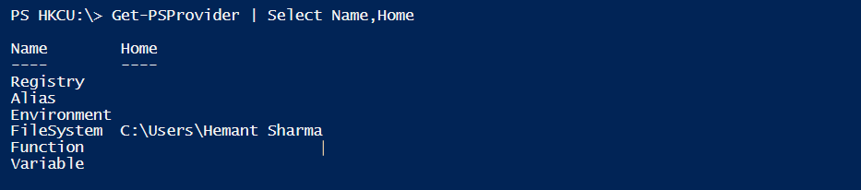

We can see here that the filesystem provider is the only provider that ships with PowerShell that provides any value for this home concept.

We can but set the home location for a provider.

(Get-PSProvider “Registry”).Home = “HKCU:\Software”

This assigns the software folder to be the home location for the registry provider.

**NOTE:** it is a recommendation to not use tilde in the scripts.

$home --a variable defined by the PowerShell always points to the current user home directory. It is the functional equivalent of tilde on linux. Also *$home never changes irrespective of where you are in the shell.*

$home is the concatenation of the $env:HOMEDRIVE + $env:HOMEPATH.

Another way to do it is [environment]::getFoldrePath(“myDocuments”); --getFolderPath is a static method. In response, this method returns the location of the documents folder for the current user.

[environment]::getFoldrePath(“history”); --this returns the path of the special folder history.

To get the list of all the special folder

[enum]::getNames([system.Environment+specialFolder])

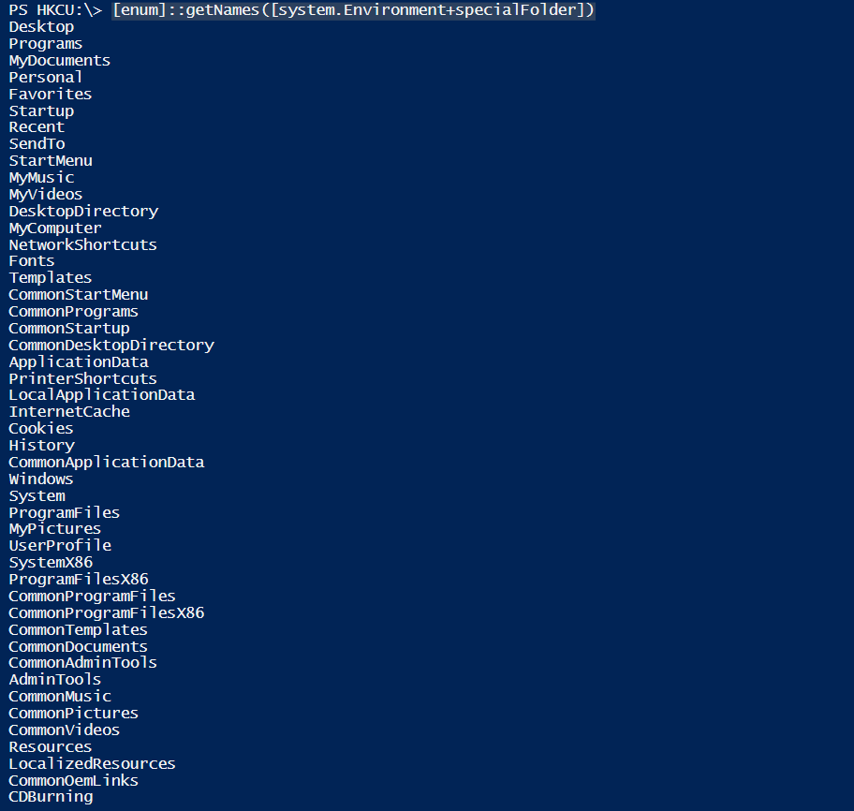

So use the $home or the static Method [Environment]::getFolderPath() in the scripts.

***Gotcha 2: Current Location vs Current Directory***

Get-location returns the current location. **$pwd** also does the same.

“$pwd/documents” is equivalent to cd ./documents or cd documents.

Set-Location ./documents --allows you to modify the current location by specifying a new path.

**Current Location is:** C:\Users\Hesh\documents

New-Item -Path sample.txt -type file -value “Hello sample file” --PowerShell will create a sample.txt file in your current location.

Another way to do it is using the static method on the Net library.

[io.file]::WriteAlltext(“sample2.txt”,”Hello sample 2”) --*if we do the dir to list all the files we will not see the sample2 file in the current location. So where does the file go?*

**PowerShell is nothing more than a Windows Process. Every windows process maintains its own notion of a Current Directory.**

With the PowerShell cmdlet New-Item, we specified a relative path sample.txt and PowerShell combined that path with the current location and resolve it to create the file in the current location. At this point, windows process has the complete path to work with due to the PowerShell layer.

When we invoked the static method on the .Net framework directly and provided the relative path of sample2.txt, the PowerShell layer isn’t really involved except for passing the arguments to .Net. .Net and by extension Windows api are given the relative path sample2.txt. In order to resolve this path, windows combines the relative path with the current directory and produces a different result. The current directory is **C:\Users\Hesh**. Hence it creates the file in the C:\Windows\System32 folder and not in the documents folder.

In a nutshell, PowerShell resolves the path based on the current location whereas windows process resolves it on the current directory.

[environment]::CurrentDirectory --gives the path of the Current directory.



It is possible that the PowerShell current location may be different from the windows current directory.

How can we get the current directory for the process to follow the current filesystem location of PowerShell?

Every time PowerShell needs to write the prompt, it calls the magic function name prompt to retrieve the string that is supposed to display. We can also call this function and PowerShell will return the string it will display. *We can change the prompt function to return the string we want and also we can modify the prompt function to execute other logic as well.*

Function prompt (

$currdir = Get-Location -PSProvider Filesystem | Select-Object -Expand Path

[Environment]::CurrentDirectory = $currdir

“PS $pwd> ”

)

Now every time, I move around in the shell, current location and current directory will be the same.now any process, or shell or any command line that bypasses the PowerShell layer will use the appropriate location to save the files.

**NOTE:** this technique to change the promt function works well in the local machine but while writing a script that relies on the current directory changing with the current location can lead into ambiguity and errors.

***Gotcha 3: Expressing yourself in an argument.***

1+1 | Out-File ./data.txt -- the content of the file will have 2.

Out-file ./data.txt -InputObject 1+1 --now the content of the file will be 1+1. Here PowerShell instead of evaluating the expression and then writing, wrote the expression itself to the out-file.

**Why?**

The reason is that in case of using the pipeline,we got 2 as the output from the PowerShell which serves as the input for the Out-File cmdlet. In the other case the input to the inputObject is 1+1 and hence the behaviour. The input is passed as the string to the Out-File cmdlet in the second case.

To rectify it, we can surround the expression with parenthethis. This tells PowerShell to evaluate the expression first before writing it to the file

Out-File ./data.txt -InputObject (1+1) --the content of the file now be 2.

*An argument to the cmdlet is no way to express yourself. PowerShell executes the pipeline from left to right. And by the time it is going to process arguments, it’s done processing the expression. The include the expression as an argument value, use the small parenthethis to tell the PowerShell explicitly.*

***Gotcha 4: Return all the things:***

Function get-numbers {

1

2

3

Return 4

5

}

The output when we call the function will be

1

2

3

4

**<cmdlet> | clip -- this will copy the output to the clipboard.**

Remember: any code that executes inside of PowerShell does so as part of the pipeline. So when we call get-numbers, we are actually creating a pipeline, even if the get-numbers is the only command gets executed inside of the pipeline. This logic also applies to every statement of the get-numbers function. That is each statement insode of the function constitutes its own standalone pipeline.

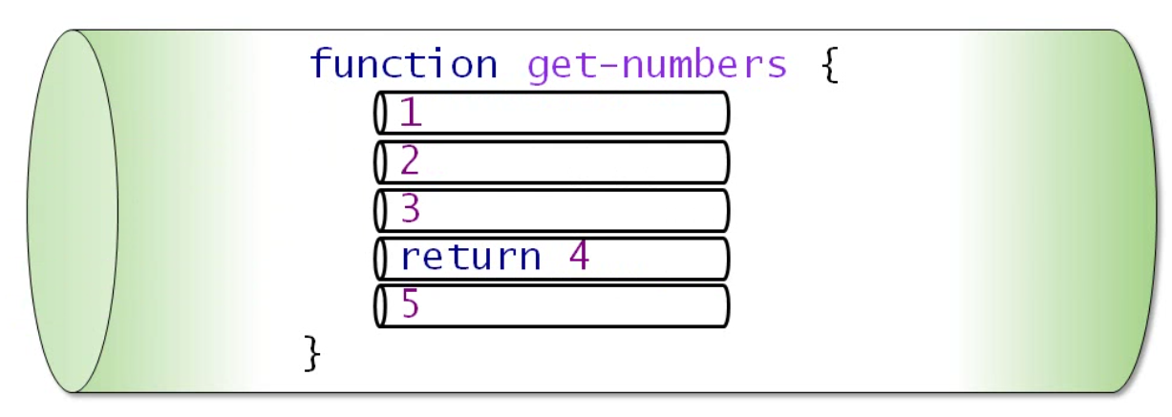

Now when get-numbers functions is executed in the pipeline, each pipeline defined in the get-numbers function is executed and the values that they output are included in the output of the get-numbers function. Now when the execution reaches the return statement, execution passes to the next cmdlet in the pipe, if any which leads our value 5 left alone.

**Errent Output can cause problem:**

function backup-Project {

push-location $home

mkdir backups -force

Write-Zip ./documents/projects “./backups/mybackup$((Get-Dtae).ticks).zip”

Pop-Location

}

What will be the output of this function?

Thw Write-Zip cmdlet of the PSCX module writes a fileinfo object into the pipeline. But when we run the function we can see that the output of the function also writes the backup directory to the pipeline.

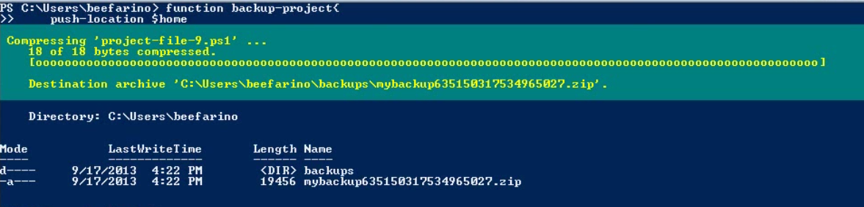

Since everything in PowerShell executes as a part of the pipeline, so when we create a backup directory as a part of function, it too executes in its own pipeline. The result of this command produces a reference to the backup folder. Since this result is never consumed as part of the pipeline, PowerShell assumes that we want it as output.

How do we prevent this output to pollute the pipeline. We can use the **Out-Null** cmdlet.

function backup-Project {

push-location $home

mkdir backups -force | Out-Null

Write-Zip ./documents/projects “./backups/mybackup$((Get-Dtae).ticks).zip”

Pop-Location

}

Another way to prevent it is that if we want to use the results of the pipeline but don’t want it to appear as part of the output, we can store the result into a variable.

***Gotcha 5: Iterating Nothing:***

Lets declare $a I PowerShell. This variable has nothing in it. So when we iterate this using foreach statement, the result is nothing.

Foreach ($item in $a) {“iteration”} --outputs nothing.

But when we iterate it using Foreach-Object cmdlet, it outputs the single value.

$a | Foreach-Object { “iteration” } --output is iteration.

Foreach statement checks for the value of $a variable and since it has nothing, the output is also nothing.

When we execute using the Foreach-Object cmdlet using the pipe, we know that pipeline executes from left to right. PowerShell has no construct to define the undefined variable, the closest equivalent to it is $null. So in case of foreach-object, the pipeline evaluates $a to $null. $null in PowerShell isn’t exactly undefined. It has a value inside of PowerShell, even though it represents nothing. So powersheell in case of second example sends $null down the pipeline. Sinc $null is a single value, the foreach-object expression evaluates single time.

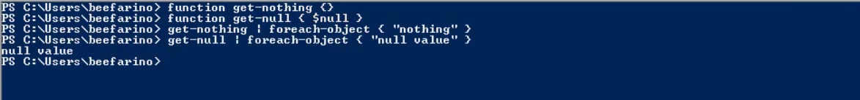

PowerShell also allows us to run strict mode. To set the PowerShell to strict mode

Set-strictmode -version latest

With strictmode enabled, we cannot reference undefined variable. So $a declared without a value cannot be referenced now.

See help set-strictmode -full --for all the best practices that comes with it.

Remember: $null is a value and can be pipelined.

***Gotcha 6: Foreign Dialects:***

Suppose we want to get all filenames and rename it such that the digits comes first followed by a – and then the characters.

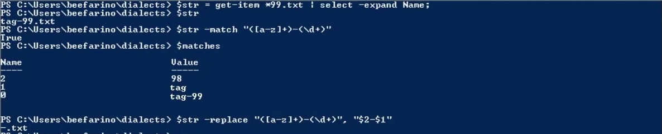

**$matches** is an automatic variable in PowerShell that tells the matched values. Like in this, the first matched value is tag and the 2nd is 98 of the file tag-99.txt

But when we try to use this with replace, it almost returns a filename with nothing.

The first string is the regex pattern that we are using to match the filename and the 2nd string is the replacement expression which contains these $2, $1 placeolders that matches the group we have identified inside of the regular expression.

What’s wrong with this?

The first layer of to interpret string is PowerShell. In the case of regular expression, the string does not contain any magical characters that would be interpolated. In this case, PowerShell will leave the string alone. But the $2 and $1 included inside of the replacement string are meant to be interpreted by .Net regular expression engine, but PowerShell sees it first. When PowerShell sess $<something>, it sees you are referencing some kind of variable. *And since inside of PowerShell the $1 and $2 variables aren’t defined and have no value. By the time it reaches the >net regular expression library, they have no hope on operating the way we except.*

We can have different type of string in PowerShell like, sql query, wmi query, regex, LDAP url and each of these targets a very unique layer of technology like SQL server, WMI,.Net, Active Directory respectively. PowerShell sits in the between. So PowerShell will always get first crack in interpreting the string before it reaches the respective technology.

$a = 1

“$a is 1” --this replaces the value of the $a at the time of computing this line. This is called interpolating a string.

**PowerShell also has a way to use non-interpolating strings with the help of single quotes.** Non-interpolated strings are not processed by PowerShell and instead are taken at their value

‘$a is 1’ --a non-interpolated string. Output is -> $a is 1

*So if we ran our replacement command with the non-interpolated string mechanism, PowerShell won’t replace the varables and we will have the output as we expect.*

$str -replace ‘([a-z]+)-(\d+)’,’$2-$1’ -- output is -> 99-tag.txt

**Another way is to use the escape character. In PowerShell the escape character is a backtick that will escape any special character.**

*“`$a is 1” --by escaping the $ sign, PowerShell will not interpret $a as a variable placeholder and instead replace it with $ sign in the actual output. This way the $a variable will go to the respective technology for interpretation.*

$str -replace “([a-z]+)-(\d+)”,”`$2-`$1” -- output is -> 99-tag.txt

----------------------------------

Another example: LDAP Url

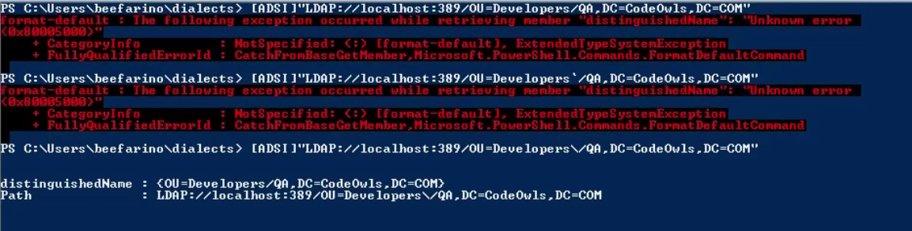

The forward slash in “...OU=Developers/QA...” is illegal for the Active directory search interface and thus we get the error.

Also since the string is in double quotes, it is an interpolated string for PowerShell. But we do not have any variable inside the string to be interpolated so PowerShell passes the string as it is to the ADSI for interpretation which causes a format exception due to the presence of the forward slash.

In the 2nd time, we are using the PowerShell escape character backtick to escape the forward slash which then passes the exact same string to interpret by the ADSI and hence the same error.

*The key thing here is to escape the forward slash according to the ADSI and to do that, we need to use the backslah escape character used in Active Directory.*

***Gotcha 7: Interpolating Scope***

**PowerShell version 3 has this gotcha already fixed.**

PowerShell also has global and local scopes.

We can use $global:<variable name> and $local:<variable name> to tag the scopes of the variables to it.

$name = “Paul”

$value = “Singer”

“$name is $value” –works fine

“$name: $value” --throws error in PowerShell 5. This is because the $name before the colon (:) is interpreted as a scope in PowerShell. So PowerShell thinks $name before the colon as a scope tag and since there is no such tag, it throws error.

Also since nothing follows the colon, PowerShell thinks that we are trying to reference a variable that has no name.

*“$($name): $value” -- works fine now.*

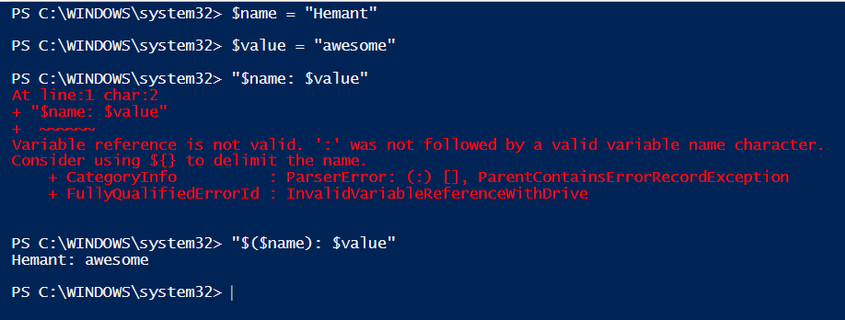

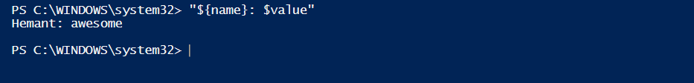

As per the error suggests, using the curly braces around the name of he variable also tells PowerShell that this is a variable name and not a scope tag.

You can also use the scopes inside of the curly braces.

*“${global:name}: $value”*

***Gotcha 8: -or and/or -and***

**How to execute a javascript inside PowerShell**

***Cscript jscript.js -- this executes the javascript file inside of PowerShell as a js file.***

$true -or $true -and $false -- Output in PowerShell is false whereas output of this in other languages like C#,python,javascript,vbscript is true. Ironically, the bash shell of linux results in false.

PowerShell behaves this way due to operator precedence.

For operators that have the same level of precedence, PowerShell evaluates the operators from left to right.

-and -r -xor -> all these three operators in PowerShell has the same level of precedence.

In other languages, the operator precedence is something like -and -> -xor -> or. That is the -and operator has the highest level of precedence.

So one way around it is using the logic as one at a time.

Another way to use parenthesis

$true -or ($true -and $false)

***Gotcha 9: Unequal Equality***

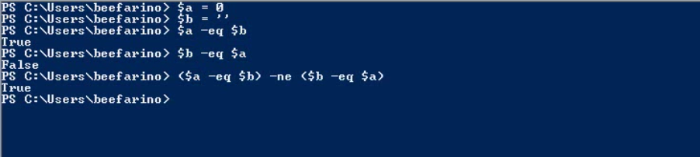

$a -eq $b is true because the $a is Integer and $b is empty string. When evaluating PowerShell converts the $b to an integer and since the value of the string variable is empty, it is converted to an integer value of 0.

You can verify this by using an integer type accelerator.

[int]’’ --output is 0

[convert]::ToInt32($b) --throws an error. We are not able to convert a string value to an integer using .net library. We get an error of ‘input string was not in correct format’

$b -eq $a is false --PowerShell coverts the value of $a variable to a string which a string value 0. And since the empty string ‘’ is not equal to “0”, it results false. *Note: PowerShell always converts the variable that comes second in the comparison expression while evaluating the variables in case of variables that are of different types.*

You can verify that by using

[string]0

**$null when converted to a string is an empty string.**

**$null -eq $null --True**

**$null -eq [string]$null --False**

‘’ -eq [string]$null --True

**PowerShell Toolmaking Fundamentals:**

What is toolmaking?

1. Solve and immediate problem
2. Robust and reuseable
3. Shared with the community

Use semicolon to execute multiple commands at the same time.

$env:ComputerName; dir

*In cmd.exe, we can do the same by using the ampersand*

Hostname && dir

Roadblock for executing a PowerShell script.

1. Execution Policy: PowerShell has a security feature called execution policy which may prevent the execution of the script in PowerShell. It can be set to either of Restricted, All Signed, Remote Signed and Unrestricted. By default, it is set to restricted. This means console commands can run but not scripts.

Get-ExecutionPolicy

Set-ExecutionPolicy Unrestricted 🡪 you have to set it once as it then sets the value into the registry.

**Active Directory Account Management Automator:**

1. Create user and computer accounts
2. Add the user to the groups
3. Reset user passwords.

To get all the modules that are available

Get-Module -ListAvailable

Get-AdComputer -Filter * -- lists all computers from active directory

Get-AdUser -Filter * -- lists all users from active directory

*Active directory Users and computers (ADUC) is a GUI tool for create, update and delete users and computer.*

Standards for creating new AD users: Can be different from company to company

1. it must contain the employee's full first name and last name, middle initial, and title.
2. the username must be the first initial and last name of the employee. If that is taken, then it must be the first initial, middle initial, and last name. If that's taken, it would then have to be looked at manually. Does this kind of scheme sound familiar in your environment?
3. it must be created in a certain OU.
4. it must have a default password that's set to be changed on first login.
5. it must be a member of a company-wide group.

------------------------------------------------------------------

param($FirstName,$MiddleInitial,$LastName,$Location = 'OU=Corporate Users',$Title)

## Not the best use of storing the password clear text

## Google on using stored secure strings on the file system as a way to get around this

$DefaultPassword = 'p@$$w0rd12'

$DomainDn = (Get-AdDomain).DistinguishedName

$DefaultGroup = 'Gigantic Corporation Inter-Intra Synergy Group'

$Username = "$($FirstName.SubString(0,1))$LastName"

## Check if an existing user already has the first intial/last name username taken

try {

if (Get-ADUser $Username) {

## If so, check to see if the first initial/middle initial/last name is taken.

$Username = "$($FirstName.SubString(0,1))$MiddleInitial$LastName"

if (Get-AdUser $Username) {

Write-Warning "No acceptable username schema could be created"

return

}

}

} catch {

}

$NewUserParams = @{

'UserPrincipalName' = $Username

'Name' = $Username

'GivenName' = $FirstName

'Surname' = $LastName

'Title' = $Title

'SamAccountName' = $Username

'AccountPassword' = (ConvertTo-SecureString $DefaultPassword -AsPlainText -Force)

'Enabled' = $true

'Initials' = $MiddleInitial

'Path' = "$Location,$DomainDn"

'ChangePasswordAtLogon' = $true

}

New-AdUser @NewUserParams

Add-ADGroupMember -Identity $DefaultGroup -Members $Username

Creating a computer account:

Standards to be followed:

1. the computer account in Active Directory has to be created ahead of time before the computer is added to the domain because the text that roll them out don't necessarily have permissions to move it into the right OU.
2. the computer account must be created at a standard default OU.

param($Computername, $Location = 'OU=Corporate Computers')

try {

if (Get-AdComputer $Computername) {

Write-Error "The computer name '$Computername' already exists"

return

}

} catch {

}

$DomainDn = (Get-AdDomain).DistinguishedName

$DefaultOuPath = "$Location,$DomainDn"

New-ADComputer -Name $Computername -Path $DefaultOuPath

Active Directory Account Management:

Changing passwords and updating names. For this purpose, to identify the user we might need to give too many parameters and that would make or script cumbersome. The way around it to use the hashtable parameter and then use this parameter to splat against our command. *this is indeed handy as a hastable can contain as many key-value pairs instead of passing parameters one by one.*

param ([string]$Username, [hashtable]$Attributes)

try {

## Attempt to find the username

$UserAccount = Get-AdUser -Identity $Username

if (!$UserAccount) {

## If the username isn't found throw an error and exit

Write-Error "The username '$Username' does not exist"

return

}

} catch {

}

## The $Attributes parameter will contain only the parameters for the Set-AdUser cmdlet other than Password. If this is in $Attributes it needs to be treated differently.

if ($Attributes.ContainsKey('Password')) {

$UserAccount | Set-ADAccountPassword -Reset -NewPassword (ConvertTo-SecureString -AsPlainText $Attributes.Password -Force)

## Remove the password key because we'll be passing this hashtable directly to Set-AdUser later. It will not work with the Set-Aduser cmdlet and thus removing the password attribute

$Attributes.Remove('Password')

}

$UserAccount | Set-AdUser @Attributes

-------------------

Calling the script. Let’s say we call this script Manage-AdUser

.\Manage-AdUser.ps1 -Username rsmith -Attributes @{givenName=’Turdy’,surname=’smithley’}

After running the script, you will notice that the displayname is the same as before. It has not changed. This is because, we have not passed any parameter to change it.

*Along the same lines of user account, domain joined users alspo have attributes that must be changed sometimes. Lets add fnctionality to modify computer accounts as well.*

param ([string]$Computername, [hashtable]$Attributes)

## Attempt to find the Computername

try {

$Computer = Get-AdComputer -Identity $Computername

if (!$Computer) {

## If the Computername isn't found throw an error and exit

Write-Error "The Computername '$Computername' does not exist"

return

}

} catch {

}

## The $Attributes parameter will contain only the parameters for the Set-AdComputer cmdlet

$Computer | Set-AdComputer @Attributes

---------------------------------

Let’s call this script as Manage-AdComputer and call it to manage the computer

.\Manage-AdComputer.ps1 -ComputerName Windows-VM -Attributes @{‘DisplayName’ = ‘my displayname’; ‘Description’= “my description” }

*Building the ToolSet*

All we have done so far is created a bunch of disparate scripts. These scripts must be converted into PowerShell functions so that they’re easily reusable, transferrable.

To do this, we need to create a PowerShell advance functions.

Lets have a look at the Advance Function Shell in PowerShell and what it actually means.

function New-AdvancedFunction {

<#

.SYNOPSIS

.DESCRIPTION

.EXAMPLE

PS> New-AdvancedFunction -Param1 MYPARAM

This example does something to this and that.

.PARAMETER Param1

This param does this thing.

.PARAMETER

.PARAMETER

.PARAMETER

#>

[CmdletBinding()]

param (

[string]$Param1

)

begin {

}

process {

try {

if ($someErrorOccured){

throw “An error occurred.”

}

}

catch {

Write-Error "$($_.Exception.Message) - Line Number: $($_.InvocationInfo.ScriptLineNumber)"

}

}

end {

}

}

1. the first thing is the function block. This is how every function in PowerShell is defined. This tells PowerShell that all the code inside of this block is meant to be a part of the PowerShell function.
2. All the comments. This is used for help related to script/function. This is how we can create our own help for the cmdlets we are creating. This comes handy when we look for help in PowerShell shell for the cmdlet. *Comments are not necessarily required for our function to work but it comes handy for other people who are using our cmdlets.*
3. Cmdlet binding line. [CmdletBinding()]. This line is extremely important. This is the line that defines an advanced function. This makes our code to do a lot more things than to execute the code inside of it. You can do Verbose, loggings, warnings etc.
4. Param block -> this contains all the parameters to run your advance function.
5. Process block -> this is where we are going to place all the code from our script. This is a required block. There are also two other blocks *begin* and *end* which can be placed before or after this block. If you don’t need the begin and the end block. Remove them.
6. Try-Catch Block -> technically, this isn’t required for an advance function but is recommended. Use this block inside of the process block. This block is for error handling

*Let’s now make a AdAccountManagementAutomator toolset.*

This toolset will contain four functions which are designed around a similar object, which is Active Directory.

1. New-EmployeeOnboardUser
2. Manage-AdUser
3. Manage-AdComputer
4. New-EmployeeeOnboardComputer

function New-EmployeeOnboardUser {

<#

.SYNOPSIS

This function is part of the Active Directory Account Management Automator tool. It is used to perform all routine

tasks that must be done when onboarding a new employee user account.

.EXAMPLE

PS> New-EmployeeOnboardUser -FirstName 'adam' -MiddleInitial D -LastName Bertram -Title 'Dr. Awesome'

This example creates an AD username based on company standards into a company-standard OU and adds the user

into the company-standard main user group.

.PARAMETER FirstName

The first name of the employee

.PARAMETER MiddleInitial

The middle initial of the employee

.PARAMETER LastName

The last name of the employee

.PARAMETER Title

The current job title of the employee

#>

[CmdletBinding()]

param (

[string]$Firstname,

[string]$MiddleInitial,

[string]$LastName,

[string]$Location = 'OU=Corporate Users',

[string]$Title

)

process {

## Not the best use of storing the password clear text

## Google/Bing on using stored secure strings on the file system as a way to get around this

$DefaultPassword = 'p@$$w0rd12'

$DomainDn = (Get-AdDomain).DistinguishedName

$DefaultGroup = 'Gigantic Corporation Inter-Intra Synergy Group'

$Username = "$($FirstName.SubString(0, 1))$LastName"

## Check if an existing user already has the first intial/last name username taken

try {

if (Get-ADUser $Username) {

## If so, check to see if the first initial/middle initial/last name is taken.

$Username = "$($FirstName.SubString(0, 1))$MiddleInitial$LastName"

if (Get-AdUser $Username) {

throw "No acceptable username schema could be created"

}

}

} catch {

Write-Error $_.Exception.Message

}

$NewUserParams = @{

'UserPrincipalName' = $Username

'Name' = $Username

'GivenName' = $FirstName

'Surname' = $LastName

'Title' = $Title

'SamAccountName' = $Username

'AccountPassword' = (ConvertTo-SecureString $DefaultPassword -AsPlainText -Force)

'Enabled' = $true

'Initials' = $MiddleInitial

'Path' = "$Location,$DomainDn"

'ChangePasswordAtLogon' = $true

}

New-AdUser @NewUserParams

Add-ADGroupMember $Username $DefaultGroup

$Username #this line will output the username from this function

}

}

function Manage-AdUser {

<#

.SYNOPSIS

This function is part of the Active Directory Account Management Automator tool. It is used to modify

one or more Active Directory attributes on a single Active Directory user account.

.EXAMPLE

PS> Set-MyAdUser -Username adam -Attributes @{'givenName' = 'bob'; 'DisplayName' = 'bobby bertram'; 'Title' = 'manager'}

This example changes the givenName to bob, the display name to 'bobby bertram' and the title to 'manager' for the username 'adam'

.PARAMETER Username

An Active Directory username to modify

.PARAMETER Attributes

A hashtable with keys as Set-AdUser parameter values and values as Set-AdUser parameter argument values

#>

[CmdletBinding()]

param (

[string]$Username,

[hashtable]$Attributes

)

process {

try {

## Attempt to find the username

$UserAccount = Get-AdUser -Identity $Username

if (!$UserAccount) {

## If the username isn't found throw an error and exit

#Write-Error "The username '$Username' does not exist"

throw "The username '$Username' does not exist"

}

## The $Attributes parameter will contain only the parameters for the Set-AdUser cmdlet other than

## Password. If this is in $Attributes it needs to be treated differently.

if ($Attributes.ContainsKey('Password')) {

$UserAccount | Set-ADAccountPassword -Reset -NewPassword (ConvertTo-SecureString -AsPlainText $Attributes.Password -Force)

## Remove the password key because we'll be passing this hashtable directly to Set-AdUser later

$Attributes.Remove('Password')

}

$UserAccount | Set-AdUser @Attributes

} catch {

Write-Error $_.Exception.Message

}

}

}

function Manage-AdComputer {

<#

.SYNOPSIS

This function is part of the Active Directory Account Management Automator tool. It is used to modify

one or more Active Directory attributes on a single Active Directory computer account.

.EXAMPLE

PS> Set-MyAdComputer -Computername adampc -Attributes @{'Location' = 'Phoenix'; 'Description' = 'is a little problematic'}

This example changes the location to Phoenix and the description of the AD computer adampc to 'is a little problematic'

.PARAMETER Computername

An Active Directory computer account to modify

.PARAMETER Attributes

A hashtable with keys as Set-AdComputer parameter values and values as Set-AdComputer parameter argument values

#>

[CmdletBinding()]

param (

[string]$Computername,

[hashtable]$Attributes

)

process {

try {

## Attempt to find the Computername

$Computer = Get-AdComputer -Identity $Computername

if (!$Computer) {

## If the Computername isn't found throw an error and exit

#Write-Error "The Computername '$Computername' does not exist"

throw "The Computername '$Computername' does not exist"

}

## The $Attributes parameter will contain only the parameters for the Set-AdComputer cmdlet

$Computer | Set-AdComputer @Attributes

} catch {

Write-Error $_.Exception.Message

}

}

}

function New-EmployeeOnboardComputer {

<#

.SYNOPSIS

This function is part of the Active Directory Account Management Automator tool. It is used to perform all routine

tasks that must be done when onboarding a new AD computer account.

.EXAMPLE

PS> New-EmployeeOnboardComputer -FirstName 'adam' -MiddleInitial D -LastName Bertram -Title 'Dr. Awesome'

This example creates an AD username based on company standards into a company-standard OU and adds the user

into the company-standard main user group.

.PARAMETER Computername

The name of the computer to create in AD

.PARAMETER Location

The AD distinguishedname of the OU that the computer account will be created in

#>

[CmdletBinding()]

param (

[string]$Computername,

[string]$Location

)

process {

try {

if (Get-AdComputer $Computername) {

#Write-Error "The computer name '$Computername' already exists"

throw "The computer name '$Computername' already exists"

}

$DomainDn = (Get-AdDomain).DistinguishedName

$DefaultOuPath = "$Location,$DomainDn"

New-ADComputer -Name $Computername -Path $DefaultOuPath

} catch {

Write-Error $_.Exception.Message

}

}

}

Let’s call this file as AdAccountManagementAutomater.ps1

Now let’s see how this toolset can be used.

Let’s create a script called CsvImportExample.ps1 that will use all the functions we created in our toolset by reading a csv file full of new employee information and make everything happen. At the beginning of this script, we will dot source the toolset file so that all the functions are available to the script for use.

. C:\AdAccountManagementAutomator.ps1

$Employees = Import-Csv -Path C:\Users.csv

foreach ($Employee in $Employees) {

## Create the AD user accounts

$NewUserParams = @{

'FirstName' = $Employee.FirstName

'MiddleInitial' = $Employee.MiddleInitial

'LastName' = $Employee.LastName

'Title' = $Employee.Title

}

#checking if the user in the csv file has location value. If it is not null add it to the parameter hashtable

if (!$Employee.Location) {

$NewUserParams.Location = $null

} else {

$NewUserParams.Location = $Employee.Location

}

## Grab the username created to use for Set-MyAdUser

$Username = New-EmployeeOnboardUser @NewUserParams

## Create the employee's AD computer account

New-EmployeeOnboardComputer -Computername $Employee.Computername

## Set the description for the employee's computer account

Set-MyAdComputer -Computername $Employee.Computername -Attributes @{'Description' = "$($Employee.FirstName) $($Employee.LastName)'s computer" }

## Set the dept the employee is in

Set-MyAdUser -Username $Username -Attributes @{'Department' = $Employee.Department}

}

--------------------

Csv file information/structure is as below

FirstName,MiddleInitial,LastName,Location,Department,Title,Computername

Adam,D,Bertram,,Accounting,Manager,ADAMCOMPUTER

Joe,E,Murphy,OU=SomeOtherOU,Information Services,The Big Dog,JOECOMPUTER

-----------------------------------------------------

**Log Investigator:**

To get the logs for analysing what wrong with the windows, PowerShell has a Get-Eventlog cmdlet to look through event logs. This fails though when it faced through parsing through dozens of event log sources

looking for various specific events.

param([string]$ComputerName = 'localhost',[datetime]$StartTimestamp,[datetime]$EndTimestamp)

$Logs = (Get-WinEvent -ListLog * -ComputerName $ComputerName | where { $_.RecordCount }).LogName

$FilterTable = @{

'StartTime' = $StartTimestamp

'EndTime' = $EndTimestamp

'LogName' = $Logs

}

Get-WinEvent -ComputerName $ComputerName -FilterHashtable $FilterTable -ErrorAction 'SilentlyContinue'

Initially, this will search through all event logs. To search for a specific event, we can have a parameter like EventLogName. We are using het-WinEvent because it allows to query all event log sources unlike Get-EventLog where we need to specify something like system, application etc.

*It is also much faster than Get-EventLog cmdlet.*

-FilterHashTable allows us to specify a bunch of parameters to narrow down the search. **Let’s call this script Get-WinEventWithin.ps1**

.\Get-WinEventWithin.ps1 -StartTimestamp ’04-16-15 04:00’ -EndTimestamp ’04-16-15 14:00’

Notice that we are passing the timestamps as string but our parameters in the params will convert these into datetime.

*Interrogating text logs:*

Applications sometimes don’t use an event log source or only some events are written to an event log. We also want to search for log files that were last written within this time frame. This may help in further investigation of the issue.

**Get-TextLogEventWithin.ps1**

param([string]$ComputerName = 'localhost',[datetime]$StartTimestamp,[datetime]$EndTimestamp,[string]$LogFileExtension = 'log')

## Define the drives to look for log files if local or the shares to look for when remote

if ($ComputerName -eq 'localhost') {

$Locations = (Get-CimInstance -ClassName Win32_LogicalDisk -Filter "DriveType = '3'").DeviceID

} else {

## Enumerate all shares

$Shares = Get-CimInstance -ComputerName $ComputerName -Class Win32_Share | where { $_.Path -match '^\w{1}:\\$' }

[System.Collections.ArrayList]$Locations = @()

foreach ($Share in $Shares) {

$Share = "\\$ComputerName\$($Share.Name)"

if (!(Test-Path $Share)) {

Write-Warning "Unable to access the '$Share' share on '$Computername'"

} else {

$Locations.Add($Share) | Out-Null

}

}

}

## Build the hashtable to perform splatting on Get-ChildItem

$GciParams = @{

Path = $Locations

Filter = "*.$LogFileExtension"

Recurse = $true

Force = $true

ErrorAction = 'SilentlyContinue'

File = $true

}

## Build the Where-Object scriptblock on a separate line due to it's length

$WhereFilter = {($_.LastWriteTime -ge $StartTimestamp) -and ($_.LastWriteTime -le $EndTimestamp) -and ($_.Length -ne 0)}

## Find all interesting log files

Get-ChildItem @GciParams | Where-Object $WhereFilter

This will find all log files on a remote or local system that has been written within the specific time frame.

First, we are finding all the drives on a system. Drive type 3 refers to the local disk.

For a remote computer, we are finding all the shares that exists on that machine like C$, D$ etc and adding those to the locations we want to find our text log files in that we have the permission to access.

Finally we are creating a hashtable to be used in the Get-ChildItem to find the files and then using it by splating it.

*Building the Toolset*

Lets create a LogInvestigator.ps1 toolset

function Get-WinEventWithin {

<#

.SYNOPSIS

This function finds all events in all event logs on a local or remote computer between a start and end time

.EXAMPLE

PS> Get-WinEventWithin -StartTimestamp '04-15-15 04:00' -EndTimestamp '04-15-15 08:00'

This example finds all events in all event logs from April 15th, 2015 at 4AM to April 15th, 2015 at 8AM.

.PARAMETER Computername

The computer in which you'd like to find event log entries on. If this is not specified, it will default to localhost.

.PARAMETER StartTimestamp

The earlier time of the event you'd like to find an event

.PARAMETER EndTimestamp

The latest time of the event you'd like to find

#>

[CmdletBinding()]

param (

[string]$Computername = 'localhost',

[Parameter(Mandatory)]

[datetime]$StartTimestamp,

[Parameter(Mandatory)]

[datetime]$EndTimestamp

)

process {

try {

$Logs = (Get-WinEvent -ListLog * -ComputerName $ComputerName | where { $_.RecordCount }).LogName

$FilterTable = @{

'StartTime' = $StartTimestamp

'EndTime' = $EndTimestamp

'LogName' = $Logs

}

Get-WinEvent -ComputerName $ComputerName -FilterHashtable $FilterTable -ErrorAction 'SilentlyContinue'

} catch {

Write-Error "$($_.Exception.Message) - Line Number: $($_.InvocationInfo.ScriptLineNumber)"

}

}

}

function Get-TextLogEventWithin {

<#

.SYNOPSIS

This function finds all files matching a specified file extension that have a last write time

between a specific start and end time.

.EXAMPLE

PS> Get-TextLogEventWithin -Computername MYCOMPUTER -StartTimestamp '04-15-15 04:00' -EndTimestamp '04-15-15 08:00' -LogFileExtension 'log'

This example finds all .log files on all drives on the remote computer MYCOMPUTER from April 15th, 2015 at 4AM to April 15th, 2015 at 8AM.

.PARAMETER Computername

The computer name you'd like to search for text log on. This defaults to localhost.

.PARAMETER StartTimestamp

The earliest last write time of a log file you'd like to find

.PARAMETER EndTimestamp

The latest last write time of a log file you'd like to find

.PARAMETER LogFileExtension

The file extension you will be limiting your search to. This defaults to 'log'

#>

[CmdletBinding()]

param (

[ValidateScript({Test-Connection -ComputerName $_ -Quiet -Count 1})]

[string]$Computername = 'localhost',

[Parameter(Mandatory)]

[datetime]$StartTimestamp,

[Parameter(Mandatory)]

[datetime]$EndTimestamp,

[ValidateSet('txt','log')]

[string]$LogFileExtension = 'log'

)

process {

try {

## Define the drives to look for log files if local or the shares to look for when remote

if ($ComputerName -eq 'localhost') {

$Locations = (Get-CimInstance -ClassName Win32_LogicalDisk -Filter "DriveType = '3'").DeviceID

} else {

## Enumerate all shares

$Shares = Get-CimInstance -ComputerName $ComputerName -Class Win32_Share | where { $_.Path -match '^\w{1}:\\$' }

[System.Collections.ArrayList]$Locations = @()

foreach ($Share in $Shares) {

$Share = "\\$ComputerName\$($Share.Name)"

if (!(Test-Path $Share)) {

Write-Warning "Unable to access the '$Share' share on '$Computername'"

} else {

$Locations.Add($Share) | Out-Null

}

}

}

## Build the hashtable to perform splatting on Get-ChildItem

$GciParams = @{

Path = $Locations

Filter = "*.$LogFileExtension"

Recurse = $true

Force = $true

ErrorAction = 'SilentlyContinue'

File = $true

}

## Build the Where-Object scriptblock on a separate line due to it's length

$WhereFilter = {($_.LastWriteTime -ge $StartTimestamp) -and ($_.LastWriteTime -le $EndTimestamp) -and ($_.Length -ne 0)}

## Find all interesting log files

Get-ChildItem @GciParams | Where-Object $WhereFilter

} catch {

Write-Error "$($_.Exception.Message) - Line Number: $($_.InvocationInfo.ScriptLineNumber)"

}

}

}

Now, instead of using two functions, we can also have a single function that can do the task of both the function combined. Lets call this function as *Get-InterestingEventLogWithinTImeframe*

<#

.SYNOPSIS

This script finds all Windows events in all event logs and all log files on a local or remote machine

recorded within a specific timeframe

.EXAMPLE

PS> Get-InterestingEventsWithinTimeframe.ps1 -Computername MYCOMPUTER -StartTimestamp '04-15-15 04:00' -EndTimestamp '04-15-15 08:00' -LogFileExtension 'log'

This example finds all events and .log files on all drives on the remote computer MYCOMPUTER from April 15th, 2015 at 4AM to April 15th, 2015 at 8AM.

.PARAMETER Computername

The computer name you'd like to search for text and event logs on. This defaults to localhost.

.PARAMETER StartTimestamp

The earliest last write time of a log file and earliest time generated on an event you'd like to find

.PARAMETER EndTimestamp

The latest last write time of a log file and latest time generated on an event you'd like to find

.PARAMETER LogFileExtension

When searching log files, this is file extension you will be limiting your search to. This defaults to 'log'

#>

[CmdletBinding()]

param (

[ValidateScript({Test-Connection -ComputerName $_ -Quiet -Count 1})]

[string]$Computername = 'localhost',

[Parameter(Mandatory)]

[datetime]$StartTimestamp,

[Parameter(Mandatory)]

[datetime]$EndTimestamp,

[string]$LogFileExtension = 'log'

)

begin {

. C:\LogInvestigator.ps1

}

process {

try {

$Params = @{

'Computername' = $Computername

'StartTimestamp' = $StartTimestamp

'EndTimestamp' = $EndTimestamp

}

Get-WinEventWithin @Params

Get-TextLogEventWithin @Params -LogFileExtension $LogFileExtension

} catch {

Write-Error "$($_.Exception.Message) - Line Number: $($_.InvocationInfo.ScriptLineNumber)"

}

}

We are using parameter validation here. This is a great way to validate the information passing to the script. We are validating the computername parameter so that if an offline computer is passed, our script does not break. VAlidateScript parameter validation requires a script block that runs before the script to validate the parameter information that is being passed.

Here, it will test the connection to the computer name being passed to ensure it is online or not.

----------------------------------------------------------

**File and Folder Management Automator:**

1. Finding files and folders
2. Setting ACL’s
3. Robust archiving solution

Getting files (Get-MyFile.ps1):

param ([string[]]$Computername = 'localhost', [string]$Criteria, [hashtable]$Attributes)

foreach ($Computer in $Computername) {

## Enumerate all of the default admin shares

$CimInstParams = @{'ClassName' = 'Win32_Share'}

if ($Computer -ne 'localhost') {

$CimInstParams.Computername = $Computer

}

$DriveShares = (Get-CimInstance @CimInstParams | where { $_.Name -match '^[A-Z]\$$' }).Name

foreach ($Drive in $DriveShares) {

switch ($Criteria) {

'Extension' {

Get-ChildItem -Path "\\$Computer\$Drive" -Filter "*.$($Attributes.Extension)" -Recurse

}

'Age' {

$Today = Get-Date

$DaysOld = $Attributes.DaysOld

Get-ChildItem -Path "\\$Computer\$Drive" -Recurse | Where-Object { $_.LastWriteTime -le $Today.AddDays(-$DaysOld)}

}

'Name' {

$Name = $Attributes.Name

Get-ChildItem -Path "\\$Computer\$Drive" -Filter "*$Name*" -Recurse

}

default {

Write-Error "Unrecognized criteria '$Criteria'"

}

}

}

}

*Calling script:*

.\Get-MyFile.ps1 -Criteria Extension -Attributes @{‘Extension’ = ‘log’}

.\Get-MyFile.ps1 -Criteria Age -Attributes @{‘DaysOld = 5 }

*We can also validate parameter to the script by using the ValidateSet parameter attribute inside the script. This will make ensure that the value of the parameter being passed is valid or not and help our script from unwanted errors. It only runs the script if the parameter being passed is valid.*

Demystifying ACL’s (Access Control Lists) - (Managing Permissions):

Each ACL is made up of ACE (Access Control entries). Each ACE has an identity or security principal like a user account or a group, the type of access like allow or deny, propagation and inheritance settings and a right like full control, modify etc.

Get-MyAcl.ps1

<#

.SYNOPSIS

This allows an easy method to get a file system access ACE

.PARAMETER Path

The file path of a file

#>

[CmdletBinding()]

param (

[Parameter(Mandatory)]

[ValidateScript({ Test-Path -Path $_ })]

[string]$Path

)

process {

try {

(Get-Acl -Path $Path).Access

} catch {

Write-Error "$($_.Exception.Message) - Line Number: $($_.InvocationInfo.ScriptLineNumber)"

}

}

Set-MyAcl.ps1

<#

.SYNOPSIS

This allows an easy method to set a file system access ACE

.PARAMETER Path

The file path of a file

.PARAMETER Identity

The security principal you'd like to set the ACE to. This should be specified like

DOMAIN\user or LOCALMACHINE\User.

.PARAMETER Right

One of many file system rights. For a list http://msdn.microsoft.com/en-us/library/system.security.accesscontrol.filesystemrights(v=vs.110).aspx

.PARAMETER InheritanceFlags

The flags to set on how you'd like the object inheritance to be set. Possible values are

ContainerInherit, None or ObjectInherit. http://msdn.microsoft.com/en-us/library/system.security.accesscontrol.inheritanceflags(v=vs.110).aspx

.PARAMETER PropagationFlags

The flag that specifies on how you'd permission propagation to behave. Possible values are

InheritOnly, None or NoPropagateInherit. http://msdn.microsoft.com/en-us/library/system.security.accesscontrol.propagationflags(v=vs.110).aspx

.PARAMETER Type

The type (Allow or Deny) of permissions to add. http://msdn.microsoft.com/en-us/library/w4ds5h86(v=vs.110).aspx

#>

[CmdletBinding()]

param (

[Parameter(Mandatory = $true)]

[ValidateScript({ Test-Path -Path $_ })]

[string]$Path,

[Parameter(Mandatory = $true)]

[string]$Identity,

[Parameter(Mandatory = $true)]

[string]$Right,

[Parameter(Mandatory = $true)]

[ValidateSet('ContainerInherit','None','ObjectInherit','ContainerInherit,ObjectInherit')]

[string]$InheritanceFlags,

[Parameter(Mandatory = $true)]

[ValidateSet('InheritOnly','None','NoPropagateInherit')]

[string]$PropagationFlags,

[Parameter(Mandatory = $true)]

[ValidateSet('Allow','Deny')]

[string]$Type

)

process {

try {

$Acl = (Get-Item $Path).GetAccessControl('Access') #Getting Access

$Ar = New-Object System.Security.AccessControl.FileSystemAccessRule($Identity, $Right, $InheritanceFlags, $PropagationFlags, $Type) #Creating a New ACE

$Acl.SetAccessRule($Ar) #Setting ACE to the ACL

Set-Acl $Path $Acl #commiting the changes to the ACL

} catch {

Write-Error -Message "Error: $($_.Exception.Message) - Line Number: $($_.InvocationInfo.ScriptLineNumber)"

}

}

Note here that we are using the ValidateSet parameter validation to check possible values of the parameter. The contents of the VAlidateSet parameter Validation are the only values PowerShell will take as valid for the parameter of this script.

ACL’s can be applied to files, folders, printer objects, Active Directory objects etc. for now, let’s focus on files and folders acl’s only.

*To set acl requires a .Net object called FileSystemAccessRule. This object requires 5 parameters. The inheritance parameter should be set to None for files but can have other values for folders.*

ValidateSet is a routine that allows you to define static entries that a parameter argument can only be. It also helps in a nice tag completion for the parameter value.

Note that we could also use the hashtable instead of these many parameters but in that case we will not be able to use parameter validation.

*We are also not using the Get-ACL command to get the Access details for a file or folder here. This is because this cmdlet does not retrieve enough information about a file or folder which set-acl needs to process correctly.* ***This is wht GetAccessControl method must be used.***

.\Set-MyAcl.ps1 -Path C:\MyFile.txt -Identity ‘Sys\Hesh’ -Right ‘FullControl’ -InheritanceFlags ‘NOne’ -PropogationFlags None -Type Allow

Remove-MyAcl.ps1

<#

.SYNOPSIS

This function allows an easy method to remove file system ACEs

.PARAMETER Path

The file path of a file

.PARAMETER Identity

The security principal to match with the ACE you'd like to remove.

#>

[CmdletBinding()]

param (

[Parameter(Mandatory)]

[ValidateScript({ Test-Path -Path $_ })]

[string]$Path,

[Parameter(Mandatory)]

[string]$Identity

)

process {

try {

$Acl = (Get-Item $Path).GetAccessControl('Access')

$Acl.Access | where { $_.IdentityReference -eq $Identity } | foreach { $Acl.RemoveAccessRule($_) | Out-Null }

Set-Acl -Path $Path -AclObject $Acl

} catch {

Write-Error "$($_.Exception.Message) - Line Number: $($_.InvocationInfo.ScriptLineNumber)"

}

}

.\Remove-MyAcl.ps1 -Path ‘C:\MyFile.txt’ -Identity ‘sys\Hesh’

*Removing acl for multiple files*

Get-ChildItem -Path C:\Files | foreach { C:\Remove-MyAcl.ps1 -Path $_.FullName -Identity ‘sys\Hesh’}

Archiving old files (Archive-File.ps1):

1. Find rarely used files in the home folder.
2. Find and create the same folder hierarchy in an archive location.

<#

.SYNOPSIS

This attempts to recursively search for files in a directory that haven't been accessed in

a specified time. Once found, this will move them to an archive location maintaining the same

folder structure.

.PARAMETER FolderPath

The folder path to search for files

.PARAMETER Age

The age of the last time a file has been accessed (in days).

.PARAMETER ArchiveFolderPath

The folder in which the old files will be moved to.

.PARAMETER Force

Use this switch parameter if you'd like to overwrite all files

#>

[CmdletBinding()]

param (

[Parameter(Mandatory)]

[ValidateScript({ Test-Path -Path $_ -PathType Container })]

[string]$FolderPath,

[Parameter(Mandatory)]

[int]$Age,

[ValidateScript({ Test-Path -Path $_ -PathType Container })]

[string]$ArchiveFolderPath,

[switch]$Force

)

process {

try {

## Get today's date to find the age later on

$Today = Get-Date

## Find all files in the folder path that have a LastWriteTime earlier than $Age days ago

$Files = Get-ChildItem -Path $FolderPath -Recurse -File | where { $_.LastWriteTime -le $Today.AddDays(-$Age) }

if (-not $Files) {

Write-Verbose 'No files found to be archived'

} else {

foreach ($File in $Files) {

## Figure out the path to where the file will be archived

$DestinationFilePath = $ArchiveFolderPath + ($File.FullName | Split-Path -NoQualifier)

Write-Verbose "The file '$($File.FullName)' is older than $Age days. It will be moved to $DestinationFilePath"

## If the file doesn't already exist in the archive path created a dummy file to create the folder structure

if (!(Test-Path -Path $DestinationFilePath -PathType Leaf)) {

Write-Verbose "The destination file path $DestinationFilePath does not exist. Archivi."

New-Item -ItemType File -Path $DestinationFilePath -Force | Out-Null

## the file exists and -Force was not chosen then skip the file

} elseif (!$Force.IsPresent) {

Write-Verbose "The file $($File.Fullname) already exists in the archive location and will not be overwritten"

continue

}

Write-Verbose "Moving $($File.FullName) to $DestinationFilePath"

## Move the old file to the archive folder

Move-Item -Path $File.FullName -Destination $DestinationFilePath -Force

}

}

} catch {

Write-Error "$($_.Exception.Message) - Line Number: $($_.InvocationInfo.ScriptLineNumber)"

}

}

Note here that the parameter Force is a switch type parameter. Switch type parmaters are used without a parameter value.

.\Archive-File.ps1 -FolderPath ‘\\testMachine\C$\UsersHOmeFolder’ -Age 1 -ArchiveFolderPath C:\ArchivedStuff -Verbose

Building the toolset (FileFolderAutomator):

function Archive-File {

<#

.SYNOPSIS

This attempts to recursively search for files in a directory that haven't been accessed in

a specified time. Once found, this will move them to an archive location maintaining the same

folder structure.

.PARAMETER FolderPath

The folder path to search for files

.PARAMETER Age

The age of the last time a file has been accessed (in days).

.PARAMETER ArchiveFolderPath

The folder in which the old files will be moved to.

.PARAMETER Force

Use this switch parameter if you'd like to overwrite all files

#>

[CmdletBinding()]

param (

[Parameter(Mandatory)]

[ValidateScript({ Test-Path -Path $_ -PathType Container })]

[string]$FolderPath,

[Parameter(Mandatory)]

[int]$Age,

[ValidateScript({ Test-Path -Path $_ -PathType Container })]

[string]$ArchiveFolderPath,

[switch]$Force

)

process {

try {

## Get today's date to find the age later on

$Today = Get-Date

## Find all files in the folder path that have a LastWriteTime earlier than $Age days ago

$Files = Get-ChildItem -Path $FolderPath -Recurse -File | where { $_.LastWriteTime -le $Today.AddDays(-$Age) }

if (-not $Files) {

Write-Verbose 'No files found to be archived'

} else {

foreach ($File in $Files) {

## Figure out the path to where the file will be archived

$DestinationFilePath = $ArchiveFolderPath + ($File.FullName | Split-Path -NoQualifier)

Write-Verbose "The file '$($File.FullName)' is older than $Age days. It will be moved to $DestinationFilePath"

## If the file doesn't already exist in the archive path created a dummy file to create the folder structure

if (!(Test-Path -Path $DestinationFilePath -PathType Leaf)) {

Write-Verbose "The destination file path $DestinationFilePath does not exist. Archivi."

New-Item -ItemType File -Path $DestinationFilePath -Force | Out-Null

## the file exists and -Force was not chosen then skip the file

} elseif (!$Force.IsPresent) {

Write-Verbose "The file $($File.Fullname) already exists in the archive location and will not be overwritten"

continue

}

Write-Verbose "Moving $($File.FullName) to $DestinationFilePath"

## Move the old file to the archive folder

Move-Item -Path $File.FullName -Destination $DestinationFilePath -Force

}

}

} catch {

Write-Error "$($_.Exception.Message) - Line Number: $($_.InvocationInfo.ScriptLineNumber)"

}

}

}

function Get-MyAcl {

<#

.SYNOPSIS

This allows an easy method to get a file system access ACE

.PARAMETER Path

The file path of a file

#>

[CmdletBinding()]

param (

[Parameter(Mandatory)]

[ValidateScript({ Test-Path -Path $_ })]

[string]$Path

)

process {

try {

(Get-Acl -Path $Path).Access

} catch {

Write-Error "$($_.Exception.Message) - Line Number: $($_.InvocationInfo.ScriptLineNumber)"

}

}

}

function Remove-MyAcl {

<#

.SYNOPSIS

This function allows an easy method to remove file system ACEs

.PARAMETER Path

The file path of a file

.PARAMETER Identity

The security principal to match with the ACE you'd like to remove.

#>

[CmdletBinding()]

param (

[Parameter(Mandatory)]

[ValidateScript({ Test-Path -Path $_ })]

[string]$Path,

[Parameter(Mandatory)]

[string]$Identity

)

process {

try {

$Acl = (Get-Item $Path).GetAccessControl('Access')

$Acl.Access | where { $_.IdentityReference -eq $Identity } | foreach { $Acl.RemoveAccessRule($_) | Out-Null }

Set-Acl -Path $Path -AclObject $Acl

} catch {

Write-Error "$($_.Exception.Message) - Line Number: $($_.InvocationInfo.ScriptLineNumber)"

}

}

}

function Set-MyAcl {

<#

.SYNOPSIS

This allows an easy method to set a file system access ACE

.PARAMETER Path

The file path of a file

.PARAMETER Identity

The security principal you'd like to set the ACE to. This should be specified like

DOMAIN\user or LOCALMACHINE\User.

.PARAMETER Right

One of many file system rights. For a list http://msdn.microsoft.com/en-us/library/system.security.accesscontrol.filesystemrights(v=vs.110).aspx

.PARAMETER InheritanceFlags

The flags to set on how you'd like the object inheritance to be set. Possible values are

ContainerInherit, None or ObjectInherit. http://msdn.microsoft.com/en-us/library/system.security.accesscontrol.inheritanceflags(v=vs.110).aspx

.PARAMETER PropagationFlags

The flag that specifies on how you'd permission propagation to behave. Possible values are

InheritOnly, None or NoPropagateInherit. http://msdn.microsoft.com/en-us/library/system.security.accesscontrol.propagationflags(v=vs.110).aspx

.PARAMETER Type

The type (Allow or Deny) of permissions to add. http://msdn.microsoft.com/en-us/library/w4ds5h86(v=vs.110).aspx

#>

[CmdletBinding()]

param (

[Parameter(Mandatory = $true)]

[ValidateScript({ Test-Path -Path $_ })]

[string]$Path,

[Parameter(Mandatory = $true)]

[string]$Identity,

[Parameter(Mandatory = $true)]

[string]$Right,

[Parameter(Mandatory = $true)]

[ValidateSet('ContainerInherit','None','ObjectInherit','ContainerInherit,ObjectInherit')]

[string]$InheritanceFlags,

[Parameter(Mandatory = $true)]

[ValidateSet('InheritOnly','None','NoPropagateInherit')]

[string]$PropagationFlags,

[Parameter(Mandatory = $true)]

[ValidateSet('Allow','Deny')]

[string]$Type

)

process {

try {

$Acl = (Get-Item $Path).GetAccessControl('Access')

$Ar = New-Object System.Security.AccessControl.FileSystemAccessRule($Identity, $Right, $InheritanceFlags, $PropagationFlags, $Type)

$Acl.SetAccessRule($Ar)

Set-Acl $Path $Acl

} catch {

Write-Error -Message "Error: $($_.Exception.Message) - Line Number: $($_.InvocationInfo.ScriptLineNumber)"

}

}

}

function Get-MyFile {

<#

.SYNOPSIS

This function finds files on all available drives on local or remote computer(s) that match a specified criteria.

If remote, default admin shares will need to be available.

.EXAMPLE

PS> Get-MyFile -Computername REMOTEPC -Attributes @{'Extension' = 'log'}

This example finds all available admin shares on REMOTEPC and searches them for all files ending with the extension of .log

.PARAMETER Computername

One or more names of a computer to search for files on. If left blank, this defaults to localhost.

.PARAMETER Attributes

A hashtable of file attributes to search for. Key names can Extension,Age or Name with values representing file extension,

file age (in days) or file name. This accepts only a single key/value pair at this time.

#>

[CmdletBinding()]

param (

[string[]]$Computername = 'localhost',

[ValidateScript({($_.Keys.Count -eq 1) -and (@('Extension','Age','Name') -like $_.Keys[0])})]

[hashtable]$Attributes

)

process {

try {

foreach ($Computer in $Computername) {

## Enumerate all of the default admin shares

$CimInstParams = @{'ClassName' = 'Win32_Share'}

if ($Computer -ne 'localhost') {

$CimInstParams.Computername = $Computer

}

$DriveShares = (Get-CimInstance @CimInstParams | where { $_.Name -match '^[A-Z]\$$' }).Name

foreach ($Drive in $DriveShares) {

switch ($Criteria) {

'Extension' {

Get-ChildItem -Path "\\$Computer\$Drive" -Filter "*.$($Attributes.Extension)" -Recurse

}

'Age' {

$Today = Get-Date

$DaysOld = $Attributes.DaysOld

Get-ChildItem -Path "\\$Computer\$Drive" -Recurse | Where-Object { $_.LastWriteTime -le $Today.AddDays(-$DaysOld)}

}

'Name' {

$Name = $Attributes.Name

Get-ChildItem -Path "\\$Computer\$Drive" -Filter "*$Name*" -Recurse

}

default {

Write-Error "Unrecognized criteria '$Criteria'"

}

}

}

}

} catch {

Write-Error "$($_.Exception.Message) - Line Number: $($_.InvocationInfo.ScriptLineNumber)"

}

}

}

Using the Toolset:

[CmdletBinding()]

param(

$RootHomeFolder = '\\labdc.lab.local\c$\usershomefolder',

$Age,

$ArchiveFolderPath = 'C:\ArchivedStuff',

$FullPermissionGroup = 'administrators'

)

. C:\FileFolderAutomator.ps1

## Find the total file count of all files in the archived location before the move

Write-Verbose 'Finding the archive file count before the archival process...'

$ArchiveFileCountBefore = (Get-ChildItem -Path $ArchiveFolderPath -Recurse -File).Count

Write-Verbose 'Done'

## Archive all user files in all home folders

Write-Verbose 'Beginning the archival process...'

Archive-File -FolderPath $RootHomeFolder -Age $Age -ArchiveFolderPath $ArchiveFolderPath -Verbose

Write-Verbose 'Done'

## Find the total file count of all files in the archived location after the move

Write-Verbose 'Finding the archive file count after the archival process...'

$AfterArchivedFiles = Get-ChildItem -Path $ArchiveFolderPath -Recurse -File

$ArchiveFileCountAfter = $AfterArchivedFiles.Count

Write-Verbose 'Done'

Write-Verbose "Archived a total of [$($ArchiveFileCountAfter - $ArchiveFileCountBefore)] files"

## Ensure the local system's admnistrators group has full control over all files in the archive folder path

Write-Verbose 'Begin ACL change process'

foreach ($File in $AfterArchivedFiles) {

Set-MyAcl -Path $File.FullName -Identity $FullPermissionGroup -Right 'FullControl' -InheritanceFlags None -PropagationFlags None -Type Allow

}

Write-Verbose 'Done'

*Calling the example ps1 file.*

.\C:\ToolsetExample.ps1 -Age 4 -Verbose

**Debugging Techniques:**

There are two ways to create breakpoints in PowerShell.

1. **Set-PSBreakPoint cmdlet:**

Set-PSBreakPoint -Script ‘C:\SampleScript.ps1’ -Line 3

This sets the breakpoint in the memory of the PowerShell.

Use question mark ? when the break point has hit. It will tell you the options which you can do when the script is in the debug mode.

Get-PSBreakPoint | Remove-PSBreakPoint

Set-PSBreakPoint -Variable <variableName> --sets the breakpoint in the script where the variable is declared.

1. **Write-Debug:**

This can only be used in a script if the script has an advanced cmdletbinding in it. We do so by having the presence of [cmdletBinding] attribute in the script on top of the param() block. Even if the script does not mean to have any parameters, we need to have the param() block present for Write-Debug to work properly.

Having these two things in any script makes the script an advance script.

Now to run the script in the Debug mode all you need to do is to call the script with the Debug switch

,\SampleScript.ps1 -Debug

**Use Modules to create a Tool Belt:**

A module is a grouping of like functions all contained in a single file. It is just the means of organising like functions. Modules are also created to easily share code with others.

Most of the modules do not need installation and configuration. They just need to import the PowerShell module into the PowerShell session and then, it’s done.

There are four types of modules.

1. Script – this can also be a manifest module as well.
2. Binary
3. Manifest
4. Dynamic

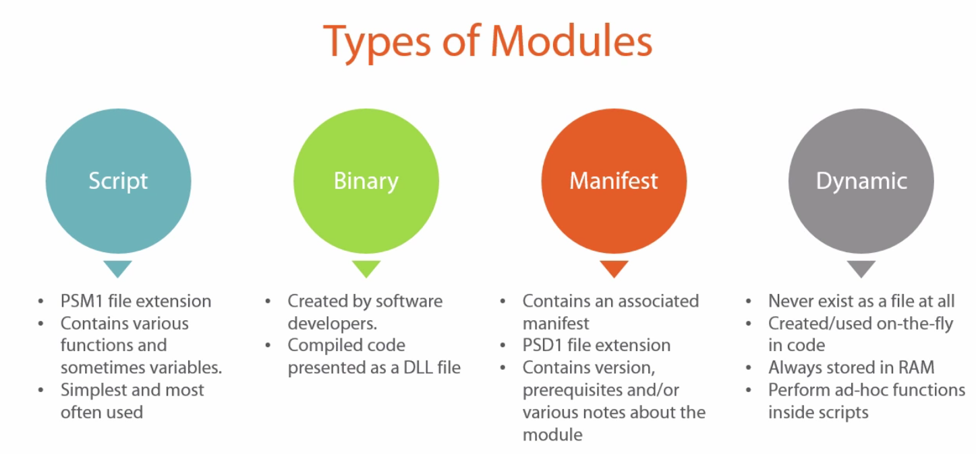Building the module:

You can create a module anywhere and still use it, but it’s not recommended.

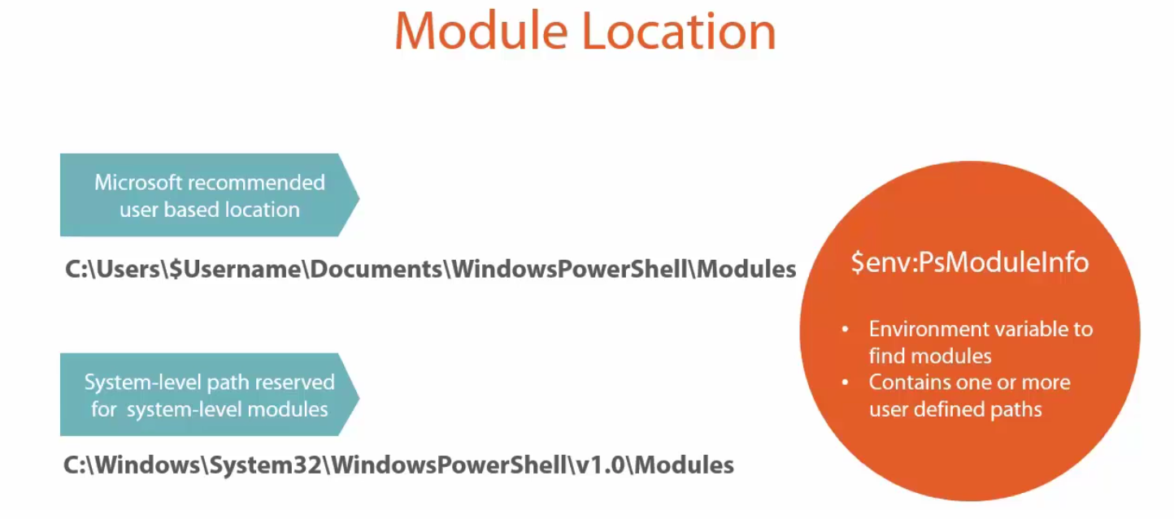

$env:PsModuleInfo contains the information for modules path where PowerShell will look for modules. More path can be added to it.

Our AdAccountManagementAutomator.ps1 contains all the functions that are required to make this module up. These functions will build up for the 90% of the process of building a module.

Step 1: Lets create a psm1 file and save the functions to it

Step 2: Use Export-ModuleMember to export functions out of this file. This is always to be added at the bottom of the module file. By using this we can set wha a person will be able to use and what will be hidden.

## New-ModuleManifest syntax to create a new manifest

## New-ModuleManifest -RequiredModules ActiveDirectory -PowerShellVersion 4.0 -Author 'Adam Bertram'

## -CompanyName 'My Company' -Description 'This module automates many tedious tasks that must be performed when

## managing Active Directory users and computers' -PowerShellHostName ConsoleHost

## -Path C:\AdAccountManagementAutomator.psd1

function New-AmaEmployeeOnboardUser {

<#

.SYNOPSIS

This function is part of the Active Directory Account Management Automator tool. It is used to perform all routine

tasks that must be done when onboarding a new employee user account.

.EXAMPLE

PS> New-AmaEmployeeOnboardUser -FirstName 'adam' -MiddleInitial D -LastName Bertram -Title 'Dr. Awesome'

This example creates an AD username based on company standards into a company-standard OU and adds the user

into the company-standard main user group.

.PARAMETER FirstName

The first name of the employee

.PARAMETER MiddleInitial

The middle initial of the employee

.PARAMETER LastName

The last name of the employee

.PARAMETER Title

The current job title of the employee

#>

[CmdletBinding()]

param (

[string]$Firstname,

[string]$MiddleInitial,

[string]$LastName,

[string]$Location = 'OU=Corporate Users',

[string]$Title

)

process {

## Not the best use of storing the password clear text

## Google/Bing on using stored secure strings on the file system as a way to get around this

$DefaultPassword = 'p@$$w0rd12'

$DomainDn = (Get-AdDomain).DistinguishedName

$DefaultGroup = 'Gigantic Corporation Inter-Intra Synergy Group'

$Username = "$($FirstName.SubString(0, 1))$LastName"

## Check if an existing user already has the first intial/last name username taken

try {

if (Get-AmaADUser -Username $Username) {

## If so, check to see if the first initial/middle initial/last name is taken.

$Username = "$($FirstName.SubString(0, 1))$MiddleInitial$LastName"

if (Get-AmaADUser -Username $Username) {

throw "No acceptable username schema could be created"

}

}

} catch {

Write-Error $_.Exception.Message

}

$NewUserParams = @{

'UserPrincipalName' = $Username

'Name' = $Username

'GivenName' = $FirstName

'Surname' = $LastName

'Title' = $Title

'SamAccountName' = $Username

'AccountPassword' = (ConvertTo-SecureString $DefaultPassword -AsPlainText -Force)

'Enabled' = $true

'Initials' = $MiddleInitial

'Path' = "$Location,$DomainDn"

'ChangePasswordAtLogon' = $true

}

New-AdUser @NewUserParams

Add-ADGroupMember $Username $DefaultGroup

$Username

}

}

function New-AmaEmployeeOnboardComputer {

<#

.SYNOPSIS

This function is part of the Active Directory Account Management Automator tool. It is used to perform all routine

tasks that must be done when onboarding a new AD computer account.

.EXAMPLE

PS> New-AmaEmployeeOnboardComputer -FirstName 'adam' -MiddleInitial D -LastName Bertram -Title 'Dr. Awesome'

This example creates an AD username based on company standards into a company-standard OU and adds the user

into the company-standard main user group.

.PARAMETER Computername

The name of the computer to create in AD

.PARAMETER Location

The AD distinguishedname of the OU that the computer account will be created in

#>

[CmdletBinding()]

param (

[string]$Computername,

[string]$Location

)

process {

try {

if (Get-AdComputer $Computername) {

#Write-Error "The computer name '$Computername' already exists"

throw "The computer name '$Computername' already exists"

}

$DomainDn = (Get-AdDomain).DistinguishedName

$DefaultOuPath = "$Location,$DomainDn"

New-ADComputer -Name $Computername -Path $DefaultOuPath

} catch {

Write-Error $_.Exception.Message

}

}

}

function Set-AmaAdUser {

<#

.SYNOPSIS

This function is part of the Active Directory Account Management Automator tool. It is used to modify

one or more Active Directory attributes on a single Active Directory user account.

.EXAMPLE

PS> Set-AmaAdUser -Username adam -Attributes @{'givenName' = 'bob'; 'DisplayName' = 'bobby bertram'; 'Title' = 'manager'}

This example changes the givenName to bob, the display name to 'bobby bertram' and the title to 'manager' for the username 'adam'

.PARAMETER Username

An Active Directory username to modify

.PARAMETER Attributes

A hashtable with keys as Set-AdUser parameter values and values as Set-AdUser parameter argument values

#>

[CmdletBinding()]

param (

[string]$Username,

[hashtable]$Attributes

)

process {

try {

## Attempt to find the username

$UserAccount = Get-AmaADUser -Username $Username

if (!$UserAccount) {

## If the username isn't found throw an error and exit

#Write-Error "The username '$Username' does not exist"

throw "The username '$Username' does not exist"

}

## The $Attributes parameter will contain only the parameters for the Set-AdUser cmdlet other than

## Password. If this is in $Attributes it needs to be treated differently.

if ($Attributes.ContainsKey('Password')) {

$UserAccount | Set-ADAccountPassword -Reset -NewPassword (ConvertTo-SecureString -AsPlainText $Attributes.Password -Force)

## Remove the password key because we'll be passing this hashtable directly to Set-AdUser later

$Attributes.Remove('Password')

}

$UserAccount | Set-AdUser @Attributes

} catch {

Write-Error $_.Exception.Message

}

}

}

function Get-AmaAdUser {

<#

.SYNOPSIS

This is a helper function for the AdAccountManagementAutomator PowerShell module. It is used by

various other functions in the module to find AD user objects.

.EXAMPLE

PS> Get-AmaAdUser -Username adam

This example queries Active Directory for a user object with the identity of 'adam'

.PARAMETER Username

One or more Active Directory usernames separated by commas

#>

[CmdletBinding()]

param (

[string[]]$Username

)

process {

try {

## Build the AD filter to find all of the user objects

$Filter = "samAccountName -eq '"

$Filter += $Username -join "' -or samAccountName -eq '"

$Filter += "'"

## Attempt to find the username

$UserAccount = Get-AdUser -Filter $Filter

if ($UserAccount) {

$UserAccount

}

} catch {

Write-Error $_.Exception.Message

}

}

}

function Set-AmaAdComputer {

<#

.SYNOPSIS

This function is part of the Active Directory Account Management Automator tool. It is used to modify

one or more Active Directory attributes on a single Active Directory computer account.

.EXAMPLE

PS> Set-AmaAdComputer -Computername adampc -Attributes @{'Location' = 'Phoenix'; 'Description' = 'is a little problematic'}

This example changes the location to Phoenix and the description of the AD computer adampc to 'is a little problematic'

.PARAMETER Computername

An Active Directory computer account to modify

.PARAMETER Attributes

A hashtable with keys as Set-AdComputer parameter values and values as Set-AdComputer parameter argument values

#>

[CmdletBinding()]

param (

[string]$Computername,

[hashtable]$Attributes

)

process {

try {

## Attempt to find the Computername

$Computer = Get-AdComputer -Identity $Computername

if (!$Computer) {

## If the Computername isn't found throw an error and exit

#Write-Error "The Computername '$Computername' does not exist"

throw "The Computername '$Computername' does not exist"

}

## The $Attributes parameter will contain only the parameters for the Set-AdComputer cmdlet

$Computer | Set-AdComputer @Attributes

} catch {

Write-Error $_.Exception.Message

}

}

}

Export-ModuleMember -Function New-AmaEmployeeOnboardComputer

Export-ModuleMember -Function New-AmaEmployeeOnboardUser

Export-ModuleMember -Function Set-AmaAdUser

Export-ModuleMember -Function Set-AmaAdComputer

Creating a Manifest:

A manifest is a plain text file with a .psd1 extension that contains a specific structure that includes information about the module. *This time, you cannot open a notepad and save the file with a psd1 extension.* **A manifest contains a hashtable that contains various other variables inside such as variable names, author, minimum PowerShell version, etc.** A manifest is although not required but is recommended to give user a better understanding of what your module can do.

To properly create a manifest you can use the *New-MOduleManifest cmdlet.* This cmdlet has a multitude of parameters like author, companyname, copyright etc. this manifest should be places in the same folder as your PSM1 file.

##New-ModuleManifest syntax to create a new manifest

New-ModuleManifest -RequiredModules ActiveDirectory -PowerShellVersion 4.0 -Author 'Adam Bertram'

-CompanyName 'My Company' -Description 'This module automates many tedious tasks that must be performed when

managing Active Directory users and computers' -PowerShellHostName ConsoleHost

-Path C:\AdAccountManagementAutomator.psd1

In order to use the module, you can use the Import-Module cmdlet or directy use the cmdlet if you know it and PowerShell will load the module for you.

**Building Advance PowerShell Functions and Modules:**

Use this block to make an advance function. Even if the function does not need any parameters, having this at the starting does not fall your world apart.

**[CmdletBinding]**

**Param()**

This gives the cmdlet a compiled power that we previously had to write in C# and get compiled.

Using this to make an advance function gives us four basic categories of functionality.

1. String Control: Control verbose, warning, debug and error output.
2. Advanced Parameters : you can now control what gets passed into your functions with parameter validation or enforce some mandatory parameters. You can use parameter sets to have your function accept different types of parameter.
3. Pipeline Input acceptance:
4. A safety net: -WhatIf and -Confirm

[Parameter(Mandatory, ValueFromPipeline)]

[ValidateSet(“This,That”)]

Param([string]$Param)

Using -ErrorAction parameter inline with the calling PowerShell statement overrides the default value of the $ErrorActionPreference.

$WarningPreference to set and get its value for writing warnings in PowerShell.

Use -Warning Action inline with the PowerShell calling statement to override t=its default value.

Similarly

$VerbosePreference : by default it is set to silentlyContinue. By default you cannot see the verbose messages from various cmdlets. It is good to have it in silentlycontinue mode in development but not in production mode.

We have to use the -Verbose switch to get the verbose output for the cmdlet statement in which it is used.

Similarly, we can use the -Debug switch to get the breakpoint set to write-debug command and you can then debug the code.

$DebugPreference

With advance function, you also get a -WarningVariable, -ErrorVariable parameter. These are used to define a warning or error variable that will contain the warnings or errors that follows the executing statement. *Note: do not use the $ sign in the variable name as value for the -ErrorVariable or -WarningVariable value.*

These warning and error variable parameter variable actually contains the warning and error associated with the statement.

Get-Service -ErrorVariable err

If($err) {

Add-Content -Path C:\SomelogFile.log -Value “Error: $($err.Exception.Message)”

}

Understanding Advance Function Parameters:

param(

[Parameter(Mandatory)]

[ValidateScript({ Test-Connection $_ })]

[string]$ComputerName,

[Parameter()]

[string]$parameter2

)

#Mandatory = $true --In PowerShell v4, $true is not required anymore. it's simply implied.

#If it is not set mandatory, it will be assumed optional by PowerShell and the variable will be empty by default.

#Mandatory parameters if not provided will be prompted inn console or will throw error

# to check the mandatory parameters

(Get-Help -Name Get-Service -Detailed).syntax

(Get-Help -Name Get-Content -Detailed).syntax

#in the results of the above, you will notice that the _path parameter of the GEt-content cmdlet

#is mandatory. you will notice that the mandatory parameters in square braces does not include its type

#another way to check mandatory parameters is :

(Get-Command -Name 'Get-Content').Parameters.Path.Attributes

#In the result, you can see the value of the Mandatory attribute to either false or true

#ValidateScript -- it is used to run a script to validate the parameter. in this case, it will test the connection to the computer name provided. returns true if successful else false.

#ValidateScript should have a script block and so curly braces are important here.

function New-VirtualMachine

{

[CmdletBinding()]

param

(

[Parameter(Mandatory)]

[ValidateCount(1, 5)]

[string[]]$Name,

[Parameter()]

[ValidateNotNullOrEmpty()]

[ValidateRange(1, 5)]

[int]$Count = 1,

[Parameter()]

[ValidateNotNull()]

[ValidateRange(512MB, 1024MB)]

[int]$MemoryStartupBytes,

[Parameter()]

[ValidateNotNullOrEmpty()]

[ValidateSet('1', '2')]

[int]$Generation = 2,

[Parameter()]

[ValidateScript({

if (-not (Test-Path -Path $_ -PathType Container)) {

throw "The folder [$_] does not exist. Try another"

}

Else {

$true

}

})]

[ValidatePattern('^C:\\')]

[string]$Path = 'C:\somebogusfolder',

[Parameter()]

[AllowNull()]

[string]$OperatingSystem,

[Parameter(Mandatory)]

[AllowNull()]

[string]$AllowNullParam

)

}

#region ValidateScript

New-VirtualMachine -Name 'MYNEWVM' -Path 'C:\somebogusfolder' ## fails if detects exception, $true otherwise

#region Make the output prettier

#[ValidateScript({

# if (-not (Test-Path -Path $_ -PathType Container))

# {

# throw "The folder [$_] does not exist. Try another"

# }

# else

# {

# $true

# }

#})]

#endregion

#region Other ValidateScript examples

#[ValidateScript({

# if (Test-Connection -ComputerName $_ -Quiet -Count 1)

# {

# throw "The computer [$_] is offline. Try another"

# }

# else

# {

# $true

# }

#})]

#endregion

#endregion

#region ValidatePattern

New-VirtualMachine -Name 'MYNEWVM' -Path 'Z:\'

'C:\somefolder' -match '^C:\\'

#endregion

#region ValidateSet

New-VirtualMachine -Name 'MYNEWVM' -Generation

help New-VirtualMachine

#endregion

#region ValidateRange

New-VirtualMachine -Name 'MYNEWVM' -MemoryStartupBytes 128MB

New-VirtualMachine -Name 'MYNEWVM' -Count 10

#endregion

#region ValidateCount

New-VirtualMachine -Name 'MYNEWVM','MYOTHERVM'

#endregion

#region Null attributes

New-VirtualMachine -Name 'MYNEWVM' -NullParamTest $null

New-VirtualMachine -Name 'MYNEWVM' -NullParamTest ''

## Change param to [ValidateNotNull]

New-VirtualMachine -Name 'MYNEWVM' -NullParamTest ''

New-VirtualMachine -Name 'MYNEWVM' -AllowNullParam '' ## Only applies to mandatory parameters

#endregion

ValidatePattern allows you to pass regex string to validate the parameter.

ValidateSet takes in a set of values and ensures that the values of the parameter should be in any of these values.

ValidateRange validates the variable between two different range set. It gives an option to set the lower and higher threshold. Anything between this range is fine.

ValidateCount also takes in a range and checks the min and max of the items passed to a parameter. It is helpful for parameter that takes in an array so that the count of the array elements passed to the parameter can be maintained. ValidateRange only applies to a single element.

ValidateNOtNullOrEmpty ensures that the parameter is not a null value or not an empty value.

ValidateNOtNull only checks for null validation. *In order for this validation to work, the parameter has to be a mandatory parameter.*

AllowNull: this is a rarely used validation. *If it is used with the mandatory parameter then it will not allow null. An error will pop up saying that it is an empty string.*

Parameter Sets:

Whenever you create a parameter, you also create a parameter set. If a parameter set is not defined, it will automatically mark parameters into the default parameter set.

Parameter sets are typically used to provide input for distinct purposes. Suppose you have a cmdlet Set-Access which can have a switch -Enable or -Disable. Obviously you cannot have both of them at the same time. These are mutually exclusive parameters and this asks for parameter sets.

Parameter sets are meant to separate mutually exclusive parameters from other.

function New-VirtualMachine

{

[CmdletBinding(DefaultParameterSetName = 'None')]

param

(

[Parameter(Mandatory, ParameterSetName = 'ByName')]

[ValidateCount(1, 5)]

[string[]]$Name,

[Parameter(Mandatory, ParameterSetName = 'ById')]

[ValidateNotNullOrEmpty()]

[string]$Id,

[Parameter()]

[ValidateNotNullOrEmpty()]

[ValidateRange(1, 5)]

[int]$Count = 1,

[Parameter()]

[ValidateNotNull()]

[ValidateRange(512MB, 1024MB)]

[int]$MemoryStartupBytes,

[Parameter()]

[ValidateNotNullOrEmpty()]

[ValidateSet('1', '2')]

[int]$Generation = 2,

[Parameter()]

[ValidateScript({ Test-Path -Path $_ -PathType Container })]

[ValidatePattern('^C:\\')]

[string]$Path = 'C:\somebogusfolder',

[Parameter()]

[AllowNull()]

[string]$OperatingSystem

)

if ($PSCmdlet.ParameterSetName -eq 'ById')

{

Write-Host "You're using the ById parameter set by using the Id parameter [$($Id)]"

}

elseif ($PSCmdlet.ParameterSetName -eq 'ByName')

{

Write-Host "You're using the ByName parameter set by using the Name parameter [$($Name)]"

}

Write-host $count

}

#region Parameter sets with mandatory parameters

New-VirtualMachine -Name 'MYNEWVM'

New-VirtualMachine -Id 'HYPERVHOST1'

#endregion

#region Parameter sets with optional params (Default)

New-VirtualMachine ## will not work

## Add a default parameter set

New-VirtualMachine -Count 2

#endregion

#region in help

help New-VirtualMachine

help Test-Connection

#endregion

#region Using Get-Command

## Add default parameter set

$command = Get-Command New-VirtualMachine

$command.DefaultParameterSet

$command.ParameterSets | Select name

## Find params inside of parameter sets

($command.ParameterSets[2]).Parameters | ft name

#endregion

Setting parameter sets will also require to set a default parameter otherwise PowerShell will get confuse which one of the mandatory parameter sets parameter to pick.

[CmdletBinding(DefaultParameterSetName = 'ByName')]

How to discover parameter sets of a cmdlet

$command = Get-Command New-VirtualMachine

$command.DefaultParameterSet

$command.ParameterSets | Select name

To get all the parameters inside of each parameter set.

($command.ParameterSets[2]).Parameters | ft name

Incorporating Advance Pipeline Input:

1. Pipeline input by object
2. Pipeline input by property
3. Parameter binding
4. Begin/process/end blocks

You can either use ValueFromPipeline(for object) or ValueFromPipelineByPropertyName(for single property). These attributes are similar yet bind in different ways.

How accepting pipeline input works?

This happens due to something called parameter binding in PowerShell. It is essentially the process that stitches the output with input in the property. If a VAlueFrom attribute is added to the parameter, it will then look for a type match. A type match simply means that either the entire object coming into your function is of the same type as what you’re defining in a parameter or a property of that object is of the same type, depending on which ValueFrom attribute you choose. *PowerShell does this matching by 4 different steps, and if it’s not bound, it will just give up. The order gives precedence to exact object type first. There are two different options when binding parameters by type that are called* ***Coercion and No coercion.***

**Coercion -> matching the type that PowerShell it thinks it should be.**

ByValue -> it binds the parameter by the entire object, so that is the ValueFromPipeline attribute. The other is the value from ValueFromPIpelineByPropertyName. You will see that it tries to match either of these with exact type first. Then if it can’t find an exact type match, it will then attempt to coerce or try to guess what type you meant. If it can’t find these ways, it will fail.

1. ByValue (No Coercion)
2. ByPropertyName (No Coercion)
3. ByValue (Coercion)
4. ByPropertyName (Coercion)

Pipeline By Value:

function Get-VirtualMachine

{

[CmdletBinding()]

[OutputType([System.Management.Automation.PSCustomObject])]

param

(

[Parameter(Mandatory)]

[string]$Name

)

#[pscustomobject]@{ 'Name' = $Name; 'HyperVHost' = 'HYPERV1' }

1234

}

## 1 object

function Set-VirtualMachine

{

[CmdletBinding()]

param

(

[Parameter(Mandatory,ValueFromPipeline)]

[pscustomobject]$InputObject

)

process

{

Write-Host $InputObject.Name

Write-Host '-------'

Write-Host $InputObject.HyperVHost

}

}

## 2 objects

function Set-VirtualMachine

{

[CmdletBinding()]

param

(

[Parameter(ValueFromPipeline)]

[pscustomobject]$Object1,

[Parameter(ValueFromPipeline)]

[System.IO.FileInfo]$Object2

)

process

{

Write-Verbose -Message "OBJECT1: Name is [$($Object1.Name)] -- HyperV host is [$($Object1.HyperVHost)]"

Write-Verbose -Message "OBJECT2: Name is [$($Object2.Name)] -- HyperV host is [$($Object2.HyperVHost)]"

}

}

## $Input

function Set-VirtualMachine

{

[CmdletBinding()]

param

(

[Parameter(ValueFromPipeline)]

[pscustomobject]$Object1

)

$Object1

}

## Verify outputs a custom object

Get-VirtualMachine -Name 'MYVM' | Get-Member

## pipeline behavior

Get-VirtualMachine -Name 'MYVM' | Set-VirtualMachine -Verbose

## parameter binding by type with 2 objects capable of pipeline input

Get-VirtualMachine -Name 'MYVM' | Set-VirtualMachine -Verbose

## choosy pipeline input by type -- coercion --change to pscustomobject

Get-VirtualMachine -Name 'MYVM' | Set-VirtualMachine -Verbose

Get-Item C:\autoexec.bat | Set-VirtualMachine -Verbose

## $Input

Get-VirtualMachine -Name 'MYVM' | Set-VirtualMachine

#region Break the pipeline

## Change the object type of $InputObject from something that Get-VirtualMachine does NOT output

Get-VirtualMachine -Name 'MYVM' | Set-VirtualMachine

#endregion

You should atleast have a process block in the function that accepts pipeline input.

$Input is an automatic variable in PowerShell. You cannot change it. $input is simply a representation of the pipeline object that’s coming in. do not use this in production script. It is always a good idea to explicit use the objects created in the script.

Begin Process and End Blocks:

When accepting pipeline input, its critical that you always use begin, process and end blocks. These blocks dictates how your function handles that pipeline input.

Begin Block: First object in pipeline (runs one single time) -> good for having helper functions. Opening connections

Process block: Every Object in the pipeline

End block: Last Object in pipeline (runs once.) -> can be used for cleanup code, ending sessions, closing connections etc.

function Get-VirtualMachine

{

[CmdletBinding()]

[OutputType([System.Management.Automation.PSCustomObject])]

param

(

[Parameter()]

[string]$Name

)

0..10 | foreach {

[pscustomobject]@{ 'Name' = "VM$PSItem"; 'HyperVHost' = 'HYPERV1' }

}

}

## No begin/process/end blocks

function Set-VirtualMachine

{

[CmdletBinding()]

param

(

[Parameter(Mandatory, ValueFromPipeline)]

[pscustomobject]$InputObject

)

begin {

}

process {

function Add-VmToFile

{

param ($Name)

Write-Verbose -Message "Adding the VM name [$($Name)] to the file"

Add-Content -Path C:\VMNames.txt -Value $Name

}

New-Item -Path C:\VMNames.txt -Type File

Add-VmToFile -Name $InputObject.Name

}

}

function Set-VirtualMachine

{

[CmdletBinding()]

param

(

[Parameter(Mandatory, ValueFromPipeline)]

[pscustomobject]$InputObject

)

begin

{

## $ErrorActionPreference will apply across ALL pipeline objects if only set once

$ErrorActionPreference = 'Stop'

## "Helper" functions are commonly placed in the begin block because they need loaded into memory once

function Add-VmToFile

{

param ($Name)

#Write-Verbose -Message "Adding the VM name [$($Name)] to the file"

Add-Content -Path C:\VMNames.txt -Value $Name

}

## Maybe you need to work with a file temporarily for all objects in this function. Create one at the start

#New-Item -Path C:\VMNames.txt -Type File

#Write-Verbose -Message 'Beginning to process pipeline objects with Get-VirtualMachine'

}

process

{

#Write-Verbose -Message "Processing pipeline object representing VM [$($InputObject.Name)]..."

#Add-VmToFile -Name $InputObject.Name

}

end

{

$input

## Common uses:

## Removing PowerShell sessions to be used for all pipeline objects

## Removing temporary files

## Closing database connections

#Write-Verbose -Message 'The function Get-VirtualMachine has completed processing all pipeline objects'

}

}

<#

---Steps---

1. Run Get-VirtualMachine to get a bunch of VM names

2. Create a text file to hold these VM names.

3. Add each of the VM names output by Get-VirtualMachine into the text file

#>

## Get-VirtualMachine outputs 10 objects of type System.Management.Automation.PSCustomObject

Get-VirtualMachine

## Demo begin/process/end blocks

Get-VirtualMachine | Set-VirtualMachine -Verbose

# $input

NOTE: without the process block, it will only run for the last item.

Using $Input:

$input in the begin block is empty even if we are accepting input from pipeline. The behaviour of $input is strange and this is why it is not recommended to use it. Same behaviour is observed in the end block also. Use parameter name instead.

**Playing it safe with WhatIf and Confirm:**

1. supportsShouldProcess keyword
2. whatIf
3. Confirm
4. ConfirmPreference behaviour
5. $WhatIfPreference behaviour

whatIf shoes in the console output of what would have happened. If you are unsure of the script of running successfully, you can use this

Confirm is meant to prompt you to blow up your system. It will just ask you if you want to proceed further.

$WhatIfPreference can either be a false or a true. It is a global variable set for all the cmlets that supports whatIf. Setting it to true will enable this functionality for all the cmdlets. After setting this preference variable to true, we do not need to pass the -WhatIf parameter in the statement. Then, executing the statement will actually execute what would happened on executing the command. It will never execute the command. *So, always set this preference variable to false and use the -WhatIf switch in the statement to see its effect.*

$ConfrmPreference gives you an option of would you like to proceed further. Rest of it behaves similar to the -WhatIf. The default value of $confirmPreference is High.

This means PowerShell will only confirm for parameters that have high impact or higher. It can also have None, Low, Medium as other values.

Every cmdlet has a specific ConfirmImpact severity level. Remove-Item has a severity level of High. It will only confirm for cmdlets whose severity level is same or higher than that of the *ConfirmImpact serverity level set.*

**Remember if you set the $WhatIfPreference to $true then it will override the $confirmPreference and will execute all the cmdlets in the -WhatIf mode.**

In the ISE, confirm popup will be prompted but in actual script it will be prompted as a text message in the console.

Even the $conformPreference valriable is set to None, using the -Confirm in the cmdlet statement will override the confirmPreference value and will prompt the confirmation.

Building your own WhatIf/Confirm support:

WhatIf

* Requires SupportsShouldProcess -> this is placed inside of the cmdletBinding attribute.
* Controlled by $WhatIfPreferences

Confirm

* Controlled by $ConfirmPreferences
* Understand the $ConfrmImpact also. This go hand in hand with $confirmPreferences variable.

#region How NOT to implement "WhatIf"

function Remove-VirtualMachine

{

[CmdletBinding()]

param

(

[Parameter()]

[string[]]$Name,

[Parameter()]

[ValidateNotNullOrEmpty()]

[switch]$WhatIf

)

if ($WhatIf.IsPresent)

{

Write-Host "I would have removed that VM $Name" -ForegroundColor Cyan

}

else

{

Write-Host "I'm removing the VM $Name now" -ForegroundColor Green

}

}

Remove-VirtualMachine -WhatIf

#endregion

Do not use this way to recreate the WhatIf functionality that is already built in with the Advance function functionality. The reason is, doing this will need us to mention the what if statement text that is already built in and generates automatically.

#region SupportsShouldProcess

function Remove-VirtualMachine

{

[CmdletBinding(SupportsShouldProcess)]

param

(

[Parameter()]

[string[]]$Name

)

if ($PSCmdlet.ShouldProcess($Name))

{

Write-Host "Removing the VM $Name now"

}

}

$WhatIfPreference

Remove-VirtualMachine -Name 'MYVM' -WhatIf

#endregion

The $PSCmdlet.ShouldProcess($Name) either returns true or false depending on whether we have -WhatIf in the statemenet or not.

The ShouldProcess property of $PSCmdlet only shows up when we use the SupportsShouldProcess in the CmdletBinding attribute on top of the Pram() tag.

If -WhatIf is present in the cmdlet state then $PSCmdlet.ShouldProcess($Name) returns false. It means that since the -WhatIf is present, it should not process the cmdlet and not execute it.

If it is not present in the statement then it will execute/process the cmdlet.

Building Confirm Support:

Use the ConfirmImpact = ‘Low/High/Medium/None’ in the cmdletBinding attribute of the function to give it a confirm support. It also has the $PSCmdlet.ShouldProcess($Name). this actually brings in the confirm support. This applies to both -WhatIf and -Confirm.

*Setting the confirm prompt to false will not give the prompt even if the conditions for prompting is matched.*

*New-Item -Path C:\Test.txt -Type File -Confirm:$false*

**Remember:** *you only need SupportsShouldProcess if you want to override the global behaviour.*

*On a regular basis, you can include both, SupportsShouldProcess, ConfirmImpact = “High” in the cmdletBinding.*

Script Modules:

Use Export-ModuleMember -Function ‘Get-*’,’New-*’ --this exports all funcions that start with Get and New in this module.

There’s another way to limit the functions exported from module. Instead of fixing the Export-ModuleMember line at the end of the module file, we want to limit it whenever the module is loaded into memory.

Get-Module -ListAvailable --show all functions that ae available for module without being loaded yet.

Import-Module -Name MyModule -Function ‘Get-*’ -- this will import the module and load only the Get related funcitons into the memory.

Restricting Unloading of Module:

What if you do not want to unload a module under any circumstances. You can do this by using AccessMode property on PSModuleInfo object. This will make sure that your module is loaded even if the Remove-Module cmdlet is used. By default, the accessMOde will be ReadWrite. Ther are couple of modes available.

PSModuleInfo.AccessMode

* Read -> this will give you a prompt first and then use a -Force parameter to remove a module.
* ReadWrite -> allows loading and unloading at will
* Constant -> here you can only unload it if a new session starts up completely, so you are not allowed to remove it under any circumstances.

$module = Get-Module -Name MyModule

$module.AccessMode

$module.AccessMode = 'ReadOnly'

Remove-Module MyModule

$module.AccessMode = 'Constant'

Remove-Module MyModule

**Building a Manifest Module:**

Create a script module and then add a manifest to it. This creates a manifest module.

A manifest is a document that outlines everything that contained within. A PowerShell module also makes sure that it meets all the criteria on the environment the script is running on. It can also act as a form validation as well. You can define criteria’s such as

Required PowerShell version

Required .Net version

CLR version

And so on.

A manifest is technically a text file with a .psd1 extension in a specified format. More specifically, it is a single PowerShell hashtable with a bunch of key names that represent certain features of the module it is representing. *A manifest will always be paired up with a module.*

So in a nutshell, a manifest is actually a script module with a manifest attached. The manifest should be present in the same folder in with the associated script file is present.

#region Notice the ModuleType is a Script module with little to no information

$module = Get-Module -ListAvailable -Name MyModule

$module | Select *

#endregion

#region Find the folder to create the manifest in

$modulePath = $module.ModuleBase

$modulePath

#endregion

#region Review New-ModuleManifest

## Even though the manifest can be created from scratch I always recommend

## creating a template from New-ModuleManifest and modifying that one.

## Get an idea on the attributes you can use

(Get-Help New-ModuleManifest).Parameters.Parameter.Name

#endregion

#region Create a basic manifest --my minimum recommendations

$params = @{

'Author' = 'Adam Bertram'

'CompanyName' = 'Adam the Automator, LLC.'

'Description' = 'This is a module that does this and that. It was designed to solve some problem.'

'NestedModules' = 'MyModule' ## This is required to expose functions in a manifest module

'Path' = "$modulePath\MyModule.psd1" ## Use the same name as the module with a PSD1 extension

}

New-ModuleManifest @params

#endregion

#region Verifying manifest behavior

Get-Module -ListAvailable -Name MyModule | select *

#endregion

#region Review the manifest and add an optional attribute

ise "$modulePath\MyModule.psd1"

PrivateData = @{

PSData = @{

Tags = 'Pluralsight','ModuleTraining' ## For the PowerShell Gallery

ProjectUri = 'https://github.com/adbertram/PluralsightModuleTraining'

}

}

(Get-Module -Name MyModule -ListAvailable).PrivateData['PSData']

#endregion

Using manifest to manage requirements and dependencies:

## Use an existing manifest and build upon it

$module = Get-Module -Name MyModule -ListAvailable

ise $module.Path

## Enforcing the version of PowerShell --good for scripts that you only test on specific versions

PowerShellVersion = '5.0'

Import-Module MyModule -Force

## To ensure your module only runs in the console (not in the ISE)

PowerShellHostName = 'ConsoleHost'

Import-Module MyModule -Force

## To ensure your module only runs on a specific architecture

ProcessorArchitecture = 'X86'

Import-Module MyModule -Force

Managing Module Dependencies:

## Use an existing manifest and build upon it

$module = Get-Module -ListAvailable -Name MyModule

ise $module.Path

## No FileList entries and only itself as NestedModules

$module | select nestedmodules,filelist

#region NestedModules --builtin dependency

## Create some blank modules

New-Item -Path "$($module.ModuleBase)\NestedModule1.psm1"

New-Item -Path "$($module.ModuleBase)\NestedModule2.psm1"

## add a function to each module

ise "$($module.ModuleBase)\NestedModule1.psm1"

ise "$($module.ModuleBase)\NestedModule2.psm1"

## Open the manifest and add the modules as NestedModules

ise $module.Path

## Nested modules are now associated with MyModule

Import-Module MyModule -Force -PassThru | select nestedmodules,filelist

## Functions in all modules show up as one

Get-Command -Module MyModule

#endregion

#region FileList --made for inventory-only purposes but can be used to enforce dependencies

## Add a TXT file to the manifest

New-Item -Path "$($module.ModuleBase)\mytextfile.txt"

ise $module.Path

$module = Import-Module MyModule -Force -PassThru

$module.FileList # currently just for inventorying

## Will show how to ensure these files exist when loading module later

#endregion

NestedMOdules

all the cmdlets of the nested modules will also be shown in the parent module as if they were a part of it.

FileList:

This is good for inventory purposes. It tells the list of files say test files or xml files that will come as part of this module.

Always put these files inside of the parent directory module folder

Running Startup Scripts:

$module = Get-Module -ListAvailable -Name MyModule

ise $module.Path

#region Use the FileList attribute to check for files before loading module

$module.FileList

## Create a script called Startup.ps1. This will be "dot-sourced" into your session

New-Item "$($module.ModuleBase)\Startup.ps1" -ItemType File

ise "$($module.ModuleBase)\Startup.ps1"

<#

$requiredFiles = (Get-Module MyModule -ListAvailable).FileList

$requiredFiles | foreach {

if (-not (Test-Path -Path $_ -PathType Leaf)) {

Write-Warning "The file [$($_)] does not exist and is required for this module."

}

}

#>

Import-Module MyModule

#endregion

Modules connect as a sort of startup connect executor by running various scripts before your module loads. This is done through the **ScriptsToProcess** key. By simply listing out various scripts in this key, you are able to run any number of startup scripts to check for things or set various configuration items before your module loads. It’s great for things like startup checks where you need to ensure that the environment your module is getting loadedin is just as the way you like it.

*You can also use manifest to act as a startup scripts.*

Let’s create a *startup.ps1* script that will check all the required files exists for this module or not.

$requiredFiles = (Get-Module MyModule -ListAvailable).FileList

$requiredFiles | foreach {

if (-not (Test-Path -Path $_ -PathType Leaf)) {

Write-Warning "The file [$($_)] does not exist and is required for this module."

}

Then, add the following line into the manifest script.

ScriptsToProcess = @(‘Startup.ps1’)

**Writing Help Content:**

1. Comment based help: Most common help content. Easiest to implement. But it does not scale well. All comment based help is just a comment but a specifically structured comment.

function Get-VirtualMachine

{

<#

.SYNOPSIS

A brief description of the function or script. This keyword can be used

only once in each topic.

.DESCRIPTION

A detailed description of the function or script. This keyword can be

used only once in each topic.

.PARAMETER Name

The description of a parameter. Add a .PARAMETER keyword for

each parameter in the function or script syntax.

Type the parameter name on the same line as the .PARAMETER keyword.

Type the parameter description on the lines following the .PARAMETER

keyword. Windows PowerShell interprets all text between the .PARAMETER

line and the next keyword or the end of the comment block as part of

the parameter description. The description can include paragraph breaks.

The Parameter keywords can appear in any order in the comment block, but

the function or script syntax determines the order in which the parameters

(and their descriptions) appear in help topic. To change the order,

change the syntax.

You can also specify a parameter description by placing a comment in the

function or script syntax immediately before the parameter variable name.

If you use both a syntax comment and a Parameter keyword, the description

associated with the Parameter keyword is used, and the syntax comment is

ignored.

.EXAMPLE

PS> Get-VirtualMachine -Name 'MYVM'

This example retrieves the virtual machine with the name of MYVM from whatever

virtualization system it's supposed to work with.

.INPUTS

None.

.OUTPUTS

System.Management.Automation.PSCustomObject

.NOTES

Requirements: This requires

.LINK

http://www.google.com

#>

[CmdletBinding()]

param

(

[Parameter(Mandatory)]

[ValidateNotNullOrEmpty()]

[string]$Name

)

[pscustomobject]@{}

}

Get-Help Get-VirtualMachine

get-help Get-VirtualMachine -Parameter Name

Get-Help Get-VirtualMachine -Examples

Get-Help Get-VirtualMachine -Online

1. XML based help

It is hard to implement and scales well. XML help requires an XML Ninja. An XML Ninja version is a specific kind of XML schema known as MAML. Comment based an xml based help, both are stored at different spots.

Comment based help is part of the function while xml help is not only not in the same function, it’s not even stored in the same file at all. It is actually stored in a separate xml file. XML help is pickier about the syntax. One small typo error in the xml file will refuse to load any help content.

*You can only use either one of them.*

## Open the XML file to go over namespace, elements and MAML schema

ise 'C:\Dropbox\Business Projects\Courses\Pluralsight\Course Authoring\Active Courses\building-advanced-PowerShell-functions-and-modules\building-advanced-PowerShell-functions-and-modules-m7\Demos\XML Help\Module Help\MyModule.psm1-help.xml'

## Tools to help

start https://www.sapien.com/software/PowerShell_helpwriter

start http://cmdletdesigner.codeplex.com

start http://blogs.msdn.com/b/PowerShell/archive/2007/05/08/cmdlet-help-editor-tool.aspx

use these tools to learn how to write xml based help.

<?xml version="1.0" ?>

<helpItems xmlns="http://msh" schema="maml">

<command:command xmlns:maml="http://schemas.microsoft.com/maml/2004/10" xmlns:command="http://schemas.microsoft.com/maml/dev/command/2004/10" xmlns:dev="http://schemas.microsoft.com/maml/dev/2004/10">

<!-- Command-->

<command:details>

<command:name>New-VirtualMachine</command:name>

<maml:description>

<maml:para>This is New-VirtualMachine synopsis</maml:para>

</maml:description>

<maml:copyright>

<maml:para>

</maml:para>

</maml:copyright>

<command:verb>New</command:verb>

<command:noun>VirtualMachine</command:noun>

<dev:version/>

</command:details>

<maml:description>

<maml:para>This is New-VirtualMachine description</maml:para>

</maml:description>

<command:syntax>

<!-- Parameter Sets-->

</command:syntax>

<command:parameters>

<!-- All Parameters-->

<command:parameter required="true" globbing="false" pipelineInput="false" position="named" aliases="">

<maml:name>Name</maml:name>

<maml:description>

<maml:para>This is the name parameter description.</maml:para>

</maml:description>

<command:parameterValue required="true">string</command:parameterValue>

<dev:defaultValue>

</dev:defaultValue>

</command:parameter>

</command:parameters>

<command:examples>

<!-- Examples-->

<command:example>

<maml:title>-------------------------- EXAMPLE 1 --------------------------</maml:title>

<maml:introduction>

<maml:para>

</maml:para>

</maml:introduction>

<dev:code>PS C:\&gt; New-VirtualMachine -Name MYVM</dev:code>

<dev:remarks>

<maml:para>This example creates a new VM called MYVM.</maml:para>

</dev:remarks>

</command:example>

</command:examples>

</command:command>

<command:command xmlns:maml="http://schemas.microsoft.com/maml/2004/10" xmlns:command="http://schemas.microsoft.com/maml/dev/command/2004/10" xmlns:dev="http://schemas.microsoft.com/maml/dev/2004/10">

<!-- Command-->

<command:details>

<command:name>Get-VirtualMachine</command:name>

<maml:description>

<maml:para>This is Get-VirtualMachine synopsis</maml:para>

</maml:description>

<maml:copyright>

<maml:para>

</maml:para>

</maml:copyright>

<command:verb>Get</command:verb>

<command:noun>VirtualMachine</command:noun>

<dev:version/>

</command:details>

<maml:description>

<maml:para>This is Get-VirtualMachine description.</maml:para>

</maml:description>

<command:syntax>

<!-- Parameter Sets-->

</command:syntax>

<command:parameters>

<!-- All Parameters-->

<command:parameter required="true" globbing="false" pipelineInput="false" position="named" aliases="">

<maml:name>Name</maml:name>

<maml:description>

<maml:para>This is name description</maml:para>

</maml:description>

<command:parameterValue required="true">string</command:parameterValue>

<dev:defaultValue>

</dev:defaultValue>

</command:parameter>

</command:parameters>

<command:examples>

<!-- Examples-->

<command:example>

<maml:title>-------------------------- EXAMPLE 1 --------------------------</maml:title>

<maml:introduction>

<maml:para>

</maml:para>

</maml:introduction>

<dev:code>PS C:\&gt;Get--VirtualMachine -Name MYVM</dev:code>

<dev:remarks>

<maml:para>This example gets a VM called MYVM.</maml:para>

</dev:remarks>

</command:example>

</command:examples>

</command:command>

</helpItems>

XML help file is based on What’s called MAML namespace schema. MAML is a way that defines how the XML is formatted.

We should always help helpItems node.

Inside of the helpItems node, we will have the various command nodes. Each of these command nodes has a reference to a individual function.

Each of the command node will have the following nodes.

1. Command:details
2. Maml:description
3. Command:syntax
4. Command:parameters
5. Command:examples

Creating XML help for functions:

PowerShell auto generates a basic help for the cmdlets for which it does not find any help or for which there is a problem with the xml help file.

Generally, paste the xml help file in the same folder where the functions ps1 files are present.

Then, on top of the cmdletBinding attribute of the function, use the below comment line to specify the xml based help path.

Generally, the functions that comes either from a console or from a dot sourcing ps1 file doesn’t have a module name. to have your functions a module name, we need to create a module.

# .EXTERNALHELP <xml-filename>

[CmdletBinding()]

param()

***xml based help does not apply unless you run a new session.***

#region Demo setup

$demoFolder = 'C:\Dropbox\Business Projects\Courses\Pluralsight\Course Authoring\Active Courses\building-advanced-PowerShell-functions-and-modules\building-advanced-PowerShell-functions-and-modules-m7\Demos\XML Help\Module Help'

$module = Get-Module -Name MyModule

del "$($module.ModuleBase)\en-US" -ea SilentlyContinue -Recurse

#endregion

#region Setup

## No tricks up my sleeve --module with just a couple standard functions

## Import or reimport the module if it's currently loaded

Import-Module -Name MyModule -Force

$module = Get-Module -Name MyModule

$module

ise (Join-Path -Path $module.ModuleBase -ChildPath 'MyModule.psm1')

## The XML (in the demo folder for now) named modulehelp.xml (remember this name)

$moduleXml = "$demoFolder\modulehelp.xml"

ise $moduleXml

#endregion

## Only the module in the module folder

Get-ChildItem -Path $module.ModuleBase

#region Language folder

## The XML file needs to go in a language-specific subfolder with a specific name.

## See what options you have for the language folder

([System.Globalization.Cultureinfo]::GetCultures('AllCultures')).Name

## Create the folder --we're using English

$languageFolder = mkdir "$($module.ModuleBase)\en-US"

$languageFolder

## Copy our prebuilt XML file into the language folder

copy $moduleXml $languageFolder

ls $languageFolder

#endregion

#region No help with a script module unless using .EXTERNALHELP

#region Why no help?

## Reload the session and import the module again.

Import-Module -Name MyModule -Force

## Check to see if the help content is available for both functions in the module

## Why no help even though the XML file is in the language folder??

Get-Help -Name Get-VirtualMachine

Get-Help -Name New-VirtualMachine

#endregion

#region Adding .EXTERNALHELP

## Add .EXTERNALHELP to functions just like we did with the function-level XML help

<#

# .EXTERNALHELP modulehelp.xml

#>

## Reload the session and import the module again.

Import-Module -Name MyModule -Force

## Check to see if the help content is available for both functions in the module now

Get-Help -Name Get-VirtualMachine

Get-Help -Name New-VirtualMachine

#endregion

#region Right XML file name but still a script module

Rename-Item "$($module.ModuleBase)\en-US\modulehelp.xml" MyModule.psm1-help.xml

Get-Item "$($module.ModuleBase)\en-US\MyModule.psm1-help.xml"

## Remove the .EXTERNALHELP references

## Ensure EXTERNALHELP references are gone

ise "$((Get-Module -Name MyModule -ListAvailable).ModuleBase)\MyModule.psm1"

## Import or reimport the module if it's currently loaded

Import-Module -Name MyModule -Force

## Check to see if the help content is available for both functions in the module

## Why still no help with no EXTERNALHELP references? It's not a manifest module

Get-Help -Name Get-VirtualMachine

Get-Help -Name New-VirtualMachine

#endregion

#endregion

#region XML help as a manifest module

## Build a manifest and put it in the module folder

$params = @{

'Author' = 'Adam Bertram'

'CompanyName' = 'Adam the Automator, LLC.'

'Description' = 'This is a module that does this and that. It was designed to solve some problem.'

'NestedModules' = 'MyModule' ## This is required to expose functions in a manifest module

'Path' = "$((Get-Module MyModule).ModuleBase)\MyModule.psd1" ## Use the same name as the module with a PSD1 extension

}

New-ModuleManifest @params

## Module and manifest now exist

Get-ChildItem -Path (Get-Module MyModule).ModuleBase

## Reimport the module

Import-Module MyModule -Force

## Ensure the module type is Manifest now

(Get-Module MyModule).ModuleType

## Ensure no .EXTERNALHELP references

ise "$((Get-Module MyModule).ModuleBase)\MyModule.psm1"

## Import or reimport the module if it's currently loaded

Import-Module -Name MyModule -Force

## Check to see if the help content is available for both functions in the module

Get-Help -Name Get-VirtualMachine

Get-Help -Name New-VirtualMachine

## No .EXTERNALHELP references

ise "$((Get-Module MyModule).ModuleBase)\MyModule.psm1"

#endregion

-----------------

Let’s create a module xml help

<?xml version="1.0"?>

<helpItems schema="maml" xmlns="http://msh">

<command:command xmlns:dev="http://schemas.microsoft.com/maml/dev/2004/10" xmlns:command="http://schemas.microsoft.com/maml/dev/command/2004/10" xmlns:maml="http://schemas.microsoft.com/maml/2004/10">

<! Command>

<command:details>

<command:name>NewVirtualMachine</command:name>

<maml:description>

<maml:para>This is NewVirtualMachine synopsis</maml:para>

</maml:description>

<maml:copyright>

<maml:para> </maml:para>

</maml:copyright>

<command:verb>New</command:verb>

<command:noun>VirtualMachine</command:noun>

<dev:version/>

</command:details>

<maml:description>

<maml:para>This is NewVirtualMachine description</maml:para>

</maml:description>

<command:syntax>

<! Parameter Sets>

</command:syntax>

<command:parameters>

<! All Parameters>

<command:parameter aliases="" position="named" pipelineInput="false" globbing="false" required="true">

<maml:name>Name</maml:name>

<maml:description>

<maml:para>This is the name parameter description.</maml:para>

</maml:description>

<command:parameterValue required="true">string</command:parameterValue>

<dev:defaultValue> </dev:defaultValue>

</command:parameter>

</command:parameters>

<command:examples>

<! Examples>

<command:example>

<maml:title> EXAMPLE 1 </maml:title>

<maml:introduction>

<maml:para> </maml:para>

</maml:introduction>

<dev:code>PS C:\> NewVirtualMachine Name MYVM</dev:code>

<dev:remarks>

<maml:para>This example creates a new VM called MYVM.</maml:para>

</dev:remarks>

</command:example>

</command:examples>

</command:command>

<command:command xmlns:dev="http://schemas.microsoft.com/maml/dev/2004/10" xmlns:command="http://schemas.microsoft.com/maml/dev/command/2004/10" xmlns:maml="http://schemas.microsoft.com/maml/2004/10">

<! Command>

<command:details>

<command:name>GetVirtualMachine</command:name>

<maml:description>

<maml:para>This is GetVirtualMachine synopsis</maml:para>

</maml:description>

<maml:copyright>

<maml:para> </maml:para>

</maml:copyright>

<command:verb>Get</command:verb>

<command:noun>VirtualMachine</command:noun>

<dev:version/>

</command:details>

<maml:description>

<maml:para>This is GetVirtualMachine description.</maml:para>

</maml:description>

<command:syntax>

<! Parameter Sets>

</command:syntax>

<command:parameters>

<! All Parameters>

<command:parameter aliases="" position="named" pipelineInput="false" globbing="false" required="true">

<maml:name>Name</maml:name>

<maml:description>

<maml:para>This is name description</maml:para>

</maml:description>

<command:parameterValue required="true">string</command:parameterValue>

<dev:defaultValue> </dev:defaultValue>

</command:parameter>

</command:parameters>

<command:examples>

<! Examples>

<command:example>

<maml:title> EXAMPLE 1 </maml:title>

<maml:introduction>

<maml:para> </maml:para>

</maml:introduction>

<dev:code>PS C:\>GetVirtualMachine Name MYVM</dev:code>

<dev:remarks>

<maml:para>This example gets a VM called MYVM.</maml:para>

</dev:remarks>

</command:example>

</command:examples>

</command:command>

</helpItems>

For module based help, we need to have a culture specific folder inside of the module folder.

Here, the xml file needs to go in a language specific subfolder with a specific name. for this purpose, you can use the below line

([System.Globalization.Cultureinfo]::GetCultures('AllCultures')).Name

If we want to build xml help for English US, we will need a folder with en-US inside of the module folder.

Let’s create a en-US folder inside of the module folder.

$languageFolder = mkdir "$($module.ModuleBase)\en-US"

$languageFolder

Then copy all the xml help files inside of the language folder

copy $moduleXml $languageFolder

ls $languageFolder

lastly, we need to have a reference in our function to that xml file same as before

# .EXTERNALHELP modulehelp.xml

*How we can remove these external help references in our functions and still get the xml based help. For that we need to have our xml file in the appropriate format and it has the appropriate name. it should be name like*

*<Name of the module>.psm1-help.xml*

Rename-Item "$($module.ModuleBase)\en-US\modulehelp.xml" MyModule.psm1-help.xml

Get-Item "$($module.ModuleBase)\en-US\MyModule.psm1-help.xml"

If it doesn’t show xml based help even after doing this then one of the reason can be that that module that is loaded is of the type script. As we have removed the External help comment based reference, for this to work properly, the module must be of the type manifest.

Let’s build a manifest for the module

## Build a manifest and put it in the module folder

$params = @{

'Author' = 'Adam Bertram'

'CompanyName' = 'Adam the Automator, LLC.'

'Description' = 'This is a module that does this and that. It was designed to solve some problem.'

'NestedModules' = 'MyModule' ## This is required to expose functions in a manifest module

'Path' = "$((Get-Module MyModule).ModuleBase)\MyModule.psd1" ## Use the same name as the module with a PSD1 extension

}

New-ModuleManifest @params

This is how we can build xml based help.

**Updatable Help:**

We can have our xml files on a network location and let our modules point to that location for showing help. By this, our module help content can be updatable by simply using the Update-Help command.

To build updatable help, there’s essentially two distinct steps

1. Create 2 files on a network accessible location: a xml file containing the manifest of help content and a cab file containing the actual help content.
2. Once this is done, it then just a matter of adding a single attribute called ***HelpInfoUri*** inside of your module manifest.

Firstly, we will be needing a manifest module for this.

Secondly, we need to host our files to the IIS server or a similar web server.

#region Create the folder on the IIS server

mkdir \\labdc.lab.local\c$\inetpub\wwwroot\PSHelp

#endregion

Update the HelpInfoUri key of the manifest with the path to the PSHelp folder

HelpInfoURI = 'http://labdc.lab.local/PSHelp'

Then we need to have the local xml file with the appropriate name present in the system because these a=files are going to get pushed up to the web server.

#region Ensure the local XML help file is the right name

$localXmlHelp = "$demoFolder\XML Help\Module Help\MyModule.psm1-help.xml"

Get-Item $localXmlHelp

#endregion

Next, we need to create is the HelpInfo file. It is just an xml file which should be named as below

<Name of the module>_<GUID from the module manifest>_HelpInfo.xml

Next, we need to update HelpInfo.xml file with the below xml content

<?xml version="1.0" encoding="utf-8"?>

<HelpInfo xmlns="http://schemas.microsoft.com/PowerShell/help/2010/05">

<HelpContentURI>http://labdc.lab.local/PSHelp/</HelpContentURI>

<SupportedUICultures>

<UICulture>

<UICultureName>en-US</UICultureName>

<UICultureVersion>3.2.15.0</UICultureVersion>

</UICulture>

</SupportedUICultures>

</HelpInfo>

The HelpContentUri should match the HelpInfoUri in the manifest of the module.

Finally now we are on the second part of the updatable help. We now need to create a cabinet (CAB) file.

Cab file name should be in the below format

<Module Name>_<Module GUID>_<UICULTURE>_HelpContent.cab

$module.Guid

$module.Name

$cabFileName = "$($module.Name)_$($module.Guid)_en-US_HelpContent.cab"

$cabFileName

Now, put the xml help file and the HelpInfo xml file into the cab file. Now once you have created a cab file, there is no good way to do that in windows. *Use the New-CabinetFile.ps1 file made from MakeCan.exe utility to do this.*

Then, we will create a cab file locally by using the New-CabinetFile cmdlet with our xml file.

## Create a CAB file anywhere locally

$cabFile = Get-Item $localXmlHelp | New-CabinetFile -Name $cabFileName -DestinationPath 'C:\Users\administrator.lab\Documents'

iex $cabFile.FullName

then, copy the cab file and the HelpInfo xml to the web server.

## Copy the CAB file to the remote server

copy $cabFile.FullName '\\labdc.lab.local\c$\inetpub\wwwroot\PSHelp'

## Copy the HelpInfo XML to the remote server

copy $helpInfoFile.FullName '\\labdc.lab.local\c$\inetpub\wwwroot\PSHelp'

Finally, enable the directory browsing on the PSHelp folder website on your IIS server and then verify it with the below command that it is accessible or not.

start http://labdc.lab.local/PSHelp/

Test your updatable help.

Now when you try to get the help for the cmdlet of the module, you will see in remarks section that this cmdlet has updatable help. This came because of the HelpInfoUri in the manifest.

## Confirm no help shows up

Get-help Get-VirtualMachine

## Load the HelpInfo.xml

Update-Help -Module MyModule -SourcePath \\labdc.lab.local\c$\Inetpub\wwwroot\PSHelp\ -Force

## Use Update-Help as normal

Update-Help -Module MyModule -Force

## We have help!

Get-help Get-VirtualMachine

Now if you do ever make any changes to the XML file inside of that CAB file that we copied up there and run Update-Help again, you will now be able to keep up to date with all your help content.

Below is the PowerShell script code for New-CabinetFile.ps1 that will do this for us.

<#

.SYNOPSIS

Creates a new cabinet .CAB file on disk.

.DESCRIPTION

This cmdlet creates a new cabinet .CAB file using MAKECAB.EXE and adds

all the files specified to the cabinet file itself.

.PARAMETER Name

The output file name of the cabinet .CAB file, such as MyNewCabinet.cab.

This should not be the entire file path, only the target file name.

.PARAMETER File

One or more file references that are to be added to the cabinet .CAB file.

FileInfo objects (as generated by Get-Item etc) or strings can be passed

in via the pipeline to be added to the cabinet file.

.PARAMETER DestinationPath

The output file path that the cabinet file will be saved in. It is also

used for resolving any ambiguous file references, i.e. any file passed in

via file name and not full path.

If not specified the current working directory is used for the output file

and attempting to resolve all ambiguous file references.

.PARAMETER NoClobber

Will not overwrite of an existing file. By default, if a file exists in the

specified path, New-CabinetFile overwrites the file without warning.

.EXAMPLE

New-CabinetFile -Name MyCabinet.cab -File "File01.exe","File02.txt"

This creates a new MyCabinet.cab file in the current directory and adds the File01.exe and File02.txt files to it, also from the current directory.

.EXAMPLE

Get-ChildItem C:\CabFile\ | New-CabinetFile -Name MyCabinet.cab -DestinationPath C:\Users\UserA\Documents

This creates a new C:\Users\UserA\Documents\MyCabinet.cab file and adds all files within the C:\CabFile\ directory into it.

#>

function New-CabinetFile

{

[CmdletBinding()]

Param (

[Parameter(HelpMessage = "Target .CAB file name.", Position = 0, Mandatory = $true, ValueFromPipelineByPropertyName = $true)]

[ValidateNotNullOrEmpty()]

[Alias("FilePath")]

[string]$Name,

[Parameter(HelpMessage = "File(s) to add to the .CAB.", Position = 1, Mandatory = $true, ValueFromPipeline = $true)]

[ValidateNotNullOrEmpty()]

[Alias("FullName")]

[string[]]$File,

[Parameter(HelpMessage = "Default intput/output path.", Position = 2, ValueFromPipelineByPropertyName = $true)]

[AllowNull()]

[string[]]$DestinationPath,

[Parameter(HelpMessage = "Do not overwrite any existing .cab file.")]

[Switch]$NoClobber

)

Begin

{

## If $DestinationPath is blank, use the current directory by default

if ($DestinationPath -eq $null) { $DestinationPath = (Get-Location).Path; }

Write-Verbose "New-CabinetFile using default path '$DestinationPath'.";

Write-Verbose "Creating target cabinet file '$(Join-Path $DestinationPath $Name)'.";

## Test the -NoClobber switch

if ($NoClobber)

{

## If file already exists then throw a terminating error

if (Test-Path -Path (Join-Path $DestinationPath $Name)) { throw "Output file '$(Join-Path $DestinationPath $Name)' already exists."; }

}

## Cab files require a directive file, see 'http://msdn.microsoft.com/en-us/library/bb417343.aspx#dir_file_syntax' for more info

$ddf = ";*** MakeCAB Directive file`r`n";

$ddf += ";`r`n";

$ddf += ".OPTION EXPLICIT`r`n";

$ddf += ".Set CabinetNameTemplate=$Name`r`n";

$ddf += ".Set DiskDirectory1=$DestinationPath`r`n";

$ddf += ".Set MaxDiskSize=0`r`n";

$ddf += ".Set Cabinet=on`r`n";

$ddf += ".Set Compress=on`r`n";

## Redirect the auto-generated Setup.rpt and Setup.inf files to the temp directory

$ddf += ".Set RptFileName=$(Join-Path $ENV:TEMP "setup.rpt")`r`n";

$ddf += ".Set InfFileName=$(Join-Path $ENV:TEMP "setup.inf")`r`n";

## If -Verbose, echo the directive file

if ($PSCmdlet.MyInvocation.BoundParameters["Verbose"].IsPresent)

{

foreach ($ddfLine in $ddf -split [Environment]::NewLine)

{

Write-Verbose $ddfLine;

}

}

}

Process

{

## Enumerate all the files add to the cabinet directive file

foreach ($fileToAdd in $File)

{

## Test whether the file is valid as given and is not a directory

if (Test-Path $fileToAdd -PathType Leaf)

{

Write-Verbose """$fileToAdd""";

$ddf += """$fileToAdd""`r`n";

}

## If not, try joining the $File with the (default) $DestinationPath

elseif (Test-Path (Join-Path $DestinationPath $fileToAdd) -PathType Leaf)

{

Write-Verbose """$(Join-Path $DestinationPath $fileToAdd)""";

$ddf += """$(Join-Path $DestinationPath $fileToAdd)""`r`n";

}

else { Write-Warning "File '$fileToAdd' is an invalid file or container object and has been ignored."; }

}

}

End

{

$ddfFile = Join-Path $DestinationPath "$Name.ddf";

$ddf | Out-File $ddfFile -Encoding ascii | Out-Null;

Write-Verbose "Launching 'MakeCab /f ""$ddfFile""'.";

$makeCab = Invoke-Expression "MakeCab /F ""$ddfFile""";

## If Verbose, echo the MakeCab response/output

if ($PSCmdlet.MyInvocation.BoundParameters["Verbose"].IsPresent)

{

## Recreate the output as Verbose output

foreach ($line in $makeCab -split [environment]::NewLine)

{

if ($line.Contains("ERROR:")) { throw $line; }

else { Write-Verbose $line; }

}

}

## Delete the temporary .ddf file

Write-Verbose "Deleting the directive file '$ddfFile'.";

Remove-Item $ddfFile;

## Return the newly created .CAB FileInfo object to the pipeline

Get-Item (Join-Path $DestinationPath $Name);

}

}

**Working with XML data in PowerShell:**

XML stands for eXtensible Markup Language. Since is a markup language, it is very similar to html. It is designed to be self-describing and used for storing and trafer of data. It is a W3c recommendation.

Information is wrapped in tags. You have a root element and then child element. Each child element can have subchilds and so on. An element can have multiple attributes.

Xml is designed to store data and focus on what that data is. However, html was designed to display data and focus on how that data looks. XML tags are not predefined like HTML

XML Syntax Rules:

1. The XML Prolog – it is optional. If included, it must be the first line in the document.

<?xml version=”1.0” encoding=”UTF-8”?>

1. Root element – it is the parent of all the tags
2. All xml elements must have a closing tag
3. XML tags are case sensitive.

<Message>this is incorrect</message>

<message>This is correct</message>

1. All elements must be properly nested.
2. XML attribute values must be quoted

<title lang=en>Incorrect attribute value</title>

<title lang=”en”>Correct attribute value</title>

1. Not all characters are permitted. Symbols like less than or greater than can actually break your xml structure. Use the entity reference instead of these symbols.

&lt; – < - less than

&gt; - > - greater than

&amp; - & - ampersand

&apos; – ‘ – apostrophe

&quot; – “ – quotation mark

You can also use csv and txt file instead of xml as an option depending upon your need. If you have the same number of properties, you can go for csv file. For multiple dynamic properties go for xml.

Use text file where you have only one property per line.

Exporting Information to XML:

There are multiple ways to export data to xml.

1. Export-CliXML
2. ConvertTo-XML
3. XmlTextWriter

**Export-Clixml ->** creates an xml-based representation of an object or objects and stores it in a file.

Get-Process | Export-Clixml C:\Test\sample.xml

This will export the object with all its properties into xml. User has nothing in his hand with Export-clixml command and its just take the object to create the xml file.

If you want your data to be filtered, your own tags, your own properties and so on, Export-clixml might not be the best solution.

**ContertTo-Xml ->** creates an xml base representation of one or more .NET framework object. This cmdlet will give you a single xml document even if the multiple objects is passed to it as input objects.

(Get-ChildItem C:\Test | ConvertTo-Xml).Save(“C:\TestResults”)

This will create a xml file with all the info of the test folder. Now suppose that we don’t want the type attribute of the xml tags generated.

(Get-ChildItem C:\Test | ConvertTo-Xml -NoTypeInformation).Save(“C:\TestResults”)

Now the generated xml will not include the type information attribute in the xml properties.

**XmlTestWriter ->** it is a fast, not cached, forward only way of generating streams or files containing XML data that confirms the w3c standard. With this cmdlet, we can actually build our xml files ourselves, and really decide how to build it, what attributes to use for each object and really customize everything.

1. Need a path to save the xml file
2. Need to create a xml text writer document
3. Set the formatting to indented
4. Set the indented character to tab
5. Finally, start writing the xml document with the xml declaration at the top

$filePath = "C:\Pluralsight\Movies.xml"

$XmlWriter = New-Object System.XMl.XmlTextWriter($filePath,$Null)

$xmlWriter.Formatting = "Indented"

$XmlWriter.IndentChar = "`t"

$xmlWriter.WriteStartDocument() #Write the XML decaration

$xmlWriter.WriteStartElement("Movies") #Root element

$XmlWriter.WriteComment("Globomantics Movie Database") # adds comments directly into the xml file.

$xmlWriter.WriteStartElement("Movie")

$XmlWriter.WriteAttributeString("type", "DVD")

$xmlWriter.WriteElementString("Title","Return of the IT Pro")

$xmlWriter.WriteElementString("Price","12.99")

$XmlWriter.WriteEndElement()

$xmlWriter.WriteStartElement("Movie")

$XmlWriter.WriteAttributeString("type", "VHS")

$xmlWriter.WriteElementString("Title","The Cloud Strikes Back")

$xmlWriter.WriteElementString("Price","15.99")

$XmlWriter.WriteEndElement()

$xmlWriter.WriteEndElement()

$xmlWriter.WriteEndDocument()

$xmlWriter.Flush()

$xmlWriter.Close()

Output will be something like this.

<?xml version="1.0"?>

<Movies>

<!--Globomantics Movie Database-->

<Movie type="DVD">

<Title>Return of the IT Pro</Title>

<Price>12.99</Price>

</Movie>

<Movie type="VHS">

<Title>The Cloud Strikes Back</Title>

<Price>15.99</Price>

</Movie>

</Movies>

Let’s now work on a real life example and build a script that will dynamically get inforation and output it to xml. Output information about a machine and its ip addresses.

$hostname = $env:computername

$IPAddresses = Get-NetIPAddress | Select IPAddress, AddressFamily

$Path = "C:\Pluralsight\inventory.xml"

$XmlWriter = New-Object System.XMl.XmlTextWriter($Path,$Null)

$xmlWriter.Formatting = 'Indented'

$xmlWriter.Indentation = 1

$XmlWriter.IndentChar = "`t"

$xmlWriter.WriteStartDocument()

$xmlWriter.WriteStartElement('Machines')

$xmlWriter.WriteElementString('Name',$hostname)

$XmlWriter.WriteStartElement('IPs')

foreach ($IP in $IPAddresses)

{

$XmlWriter.WriteStartElement('IP')

$XmlWriter.WriteAttributeString('Type',$IP.AddressFamily)

$XmlWriter.WriteRaw($IP.IPAddress)

$xmlWriter.WriteEndElement()

}

$xmlWriter.WriteEndElement()

$xmlWriter.WriteEndDocument()

$xmlWriter.Flush()

$xmlWriter.Close()

Output is

<?xml version="1.0"?>

<Machines>

<Name>HEMANT</Name>

<IPs>

<IP Type="IPv6">fe80::918f:73c3:cc01:ef01%11</IP>

<IP Type="IPv6">fe80::e98a:7564:f69a:e430%14</IP>

<IP Type="IPv6">fe80::19a3:908d:d745:a69e%9</IP>

<IP Type="IPv6">fe80::a5d9:8567:74ca:8809%4</IP>

<IP Type="IPv6">::1</IP>

<IP Type="IPv6">fe80::e453:c2dc:907a:66ba%20</IP>

<IP Type="IPv4">169.254.239.1</IP>

<IP Type="IPv4">169.254.228.48</IP>

<IP Type="IPv4">169.254.166.158</IP>

<IP Type="IPv4">169.254.136.9</IP>

<IP Type="IPv4">127.0.0.1</IP>

<IP Type="IPv4">192.168.0.107</IP>

</IPs>

</Machines>

Importing information from XML:

if you have save the file using Export-Clixml then you can actually import it back by using **Import-Clixml** cmdlet. This will recreate the object that was originally created in the xml file back in PowerShell.

Another way is the below one.

<ServiceAccounts>

<User type=”A”>

<FirstName>SharePoint</FirstName>

<LastName>Farm</LastName>

<Accounts>

<Account>Account 1 </Account>

<Account>Account 2 </Account>

<Account>Account 3 </Account>

</Accounts>

</User>

<User type=”B”>

<FirstName>SharePoint</FirstName>

<LastName>Admin</LastName>

<Accounts>

<Account>Account 1 </Account>

<Account>Account 2 </Account>

</Accounts>

</User>

</ServiceAccounts>

1. Use the Get-Content cmdlet to read the content of the xml file and typecast the variable to the type xml.

[xml]$file = Get-Content Accounts.xml #this tells PowerShell that we want this variable to be typecasted into system.xml.xmlDocument instead of the default array type that normally comes from the get-content cmdlet.

1. We will then loop through

[xml]$file = Get-Content C:\Pluralsight\M3\Input\Accounts.xml

Foreach ($User in $file.ServiceAccounts.User)

{

$UserType = $User.Type

$UserFirstname = $User.FirstName

$UserLastName = $User.LastName

$UserAccounts = $User.Accounts

Foreach ($account in $UsrAccounts.Act)

{

$AccountName = $account.Account

}

Write-Host " First Name: $UserFirstname - Last Name : $UserLastName"

}

**Windows Workflows with PowerShell:**

Microsoft first announced Monad in 2003 which later became PowerShell.

A workflow is a set of activities through which some work product moves from start to finish. Within workflows, there are activities. An activity is a discreet unit of work within a workflow. A workflow combines and coordinates the execution of multiple activities. An activity defines the work to be done and the workflow defines the flow of control between activities that make up the workflow.

*A PowerShell script is not an activity. Similarly, activities are not PowerShell scripts. Parts of PowerShell scripts can be converted into activities and then run within a PowerShell workflow.*

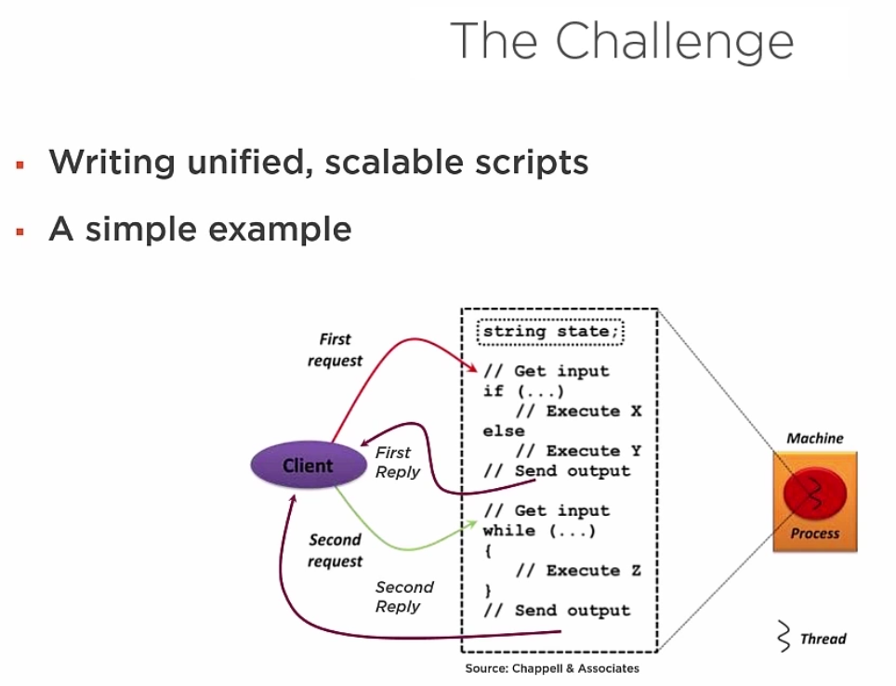

This can be achieved with a PowerShell script but then the script needs to wait for the reply from the client and that is not very scalable.

In General, a workflow needs to maintain state because a workflow could be long running, it could fail partway through, we need to be able to maintain state so that we can continue where we left off. Workflows need to get input from the outside world and sometimes need to send the output to the outside world.

A workflow also needs to provide alternative paths through logic using control statements. And finally, workflow needs to do application specific work inside the script.

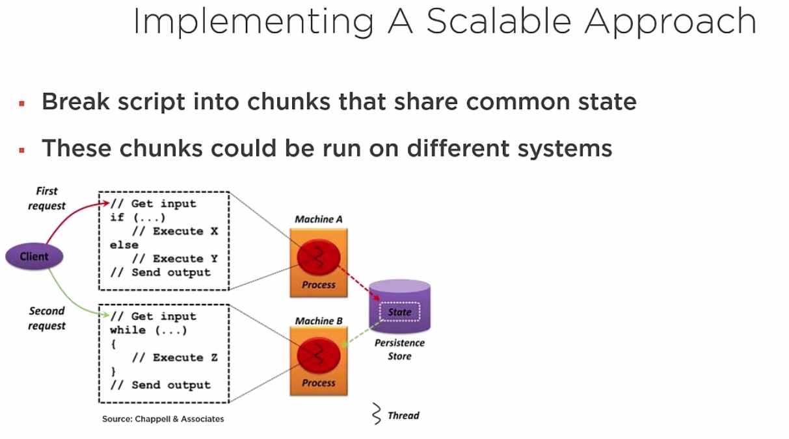

The only problem with this is how do we tell the system to run chunk 1 and chunk 2. This is where workflow comes in. Another question is how this separation is achieved and how do we know that a chunk has executed.

This is done via creating activities that describe this all via a workflow. So there was the code, but now in the Workflow foundation of workflows we have a series of steps.

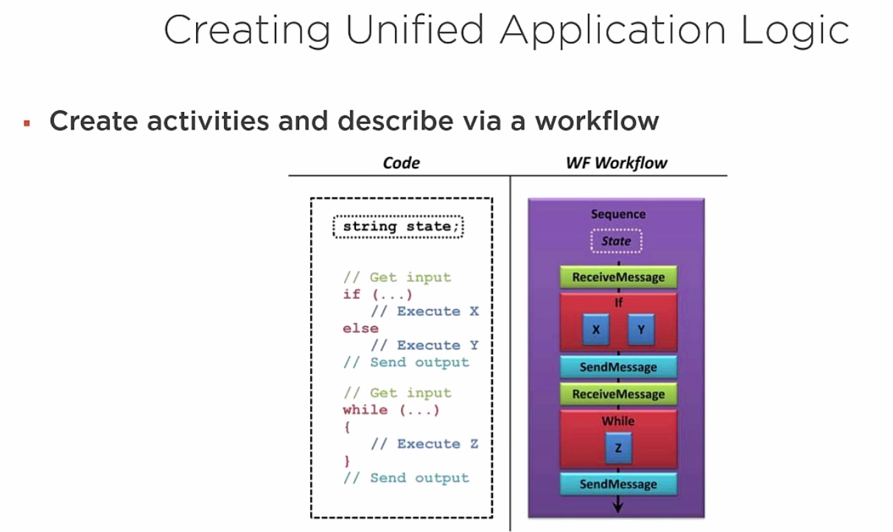

The first activity is receive message and then the if activity and so on. And when this workflow is ready, we can hand this workflow to windows and have it run. Workflow runtime will execute activities one by one.

A workflow state can be persisted. So in between of let’s say send and receive message activity, we can persist everything to a state to a file somewhere and then, when we receive the message that is when the input arrives, we can then restart the workflow and resume from where we left off. The impact of this scalability is that the workflow can be run on different threads, different processes and different hosts during its lifetime.

Once we save our persisted state in the persistence store after the send message, now whenever the client sends a message i.e. a receive message activity is triggered, we can get our persisted state from the persistence store and then carry on woth the second set of activities.

Windows workflow foundation (WWF):

It was a framework built into the .NET that enables workflow applications. It was first became available in Windows XP/Windows Server 2003. WWF contains a programming model, a rich workflow engines along with designers for visual studio. In general , you use WWF to solve a range of problems from simple to highly complex scenarios.

PowerShell v3 added a workflow feature. Now you can write what looks like PowerShell syntax and then PowerShell compiles that into a workflow that can be run with WWF.

In PowerShell, a workflow is a high level orchestrated execution of activities that is executed separately. Workflows in PowerShell are aimed at reliable execution of tasks that can run from a long time, focussed on robustness and reliability primarily.

Workflows in PowerShell provies state persistence and suspend/resume. That means that you can survive a reboot, the state after reboot will be retained. Also you can suspend and restart workflows as appropriate.

In general, workflows are designed for high concurrency, particularly building virtual machines in azure.

PowerShell cmdlets and control features can be converted into WWF workflows and activities but remember that *a PowerShell script is not an activity and activities are not PowerShell scripts.*

PowerShell workflows use extended PowerShell syntax. Cmdlets are translated into workflows activites. While most of the core PowerShell cmdlets can easily be translated into workflows and therefore into workflow activities, not all modules are going to that. Extended syntax maps to workflow features such as parallel execution.

Some PowerShell cmdlets do not map to workflow activities like Read-Host etc.

*When you use a workflow in PowerShell, you first compile the workflow and then you can call it to execute. This is just like a function. We run the function that has the code to effectively create a compiled function that loads it into the memory and then we can call it to execute the code inside of the it.*

Workflows can be discovered in PowerShell using

* Get-command
* Get-Help
* Get-ChildItem Function:

How do I use PowerShell and workflow:

Basically, use the workflow statement to create a workflow.

Use the PowerShell workflow syntax extensions inside the workflow and then you can run that workflow remotely or locally.

***Defining a PowerShell workflow:***

These are defined by the Workflow keyword.

Workflow <name of the workfkow> { script block that defines the workflow }

*Workflow Foo { “Hello World” } --displays string hello world.*

Here the hello world string gets converted into a workflow during the compilation time. The workflow activity then displays the string on the screen.

#A richer workflow

Workflow Get-PSHProcesses {

Get-Process *PowerShell* -PSComputerName DC1

Get-Process *PowerShell* -PSComputerName SRV1

Get-Process *PowerShell* -PSComputerName SQL2012

}

PSComputerName is not a Get-Process parameter. It is infact an activity common parameter.

This workflow allows us to use th Get-Process cmdlet, converts that into an workflow and then remote that into DC1,SRV1 etc.

Workflow Get-PSHProcesses2 {

Parallel {

Get-Process *PowerShell* -PSComputerName DC1

Get-Process *PowerShell* -PSComputerName SRV1

Get-Process *PowerShell* -PSComputerName SQL2012

}

}

In this case, we are getting the processes parallelly.

References

The Workflow Way: Understanding Windows Workflow Foundation by Don Chappellhttp://bit.ly/wfway

PowerShell Workflow: when should you use ithttp://bit.ly/pswfwhen

PowerShell Workflows: The Basicshttp://bit.ly/pshwfintro2

PowerShell Workflows: everything you need to know about it. <http://bit.ly/pshwfall>

**Building Workflows using PowerShell:**

PowerShell workflow syntax elements

* Workflow
* Parallel
* Foreach-Parallel
* Sequence
* InlineScript

*The workflow Staement:*

Syntactically, a workflow is similar to a function

* Both have a Name followed by a script block
* Both are ‘compiled’ then invoked
* Both can take parameters
* You can see both in the Function:drive and via Get-Command

Workflow Hello-World {

Param($String = 'Hello World')

$String

}

# Once compiled –you can see details in the Function driveGet-Item Function:Hello-World

# And get similar details from Get-Command Get-CommandHello-World

*Sequence Parallel and Foreach-Parallel Statements:*

Activitites can either run sequentially or in parallel. For sequentially, use the sequence statement. For running in parallel, use the Parallel or foreach-parallel statement.

Parallel activities can be throttled to minimise resource usage. By default, everything is run sequentially. You can embed sequences in parallel constructs and vice-versa.

Sequence { <script block> }

Workflow Do-Sequence {

Sequence

{

Get-CimInstance Win32_Bios –PSComputerDc1

Get-CimInstance Win32_Bios –PSComputerSrv1

}

}

There are two ways to run Workflow activities in parallel

Parallel { <statements> } -activies run in parallel

Foreach–Parallel {<statements>} -each iteration of the script block is run in parallel

When running in parallel, PowerShell handles throttling by default.Use New-PSWorkflowExecutionOption to change defaults.

Workflow Do-Parallel {

Parallel {

Get-CimInstance Win32_Bios –PSComputerDc1

Get-CimInstance Win32_Bios –PSComputerSrv1

}

}

----------------------------

Workflow Do-Parallel2 {

$Objs= @('Win32_Bios', 'Win32_ComputerSystem')

Foreach -Parallel ($Obj in $Objs) {

Get-CimInstance$Obj

}

}

---------------------------------

# Test Sequence vs Parallel

$Starts = Get-Date

1..100 | foreach { $o = Do-Sequence }

$Ends = Get-Date

"Sequence: $(($Ends-$Starts).totalmilliseconds)"

$Startp = Get-Date

1..100 | foreach { $o = Do-Parallel }

$Endp = Get-Date

"Parallel: $(($Endp-$Startp).totalmilliseconds)"

*Inline Script:*

Some PowerShell syntax does not really work inside a workflow. This is because in some cases you can’t really convert the PowerShell cmdlet into an activity. For these kind of scenarios, you can wrap all these cmdlets call inside of an inline script statement.

Activities contained inside of an inline script block are executed as a single process. Inline scripts can contain PowerShell cmdlets that aren’t available in a normal workflow. You can return objects from inline scripts.

*It is your get out of jail card.*

WorkFlowDo-Inline {

Param($Path)

$Files = InlineScript {

Get-ChildItem $Using:Path –Files –Filter *.txt

Get-ChildItem $Using:Path –Files –Filter *.ps1

}

$Files

}

Because we are using the the inline script as a separate process, we need to tell PowerShell the path parameter that we want to use is the path of the workflow parameter $Path and not something inside of the inline script.

And to do that we need to use the **$Using:Path.** Inline scripts does not have access to workflow variables and parameters by default. User has to explicit tell PowerShell to use the workflow variables and parameters inside of online script with use of $using scope keyword.

*Compiling Workflow’s:*

Whenever we run a script containing a function or a workflow definition, nothing seems to happen. But actually we are compiling the sctipt.

Running a Workflow definition compiles the workflow. Workflow is converted into a function and a function script block is created.

All the activities in that workflow is converted into a block of xaml. XAML is the markup language in which workflows are defined. If you are coding in the traditional C#, you would use xml to define the activities and then you actually have those activities coded in C#.

Here we are using the PowerShell cmdlets and language features t define the workflow activities and then these are converted to xaml. So the compilation process truns the workflow into a function and that function inturn runs the xaml.

*When you run a script containing a workflow, by default, you won’t see anything compiling. This is a typical scope issue. When you run a script in a child scope, the workflow id garbage collected when that scope is complete.*

**The trick here is to use the dot sourcing to run the script file.** If you run it in the ISE, the script is automatically dot sourced when you run it.

When you compile a workflow, PowerShell creates a new function definition you can see.

* Use Get-Command <workflowname>
* Or Get-Item Function:<Workflowname>

An actual funcition definition/scriptblock is also created and you can view that by:

* (LS Function:<workflowname>).ScriptBlock

The workflow xaml definition is also created.

* ( LS Function:<workflowname>).XamlDefinition

When you run a workflow, PowerShell executes the function scriptblock. The function converts any specified parameters into data for the workflow. Then it will call the API call to the [Microsoft.PowerShell.Commands.ImportWorkflowCommand]::StartWorkflowApplication()

And that’s where we actually run the application or run the workflow. Now, this process passes the necessary parameters to the workflow engine and WWF, then runs the actual workflow.

# Workflow Compilation Output.

#See the scriptblock

(DIR Function:<workflowname>).ScriptBlock | Out-File C:\Test\sb.ps1

#See the xaml

(DIR Function:<workflowname>).XamlDefinition | Out-File C:\Test\xaml.xml

**Restrictions in Workflow:**

It primarily arise due to architectural differences between PowerShell and WWF and the conversion between them. Not everything that you can do in PowerShell is valid with a Windows Workflow Foundation workflow. These restrictions include

- Some Automatic Variables unavailable

- Some cmdlets you can’t call

- Some PowerShell language features you can’t use

Language Restrictions:

Keywords that are reserved in Visual Basic .NET cannot be used as variable names in workflow

* $Date is disallowed

You can’t assign a variable value to another variable in one statement

* $a=$b=42 is disallowed

You can’t assign a value to an environment variable directly

* $env:foo=41 is disallowed

You cannot use variable references to change property values.

Cmdlets Restrictions:

Some groups of Cmdlets are unsupported

- *-Alias, $-FormatData, *-History, *-PSDrive, *-Transcript, *-TypeDate, *-Variable and Connect/Disconnect-WSMan

- These cmdlets change PowerShell Session

Interactive cmdlets are also unsupported

* Debug-Process, Get-Credential, Out-Gridview, Read-Host, Show-Command , Show-ControlPanelItem, Show-Eventlog

Transaction cmdlets are not supported in a workflow

* No *-transactioncmdlets

Other Restrictions:

Some PowerShell language features are not supported in Workflows

|  |  |  |
| --- | --- | --- |
| Begin/Process/End | Break, Continue | Sub Expressions |
| Multiple Assignment | Modify Loop Variables | Dynamicparameters |
| Set Properties | Dot Sourcing | Advanced parametervalidation |
| Positional Parameters | Switch statement | Trap statement |
| Inline Help | Setting drive qualified variables | Method invocation on objects |

This is going to make the conversion of a complex script into a workflow even more complex.

Some automatic variables cannot be used in a workflow:

- $Args

- $Error

- $MyInvocation

- $PID

- $PSBoundParameters

- $PsCmdlet

- $PSCommandPath

- $PSScriptRoot

- $StackTrace

Workflow Bad-Environment {

$env:foo = 21

}

Workflow Good-Environment {

InlineScript {

$env:foo = 21

'inside'

$Env:foo

}

'outside'

$env:foo #this won't work.

}

The first one throws compile-time error on assigning to the environment variable. In the second one, you will get the output o 21 for the inside use but no output will be there outside of the inline script.

Workflow Bad-Property {

$o = New-PSSessionOption

$o.SkipCACheck = $true

}

Workflow Good-Property {

$o = New-PSSessionOption -SkipCACheck

}

Using variables in a workflow:

You can use variables to do all the things that you used to do in the PowerShell script except that the variables work a little differently in workflow.

Workflow variables are variables created in the top level scope in a workflow

The commands/expressions in top level scope can view and update the values of these variables

Each command in a work flow runs in a separate runspace thus variables created in one part of a workflow may not accessible elsewhere

*Variables in a Nested Statements:*

In a loop or control statement

* You can view Workflow variable values
* You can change workflow variables
* Internal variables visible in workflow scope

Parallel/Sequence

* You can view workflow variable values
* You can’t change Workflow variable values (use $Workflow)
* Internal variables are not visible in workflow scope –return the values instead

InlineScript

* You cannot view Workflow variable values (Use $Using)
* You can’t change Workflow variable values –return values instead
* Internal variables are not visible in workflow scope –return the values
* Variables defined in a higher scope are visible to lower workflow scopes
  + But not Inlinescriptscopes
* No $Globalscope
* Use “$Using:” in InlineScriptblocks to access/modify variables defined in a higher scope
* Use “$Workflow” to access/modify Workflow variables

# Workflow variables visible inside lower level scopes

# Internal variables visible in workflow scope

Workflow test-variables1 {

$a = 1,9,42

foreach($number in $a) {

"number = $number“

$i++

}

$i

}

PS C:\WINDOWS\system32> test-variables1

number = 1

number = 9

number = 42

3

# Variables restrictions – you can view workflow variables inside sequence but cannot change it without using the $workflow: scope. In this case the assignment of a to b will not work.

Workflow test1 {

$a = 42

Sequence {

$b = $a

$workflow:c = $a

}

"variable a is: [$a]"

"variable b is: [$b]"

"variable c is: [$c]"

}

PS C:\WINDOWS\system32> test1

variable a is: [42]

variable b is: []

variable c is: [42]

# Variables restrictions – Inline script : use the $using scope to access workflow variables inside the InlineScript. Also notice that there is no output for the $i used outside of the foreach loop. This is because we cannot access inlinescript variables outside in the workflow unless it is not been outputted.

Workflow test-variables2 {

$a = 1,9,42

foreach ($number in $a) {

InlineScript {

"inside number = $number"

"inside number = $using:number (from workflow"

$i++

}

"outside number = $number"

}

$i

}

PS C:\WINDOWS\system32> test-variables2

inside number =

inside number = 1 (from workflow

outside number = 1

inside number =

inside number = 9 (from workflow

outside number = 9

inside number =

inside number = 42 (from workflow

outside number = 42

Workflow Test-Workflow {

#Workflow (top-level) variable

$w = 42

Parallel {

Sequence {

# You can get the values of workflow variables.

"Sequence W = [$w]"

# To change the value use the $Workflow scope

$Workflow:w= 5

"New w = [$w]"

}

}

# The change is visible in workflow scope.

"Workflow = [$w]"

}

PS C:\WINDOWS\system32> Test-Workflow

Sequence W = [42]

New w = [5]

Workflow = [5]

Workflow References:

PowerShell Workflow –what you need to know

-http://bit.ly/pswfayntk

Writing a Script Workflow

-http://bit.ly/pshwawf

Using Variables in Script Workflows

-http://bit.ly/pswfvar

Running Windows PowerShell Commands in a Workflow

-http://bit.ly/pshwfcom

Workflow Help References:

Each reference is both a help file inside PowerShell and a page in TechNet

The help files are contained in the PsWorkFlowmodule

Key Help files re workflow syntax –in TechNet

About_InlineScript

•http://bit.ly/psilswf

About_Parallel

•http://bit.ly/psparwf

About_Foreach-Parallel

•http://bit.ly/psfepwf

About_Sequence

•http://bit.ly/psseqwf

**Running PowerShell Workflows:**

Before we can actually run a workflow, we have to make sure we make a suitable environment for which they can run.

3 key aspects of a workflow environment

1. Ensuring supported operating systems and system architectures
   1. Needs PowerShell v3 atleast.
   2. You also need to install windows management framework or run an OS that has the WMF loaded. WMF is a package that contains PowerShell itself plus all the supporting features such as WMI updates.
2. Configuring workflow -> if we want to run a workflow on a non domain joined machine, we need to configure the workflow to have a parameter to specify the credentials against which the workflow will run on that machine.
   1. Ensure correct versions of PowerShell and .net installed
   2. Ensure PowerShell remote management is enabled.
   3. Configure workflow session. Doing this will
      1. Optimize performance
      2. Enabling shared process hosting
      3. Adjusting WinRM memory quota
      4. Configure the location of the modules containing workflows
3. Enable host to run a workflow.
   1. There are basically 3 hosts involved in workflows
      1. Workflow management server – machine on which you would actually manage or edit a workflow. Requires PowerShell v2 or higher. You can do debugging if you have PowerShell v4 or higher
      2. The workflow client – requires PowerShell v3 or higher. Machine onn which we will actually run the workflow
      3. Managed nodes – it is the machine on which we will configure the nodes using the workflow. Requires PowerShell 3 or higher.
   2. Edit workflow on management host and run workflow on client
   3. Edit and run workflow on client
   4. Run workflows and activities directly on managed hosts – only for small businesses.

-----------------------------------

Workflows can be run direcly on a managed node. It is much like running a function compile then use

Workflows can also be run remotely. It is much like using Invoke-Command to run a script remotely

Workflows can be run locally as a job. The job can run activities remotely

Workflows have common parameters that allow you to manage and run a workflow or activity remotely

*Running it locally: Compile it and then run:*

# Demo 3-1

# Running a basic PowerShell Workflow

# Define the workflow

Workflow Get-BiosWF

_ {

_ Get-CimInstance Win32_Bios

_ }

# Invoke the workflow

Get-BiosWF

Get-BiosWF

SMBIOSBIOSVersion : F.21

Manufacturer : Insyde

Name : F.21

SerialNumber : CND7324M30

Version : HPQOEM - 0

PSComputerName :

*Running a workflow remotely:*

There are two ways to do this.

1. Run workflow and use a common workflow parameter to specify a managed node that should actually run the workflow.
2. Run the workflow locally, but inside the workflow, use common activity parameters and run all or part of workflow remotely.

Workflow Get-BiosWFR

{

Get-CimInstance Win32_Bios

}

# having compiled, we can now call the workflow. PSComputerName is a common Workflow parameter.

Get-BiosWFR -PSComputerName DC1

# Run parts of a workflow remotely

# Define the workflow . Here PSComputerName is a common activity parameter

Workflow Get-BiosWFR

_ {

_ Get-CimInstance Win32_Bios -PSComputerName DC1

_ Get-CimInstance Win32_Bios -PSComputerName srv2

}

# And now, invoke the workflow

Get-BiosWFR

*Workflows Parameter:*

A workflow can have its own parameter defined in the param() block.

-Common Workflow parameters.

These change how the workflow is run and implicitly defined for all workflows. You can see these in the compiled function block. These common parameters mainly begin with a ‘PS’.

You can have a look about all the common parameters in PowerShell

About_Workflow_Common_Parameters

Below are the common workflow parameters

The below set tells us how we are gonna get to the machine where we are going to run this workflow

PSComputerName

PSPort

PSUseSSL

PSAllowRedirection

PSConnectionURI

PSApplicationName

PSConfigurationName

When we get on that machine, we may need to specify alternate credentials so I can for example run a workflow on a workgroup machine not member of my domain, but pass it workgroup credentials and possibly specify authentication and so on.

PSCredential

PSAuthentication

PSAuthenticationLevel

PSCertificateThumbprint

To run the workflow as a job.

AsJob

JobName

Given that networking is involved and we are running workflow on a remote machine, we may need to adjust some of the networking parameters like below.

PSConnectionRetryCount

PSConnectionRetryIntervalSec

PSElapsedTimeoutSec

PSParameterCollection

PSRunningTimeoutSec

We can manage persistence.

PSPersist

PSPrivateMetadata

PSSessionOption

# Common Workflow Parameters – From SRV1

Workflow Get-Bios

{

Get-CimInstance –Class Win32_Bios_

}

# Use Common Workflow parameters when invoking workflow

Get-Bios –PSComputer DC1 -PSAuthentication Kerberos -Verbose

This will run the workflow on our machine but against the DC1

Using PsParameterCollection. Calling a workflow with -PSParameterCollection runs the workflow multiple times with different sets of parameters.

This is easier instead of calling the workflow multiple times.

This parameter is an array of hastables, each array member holds a hoshtable that holds the parmaters for the invocation of the workflow.

**Note: there are errors in the help file for the PSParameterCollection. The examples that are shown are not correct. So you cannot rely on this help file unless it is correct. This error has already been reported. Be cautious.**

# Workflows Using ParameterCollection

$PSParameterCollection = @{

PSComputerName = 'DC1'

PSElapsedTimeoutSec = 5

PSConnectionRetryCount = 6

PSCredential = $Cred_DC1

},

@{

PSComputerName = 'SQL2012';

PSElapsedTimeoutSec = 10

PSConnectionRetryCount = 10

PSCredential = $Cred_SQL2012 }

# Define a simple workflow

Workflow Get-Bios {Get-CimInstance -Class Win32_Bios}

# Invoke it

Get-Bios -PSParameterCollection $PSParameterCollection `

-AsJob -JobName 'Job4.3'

# setup

$Cred_DC1 = $credrk

$Cred_SQL2012= $Credrk

*Common Workflow Activity Parameters:*

Within a workflow , you can specify additional common parameters for each activity.

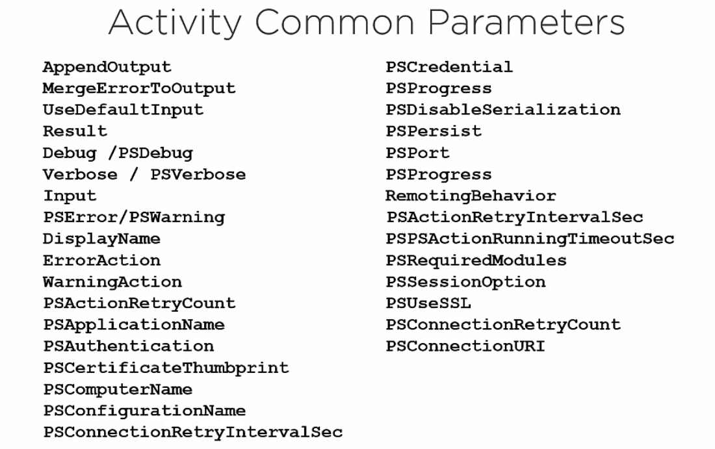

#Activity Parameters

Workflow Get-CimClassWF_

{

_ [CmdletBinding()]

_ Param ($CimClass = 'Win32_Bios',

$comp = 'DC1')

#Get The CIM Class

_ Get-CimInstance $CimClass –PSComputer $comp –PSCredential $credrk

_}

#Invoke the workflow WITH parameters_

Get-CimClassWF -CimClass 'Win32_ComputerSystem'

Get-CimClassWF -CimClass 'Win32_ComputerSystem' -Comp ‘SRV1’

*PowerShell Workflow Modules:*

PowerShell from v3 and above coms with 2 workflow modules

1. PSWorkflow
   1. New-PSWorkflowSesson
   2. New-PSWorkflowExecutionOption
   3. There are 9 conceptual workflow help files
   4. It also contains some MAML (Microsoft Assisted Markup Language)
2. PSWorkflowUtility
   1. Invoke-ASWorkflow

#Workflow Modules

# Import the modules

Get-Module PSWorkFlow -ListAvailable | Import-Module

Get-Module PSWorkFlowUtility -ListAvailable | Import-Module

# What's inside?

Get-Command -Module PSWorkFlow

Get-Command -Module PSWorkFlowUtility

# Get details of PSWorkflow

Explorer $pshome\Modules\psworkflow

*PowerShell workflow preference variables:*

You can use all of the PowerShell preference variables in a workflow. Like other preference variables, these can be set and would have an effect on any workflows subsequently run.

Some of the PowerShell workflow specific preference variables are:

* $PSDisableSerializationPreference
* PSParentActivityId
* PSPersistPreference
* PSRunInProcess

# Workflow Preference Variables

Workflow Invoke-Preference

{

Param ($pref)

# set preference variable

$PSPersistPreference = $pref

# rest of workflow

$a = 42

$i = Get-CimInstance win32_bios

$b = 42

}

$s = Get-date ; Invoke-Preference -pref $true

$e = Get-date ; " Total time: {0}" -f ($e-$s).TotalMilliseconds

$s = Get-date ; Invoke-Preference -pref $false

$e = Get-date ; " Total time: {0}" -f ($e-$s).TotalMilliseconds

**Managing Workflows:**

Workflows and functions are similar in many ways. Unlike funcitons though, workflows can be suspended and resumed. You can suspend a workflow for a human input and resume it once the input is received. Long running workflows can also be checkponted. This enables the workflow to be restarted from the last checkpoint in case of error.

A checkpoint is a snapshot of the current state of the workflow. PowerShell automatically uses the data in the newest checkpoint for the workflow to recover and resume. The checkpoint data (or persisted data) for a workflow is saved in the user profile of the computer that hosting the workflow session.

If you run the workflow as a job, checkpoints are retained until you delete a job such as by using the Remove-Job cmdlet or when the workflow completes.

You can implement workflow in mainly 2 ways.

1. Use Checkpoint-workflow activity inside the workflow to save state.
2. Use -PSPersist activity or workflow common parameter. Using this will make every activity in the workflow to cause a checkpoint. If we use this parameter with the activity then it will create a checkpoint after that activity.

Checkpoint-workflow is little more explicit.

*Once the workflow has been suspended, you can resume it by using the Resume-Job cmdlet. Notice that the cmdlet is not the Resume-Workflow. This is because workflows hook into the job architecture and so, if we suspend a workflow, job related to that workflow is suspended that can be resumed.*

# Checkpointing of workflows

Workflow chkpt-wf {

Get-Process

foreach ($x in 1..100)

{$x; checkpoint-workflow; Start-Sleep -Seconds 2}

}

chkpt-wf -asjob

Get-Job | Receive-Job -Keep

Use the Suspend-Job to suspend the currently running job.

References:

Windows PowerShell: PowerShell scripts versus PowerShell workflowshttp://bit.ly/28ZTwKr

**Debugging/Troubleshooting Workflows:**

Set line breakpoints in the script workflows can be helpful. Write-Debug and Write-Verbose can be helpful.

You cannot set variable change breakpoints. That is when a variable value changes, set the breakpoint. That is not possible.

No command breakpoint can also be set.

You can set conditional breakpoints.

Nested workflow debugging is not supported. You can’t step into a workflow that’s being called by another workflow. Breakpoints set in the nested workflows are never hit.

You also can’t debug individual PowerShell activity as they execute.

You can’t debug a script workflow that runs as a job.

You can get value of workflow variables at the debugger point but you cannot set the variable at that point.

You also can’t set a breakpoints in Inline Scripts block. Even if you set the breakpoint inside the inline script, they are never hit.

# Demo 5-1_

# Define a workflow_

Workflow Debug1 {

_ $A = 42

_ $B = Get-CimInstance –Class Win32_Bios

_ $L = $B.CurrentLanguage

InlineScript {

$i=42

Get-Ciminstance -class win32_computersystem

Get-CimInstance -class win32_processor

$Using:a

}

_ "Language: $L"

_}

# Set a breakpoint_

Set-PSBreakpoint -Script '.\Demo 5-1.ps1' -Line 5

Debug1

Use Set-Breakpoint cdlet to set the breakpoint inside a script.

When you run a work flow with –ASJOB parameter, PowerShell creates/uses a job object to track the flow

If the workflow has crashed due to an error

- Get the job object representing the workflow ( Use Get-Job)

- Examine job’s JobStateInfoproperty and it’s Reasonsub-property

ETL Logging:

You can turn on ETL (Event Trace Log) logging

-Creates detailed logging information on workflow

-Probably more useful for MS Support than the average use

Turn ETL Logging on

* Use Enable-PSWSManCombinedTrace

Turn ETL Logging off

* Use Disable-PSWSManCombinedTrace

# Demo 5-2 -ETL Logging

WorkflowTest-Etl {

'1'

Get-CimInstanceWin32.Bios # Note typo'2'

}

# Now enable ETL logging and run the workflow

Enable-PSWSManCombinedTrace # Turn on the logging

Test-Etl # Run the workflow

Disable-PSWSManCombinedTrace # Turn off logging

# View Results

$events=Get-WinEvent-Path$PsHome\Traces\PSTrace.Etl–Oldest

$events|Where-Objectmessage-match'workflow'|Select Time,Message| Out-GridView

**PowerShell cmdlet development in C# - In’s and Out’s:**

The first question is why we want to write our own cmdlet’s in C# when we know we can write powerful functions in PowerShell alone. The reason is we know this language comfortably and what’s harm in writing PowerShell cmdlet in C#. further, we have some tricks like lambda, linq in C# which is not there in PowerShell.

You can also reuse existing code. Also tools available for testing the cmdlets in C# are far superior than PowerShell tool for testing.

Requirements

1. Windows
2. PowerShell version 3+ - PowerShell v3 supports.Net framework 4.0
3. Visual Studio

Create a new project with blank solution in visual studio.

Then, Create a windows class library project in the solution (the class library project should be a .Net framework one and not .Net Standard)

Add the below references

* System.Management.Automation (type in install-Package System.Management.Automation to install references of this nuget directly into your solution in the package console manager)

Creating a cmdlet involves inheriting from one of the two classes.

1. Cmdlet – this is the quicker and easier route.
2. PSCmdlet – this is the most powerful and flexible of the two classes

Just inherit from this class, override one or more methods and you are done.

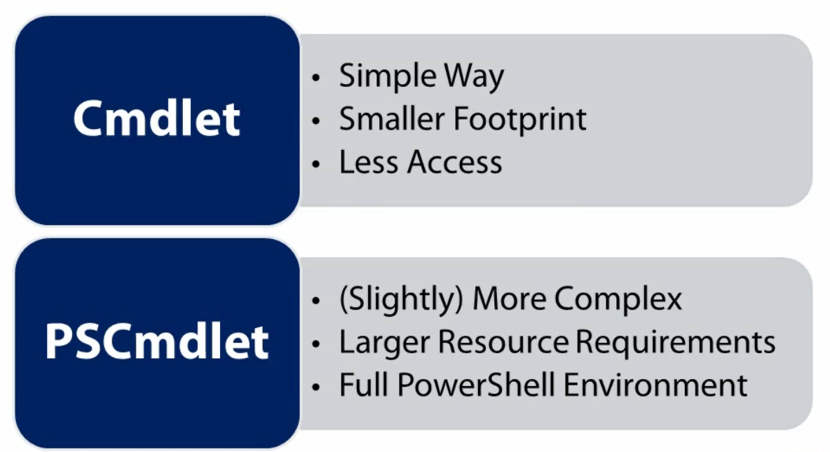

Creating cmdlets in C# creates a Binary Module in PowerShell

To use the cmdlets in PowerShell, we need to import the dll of our solution. Then run your cmdlet. It is as simple as this.

Now suppose you want to change something for the cmdlet. *You have to go to the C# solution and change it. Rebuild the solution.* ***But you rebuild will fail. This is because you are using the dll in powerhsell***

***So let’s remove the module from PowerShell by using the cmdlet Remove-Module in PowerShell and then build the solution again. The build fails again.*** This is because PowerShell keeps a lock on the dll even if the module is removed.

So close the PowerShell and try rebuilding again. This time it will build successfully.

Now when you restart the PowerShell, it will take slightly longer to load than before.

So here we have two problems

1. PowerShell kepps a lock on the dll once it is imported.
2. Restarting PowerShell takes a long time.

Let’s change the dubug settings for the project. Right-click on the project and select properties. Go to debug and select Start External program. Provide the path of the PowerShell exe. C:\Windows\System32\windowsPowerShell\v1.0\PowerShell.exe

Also provide the command line argument.

-NoProfile -NoExit -Command “Import-Module .\MyCmdlets.dll”

Now since the debugger starts directly in the context of the bin\debug directory, we will directly import out project dl lao that our cmdlets are available as soon as the PowerShell starts.

NoExit says that do not exit the PowerShell. NoProfile switch says to not load the user profile as this will make PowerShell to load faster.

**The Cmdlet Class:**

It is the simplest way to create a cmdlet in PowerShell. It has a smaller footprint to keep loaded in your PowerShell environment. This comes with the cost of lower feature subset.

There might be a confusion between cmdlet and Cmdlet. The one with the lower c and he one with the upper C. when the base class shares the same name with the thing you create by extending the class, some confusion is unavoidable. The Uppercase Cmdlet name is used for the base class name and the lowercase c cmdlet for the general concept of those things that poewrshell runs.

It is always appropriate to use cmdlet. But let’s take some things into account

1. No environment access need – it is helpful when the cmdlet does not need access to the current poewrshell environment. For example, you don’t need to share state variables with the environment or with other cmdlets.
2. If a cmdlet does not concerned about its own state between calls, it is a good choice to use Cmdlet base class.

Let’s build a cmdlet to Scrub data.

What we want to achieve is that we want to pass a name to the cmdlet and then it will return us a random name with the same length as that of the input name.

If we pass a name with the name parameter, it should return us the same name

The cmdlet should also be able to take names through a pipeline.

*Minimum Viable Cmdlet:*

To be considered a cmdlet in PowerShell, your class really needs to do two things. It should inherit from the cmdlet class. This gives it all of its default behaviour and all of h hokks PowerShell needs to call your cmdlet.

You also eed to decorate your class with the verb and noun you need to identify the cmdlet.

Import System.Management.Automation in your class and then inherit you class with Cmdlet.

Decorate your class with the cmdlet attribute. It does’t matter what is the name of the class. We are defining the what our cmdlet is called through the decorator. Also the class should be public otherwise PowerShell will not be able to see the cmdlet no matter how much we follow the rest of the steps.

Let’s decorate our class with [Cmdlet("Get","RandomName")]

Now here, we have our verb and Noun as string and we can name it anything. If we change our verb from Get to something like GiveMeA, it is also valid but when PowerShell loads it will throw us a warning saying that this is not a standard way to name your cmdlet.

The more standatd way to do this is to decorate the verb using the VerbsCommon class. This class gives us all the standard verbs as per the PowerShell rule.

We also have verb classes for VerbsCommunication, VerbsData, VerbsDiagonostic, VerbsLIfeCycle, VerbsOther, VerbsSecurity.

All of these classes are really a collection of public string constants.

*Parameters:*

Let’s now see how we can give information to your cmdlet. Parameters are usually public properties on your cmdlet class. These properties can be either auto properties or backed properties. You can also use public member variables as well.

*You have to decorate your public properties with the parameter attribute.*

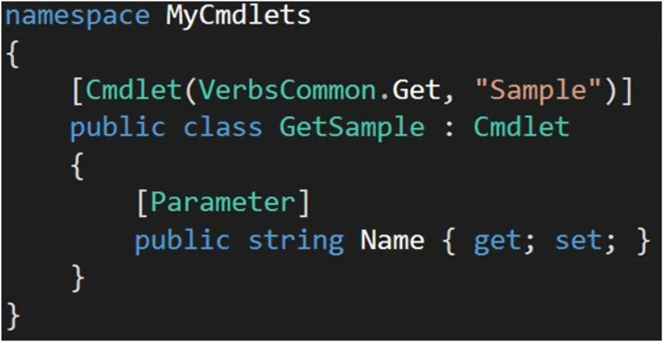

This is called auto properties. We are not explicating implementing the getter and setter property here.

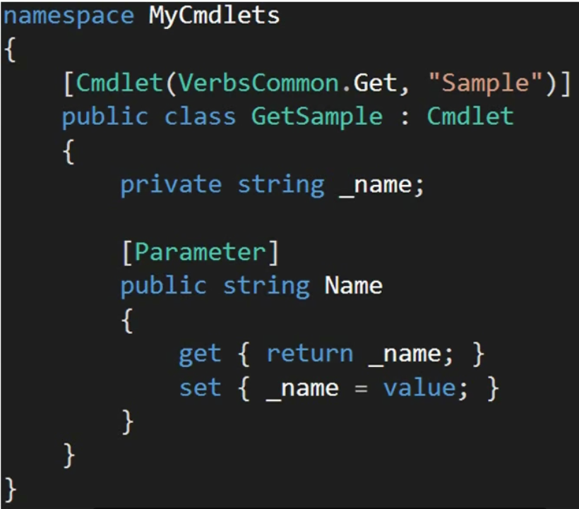

This is called backed property. We are explicitly implementing getter and setter here.

PowerShell does not care how you do it. It just need the property to act as a parameter in order to identify if the cmdlet has any parameters or not.

*Out parameter requires a string parameter but it is not necessary. PowerShell parameters are typed. But using the specific type parameter saves you from a lot of overhead of type-casting.*

We can also have complex type. Just that using these complex type in PowerShell is a little more tricker.

Let’s say

Public class NumberRange {

Public int Min { get; set; }

Public int Max { get; set; }

}

Public class GetNumbersInRange

{

Public NumberRange Numbers { get; set;}

}

*In PowerShell,*

Get-NumbersInRange -Numbers @{Min=5; Max=10}

So we are creating a hashtable that has keys which are member of the NumberRange class. PowerShell will automatically convert this hashtable into a NUmberRange type.

Another way to do this is

$nums = new-Object MyCmdlets.NumberRange

$nums.Min = 4

$nums.Max = 7

Get-NumbersInRange -Numbers $nums

It is going to be hard to show what’s going on with parameters if we don’t have any output. Let’s override the ProcessRecord method of the Cmdlet base class. *ProcessRecord() method is called when our cmdlet runs in PowerShell and this can be used to provide output.*

public class GetRandomName : Cmdlet

{

[Parameter(Mandatory = true, Position = 1, ValueFromPipeline = true)]

public string Name { get; set; }

protected override void ProcessRecord()

{

Console.WriteLine("{0} Len{1} ", Name, Name.Length);

}

}

*Other overridable methods:*

1. **ProcessRecord() –** it is called one or more times per invocation depending on how much input is supplied. It is called once per pipeline element. If you are passing singular object, this method is called once. If you are passing array, processREcord() is called once per array. If values from pipeline are coming the the processRecord() is called for each value in the pipeline. This method id used when youneed to do bulk of processing.

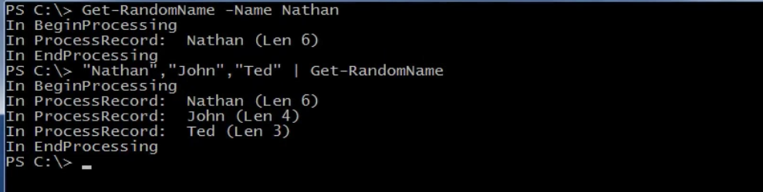

1. **BeginProcessing()** – called once per invocation. It is not really for working with parameter values. It is uused of the parameter values are questionable. If these parameters are passed by name or by position, beginProcessing() can’t access them. If a parameter is passed by the pipeline, beginProcessig() will not be able to see that value. If your cmdlet is supplied with configuration values as parameters, it’s safe for beginProcessing() to deal with those values. Outside of this, you shouldn’t be working with data in the begin processing.

*So, in short we can say that it is used for initializing resources.*

1. **EndProcessing()** – it is opposite of beginProcessing(). It is also called only once per invocation when your cmdlet finishes execution. It is only called when your cmdlet runs for completion. If anything interrupts your parameter, endProcessig will not necessarily be run.

It is a good place for disposing resources if used any. Endprocessig() will be able to see the last value of the pipeline of the parameter.

1. **StopProcessing()** – this method is very closely related to endProcessing(). *It is only called sometimes and in place of the EndProcessing(). When the cmdlet execution is interrupted, stopProcessing() is called.* This means if you hit Ctrl + C to end execution, stopProcessing() is called. ***It is important to cleanup your resources here.*** *So in general it is a good practice to clean up resources both in endProcessing() and stopProcessing().*

with endProcessing(), you cmdlet processes to the completion so part of the cleanup is to commit the transaction. Since, stopProcessingn() represents an interruption, the more appropriate action here is to rollback the transaction.

Where endProcessing sees the last value supplied, stopProcessing sess the last value before the execution was interrupted.

Either StopProcessing() is called or EndProcessing() is called. Both of them cannot be called simultaneously.

*Cmdlet Output:*

We need some way to write the output directly to the pipeline. We need WriteObject() for this. It’s purpose is to take whatever you pass it and send it further down the pipeline. It deals with objects and not just strings. If you are working with primitive types like integers and Boolean, this method sends those to the pipeline.

Striing are object in .Net . StringBuilder, XmlREquest, WebRequest these are also objects in .Net.

This is the most important method provided to you by the Cmdlet base class.

Secondary methods for providing cmdlets output are:

WriteVerbose – the output of this is not passed down the pipeline and it can be used to display more detailed information of what going on in your cmdlet. Cmdlet must be invoked with -Verbose or -Debug parameter.

WriteDebug()

Write-Warning() – the execution keeps to go on after displaying the warning and this behaviour can bechanged by using the WarningAction parameter. Accepts string as the parameter value.

WriteError() – accepts Error object as the parameter value.

WriteCommandDetail() – this method is used for writing detailed information about the pipeline to the windows event log. These messages will only show up if your module has the log pipeline exception details property set to true. If this is true, the messages themselves only shoe up in the windows PowerShell section of the Event Viewer and won’t be displayed directly to the user.

WriteProgress() – this is used to display a small status section in which you can provide the user with some small feedback on what your cmdlet is currently doing. *You might use this to show which record number you are processing so users can clearly see the long running cmdlet is still working. In our case, it might show which name is currently being processed.*

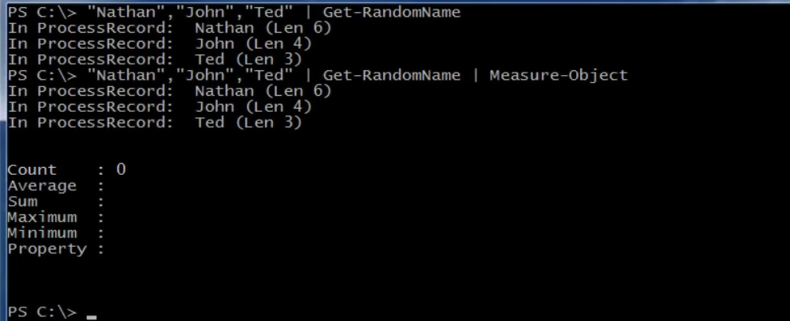

We have removed the output from the beingProcessing(0, endProcessing() and stopProcessing().

We see two problems in the current output. We see that Measure-Object outputs the ProcessRecord() console writeline and says the count to 0. We can say that output from randomName fell out of the pipeline. We know that console writeline does not write to the pipeline and directly writes to the screen.

Let’s now use the WriteObjecct() method instead of Console.WriteLine()

protected override void ProcessRecord()

{

var nameCharachers = Name.ToCharArray();

Array.Reverse(nameCharachers);

WriteObject(new {

ReversedName = new String(nameCharachers),

NameLength = Name.Length

});

}

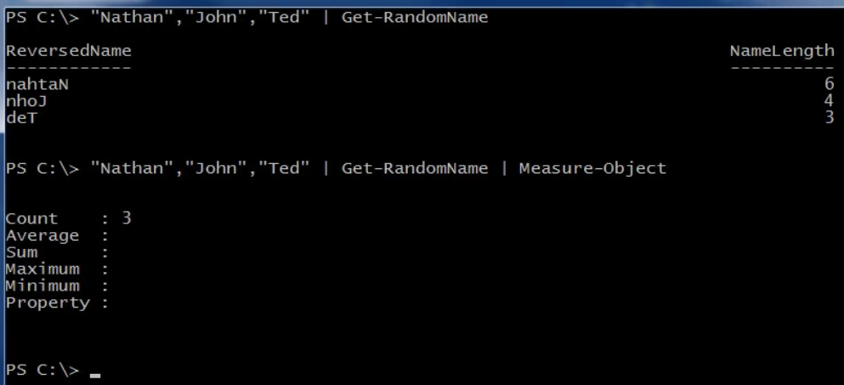

Now this works fine. Now measure-Object says the count as 3. This is because with WriteObject, output is going to the pipeline.

Sometimes we need to see the output in the console but without breaking the pipeline. Here now to achieve this, we will use WriteVerbose() method.

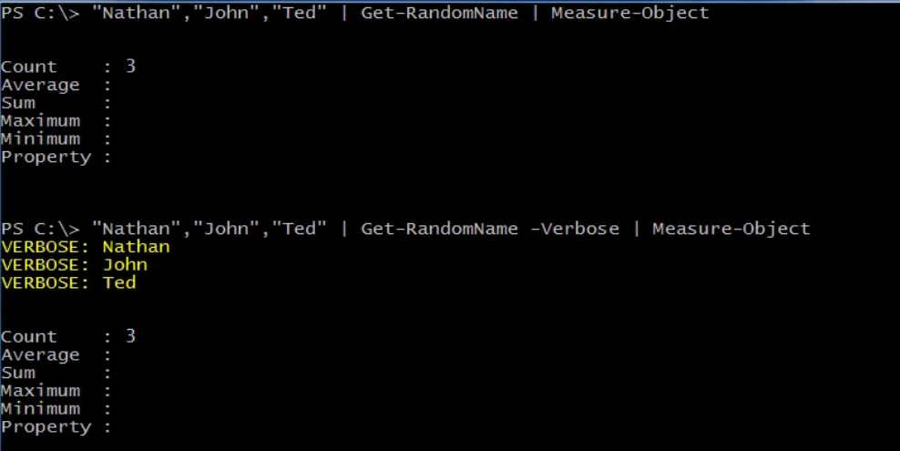

*Leveraging Outside Data:*

Some cmdlets need external data in order to do the job. Wee want to replace the name with another name of the same length. In order to do that, we need to have a list of valid names.

**The PSCmdlet Class:**

It provides more access to the PowerShell environment. By using this, we will be able to access the state of the pPowerShell sessions, get and set PowerShell variables etc. these are additions to the Cmdlet base class. PSCmdlet itself extends the cmdlet base class. So everything we learned there is still applicable.

Note here that PSCmdlet isn’t always the right choice.

It’s advantages are

1. Persist state between invocations.
2. Better parameter set support.
3. Run scripts from your cmdlet.

It’s disadvantages are

1. Greater memory footprint.
2. Dependency on the PowerShell environment.

*We are going to build invoke sqlQuery in this module.*

We will open the Sql connection in the beginProcessing(). We will not be using the using statement for opening connection that we normally do when working with a disposable resources like sql connection. This is because we are opening our connection in begin processing and then using that connection in another method.

Using statement opens the connection, does the task and then closes the connection. We don’t want that here.

The right thing to do here id to handle any exceptions by using the try catch fially blocks.

public class InvokeSqlQuery : PSCmdlet

{

[Parameter(Position = 1)]

public string Server { get; set; }

[Parameter(Position = 2)]

public string Database { get; set; }

[Parameter(Position = 3, Mandatory = true)]

public string Query { get; set; }

private SqlConnection _connection;

protected override void BeginProcessing()

{

ValidateParameters();

var connectionString = String.Format(@"DataSource={0};InitialCatalog={1};IntegratedSecurity=SSPI", Server, Database);

_connection = new SqlConnection(connectionString);

_connection.Open();

}

protected override void EndProcessing()

{

if (_connection != null)

_connection.Dispose();

}

protected override void StopProcessing()

{

if (_connection != null)

_connection.Dispose();

}

protected override void ProcessRecord()

{

using (var command = _connection.CreateCommand())

{

command.CommandType = System.Data.CommandType.Text;

command.CommandText = Query;

using (var reader = command.ExecuteReader())

{

while (reader.Read())

{

var record = new PSObject();

for (int i = 0; i < reader.FieldCount; i++)

{

record.Properties.Add(new PSVariableProperty(new PSVariable( reader.GetName(i),reader[i])));

}

WriteObject(record);

}

}

}

}

private void ValidateParameters()

{

if (string.IsNullOrEmpty(Server))

ThrowParameterError("Server");

if (string.IsNullOrEmpty(Database))

ThrowParameterError("Database");

}

private void ThrowParameterError(string parameterName)

{

ThrowTerminatingError(

new ErrorRecord(

new ArgumentException(String.Format("Must Specify '{0}'", parameterName)), Guid.NewGuid().ToString(), ErrorCategory.InvalidArgument, null

));

}

}

**Parameters Sets:**

This is grouping of parameters. These let your cmdlet to respond to multiple type of input. Parameters can themselves be a part of multiple parameter sets.

**Session Variables:**

These are used to persist values between invocations. Your cmdlet can set some value when its invoked and then retrieve that value when invoked next time.

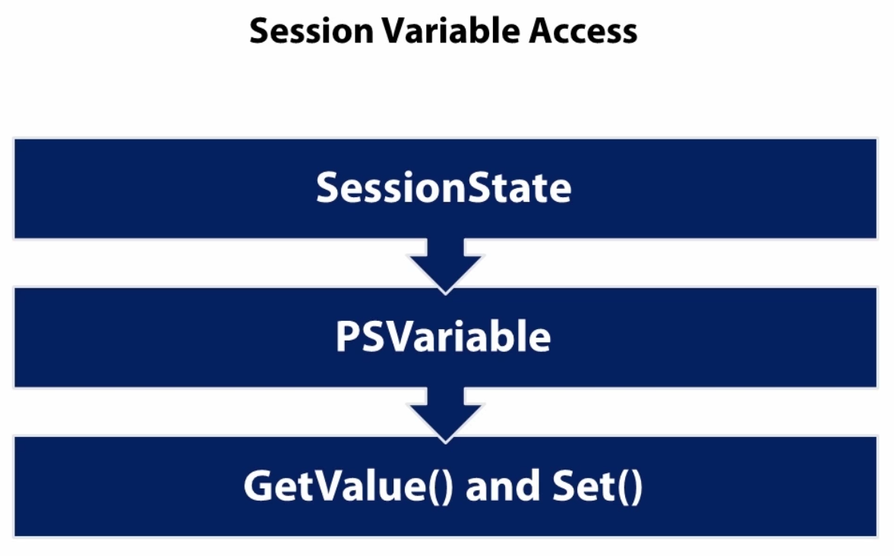

These are stored as regular PowerShell variables. PowerShell stores these variables for the current session. You can think of this as the current console. A variable open in one session won’t be available in the other session. Anything your cmdlet stores can easily be discovered by your users with the help of Get-variable cmdlet. If you don’t want user to know about a value, don’t put it in the session variable.

We are going to store the server and the database in the session variable and this way every time we use our cmdlet, we do not need to supply for server and database parameter. We are doing this as these parameter are not changing frequently.

[Cmdlet(VerbsLifecycle.Invoke, "SqlQuery", DefaultParameterSetName = IntegratedAuth)]

public class InvokeSqlQuery : PSCmdlet

{

private const string IntegratedAuth = "IntegratedAuth";

private const string SqlAuth = "SqlAuth";

[Parameter(Position = 1, ParameterSetName = IntegratedAuth)]

[Parameter(Position = 1, ParameterSetName = SqlAuth)]

public string Server { get; set; }

[Parameter(Position = 2, ParameterSetName = IntegratedAuth)]

[Parameter(Position = 2, ParameterSetName = SqlAuth)]

public string Database { get; set; }

[Parameter(Position = 3, Mandatory = true, ParameterSetName = IntegratedAuth)]

[Parameter(Position = 3, Mandatory = true, ParameterSetName = SqlAuth)]

public string Query { get; set; }

[Parameter(Position = 4, Mandatory = true, ParameterSetName = SqlAuth)]

public string Username { get; set; }

[Parameter(Position = 5, Mandatory = true, ParameterSetName = SqlAuth)]

public string Password { get; set; }

private SqlConnection _connection;

protected override void BeginProcessing()

{

ValidateParameters();

WriteVerbose(this.ParameterSetName);

string connectionString;

if (this.ParameterSetName == IntegratedAuth)

{

connectionString = String.Format(@"DataSource={0};InitialCatalog={1};IntegratedSecurity=SSPI;Persist Security Info = true", Server, Database);

}

else

{

connectionString = String.Format(@"DataSource={0};InitialCatalog={1};User ID={2};Password={3}", Server, Database,Username,Password);

}

_connection = new SqlConnection(connectionString);

_connection.Open();

}

protected override void EndProcessing()

{

if (_connection != null)

_connection.Dispose();

}

protected override void StopProcessing()

{

if (_connection != null)

_connection.Dispose();

}

protected override void ProcessRecord()

{

using (var command = _connection.CreateCommand())

{

command.CommandType = System.Data.CommandType.Text;

command.CommandText = Query;

using (var reader = command.ExecuteReader())

{

while (reader.Read())

{

var record = new PSObject();

for (int i = 0; i < reader.FieldCount; i++)

{

record.Properties.Add(new PSVariableProperty(new PSVariable( reader.GetName(i),reader[i])));

}

WriteObject(record);

}

}

}

}

private void ValidateParameters()

{

////If not using session state

//if (string.IsNullOrEmpty(Server))

// ThrowParameterError("Server");

//if (string.IsNullOrEmpty(Database))

// ThrowParameterError("Database");

const string serverVariable = "InvokeSqlQueryServer";

const string databaseVariable = "InvokeSqlQueryDatabase";

//make these names longer to make sure these aren't going to be used by any other cmdlet.

//we could have used Server and Database here but then there will be a high chance of these getting preseent as a parameter

//in some other cmdlet.

if (!String.IsNullOrEmpty(Server))

{

SessionState.PSVariable.Set(serverVariable, Server);

}

else

{

//if the server and database variables are not supplied then

//we will look for these variables/Parameters in the currently saved session variable.

SessionState.PSVariable.GetValue(serverVariable, String.Empty).ToString();

if (string.IsNullOrEmpty(Server))

{

ThrowParameterError("Server");

}

}

if (!String.IsNullOrEmpty(Database))

{

SessionState.PSVariable.Set(databaseVariable, Database);

}

else

{

//if the server and database variables are not supplied then

//we will look for these variables/Parameters in the currently saved session variable.

SessionState.PSVariable.GetValue(databaseVariable, String.Empty).ToString();

if (string.IsNullOrEmpty(Database))

{

ThrowParameterError("Database");

}

}

}

private void ThrowParameterError(string parameterName)

{t

ThrowTerminatingError(

new ErrorRecord(

new ArgumentException(String.Format("Must Specify '{0}'", parameterName)), Guid.NewGuid().ToString(), ErrorCategory.InvalidArgument, null

));

}

}

**Automated Testing:**

There are ways to automatically test our cmdlets.

1. Using PowerShell Scripts to Test
2. Unit Testing in C# with Cmdlet - If you are using the Cmdlet base class, invoking that cmdlet in code is straightforward. This will remove the dependency on the PowerShell environment.
3. Unit Testing in C# with PSCmdlet – if you are using the PSCmdlet base class, its more complicated to test. This is the disadvantage of a PSCmdlet dependency on the PowerShell environment.

Requirements:

1. Knowledge of PowerShell scripting
2. NUnit

It’s not limited to NUnit. The knowledge will be applicable with any uit testing framework like SpecsFor, MSTest etc.

Why do automamted Testing with Cmdlets:

1. Test Driven Development
2. Test all shipped code
3. Repeatable tests makes you worry less about unintended bugs in your cmdlets.

Pitfalls:

1. In PowerShell there is no dependency injection.
2. No Mocking available. – if your cmdlet workd with the file system then you cannot mock the file system. You will need to test it with the file system. Test you code and then clean that up when you are done. Same thing goes with the database. You will have to set it up and clean it out yourself.
3. External Resource must exists.

Using Scripts to Test Cmdlets:

We will be taking advantage of storing script block as variable. We will also be storing results in a variable to validate the output.

We are going to create a simple script that will serve as the automated test or tests for a cmdlet. When we are done with the script, we can then remove the cmdlet’s specific pieces and then can turn it into a template for further cmdlet testing.

We will be assigning the script block that is going to run and the expected output of the cmdlet call to the variables. In most cases we will have more than one test scenarios,so we will be having an array of assigned script blocks.

We will then run each script block saving the output in a variable, comparing that output with the expected result.

*Let’s create a Test Harness Script.*

Clear-Host

If(-not (Get-Module MyCmdlets)) {

Import-Module 'C:\Code\PowerShell Solution\MyCmdlets\bin\Debug\MyCmdlets.dll'

}

# Array of hashtable

$TestCases = @(

@{"Test"={Get-SquaredValue -Number 1};"Expected"=1}

@{"Test"={Get-SquaredValue -Number 3};"Expected"=9}

)

$TestCount = 0

$PassedTests = 0

foreach ($testCase in $TestCases) {

$TestCount++

# dot sourcing to run the script block

$output = . $testCase["Test"]

if ($output -eq $testCase["Expected"]) {

$PassedTests++

}

else {

Write-Host ("Failed '{0}' yielded '{1}' instead of '{2}'" -f

$testCase["Test"], $output, $testCase["Expected"]) -ForegroundColor Red

}

}

if ($PassedTests.Count -gt 0) {

Write-Host "Passed $PassesTests of $TestCount" -ForegroundColor Green

}

else {

Write-Host "Failed All TESTS" -ForegroundColor Red

}

*Unit Testing in C# with Cmdlet:*

In order to run our cmdlet from code, all we have to do is call Invoke() on an instance of the cmdlet we have newed up. The invoke() mehod is provided by the cmdlet base class. Its our entry point to running the cmdlet through code.

Invoke() actually runs beginProcessing(0, ProcessRecord() and EndProcessing(). It does not call StopProcessing(). So this is the condition we won’t be able to test automatically.

StopProcessing() can’t be tested with the sctipt based automation testing either.

Var cmdlet = new GetRandomName();

//...

Var results = cmdlet.Invoke();

Parameters are still properties of the class. We can set parameters

individually

Cmdlet.Name = “Nathan”;

Or by using the object initializer syntax.

Var cmdlet = new GetRandomName {

Name = “Nathan”

};

Object initializer makes it looks more concise and should be preferred.

The cmdlets output will be returned as IEnumerable. The real difference is whether to call Invoke(0 or Invoke<T>(). If your cmdlet will always return the same type of object, you can call Invoke<T>. if it can return multiple types of object, you can call the untyped Invoke().

The untyped invoke returns IEnumerable. From the object you need to call GetEnumerator in order to get something you can work with. You will have to process the IEnumerator that is returned from GetEnumerator using a combination of the current object and moveNext method.

This approach is not a full pipeline test. We are not sending multiple values down the pipeline and testing how our cmdlet response to the whole pipeline. We are testing a single invocation with a single input element. Also there is no mocking here.

*Install NUnit and System.Management.Automation nuget package to your tests project before continuing.*

*Also note that the test cases won’t run unless you add Nunit Test Adaptor nuget package to the project.*

**Unit Testing in C# with PSCmdlet:**

PSCmdlet has a dependency on PowerShell sco we cannot write automated test cases to test PSCmdlets as we did with Cmdlet.

Here creating an instance of the class won’t work. Instead, we will have to use C# to create an actual powerhsell environment. You can test any cmdlet with this approach whether built on PSCmdlet or just Cmdlet. We will configure both our cmdlet and PowerShell environment in our C# code. Adding modules to the PowerShell environment through code is just one of the things you can do to configure that environment. Here we will be able to run actual pipeline.

We aren’t testing just a single invocation of our cmdlet, we will be testing full pipeline. This approach also works with the Cmdlet class but that will be a little complicated.

When we create a PowerShell environment in code, the first thing we have to do is set the initial session state. We do that by leveraging the *InitialSessionnState* class. There are various ways to do it, the most used is though CreateDefault factory method.

InitialsessionState is where you specify the configuration options for the PowerShell environment you are creating for your tests. You can set variables, load modules. You have to load the cmdlet into the PowerShell environment so that it is available for testing. You can do that by adding a SessionState command Entry object to the initialsessionState. The sessionStateCommandEntry class itself is an abstract class so what you actually be adding to the iNitialSessionState is one of the five subclasses.

These let you add aliases, functions, scripts and so on to the configuration.

The next step is to create the PowerShell environment itself. This is done by creating both a runspace and a PowerShell object. The runspace really is the PowerShell object. This is the space where you will be running your cmdlet and getting the results. You create both of these in code by using factory methods. There is a runspace factory on which you will call CreateRunspace. There is also a create method on the powerhell class.

You configure that runspace with the initialSessonState and then your runspace will know about the cmdlet you are going to test.

Now all that’s left to run your cmdlet is to build the pipeline. In PowerShell everything is a pipeline. Even a single cmdlet is considered a pipeline by PowerShell. So by creating a PowerShell object to the runspace, we have a pipeline. Now we just have to add command to that pipeline. In many cases, we will only be adding one command, the cmdlet we are testing. Once built, we can invoke our pipeline. This time we will be calling the Invoke() method on the powershell object.

The invoke() method has several overloads that can be used to specify parameters.

Examining results is also easy with this approach. The invoke(0 method we call to run the pipeline can return the result as a collection of PSObject or as a generic collection of type <T>. in case of out Invoke-SqlObject cmdlet, the collection of PSObject is perfect. You can use foreach(), linq, array indexing to check the results.

Checking Results through Assertions in NUnit. Always verify the size of the result set. Check for specific values.

using MyCmdlets;

using NUnit.Framework;

using System.Linq;

using System.Management.Automation;

using System.Management.Automation.Runspaces;

namespace MyCmdletTests

{

[TestFixture]

public class InvokeSqlQueryTests : PSCmdlet

{

[Test]

public void SelectStarTest()

{

var initialSessionState = InitialSessionState.CreateDefault();

initialSessionState.Commands.Add(new SessionStateCmdletEntry("Invoke-SqlQuery", typeof(InvokeSqlQuery), null));

using (var runspace = RunspaceFactory.CreateRunspace(initialSessionState))

{

runspace.Open();

using (var powershell = PowerShell.Create())

{

powershell.Runspace = runspace;

var sqlQueryCommand = new Command("Invoke-SqlQuery");

sqlQueryCommand.Parameters.Add("Server", "localhost");

sqlQueryCommand.Parameters.Add("Database", "NTest");

sqlQueryCommand.Parameters.Add("Query", "SELECT * FROM People");

powershell.Commands.AddCommand(sqlQueryCommand);

var results = powershell.Invoke();

Assert.AreEqual(results.Count, 4);

Assert.AreEqual(results[0].Properties.Count(), 3);

Assert.IsNotNull(results[0].Properties["FirstName"]);

Assert.IsNotNull(results[0].Properties["LastName"]);

Assert.IsNotNull(results[0].Properties["EmailAddress"]);

}

}

}

}

}

**Simple Deployments:**

How to share the cmdlets we have been creating. Deploying your cmdlets is all about making powershell know about cmdlets so that it can find the class that implements them. We are talking about Powershell Modules here. Powershell only knows cmdlets that are in a module and the module is accessible in that powershell session. A C# project here is a Binary Module.

Powershell has different type of modules

1. Script – just .psm1 files
2. Manifest – also has a .psd1 files associated with the .psm1 files
3. Binary – just .dll files written in .Net
4. Dynamic – these are temporary modules which are created on the fly and are not persisted to disk. You can create a dynamic module by using the New-Module cmdlet.

The Module path is where powershell looks for modules. When you import a module by name powershell looks for that module in every folder in the module path. Check the available modules path with *$env:PSModulePath*

The folder name in any of the module path folders should match the name of the dll file for powershell to figure out your module. Powershell looks for modules in folders inside the module path. So you have to create a folder with the same name of the module you have created inside the ps module path.

The version number of the powershell module without the manifest file will be 0. This version is not the version of the dll file. It is the version of the powershell module folder. Without the manifest file powershell cannot look for the version of the module before loading the dll. If version of the module is important then create a manifest file for the binary module.

Deployments techniques

1. Import the dll file directly from whatever path it is in.
2. Create a folder with the module containing all the module dll or other necessary required files and add that folder in any one of the PSModulePath directory.

A module manifest provides details about your module and the cmdlets it contains. Who created it, what is the version and such stuff. It is just a .psd1 file paired with your dll. It should be named same as the name of the module. This file is nothing more than a powershell hashtable. It contains name and value pairs for details about your module.

Create a manifest in the powershell console using the New-ModuleManifest cmdlet.

**Extra Notes on PowerShell:**

Add-Member cmdlet – used for extending the properties. This is not permanent. There are other ways to add properties permanently. Also with this cmdlet, we use $this to refer the current property instead of $_.

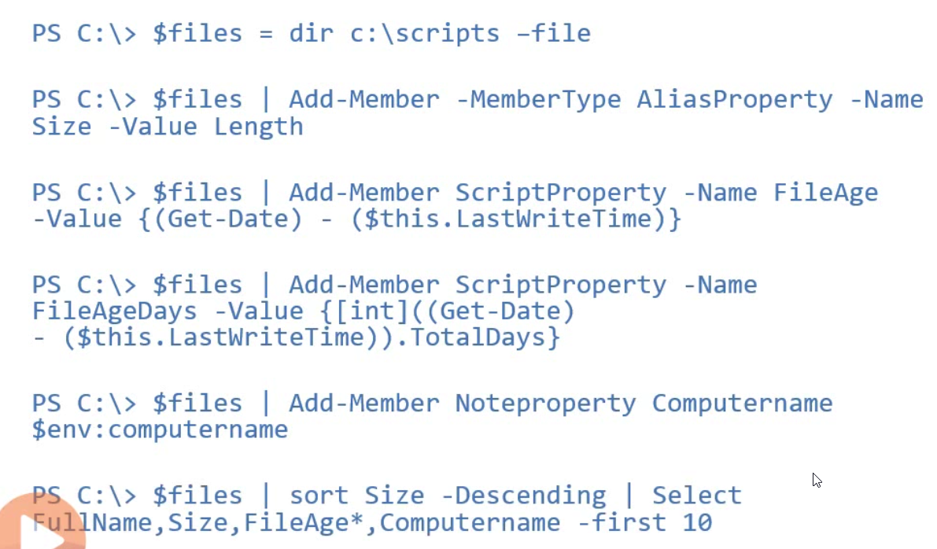

With add-member way of adding properties we can now use this properties in sort etc which we cannot do via adding custom properties.

*Discover all of the type accelerators in PowerShell*

[psobject].assembly.gettype(‘Microsoft.Management.Automation.TypeAccelerators’)::Get

**New-Object**

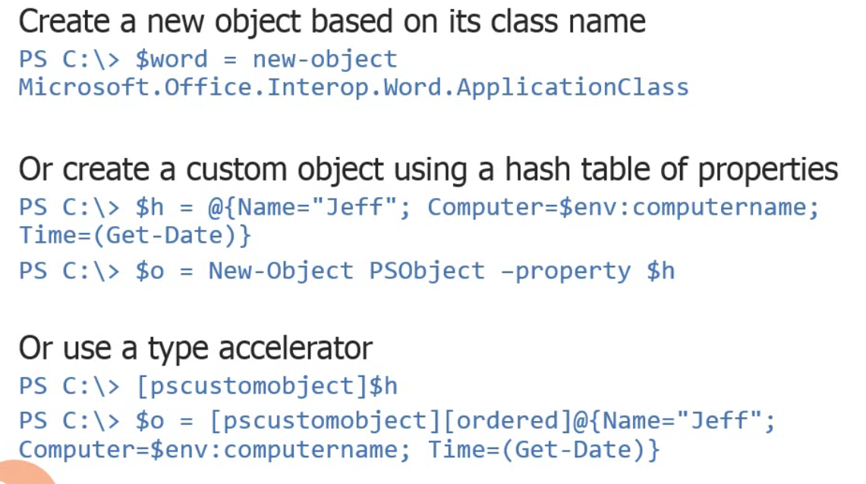

COM Objects:

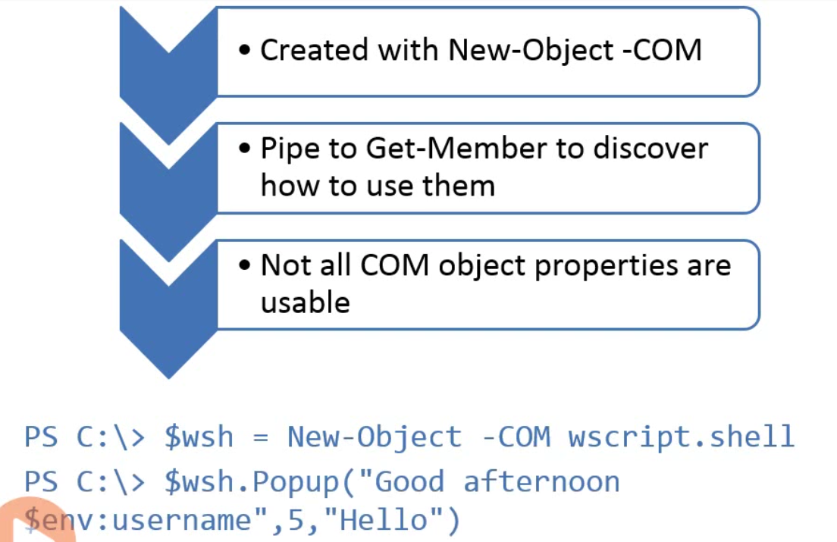

**Managing Jobs:**

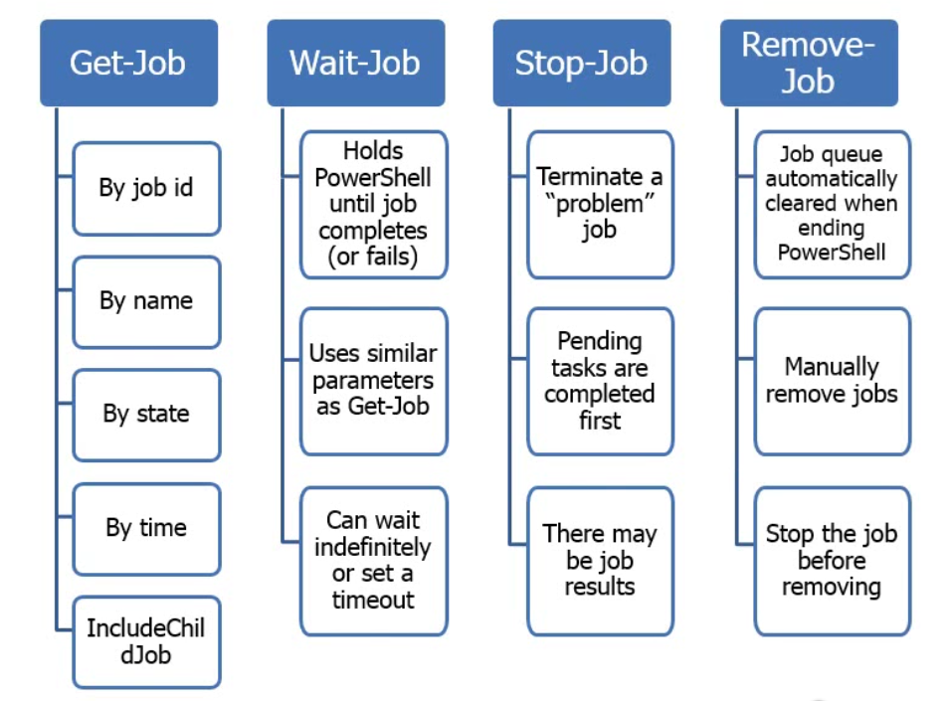

When you stop your job all the child jobs that are running are completed first.

It is recommended to stop a job before removing it from the powershell queue.

Job results are stored as part of the job queue. Use Receive-Job to get the results. Results are cleared unless you use -Keep parameter. The results will be deserialized objects.

Always retrieve the job results even if the job is failed as failed jobs can also have results. Sometimes the error will be returned with the results.

Job object has a JobStateInfo object with a Reason property which can explain why the job failed.

Get-Job -ChildStateJob Failed --retrives all the failed jobs, normally the first jo in the list of results will be the parent job.

*To get the failed job reason.*

$wsjob | Get-Job -ChildJobState Failed | Select Skip 1 | Select -ExpandProperty JobStateInfo | Select -ExpandProperty Reason

**Running jobs on remote computer:**

Normally when using Invoke-Command, job queue is local but command runs remotey. Results written to the local job queue. Remote jobs run everything on the remote computer. *This does required the use of maintained PSSession.*

#create pssessions

$sess = new-pssession chi-dc01,chi-dc02,chi-dc04

#start the job on the remote computers

Invoke-Command { start-job {get-eventlog "Directory Service" -Newest 10 -EntryType Error,Warning}} -session $sess

#nothing is local

Get-Job --no output will be there.

icm {get-job} -session $sess

#get the results from the remote computers

$dcdata = icm {get-job | receive-job -Keep} -session $sess

$dcdata

$dcdata | Select Machinename,TimeGenerated,EventID,Source,Category,EntryType,Message | Out-GridView

#remote job will go away when I end the session

$sess | Remove-PSSession

**PowerShell Scheduled Jobs:**

Started in powershell 3.

It is a combination of a PowerShell background job and scheduled task. What we need to do is to run a powershell command at a scheduled time. For this, powershell does not even need to be running.

Schedule Task of windows allows you to manage all scheduled tasks. Do not confuse this with powershell scheduled jobs. Both are different.

Cmdlets for creating the job definition are in the PSScheduledJob module. Scheduled job definition that we create is stored in disk. By default, it is stored in

*C:\Users\Hesh\AppData\Local\Microsoft\windows\PowerShell\ScheduledJobs\<Jobname>*

Results are also written to disk in that same location.

**NOTE:** scheduled jobs related cmdlets must run in an elevated powershell session. This will create a schedule jobs locally.

Define a job trigger. This is basically how often I want this job to run. Like weekly, Sunday night etc and at what time I want this to run.

Define a job action such as a script block or a script file.

Define job options like Run elevated, Require network, idle settings,

Then, finally register the job. The scheduled job that we are creating will run under your credentials by default. You can also specify alternate credentials if you need to. You can also specify to initialize an environment like loading a module etc. you can also set the history count.

$trigger = New-JobTrigger -Daily -At "6:00 AM"

$action = { get-eventlog system -EntryType Error,Warning -After (Get-Date).AddHours(-24) }

$opt = New-ScheduledJobOption -RunElevated

# Define a name for the scheduled job to save typing

$name="Daily Event Log"

Register-ScheduledJob -Name $name -ScriptBlock $action -Trigger $trigger -ScheduledJobOption $opt

#let's create a second job as well in a oneline command using splatting

$computers = "chi-dc01","chi-dc02","chi-dc04","chi-fp01"

$jobParams = @{

Name="DiskReport"

Trigger = New-JobTrigger -DaysOfWeek Sunday -At "10:00 PM" -Weekly

ScheduledJobOption = New-ScheduledJobOption -RunElevated -RequireNetwork

FilePath = "C:\scripts\WeeklyDiskReport.ps1"

ArgumentList = ,$computers

}

Register-ScheduledJob @jobParams

#Modify JOb Trigger

Set-JobTrigger

#Modify Job Option

Set-ScheduledJobOption

#Modify Job

Set-ScheduledJob

#Managing a scheduled job

Start-Job -DefinitionName "MyJob"

#Get job results with Recereve-Job

Receieve-Job MyJob -Keep

#Enable/Disable Scheduled Jobs

Enable-ScheduledJob MyJob

Disable-ScheduledJob MyJob

#Remove a schedule job and its history.

Unregister-ScheduledJob MyJob #use this cmdlet and not the Task Schedular because

#if you remove through the task schedular, you will have some leftover left in the file system.

#in your app data folder.

Get-ScheduledJob #shows you all the scheduled jobs

Get-Job #shows you the jobs that ran including background and scheduledd jobs.

**PowerShell and Regular Expressions:**

It is a way of describing data by what it looks like. *Regular Expressions can be case sensitive.*

**Wildcard comparisons:** -Like and -NotLike operators

Comparison string uses wildcard characters like *etc. useful for simple matching.

“Powershell” -Like “*shell” --returns True

“Powershell” -NotLike “cmd*” --returns True

**Regular Expression Comaprison:** -Match and -NotMatch

When we do a matching, remember that a match will “float” that is if it finds that match anywhere within that string, it will be considered true unless we anchor that and ask to find at a specific position.

Matching creates a MatchInfo object which can be used to identify where you matched. Matching then will stop at the first non-matching character.

“Powershell” -match “shell” --returns True

“Powershell” -NotMatch “cmd*” --returns True

These returns either True or False as results.

***Basics of Regular Expression:***

Regular expression matches on character sets.

1. We can match on any single character using a period(.).
2. We can match on single set of characters in square brackets[abc]. For whatever letters in the string we ave, as long as they have a,b or c anywhere in the string it will match.
3. Match on a range of characters [m-z]. these are case sensitive.
4. **^ ->** when we need to do anchoring, we need to put caret(^) at the beginning of the regular expression pattern and this will mean that the string we are comparing has to be startwith whatever letter comes after the anchor(^)
5. **$ ->** it is used as an anchor from the end.
6. **\ ->** escape character in regular expression.

*Commonly used character sets:*

1. \w -> Match any word character including numbers(alphanumeric characters)
2. \W -> Match any non-word character
3. \d -> Match any digit
4. \D -> Match any non-digit
5. \s -> Match any white space character
6. \S -> Match any non-white space character

*Quantifiers:*

1. + -> Match repeating instances of preceding character
2. * -> Match zero or more instances of preceding character
3. ? -> Match 0 or 1 instance of preceding character
4. {n} -> Match exactly n number of preceding characters
5. {n,} -> Match atleast n number of preceding characters
6. {n,m} -> Match atleast n number of preceding character and no more than m

*Common Regular Expression Patterns:*

1. North American Phone -> “\d{3}-\d{4}”
2. IPv4 Address -> “\d{1,3}\.\d{1,3}\.\d{1,3}\.\d{1,3}”
3. Logon -> “\w+\\\w+”
4. UNC -> “\\\\\w+\\\w+”

These patterns just describe it but does not validates it. Logic for validation needs to be added.

You also may need to anchor to stop float.

#region LIKE

"jeff" -like "j*" #returns True

"JEFF" -like "*ff" #returns True

"jeff" -like "myles" #returns False

get-content c:\work\computers.txt |

where {$_ -like "*DC*" -and !(Test-Connection $_ -quiet -Count 1)}

#endregion

#region MATCH

#match uses regular expressions

"jeff" -match "j" #returns True; Matches j at 0

#$matches created automatically

$Matches

"JEFF" -match "ff" #returns True; Matches FF at 0

$Matches

"jeff" -match "J.ff" #returns True; Matches jeff at 0

$matches

get-process |

where {$_.company -AND $_.company -notmatch "Microsoft"} |

Select Name,Company

#beware of floating

"powershell" -match "pow" #returns True

$matches

"turtlepower" -match "pow" #returns True

$matches

"powershell" -match "^pow" #returns True. anchor used to denote it should start with pow

"turtlepower" -match "^pow" #returns False

"powershell" -match "^powershell$" #returns True

$matches

"powershelll" -match "^powershell$" #returns False

dir "\\chi-fp01\executive" -filter "datareport*.docx" |

Where {$_.name -match "t\d{2}\.docx$"}

#endregion

#region common regular expression patterns

#region unc

$unc = "\\\\\w+\\\w+"

"\\server01\public","server\public","\\server-3\files","\\server\share\folder" |

where {$_ -notmatch $unc}

#so invalid unc's are

server\public

\\server-3\files

#endregion

#region Logon

$names = "globomantics\jeff","domain\jeff\foo","globo2\admin"

$acct = "\w+\\\w+"

#beware of float

$names | where {$_ -match $acct}

#valid login's because of float are all of them but that's not true. regex is not correct and needs to be modified.

#float matching needs to be taken care of

$acct = "^\w+\\\w+$"

$names | where {$_ -match $acct}

#Now valid logon's are

globomantics\jeff

globo2\admin

#endregion

#region ipv4 address

$ips = "172.16.30.200","172.16.3.4","172.16.30.203","10.100.10.1000","100.200.300.400"

$ip = "\d{1,3}\.\d{1,3}\.\d{1,3}\.\d{1,3}"

$ips | where {$_ -match $ip}

#fix the float

$ip = "^\d{1,3}\.\d{1,3}\.\d{1,3}\.\d{1,3}$"

$ips | where {$_ -match $ip}

#or narrow it down

$ip = "^172\.16\.30\.\d{1,3}$"

$ips | where {$_ -match $ip} | Resolve-DnsName | Select Name,Server

#endregion

#region phone number

$phone="\d{3}-\d{4}"

#get all users with a phone number defined

$users = get-aduser -filter "telephonenumber -like '*'" -property telephonenumber

$users | select Name,*number

#find users with a mis-entered phone

$users | where {$_.telephonenumber -notmatch $phone} |

Select Distinguishedname

#endregion

#endregion

*Introducing the Regex Object:*

Create with the [regex] type accelerator. With this you can find multiple matches. It is case sensitive.

Example

[regex]$rx = “^\\\\CHI-\w+\d{2}\\\w+$”

$rx.match($name)

Groups : {\\CHI-FP01\public}

Success : True

Captures : {\\CHI-FP01\public}

Index : 0

Length : 17

Value : \\CHI-FP01\public

$p = "\\\\CHI-\w+\d{2}\\\w+"

#regex is case sensitive

[regex]$rx = $p

$unc = "\\chi-fp01\public"

$unc -match $p

$rx.match($unc)

$rx.match($unc.toUpper())

#or adjust regex

[regex]$rx = "^\\\\[Cc][Hh][Ii]-\w+\d{2}\\\w+$"

$rx.match("\\chi-fp01\public")

$rx.match("\\CHI-fp01\public")

$rx.match("\\cHi-fp01\public")

#use the regex result

$f = read-host "Enter a folder path"

$rx.match($f)

Test-Path $rx.Match($f).Value

#find multiple matches. Use Matches instead of Match

$line = "172.16.30.8 192.10.1.1 Error Some event happened"

[regex]$ip="\d{1,3}\.\d{1,3}\.\d{1,3}\.\d{1,3}"

$data = $ip.Matches($line)

$data

$data[0].value

$d = get-content C:\Windows\system32\LogFiles\HTTPERR\httperr1.log

$ip.matches($d) | select Value -Unique

**Select-String**

It can be used to find text in strings and files. This is similar to grep in cmd.

We can use it with simple or complex patterns. We can make it to be case sensitive. We can find multiple matches. We can also use it to display context.

This will write a MatchInfo object to the pipeline.

Dir C:\Work\*.txt | select-String “globomantics” | Selet filename

This will give us all the text file inside the work folder that has globomantics in the text.

#requires -version 3.0

#this is actually a regular expression match

dir s:\*.ps1 | select-string "get-ciminstance"

dir s:\*.ps1 | select-string "get-ciminstance" -SimpleMatch

#list matchings files

dir s:\*.ps1 | select-string "get-ciminstance" -List

#matchinfo object

dir s:\*.ps1 | select-string "get-ciminstance" -List | Get-Member

dir s:\*.ps1 | select-string "get-ciminstance" -List | select Filename

#use regular expression patterns

get-content C:\Windows\system32\LogFiles\HTTPERR\httperr1.log |

Select-string "\d{1,3}\.\d{1,3}\.\d{1,3}\.\d{1,3}" -AllMatches

#context – the context number displays the specified number of lines before and after the matched line.

$r = get-content C:\windows\WindowsUpdate.log |

Select-string "\d{1,3}\.\d{1,3}\.\d{1,3}\.\d{1,3}" -AllMatches -Context 2

$r

$r[-1]

**Serialization and using CSV:**

Serialization is the process that allows us to save an object usually to a file. The typical formats used are either CSV or XML. Objects can then be recreated by deserializing the csv or xml file.

We can serialize an object in one powershell session and then can recreate it in another powershell session.

CSV – comma separated value. Default Delimeter is comma but it can be almost anything.it works best for the flat object types.

**Export-CSV ->** turns the object into a csv file. Specify the filename, default delimeter is comma but you can change it. Properties of the objects becomes csv headings.

Be careful of what you are exporting. Arrays and objects don’t export.

Powershell includes a type information comment when exporting which helps in recreating the object back via deserialization. However, you can skip the type information if you are going to use the csv outside of powershell.

You can also append content to an existing csv file. This feature included in powershell 3

**Import-CSV ->** powershell can import any csv file. It turns the data inside of the csv files into objects. Headings becomes property names. You can also specify alternate header.

*All values when Imported are strings.*

When we serialize, we do not capture methods. So when we import a csv, we won’t see any methods associated with the object.

Import with TypeInformation creates a CSV:Selected Object otherwise you will get a custom object.

*Objects can be converted to and from CSV without a file. This is useful to modify csv on the fly.*

**ConvertTo-CSV**

**ConvertFrom-CSV**

#requires -version 3.0

#demo CSV serialization.

#these commands are designed for the ISE

#region Export-CSV

#region be careful what you export

get-service m* -ComputerName $env:computername |

Export-Csv -Path c:\work\msvc.csv

psedit C:\work\msvc.csv

#endregion

#region select the properties you want

get-service m* -ComputerName $env:computername |

Select Name,Displayname,Status,Machinename |

Export-Csv -Path c:\work\msvc.csv

psedit C:\work\msvc.csv

#endregion

#region no type information

get-service | Select name,displayname,status |

Export-csv c:\work\svc.csv -NoTypeInformation -Delimiter ";"

psedit C:\work\svc.csv

#endregion

#region appending

#keep properties the same.

#run at least 3 times with a little time between each sample

get-process svchost |

Add-Member -membertype Noteproperty -name SampleTime -Value (get-date) -PassThru |

Select * -ExcludeProperty Modules,Threads |

Export-Csv c:\work\svchost.csv -Append

#we'll use this later

#endregion

#endregion

#region Import-CSV

#region default delimiter is comma

$impSvc = Import-Csv C:\work\msvc.csv

$impSvc

$impSvc | gm

#endregion

#region works with any CSV

$s = import-csv C:\work\svc.csv -Delimiter ";"

$s

$s | gm

psedit .\newusers.csv

#import and filter out blank lines

$n = import-csv \\serenity\trainsignal\lesson_14\newusers.csv | where {$_.OU}

$n

#these objects could then be piped to AD cmdlets

#importing our appended csv file

#I've added code to change some properties back into different

#object type instead of string

import-csv c:\work\svchost.csv | sort id,@{expression={[datetime]$_.sampletime}} |

ft -group id -Property @{N="Sample";Expression={([datetime]$_.SampleTime).ToLongTimeString()}},WS,VM,PM,CPU

#endregion

#endregion

#region Convert CSV

help convertto-csv -online

$a = get-service | select name,displayname,status | Convertto-CSV

$a[0..4]

#not sure what this really gives us

$b = $a | convertFrom-csv

#endregion

------------------------------------------------------------

**PowerShell Intros: Quick look:**

You can use the [ref] keyword to pass a variable by reference. The function definition should also have the ref keyword against the parameter.

# Rather than using Set-Variable with its -scope, you can pass by ref

# Note however it turns it into an object, thus requiring the .Value syntax

function Set-FVar([ref] $myparam)

{

$myparam.Value = 33

}

Clear-Host

$fvar = 42

"fvar before: $fvar"

Set-FVar ([ref] $fvar) # Must add ref to call

"fvar after: $fvar"

For a function to work with pipeline, it must have a begin{}, process{} and end{} block.

Similar to functions, a filter can also be created. A filter works something like the where object command. the filter takes what is passed through the pipeline and looks for something specific in the object that is coming in.

# Filters can be built to remove unwantd files

filter Show-PS1Files

{

$filename = $_.Name

if ($filename -like "*.ps1")

{

return $_

}

}

Clear-Host

Get-ChildItem | Show-PS1Files

------------------

Error Handling:

Error handling in powershell is very extensive. Normally when powershell code runs, it keeps on running even after throwing error. This is because of the $ErrorActionPreference variable set to Continue.

There are various ways to handle errors in powershell. One of them is trap script block. *Trap statements can be placed anywhere inside the function. They can be placed at the top and also at the bottom.*

function divver($enum,$denom)

{

Write-Host "Divver begin."

$result = $enum / $denom

Write-Host "Result: $result"

Write-Host "Divver done."

trap

{

Write-Host "Oh NO! An error has occurred!!"

Write-Host $_.ErrorID

Write-Host $_.Exception.Message

continue # Continue will continue with the next line of code after the error

}

}

In the above example, powershell will continue to execute lines after error due to the use of continue keyword.

function divver($enum,$denom)

{

Write-Host "Divver begin."

$result = $enum / $denom

Write-Host "Result: $result"

Write-Host "Divver done."

trap

{

Write-Host "Oh NO! An error has occurred!!"

Write-Host $_.ErrorID

Write-Host $_.Exception.Message

break # With break, or omitting it, error bubbles up to parent

}

}

In the above example, powershell will also show its error message along with our message in the trap script block.

Divver begin.

Oh NO! An error has occurred!!

Attempted to divide by zero.

Attempted to divide by zero.

At line:4 char:3

+ $result = $enum / $denom

+ ~~~~~~~~~~~~~~~~~~~~~~~~

+ CategoryInfo : NotSpecified: (:) [], ParentContainsErrorRecordException

+ FullyQualifiedErrorId : RuntimeException

To handle this, we need to check for specific error and add the trap logic within our parent because the break statement passes the error to the parent.

# Check for specific errors

function divver($enum,$denom)

{

trap [System.DivideByZeroException]

{

Write-Host "Hey, chowderhead, you can't divide by zero!"

continue

}

trap

{

Write-Host "Oh NO! An error has occurred!!"

Write-Host $_.ErrorID

Write-Host $_.Exception.Message

break # With break, or omitting it, error bubbles up to parent

}

Write-Host "Divver begin."

$result = $enum / $denom

Write-Host "Result: $result"

Write-Host "Divver done."

}

The downside of this approach is that you will end up with a lot of trap blocks which might become hard to maintain. Using *try catch and finally block instead is a good approach.*

-----------------

Working with files:

The Get-Content command reads the content of a file and returns the content as an array. Each line in the file corresponds to an element of that array. Get-Content supports wildcards. Use Set-Content to write to a file. Use Get-ChildItem to get the contents of a Directory. Use Add-Content to add lines to a file.

$a = Get-Content "a.txt"

# Looks are deceptive, this is actually an array

$a[0]

$a[3]

# To combine, we can use Join, passing in the seperator and the variable

$separator = [System.Environment]::NewLine # could have done `r`n

$all = [string]::Join($separator, $a)

--------------------------------------

Execution Policy:

It can be AllSigned, RemoteSigned, Restricted, UnRestricted etc.

In addition to these settings, these can also have scopes.

MachinePolicy - Applies to all users on the machine. Must be set via

Group Policy.

UserPolicy - Applies to the current user. Again, must be done via

Group Policy.

Process - Applies only to the current process. Once the process

completes (i.e. the PS window is closed) the previous

setting is restored.

CurrentUser - Setting is only valid for this user.

LocalMachine - Setting is valid for all users of this computer.

Best practice suggests only enabling script execution if you need it.

Then, set to RemoteSigned so you can run the scripts you develop but

will have some protection from malicious scripts from the web.

# With Restricted Policy, can't run script

Set-ExecutionPolicy -ExecutionPolicy Restricted -Scope CurrentUser

. 'C:\PS\Beginning PowerShell Scripting for Developers\demo\bpsd-m06-do-something.ps1'

# With RemoteSigned we can run our script

Set-Location 'C:\PS\Beginning PowerShell Scripting for Developers\demo\'

Set-ExecutionPolicy -ExecutionPolicy RemoteSigned -Scope CurrentUser

. '.\bpsd-m06-do-something.ps1'

# With Unrestricted we can run anything

Set-ExecutionPolicy -ExecutionPolicy Unrestricted -Scope CurrentUser

$doSomething = 'C:\PS\Beginning PowerShell Scripting for Developers\demo\bpsd-m06-do-something.ps1'

. $doSomething

--------------------------------------------

**Code Signing:**

# Code Signing a script

#

# Before we can sign a file, we need to create a certificate.

# There are many ways to create a certificate.

# 1. Create a certificate yourself, this is called self signing

# 2. Have your system admin create a certificate using Active Directory

# 3. Get a certificate from a certificate authority, such as Verisign

#

# For this demo, we will create a self signed certificate (option 1).

# Follow the instructions in the document bpsd-m06-code-signing.pdf

# to create your certificate before executing the code below

Let’s go ahead with the option 1.

Creating a Self-Signed Certificate

This document will walk through the steps of creating a self-signed security certificate. Note that self-signed certificates are useful for development purposes. In a production situation you will want to obtain a certificate from either your system administrator who uses Active Directory to create a certificate for use in your corporate domain, or use a third party certificate vendor such as Verisign.

In this document we will be using the Microsoft Management Console (MMC). The appearance of MMC will vary depending on what version of Windows it is running on, thus the screen shots in this document may not exactly match what is on your display. The steps though are the same regardless of the version of Windows.

1. Run the program MMC.EXE. (Note, the MMC application may appear different depending on the version of Windows you are running. The steps are basically the same regardless of the version of Windows you are using.)

2. Add the Certificate Snapin

a. Select *File, Add/Remove Snap-in…* from the menu

b. Select *Certificates* on the list of available snap-ins, then click *Add* to move it to the list of Selected snap-ins.

c. When you click the Add button, you will be prompted for which set of certificates to manage. Ensure *My user account* (the default) is selected and click *Finish*.

d. Click *OK* to close the Add or Remove Snap-ins dialog.

3. Next, you will want to open a Command Prompt window. You can search for it by typing CMD in the search window, the same way you searched for PowerShell. Make sure to right click on it, then select “*Run as administrator*”.

4. You are going to run the makecert.exe program. It is included in either the Microsoft .Net Framework SDK or the Microsoft Windows Platform SDK. On the computer this document was developed on, Visual Studio 2013 with Update 5 is installed. There are multiple versions of MakeCert installed, the makecert utility used in this demo was be found in: C:\Program Files (x86)\Windows Kits\8.1\bin\x86 If you are unsure of the location of use, just move to C:\Program Files (x86) in the Command Window, and type in DIR MAKECERT.EXE /S. This will look for makecert.exe in all of the subdirectories. You may find multiple copies, if so use the one with the most current date.

5. Once in the folder, enter the following command, all in one line (it wraps here due to document width limitations):

makecert -n "CN=PowerShell Local Certificate Root" -a sha1 -eku 1.3.6.1.5.5.7.3.3 -r -sv root.pvk root.cer -ss Root -sr localMachine

6. Upon hitting enter you will be prompted to enter a key. Either write it down, put it into a password safe such as LastPass, or use something you can remember.

7. Click OK once you’ve entered the password. In the next screen you’ll be prompted to enter your private key. This is the one you just entered when you created it, so just enter the same password again.

8. Return to MMC, and drill down to *Certificates – Current User, Trusted Root Certification Authorities, Certificates*. Scroll down and you should see the *PowerShell Local Certificate Root*. (Note for security reasons the other certificates in this image have been whited out).

9. Return to the command window and run the following command (again all on one line):

makecert -pe -n "CN=PowerShell User" -ss MY -a sha1 -eku 1.3.6.1.5.5.7.3.3 -iv root.pvk -ic root.cer

10. You will be prompted to enter your password. Enter and click OK.

11. Return to the MMC, and this time navigate to *Certificates – Current User, Personal, Certificates*. You should now see an entry for PowerShell User. (Again, other certificates have been whited out of this image for security reasons.)

12. Your certificate is now ready. Return to PowerShell to continue.

# After creating the certificate we should verify it exists.

Get-ChildItem cert:\CurrentUser\My -CodeSigningCert

# After creating our self signed certificate, we need a file to sign.

# Just copy the do something script.

$demoPath = 'C:\PS\Beginning PowerShell Scripting for Developers\demo\'

$doSomething = "$($demoPath)bpsd-m06-do-something.ps1"

$doSomethingSigned = "$($demoPath)bpsd-m06-do-something-signed.ps1"

Copy-Item $doSomething $doSomethingSigned -Force

# To test, we will set the execution policy to require all scripts

# to be signed

Set-ExecutionPolicy -ExecutionPolicy AllSigned -Scope CurrentUser

# Now try to execute the script. Should produce an error.

. $doSomethingSigned

# Now we'll sign the script.

Set-AuthenticodeSignature `

$doSomethingSigned `

@(Get-ChildItem cert:\CurrentUser\My -CodeSigningCert)[0]

# Now try to execute the script a second time. We will be prompted as to

# whether we should run or not. Run Once means the next time we run,

# we will again be prompted.

# Always will save our choice and henceforth will run.

# Now run. (Note, depending on machine settings, you may see a dialog

# asking to run once, run always, or not run. Answer appropriatly.)

. $doSomethingSigned

# Open the file to see what happened

psEdit $doSomethingSigned

# Make a simple change to the file. Even adding one space on a blank line.

# Save and try to rerun. Pandamonium ensues.

. $doSomethingSigned

# Even reverting the change still won't fix it, must resign.